医疗解决方案

w w w . i e i w o r l d . c o m
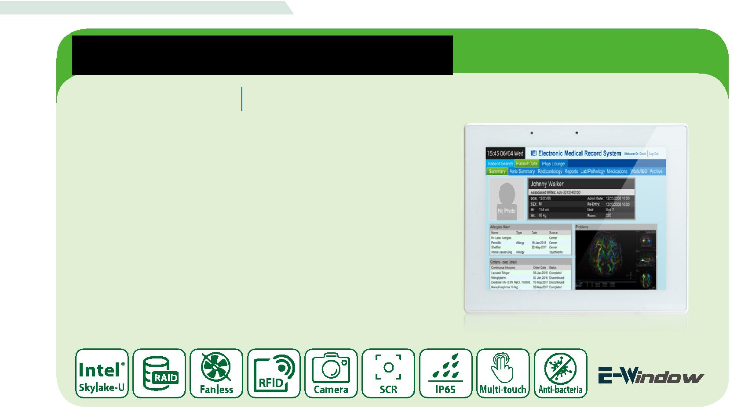

定点照护终端

POC-17C-ULT3 17”第六代英特尔®移动ULT核心™i7 / i5 /赛扬处理器医疗平板电脑

特征

- 17" 5:4 LED面板（1280 x 1024）

- 第六代英特尔®移动ULT核心™i7-6600u /核心™i5-6300u /赛扬 ®3 855u

- 投射电容式多点触摸10点

- IP65标准的前面板

- 抗菌盖

- 支持RAID功能（RAID 0和RAID 1）
（仅为核心™i5或i7核心™）
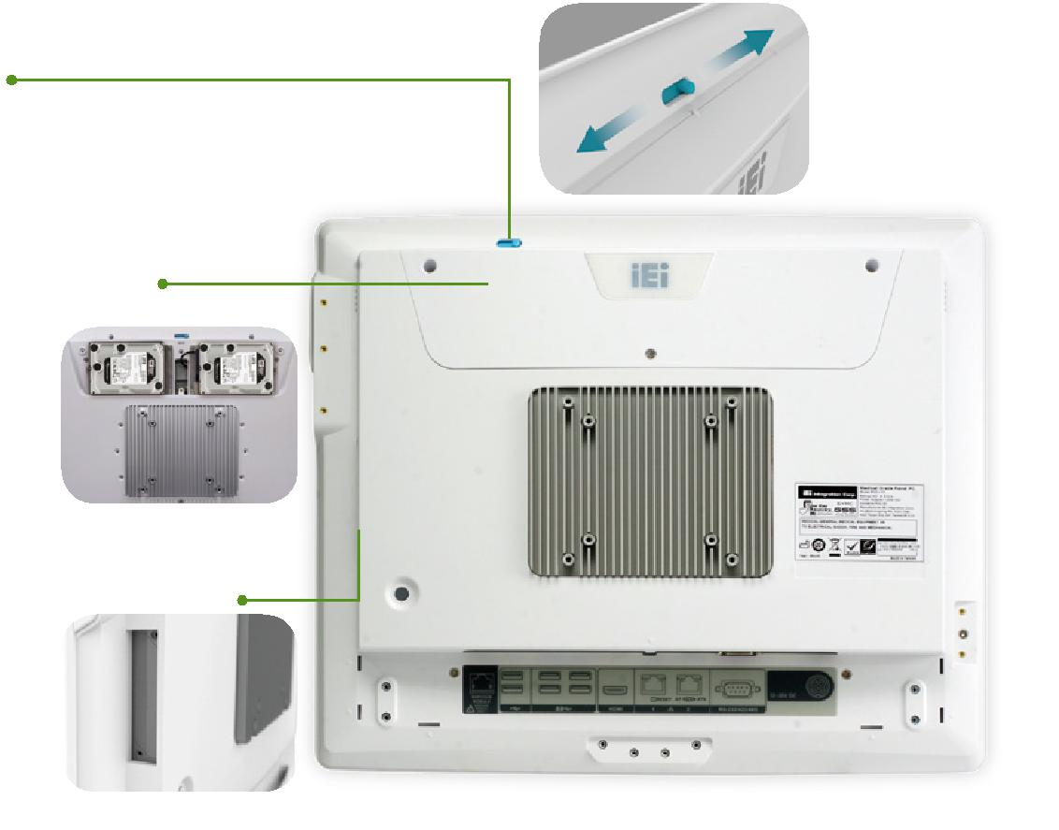

● 内置摄像机盖

相机罩保护病人的隐私。内置式设计，维护更方便，防止盖损。

● RAID 0 and RAID 1 功能

RAID0/1通过镜像提供冗余—数据与两个驱动器完全相同。医院里的用户不再需要担心丢失的数据了。（仅为核心™i5或以上）

● E-Window 多个扩展

保留的PC Ie mini插槽扩展帮助系统集成商轻松添加更多的功能，而无需任何附加费用。

● 前面IP65

易于清洁，喷洗涤剂正面擦拭

- 高级盐水触摸屏

PCAP触摸不仅支持多点触摸功能，佩戴手套时也可进行平稳的控制。此外，我们还与供应商合作，努力避免触摸屏存在无菌盐水时发生意外操作。

医疗解决方案

w w w . i e i w o r l d . c o m

规格

 |  | Model | POC-17C-ULT3
 |  | LCD 显示屏 | 17” (5:4)
 |  | 最大分辨率 | 1280 (W) x 1024 (H)
 |  | 亮度(cd/m²) | 350
LCD | 规格 | 对比度 | 1000:1
 |  | LCD 颜色 | 16.7M
 |  | 像素间距(mm) | 0.264 (H) x 0.264 (V)
 |  | 可视角度 (H-V) | 170° / 160°
 |  | 背光MTBF (hrs) | 30000 (LED backlight)
触摸屏 |  | 触摸屏类型 | Projected capacitive type with 10-point multi-touch
 |  | 表面硬度 | 6H
 |  | 支持的CPU | 6th Generation Intel® mobile ULT Core™ i7-6600U / Core™ i5-6300U / Celeron®
 |  |  | 3855U
 |  | 内存 | Two 260-pin 1600/1333MHz dual-channel DDR4 SO-DIMM, 4GB pre-installed (system
 |  |  | max.32GB)
 |  |  | 1 x RJ-11 for barcode module (1D/2D)
 |  |  | 4 x USB 2.0 (2 for side)
 |  |  | 4 x USB 3.0 port
 |  | I/O 接口 | 1 x HDMI output
系统 |  |  | 2 x GbE LAN port
 |  |  | 1 x RS-232/422/485
 |  |  | 1 x 12~28V DC jack
 |  |  | 2 x 2.5” SATA 6Gb/s accessible HDD bay with RAID 0,1 (RAID function only for Core™
 |  | 存储卡 | i5 and Core i7™)
 |  |  | 1 x mSATA (E-Window)
 |  | 音频 | 2 x 2W speaker and digital microphone
 |  | 摄像头和麦克风 | 2-megapixel CMOS front-facing camera with auto-focus and digital microphone
 |  | 扩展 | 1 x E-Window slot (full-size PCIe Mini slot with PCIe/mSATA/USB)
 |  |  | 1 x LCD on/off
 |  |  | 1 x Brightness up
 |  |  | 1 x Brightness down
 |  |  | 1 x Volume up
 |  | 功能 键 | 1 x Volume down
 |  |  | 1 x Touch lock button for cleaning
其他特点
 |  |  | Combinations:
 |  |  | 1 x Lock/Unlock OSD
 |  |  | 1 x Power on/off
 |  | 自动感光 | Yes
 |  | 散热 | Fanless
链接 |  | 无线和蓝牙 | IEEE 802.11 a/b/g/n/ac 2T2R module with Bluetooth V4.1 (M.2 2230 A-E key module)
 |  | 材质 | ABS+PC plastic with anti-bacterial material pantone RAL 9016 (apple white)
 |  | 安装 | Wall, Stand and Arm VESA 100/75
物理 |  | 净重 | 6.0 Kg
 |  | 尺寸 (WxHxD) (mm) | 435 x 376 x 64.5
 |  | 操作温度 | 0°C ~4 0°C
 |  | 存储温度 | -20°C ~ 65°C
 |  | 湿度 | 10% to 95% (non-condensing)
环境 |  | 震动 | 1G
 |  | 冲击 | Operating Shock: 5G peak acceleration (11ms duration)
 |  |  | Non-Operating Shock: 15G peak acceleration (11ms duration)
 |  | IP 等级 | IP65 compliant front panel
电源 |  | 电源输入 | 12V~28V DC input
 |  | 电源适配器 | 120W medical power adapter: Input: 90V~264V AC, Output: 19V DC
认证 |  |  | CE, FCC Class B part 18,ANSI/AAMI ES60601-1
 |  |  | CAN/CSA-C22.2 No. 60601-1:14,IEC 60601-1-6/IEC62366,ISO 14971

医疗解决方案

w w w . i e i w o r l d . c o m

订购信息

P料号. | 描述
POC-17C-ULT3-C/PC/4G-R10 | 17” 350 cd/m² 1280x1024 | Panel PC with 6th generation 14nm Intel® mobile Celeron® 3855U (15W) 1.6GHz on-board processor (ULT), one 4GB
 | DDR4 RAM, 802.11a/b/g/n/ac Wi-Fi module, PCAP touchscreen, 2-megapixel camera, microphone, R10
POC-17C-ULT3-i5/PC/4G-R10 | 17” 350 cd/m² 1280x1024 | Panel PC with 6th generation 14nm Intel® mobile Core™ i5-6300U (15W) 2.4GHz on-board processor (ULT), one 4GB
 | DDR4 RAM, 802.11a/b/g/n/ac Wi-Fi module, PCAP touchscreen, 2-megapixel camera, microphone, R10
POC-17C-ULT3-i7/PC/4G-R10 | 17” 350 cd/m² 1280x1024 | Panel PC with 6th generation 14nm Intel® mobile Core™ i7-6600U (15W) 2.6GHz on-board processor (ULT), one 4GB
 | DDR4 RAM, 802.11a/b/g/n/ac Wi-Fi module, PCAP touchscreen, 2-megapixel camera, microphone, R10

可选配件

料号 | 描述
MEDP-HS-R10 | USB interface VoIP phone and its holder, white
MEDP-CR-02-R10 | Magnetic card reader/Smart card reader/Fingerprint sensor, white
MEDP-HD-R10 | Metal handle covered with soft rubber
MEDP-HD-BR-R11 | Metal handle covered with soft rubber, with barcode reader and reading light, white
MEDP-MF-RFID-02-R10 | Mifare RFID reader, 13.56MHz, with LED indicator and 100mm antenna, IEI assembly only
MEDP-TPM-02-R10 | Trusted platform module kit with 300mm cable, IEI assembly only
MEDP-EZS-R10 | VESA 100 x 100 mm panel PC stand with a cable management hole, white
POC-17C-ULT3-W10E64-V-R10 | OS Image with Windows Embedded Standard 10 E Value 64-bit for POC-17C/W24C Series, with DVD-ROM, RoHS
POCP-CC03-R10 | POC-17C-ULT3 cable cover, white, plastic, R10

IQ 安装选项

名称 | 料号
壁挂套件 | AFLWK-19B
臂 | ARM-31-RS
站架 | STAND-A21-R10
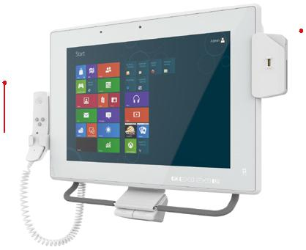

包装清单

名称 | 料号 | 数量 描述
 | 63040-580120-000- | 1 | 120W medical power adapter: Input:
电源适配器 | RS |  | 90V~264V AC, Output: 19 V DC
电源线 |  | 1 | European power cords, 183 CM, C13

 |  | 3合1读卡器 (可
 |  | 选)
 |  |  |  |  | I/O 接口
VoIP 电话 |  |  |  |  |  | Barcode 模块USB 3.0 GbE LAN |  |  |  |  |  |  |  |  |  |  | 12~28V 电源接口
(可选) |  |  |  | E-Window
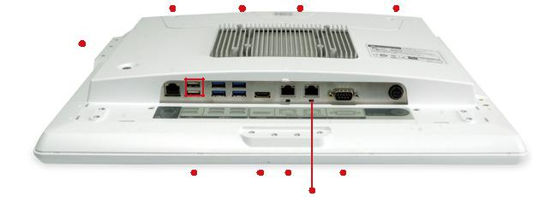
 | USB 2.0 | HDMI Reset | RS-232/422/485
Mifare RFID | module(optional) | AT/ATX
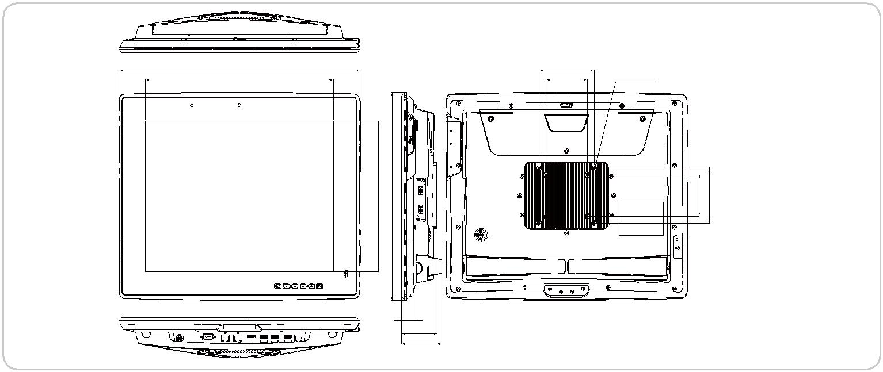

 | POC-17C-ULT3 尺寸 (单位: mm)
435 | 100
338.92 | ⁷⁵8-KFE-M4-5L

34271. | 85375. | 75100

26.2

64.5

73.2

