医疗解决方案

w w w . i e i w o r l d . c o m
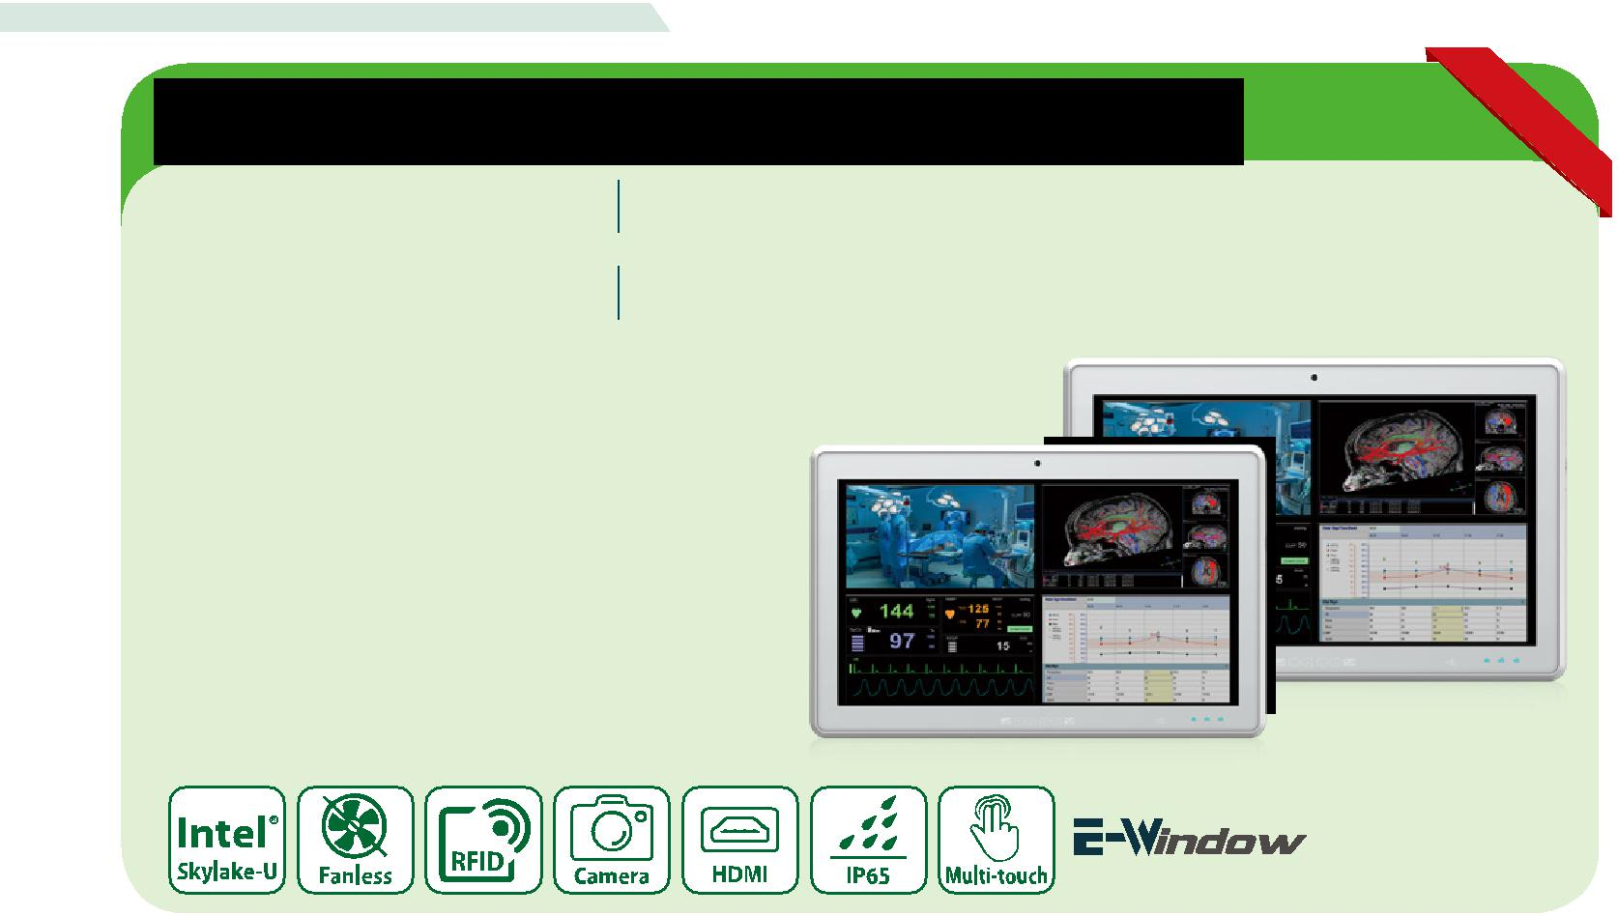

移动照护终端

POCm-W22C-ULT3 POCm-W24C-ULT3

22”医疗平板电脑，具有第六代 Intel® mobile ULT Core™ i7/ i5/Celeron®处理器
24” 医疗平板电脑，具有第六代 Intel® mobile ULT Core™ i7/i5/ Celeron®处理器

特征

- 22“和24“FHD(全高清）无风扇平板电脑

- Intel® Celeron®, Core™ i5/i7 Skylake处理器
- PCAP多点触控触摸屏，戴多层手套在有水的屏幕上也可操作

- 抗菌外壳IP65前面板，后盖IP32
- 总计运行时间为8小时的三个热插拔电池非常适合用于非动力医疗车

主要特点

热插拔电池可以提供足够的电力，符合人体工程学的侧面设计，方便不同身高的护士使用。与传统护理车的Lifepo4电池相比，安装在POCm上的电池通过减轻5公斤以上的重量而具有更好的设计。电池扩展底座可以快速充电，从0%到100%只需3.5小时。

- 轻量化设计

传统上工作站的电池体积庞大，占用空间。热插拔电池使POCm系列成为理想的医疗手推车电脑，可将总重量降至5公斤以下。
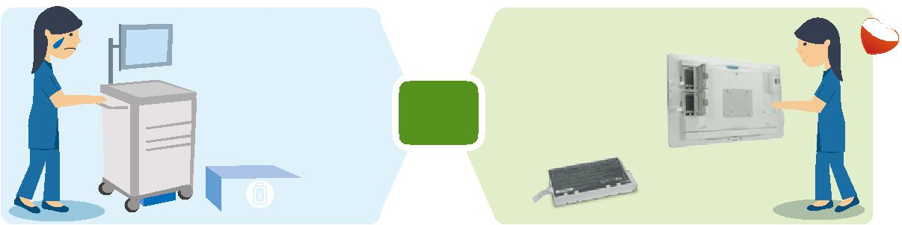

LiFePO4 |  |  |  |  | 3 pcs 锂离
 | 6.5kg! |  |  | v.s | 子电池
 |  |  |  |  | 1.38kg

● 高度集成 ● 有效成本

POC m 系列产品是高度集成的平板电脑。在构建移动 典型的护理车电池价格范围超过600美元（包括售后服务）。我们的抗

工作站时，安装步骤简单，避免了集成不同组件和混 菌电池节省超过400美元的成本。充电底座设计满足医疗环境的需要，

乱布线的麻烦。 节省了医护人员在护士站和病房之间奔波的时间和精力。

医疗解决方案

w w w . i e i w o r l d . c o m

POCm-W22C-ULT3 / POCm-W24C-ULT3
I/O 接口

GbE LAN HDMI
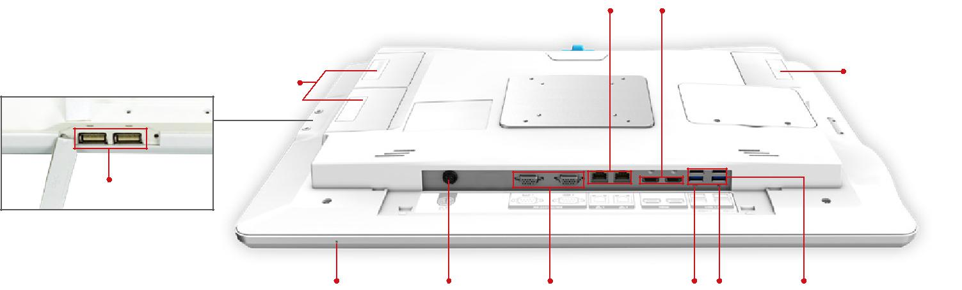

电池
电池 x2

USB 2.0

数位麦克风 12~28V DC 接口 RS-232/422/485 AT/ATX Reset USB 3.0
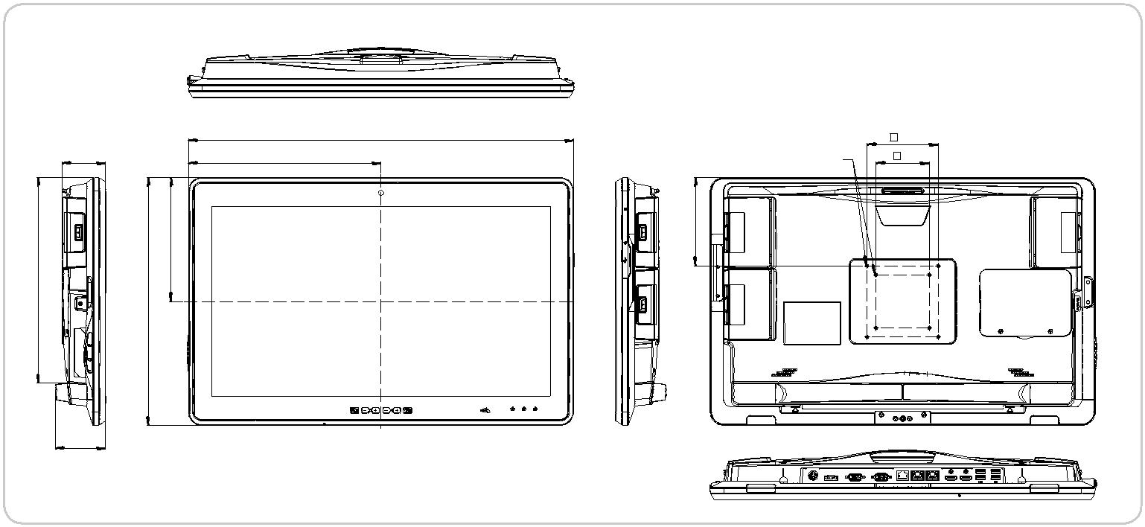

 |  | POCm-W22C-ULT3
 |  | 尺寸 (单位: mm)
61 | 543 | M4x8L | 100
 | 271 |  | 75
 | 175 | 125
290 | 350

71
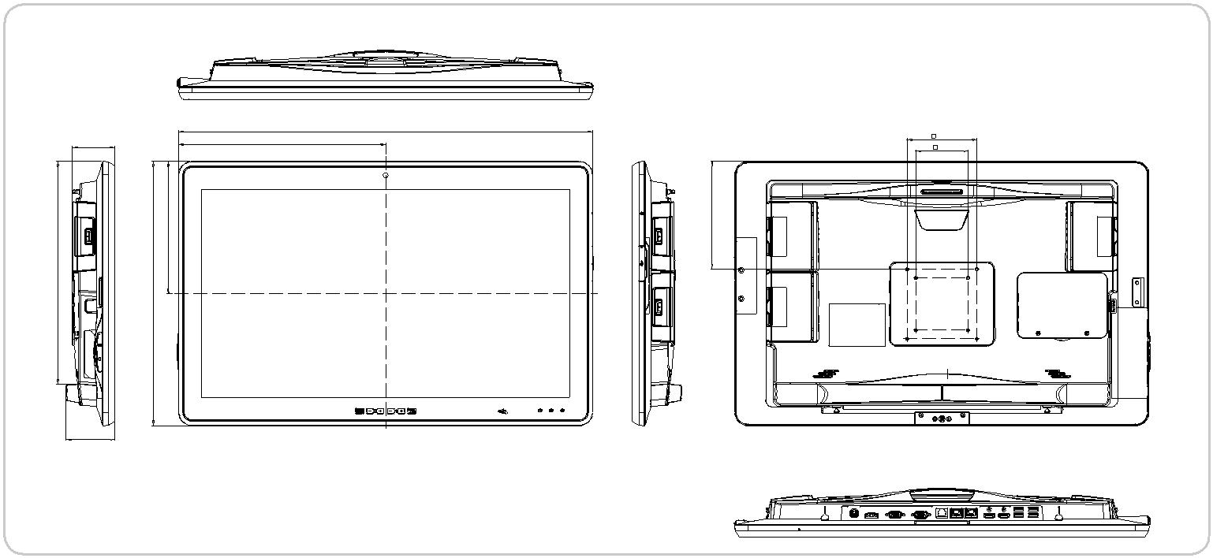

 | 61.0 | 297.3 | 594.6
 | 8189. |  | 154.8
9319. | 379.6

71.0

POCm-W24C-ULT3
尺寸 (单位: mm)

100.0
75.0

医疗解决方案

 |  |  |  |  | w w w . i e i w o r l d . c o m
规格
 |  | 型号 |  | POCm-W22C-ULT3 | POCm-W24C-ULT3
 |  | LCD 显示 |  | 21.5'' (16:9) | 23.8"
 |  | 最大分辨率 |  | 1920 (W) x 1080 (H) | 1920 (W) x 1080 (H)
 | LCD规格 | 亮度 (cd/m²) |  | 250 | 250
 |  | 对比度 |  | 1000:1 | 1000:1
 |  | LCD 颜色 |  | 16.7M colors (RGB 6-bit) | 16.7M colors (RGB 6-bit)
 |  | 像素间距(mm) |  | 0.24825 (H) x 0.24825 (V) | 0.2745 (H) x 0.2745 (V)
 |  | 可视角度 (H-V) |  | 170°/160° | 178°(H) / 178°(V)
 |  | 背光灯平均无故障时间(hrs) |  | 30000 (LED backlight) | 30000 (LED backlight)
 | 触摸 | 触摸屏 |  | Projected capacitive type with 10-point multi-touch
 |  | 表面硬度 |  |  | 6H
 |  | CPU 支持 |  | 6th Generation Intel® mobile ULT Core™ i7-6600U / Core™ i5-6300U and /Celeron® 3855U
 |  | 内存 | 1 x 4GB, 260-pin 2133/1866 MHz dual-channel DDR4 non-ECC unbuffered SO-DIMMs (system max.
 |  |  |  |  | 32GB)
 |  | LAN 控制器 |  | 1 x Intel® Ethernet Controller I219, 1 x Intel® Ethernet Controller I211
 |  |  |  | Bottom I/O | Other
 |  |  |  | 1 x DC Jack | 2 x USB 2.0 port (side)
 |  | I/O 接口 |  | 2 x HDMI out | 1 x Audio out (side) + 1 x Mic in (side)
 |  |  |  | 2 x GbE LAN port | 1 x Digital Mic (front, bottom)
 |  |  |  | 2 x RS232/422/485
 | 系统 |  |  | 4 x USB 3.0 port
 |  | 存储 |  | 1 x 2.5" Accessible SATA HDD bay
 |  |  |  | 2 x M-key M.2 2242/60/80 (PCIe+SATA) with RAID
 |  | 音频 |  |  | 2 x 3W Speaker
 |  | 摄像头和麦克风 |  | 5-megapixel CMOS front-facing camera with auto-focus and digital microphone
 |  | 扩展接口 |  | 1 x Full-size/half-size PCIe Mini (PCIe+USB)
 |  | LED 指示灯 |  |  | 1 x RFID indicator
 |  |  |  | 3 x Battery indicator (Color : Blue/Red)
 |  |  |  |  | 1 x Power Indicator
 | 其他特征 | 冷却方式 |  |  | Fan-less
 | 链接 | 无线和蓝牙 |  | IEEE 802.11 a/b/g/n/ac 2T2R module with Bluetooth V4.2 (M.2 2230)
 |  | 材质 |  | ABS+PC plastic with anti-bacterial material
 |  | 安装方式 |  | Wall, Stand and Arm VESA 75/100
 | 物理属性 | 净重 |  | 7.07 kg without batteries | 8.18 kg without batteries
 |  |  |  | 8.43 kg with 3 batteries | 9.53 kg with 3 batteries
 |  | 尺寸 (WxHxD) (mm) |  | 543 x 350 x 71 mm | 594.6 x 379.6 x 71 mm
 |  | 操作温度 |  |  | 0°C~40°C
 |  | 存储温度 |  |  | -20°C~60°C
 | 环境因素 | 湿度 |  | 10% to 90% (non-condensing)
 |  | 震动 |  |  | 1G
 |  | 抗冲击 |  | Operating Shock: 5G peak acceleration (11ms duration)
 |  |  |  | Non-Operating Shock: 10G peak acceleration (11ms duration)
 |  | IP 等级 |  | Front: IP65, Back: IP32
 |  | 电源输入 |  |  | 19V DC input
 | 电源 | 电源适配器 |  | 150W medical power adapter
 |  | 电池 |  | 3 slots for Li-ion battery pack
 | 认证 |  |  | CE, FCC Class B part 18,ANSI / AAMI ES60601-1
 |  |  |  | CAN/CSA-C22.2 No. 60601-1:14, IEC 60601-1-6 / IEC62366, ISO 14971

医疗解决方案

w w w . i e i w o r l d . c o m

订购信息

料号 | 描述
 | 21.5” 250cd/m² FHD medical panel PC with 6th generation 14nm Intel® mobile Celeron® 3855U
POCm-W22C-ULT3-C/PC/4G-R10 (15W) 1.6GHz on-board processor (ULT),one 4GB DDR4 RAM,802.11a/b/g/n/ac Wi-Fi module,PCAP
 | touchscreen,5-megapixel camera,microphone,w/o battery,R10
 | 21.5” 250cd/m² FHD medical panel PC with 6th generation 14nm Intel® mobile Core™i5-6300U
POCm-W22C-ULT3-i5/PC/4G-R10 | (15W) 2.4GHz on-board processor (ULT),one 4GB DDR4 RAM,802.11a/b/g/n/ac Wi-Fi module,PCAP
 | touchscreen,5-megapixel camera,microphone,w/o battery,R10
 | 21.5” 250cd/m² FHD medical panel PC with 6th generation 14nm Intel® mobile Core™i7-6600U
POCm-W22C-ULT3-i7/PC/4G-R10 | (15W) 2.6GHz on-board processor (ULT),one 4GB DDR4 RAM,802.11a/b/g/n/ac Wi-Fi module,PCAP
 | touchscreen,5-megapixel camera,microphone,w/o battery,R10
 | 24” 250cd/m² FHD medical panel PC with 6th generation 14nm Intel® mobile Celeron® 3855U (15W)
POCm-W24C-ULT3-C/PC/4G-R10 | 2.4GHz on-board processor (ULT),one 4GB DDR4 RAM,802.11a/b/g/n/ac Wi-Fi module,PCAP
 | touchscreen,5-megapixel camera,microphone,w/o battery,R10
 | 24” 250cd/m² FHD medical panel PC with 6th generation 14nm Intel® mobile Core™i5-6300U (15W)
POCm-W24C-ULT3-i5/PC/4G-R10 | 2.4GHz on-board processor (ULT),one 4GB DDR4 RAM,802.11a/b/g/n/ac Wi-Fi module,PCAP
 | touchscreen,5-megapixel camera,microphone,w/o battery,R10
 | 24” 250cd/m² FHD medical panel PC with 6th generation 14nm Intel® mobile Core™i7-6600U (15W)
POCm-W24C-ULT3-i7/PC/4G-R10 | 2.6GHz on-board processor (ULT),one 4GB DDR4 RAM,802.11a/b/g/n/ac Wi-Fi module,PCAP
 | touchscreen,5-megapixel camera,microphone,w/o battery,R10

可选配件

料号 | 描述
MEDP-HS-R10 | USB interface VoIP phone and its holder, white
MEDP-CR-02-R10 | Magnetic card reader/Smart card reader/Fingerprint sensor for BIS-W19C, White
MEDP-MF-RFID-R10 | MIFARE RFID reader, 13.56MHz, with LED indicator, IEI assembly only
MEDP-TPM-R10 | Trusted platform module kit, IEI assembly only
MEDP-EZS-R10 | VESA 100 x 100 mm panel PC stand with a cable management hole, white
MEDP-HSBAT-R10 | 3S3P Li-ion battery pack, 11.1V, 7800mAh, Eco packing should be purchase base on 14 pcs (Per box)
 | or multiple of 14 per order.
POCm-DOCKING-6BAY-R10 | 6-slot battery charger, LED indicator, 15V/280W power adapter
POCm-W22C-ULT3-W10E64- | OS image with 64bit Windows 10 IOT Enterprise for POCm series, with DVD-ROM
V-R10
POCP-CC05-R10 | Cable cover, white, plastic, R10
31603-000069-RS | 3S3P Li-ion battery pack, 11.1V, 7800mAh, ATO only

IQ 安装选项

名称 | 料号
Wall Mount Kit | AFLWK-19B
Arm | ARM-31-RS
Stand | STAND-A21-R10

包装清单

名称 | 数量 | 描述
Power Adapter | 1 | 150W medical power adapter
Power Cord | 1 | European power cords, 183 CM, C13

