医疗解决方案

w w w . i e i w o r l d . c o m
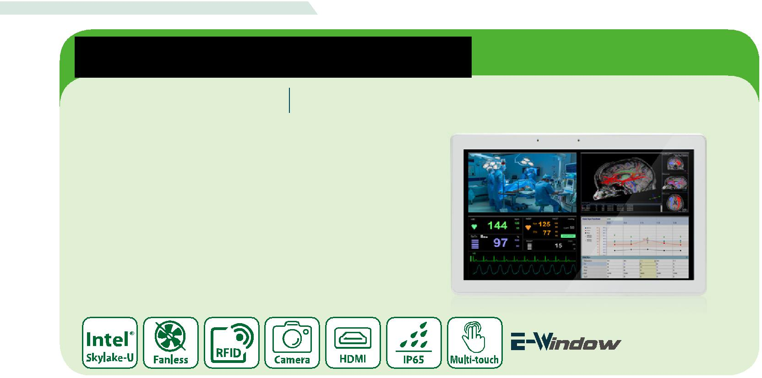

定点照护终端

POC-W24C-ULT3 24“医疗平板电脑第六代 Intel® mobile ULT Core™ i7/
i5/Celeron® 处理器

特征

- 24“无风扇FHD医疗级平板电脑

- Intel® Core™ i5-6300U (Skylake)处理器
- PCAP多点触控触摸屏，戴多层手套在有水的屏幕上也可操作

- 抗菌外壳IP65前面板，后盖IP32

- e-window 扩展插槽

规格

 | Model | POC-W24C-ULT3
 | LCD 显示 |  | 24”
 | 最大分辨率 | 1920 (W) x 1080 (H)
 | 亮度 (cd/m²) |  | 250
LCD 规格 | 对比度 |  | 1000:1
 | LCD 颜色 | 16.7M colors (RGB 6-bit + HI_FRC)
 | 像素间距(mm) | 0.2745 (H) x 0.2745 (V)
 | 可视角度(H-V) | 178°(H) / 178°(V)
 | 背光灯平均无故障时间 (hrs) | 30000 (LED backlight)
触摸 | 触摸屏 | Projected capacitive type with 10-point multi-touch
 | 表面硬度 |  | 6H
 | 支持的CPU | 6th generation Intel® mobile ULT Core™ i7-6600U / Core™ i5-6300U /Celeron® 3855U
 |  | 7th generation Intel® mobile ULT Kaby Lake on-board SoC (by project base)
 | 内存 | Two 260-pin 1600/1333MHz dual-channel DDR4 SO-DIMM, 4GB pre-installed (system max. 32GB)
 |  | 1 x RJ-11 for 1D/2D barcode reader | 2 x GbE LAN port
 | I/O 接口 | 4 x USB 2.0 (2 on the side) | 1 x RS-232/422/485
 |  | 4 x USB 3.0 port | 1 x 12~28V DC jack
系统 |  | 1 x HDMI output
 |  | 1 x 2.5" SATA 6Gb/s HDD bay
 | 存储
 |  | 1 x mSATA (E-Window)
 | 音频 | 2 x 3W Speaker
 | 摄像头和麦克风 | 5-megapixel CMOS front-facing camera with auto-focus and digital microphone
 | 扩展接口 | 1 x PCIe Mini reserved for E-Window expansion
 | LED 指示灯 | RFID indicator
 |  | 1 x LCD on/off | Combinations:
 |  | 1 x Brightness up | 1 x Lock/Unlock OSD
 | 功能键 | 1 x Brightness down | 1 x Power on/off
 |  | 1 x Volume up
其他特征
 |  | 1 x Volume down
 |  | 1 x Touch lock button for cleaning
 | 光传感器 | Ambient light sensor for panel brightness adjustment
 | 冷却方式 | Fan-less
链接 | 无线和蓝牙 | IEEE 802.11 a/b/g/n/ac 2T2R module with Bluetooth V4.1 (M.2 2230 A-E key module)
 | 材质 | ABS+PC plastic with anti-bacterial material
物理属性 |  | Wall, Stand and Arm VESA 100/75
 | 净重 |  | 7.5 Kg
 | 尺寸 (WxHxD) (mm) | 594.6 x 379.6 x 60.68mm
 | 操作温度 | 0°C~40°C
 | 存储温度 | -20°C~60°C
 | 湿度 | 10% to 95% (non-condensing)
环境因素 | 抗震动 |  | 1G
 | 抗冲击 | Operating Shock: 5G peak acceleration (11ms duration)
 |  | Non-Operating Shock: 15G peak acceleration (11ms duration)
 | IP 等级 | IP65 compliant front panel
电源 | 电源输入 | 12V~28V DC input
 | 电源适配器 | 120W medical power adapter: Input: 90V~264V AC, Output: 19V DC
认证 |  | CE, FCC Class B part 18,ANSI/AAMI ES60601-1
 |  | CAN/CSA-C22.2 No. 60601-1:14,IEC 60601-1-6/IEC62366,ISO 14971

医疗解决方案

w w w . i e i w o r l d . c o m

订购信息

料号 | 描述
POC-W24C-ULT3-C/PC/4G-R10 | 24” 250cd/m² 1920 x 1080 panel PC with 6th generation 14nm Intel® mobile Celeron™ 3855U (15W) on-board processor (ULT), one 4GB DDR4
 | RAM, 802.11 a/b/g/n/ac WiFi module, PCAP touchscreen, 5-megapixel camera, microphone, R10
POC-W24C-ULT3-i5/PC/4G-R10 | 24” 250 cd/m² 1920 x 1080 panel PC with 6th generation 14nm Intel® mobile Core™ i5-6300U (15W) on-board processor (ULT), one 4GB DDR4
 | RAM, 802.11a/b/g/n/ac WiFi module, PCAP touchscreen, 5-megapixel camera, microphone, R10
POC-W24C-ULT3-i7/PC/4G-R10 | 24” 250 cd/m² 1920 x 1080 panel PC with 7th generation 14nm Intel® mobile Core™ i7-6600U (15W) on-board processor (ULT), one 4GB DDR4
 | RAM, 802.11a/b/g/n/ac WiFi module, PCAP touchscreen, 5-megapixel camera, microphone, R10

选项

料号 | 描述
MEDP-HS-R10 | USB interface VoIP phone and its holder, white
MEDP-CR-02-R10 | Magnetic card reader/Smart card reader/Fingerprint sensor, white
MEDP-HD-R10 | Metal handle covered with soft rubber
MEDP-HD-BR-R11 | Metal handle covered with soft rubber, with barcode reader and reading light, white
MEDP-MF-RFID-03-R10 | Mifare RFID reader, 13.56MHz, with LED indicator,200mm antenna,RFID & LED cable, IEI assembly only
MEDP-TPM-03-R10 | Trusted platform module kit with 150mm cable, IEI assembly only
MEDP-EZS-R10 | VESA 100 x 100 mm panel PC stand with a cable management hole, white
POC-17C-ULT3-W10E64-V-R10 | OS Image with Windows Embedded Standard 10 E Value 64-bit for POC-17C/W24C Series, with DVD-ROM, RoHS

IQ 安装选项

名称 | 料号
Wall Mount Kit | AFLWK-19B
Arm | ARM-31-RS
Stand | STAND-A21-R10
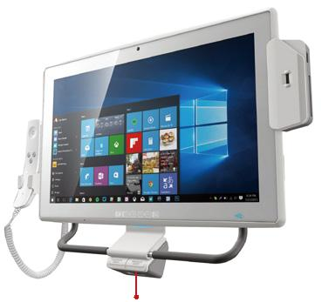

VoIP 电话
 |  |  |  | 3合1读卡器（可
(可选) |  |  |  | 选）

包装清单

名称 | 料号 | 数量 描述
Power | 63040-580120-000- | 1 | 120W medical power adapter: Input:
Adapter | RS |  | 90V~264V AC, Output: 19 V DC
Power Cord |  | 1 | European power cords, 183 CM, C13

I/O 接口

Barcode Module USB 3.0 GbE LAN 12~28V DC接口
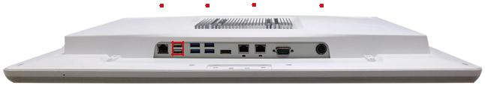

数位麦克风 |  | USB 2.0 |  |  |  |  | Reset |  |  |  |  |  | RS-232/422/485
 |  |  |  |  | HDMI AT/ATX

Mifare RFID模块（可选）
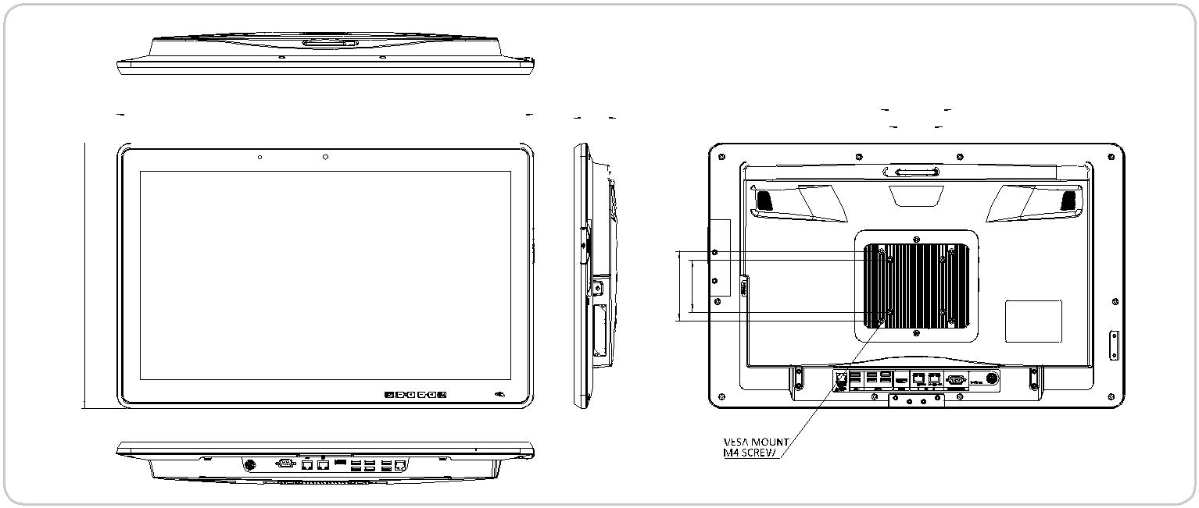

POC-W24C-ULT3/ULT4
尺寸 (单位: mm)

 |  |  | 594.6 |  |  | 60.68 |  |  |  |  |  |  |  |  |  |  |  |  |  |  | 100
 |  |  |  |  |  |  |  |  |  |  |  |  |  |  |  |  |  |  |  |  |  |  | 75

6379. | 100
 | 75

