医疗解决方案

w w w . i e i w o r l d . c o m
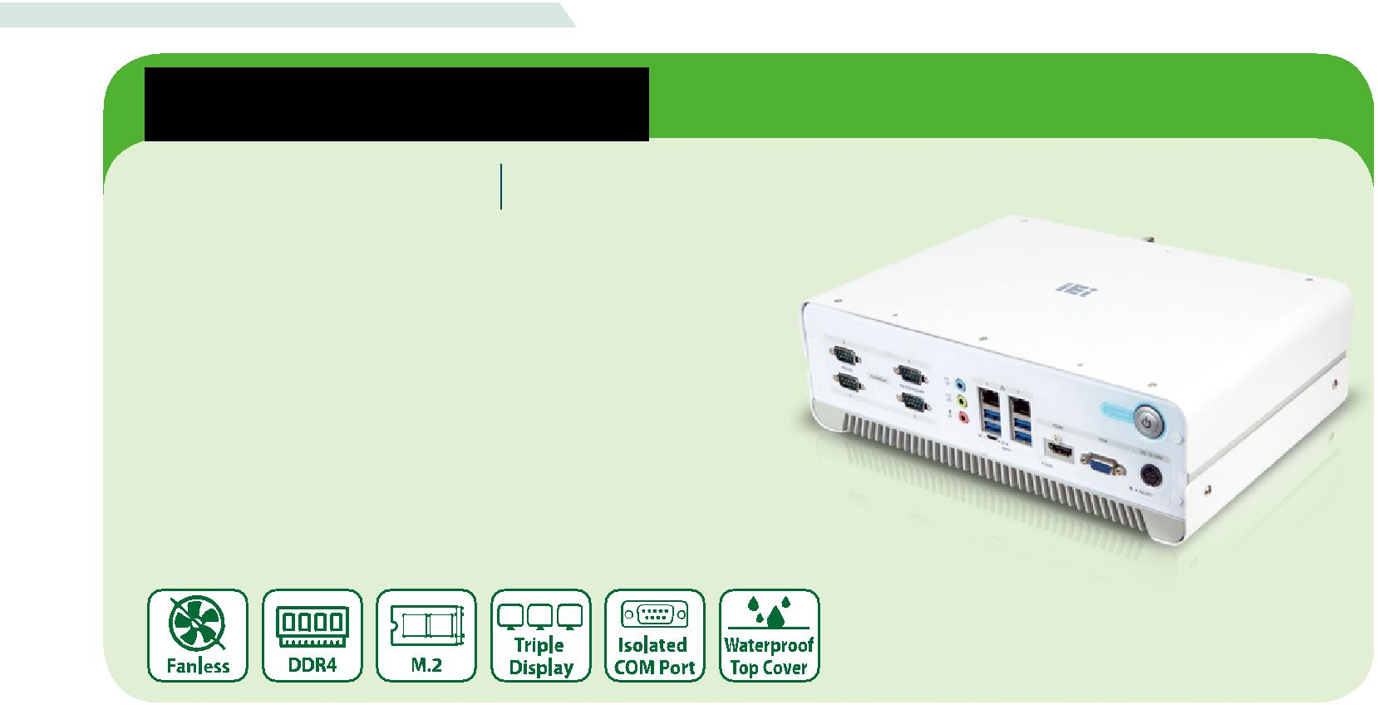

医疗Box PC

HTB-100-HM170 无风扇四核Box PC

特征

- 医疗等级高性能无风扇嵌入式计算机
- 第六代 Intel® Core™ 处理器平台支持 Intel® HM170芯片组和 DDR4 内存

- 支持独立高清三显
- 隔离 COM 端口增强设备间的安全性
- 可选 PCIe x16 扩展槽支持更多灵活功能

智能 & 人性化设计! HTB-100让您更满意

隔离 COM口，丰富的 I/O 接口，多个扩展槽集于 HTB-100 内。智能 HTB-100 医疗计算系统能满足医疗应用的所有需求。
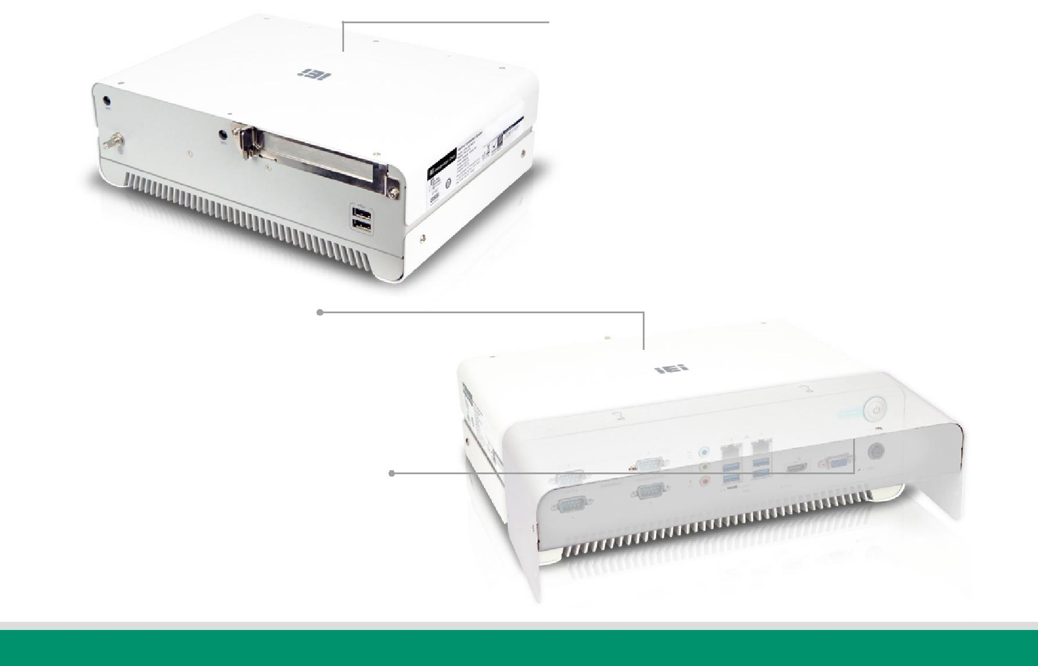

● 符合医疗标准

HTB-100符合医疗标准，包括IEC60601-1 V3.1，IEC60601-1-2

V4.0，IEC62304，IEC 6 2366，ISO 14971和 FCC part 18 class

B，让医疗环境更加可靠。

● 灵活扩展

灵活的扩展是HTB-100医疗应用的优势之一。HTB-100预留 PCIe

x16插槽支持附加卡扩展，如采集卡，用于手术中医疗影像检测。

● 防水顶盖

HTB-100 配备防水顶盖，以防止清洁或液体造成的任何损害，这些损害可能间接影响患者。HTB-100可以满足平面设计，减少维护工作量。

● 集线盒方便布线

集线盒保护HTB-100免受灰尘和液体侵入，允许医疗工作者管理所有 I/O 接口的线材，让医疗环境中的清洁流程更加方便。

医疗解决方案

w w w . i e i w o r l d . c o m

强大的系统设计和创新技术

● 隔离 COM 口支持安全保护
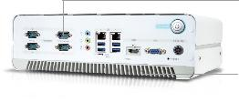

COM端口支持符合医疗标准（IEC 60601-1-2 V4.00）的2.5kV隔离。隔离端口可以提高设计用于医疗环境的设备的安全性，并为患者和医务人员提供全面的防浪涌保护。

● 无风扇，易于维护

HTB-100是一款无风扇嵌入式系统，散热片位于底部。该设计使 HTB-100 易于清洁，是医疗环境下非常可靠的系统。

● 接地插脚防止伤害病人和医护人员
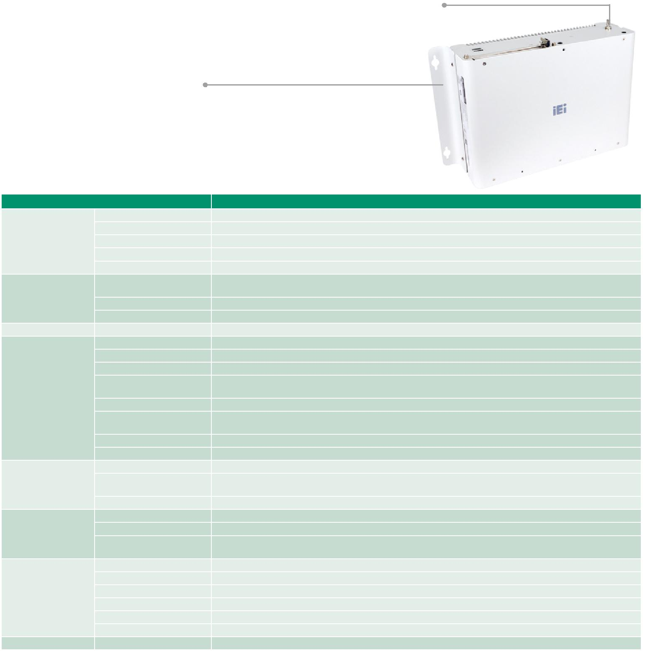

完美的接地插脚设计避免电流从 HTB-100 到连接病人的重要设备，避免电流损害其他设备。

● 方便安装的设计

各种安装方式如桌面式和壁挂式都支持，方便应用于医疗环境。提供灵活的安装支架，可转向

- 度从桌面改为壁挂式安装。

规格

 | 型号 | HTB-100-HM170
 | 颜色 | Silver+Greyish blue
 | 尺寸 (WxDxH) | 294 x 209 x 90.2
机箱 | 净重 | 2.2 kg
 | 系统风扇 | Fanless
 | 机身材质 | Extruded aluminum alloy
 | CPU | Intel® Core™ i7-6822EQ (2 GHz, quad-core, TDP=25)
 |  | Intel® Core™ i5-6442EQ (1.9 GHz, quad-core, TDP=25)
主板
 | 芯片组 | Intel® HM170
 | 内存 | 2 x 260-pin DDR4 SO-DIMM, one 4 GB pre-installed (system max: 32GB)
存储 | 硬盘 | 1 x 2.5" SATA 6Gb/s HDD/SSD bay
 | USB 3.0 | 4
 | USB 2.0 | 2
 | 以太网 | 2 x RJ-45 PCIe GbE by Intel® I211 controller
 | COM 口 | 2 x RS-232 (DB-9, with 2.5 kV isolation)
 |  | 2 x RS-232/422/485 (DB-9, with 2.5 kV isolation)
I/O 接口
 | 显示 | 1 x VGA, 1 x HDMI 2.0, 1 x iDP (optional)
 | 分辨率 | VGA: Up to 1920 x 1200@60HZ HDMI
 |  | 2.0: Up to 4096 x 2160@60Hz
 | 音频 | Realtek ALC662, 5.1-channel High Definition Audio (HDA), Line-in, Line-out, Mic-in
 | 无线 | 1 x 802.11a/b/g/n/ac 2T2R (optional)
 | PCIe | 1 x PCIe x16
扩展 | PCIe Mini | 1 x Half-size PCIe Mini
 |  | 1 x Full-size PCIe Mini (supports mSATA, colay with SATA)
 | M.2 | 1 x M.2 A & E key (2230/ USB or PCIe)
 | 电源输入 | DC Jack: 12~28V DC
电源 | 功耗 | 19V@4.4A (Intel® Core™ i7-6822EQ with 4 GB memory)
 |  | Adapter Power; Vin:90~264VAC; 150W; Dim:85*170*42.5mm; Plug=6.5mm; Cable=1200mm; MEDICAL; Vout:19VDC; Din
 | 电源适配器
 |  | 4Pin/lock; CCL; R10
 | 安装方式 | Wall mounting
 | 操作温度 | 0°C ~ 40°C with air flow (SSD), 10% ~ 95%, non-condensing
可靠性 | 存储温度 | -40°C ~ 70°C with air flow (SSD), 10% ~ 90%, non-condensing
 | 抗冲击 | Half-sine wave shock 5G; 11ms; 100 shocks per axis
 | 抗震动 | MIL-STD-810G 514.6 C-1 (with SSD)
 | 认证 | CE, FCC class B part 18, IEC 60601-1 V3.1, IEC 60601-1-2 V4.0, IEC 62304, ISO 14971
OS | 支持的 OS | Microsoft® Windows 8, Microsoft® Embedded Standard 7

医疗解决方案

 |  | w w w . i e i w o r l d . c o m
订购信息
 | 料号 | 描述
 |  | Ruggedized fanless embedded system with Intel® Core™ i5-6442EQ 1.9 GHz (up to 2.7 GHz, quad core, TDP 25W), 4GB DDR4 pre-installed
 | HTB-100-HM170-i5/4G-R10 | memory, one PCIe x16 expansion, VGA/HDMI/iDP, COM port, 12~28V DC, Adapter Power; Vin:90~264VAC; 150W; Dim:85*170*42.5mm;
 |  | Plug=6.5mm; Cable=1200mm; MEDICAL; Vout:19VDC; Din 4Pin/lock; CCL; R10
 |  | Ruggedized fanless embedded system with Intel® Core™ i7-6822EQ 2.0 GHz (up to 2.8 GHz, quad core, TDP 25W), 4GB DDR4 pre-installed
 | HTB-100-HM170-i7/4G-R10 | memory, one PCIe x16 expansion, VGA/HDMI/iDP, COM port, 12~28V DC, Adapter Power; Vin:90~264VAC; 150W; Dim:85*170*42.5mm;
 |  | Plug=6.5mm; Cable=1200mm; MEDICAL; Vout:19VDC; Din 4Pin/lock; CCL; R10
选项
 | 料号 | 描述
 | 41008-0803K6-00-RS | Cable COVER; HTB-100ME; White; R10

包装清单

1 x Chassis Screw | 1 x Mounting Bracket

I/O 接口

Wi-Fi Wi-Fi Expansion for PCIe 2 x RS-232 with Isolation Audio 2 x GbE LAN HDMI Power Switch

 |  |  |  |  |  |  |  |  |  |  |  |  |  |  | AT/ATX mode |  |  |  |  |  |  |  | Reset
Ground Pin |  |  |  | 2 x USB 2.0 |  |  |  | 2 x RS-232/422/485 with Isolation4 x USB 3.0 |  |  |  |  |  |  |  |  |  |  |  |  |  | VGA DC Input
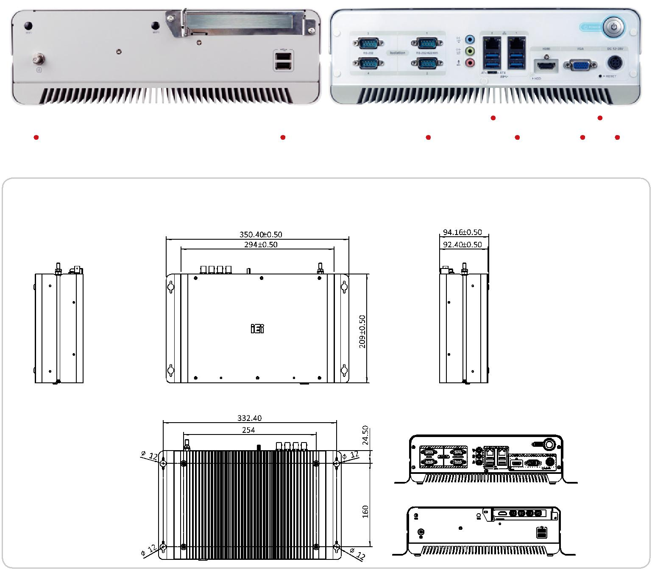

HTB-100-HM170 尺寸 (单位: mm)

