单板计算机
工业主板

w w w . i e i w o r l d . c o m

ATX主板支持14nmLGA1151Intel®第8代Core™i7 / i5 / i3，Celeron®和Pemtium®处理 IMBA-Q370 器，DDR4，三重独立显示器，双GbE LAN，M.2，USB 3.1 Gen 2（10Gb / s），SATA

6Gb / s，HD Audio和RoHS

 |  |  |  | 双通道DDR4 2666MHz |  |  |  |  | M.2 A key |  |  |  |  |  |  |  |  |  |  |  |  |  |  |  |  |  |  |  |  |  |  |  | 机箱
 |  |  |  | USB 3.1 Gen1 |  |  |  |  |  |  |  | 6 x SATA 6Gb/s
 |  |  |  |  |  |  |  |  |  |  |  |  |  |  |  |  |  |  |  |  |  |  |  |  |  |  |  |  |  |  |  |  | Intrusion
 |  |  |  |  |  |  |  |  |  |  |  |  |  |  |  |  |  |  |  |  |  |  |  |  |  |  |  |  |  |  |  |  | 前面板l
 |  |  |  |  |  |  |  |  |  |  |  |  |  |  |  |  |  |  |  |  |  |  |  |  |  |  |  |  |  |  |  |  | M.2 M key
 |  |  |  |  |  |  |  |  |  |  |  |  |  |  |  |  |  |  |  |  |  |  |  |  |  |  |  |  |  |  | RS-232/422/485
 |  |  |  |  |  |  |  |  |  |  |  |  |  |  |  |  |  |  |  |  |  |  |  |  |  |  |  |  |  |  |  |  | TPM
 |  |  |  |  |  |  |  |  |  |  |  |  |  |  |  |  |  |  |  |  |  |  |  |  |  |  |  |  |  |  |  |  | RS-232
4 x USB 2.0 |  |  |  |  |  |  |  |  |  |  |  |  |  |  |  |  |  |  |  |  |  |  |  |  |  |  |  |  |  |  |  |  | 2 x PCI
Displayport |  |  |  |  |  |  |  |  |  |  |  |  |  |  |  |  |  |  |  |  |  |  |  |  |  |  |  |  |  |  |  |  | LPT (可选)
KB/MS
 |  |  |  |  | 前置音频 |  |  |  |  |  |  |  |  | PCIe x8 |  |  |  |  |  |  |  |  | DIO
规格 |  |  |  |  |  |  |  |  |  |  |  | PCIe x4 2 x PCIe x4
 |  |  |  |  |  | PCIe x8
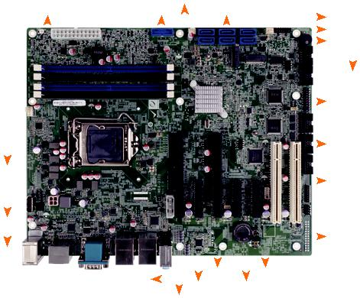

CPU

LGA1151 插槽 支持 8th代 Intel® Core™ i7/i5/i3, Pentium® or Celeron® 处理器 芯片组

Intel® Q370

BIOS: AMI UEFI BIOS

内存

四个288-pin 2666/2400 MHz 双通道 DDR4 SDRAM 无缓冲 DIMMs 最高支持达64GB

图形引擎

英特尔®高清显卡Gen9引擎具有低功耗16执行单元，支持DX11.3 / 12，OpenGL 4.3 / 4.4 / 4.5和OpenCL1.2 / 2.0 / 2.1

显示输出

三重独立显示

1 x VGA (最高至 1920 x 1080@60Hz)

1 x DP++ (最高至 4096 x 2304@60Hz)

1 x HDMI (最高至 4096 x 2304@30Hz)

1 x 内置 Displayport (最高至 4096 x 2304@60Hz)

网络

LAN1 : Intel® I219LM PCIe 控制器支持 AMT 11.0

LAN2: Intel® I211AT PCIe 控制器
超级 I/O: 嵌入式控制器
外部 I/O 接口
2 x USB 3.1 | Gen 2 | (10Gb/s) | 1 x RS-232
2 x USB 3.1 | Gen 1 | (5Gb/s) | 1 x PS/2 KB/MS
2 x USB 2.0
内部 I/O 接口
1 x 180º Displyport |  |  | 1 x KB/MS (1x6 pin)
2 x RS-232/422/485 (2x5 pin, P=2.54) |  |  | 3 x RS-232 (2x5 pin, P=2.54)
2 x USB 3.1 | Gen 1 | (5Gb/s) (2x10 pin, P=2.0) | 4 x USB 2.0 (2x4 pin, P=2.54)
6 x SATA 6G/s (RAID 0/1/5/10 supported)

SMBus: 1 x SMBus (1x4 pin)

I²C: 1 x I²C (1x4 pin)

音频

Realtek ALC662 高清编解码器

3 x 音频插孔 ( 音频输入 ，音频输出 , 麦克风输入 ）

1 x 模拟音频 (2x5 pin)

前面板

1 x前面板 (2x7 pin, power LED, HDD LED, 扬声器 , 电源按钮 , 重启按钮 )

网络灯: 2 x 网络灯 (1x2 pin)

扩展接口

2 x PCIe x8 1 x M.2 A key (2230, PCIe x1 & USB 2.0)

3 x PCIe x4 1 x M.2 M Key (2280, PCIe x2 only)

2 x PCI

数字 I/O: 1 x 8-bit 数字 I/O (2x5 pin)

TPM: 1 x TPM (2x10 pin)

风扇接口

1 x CPU 风扇接口(1x4 pin)

2 x System 风扇接口 (1x3 pin)

机箱 : 1 x Chassis intrusion (1x2 pin)

电源

支持 ATX/AT 电源

支持AT/ATX 模式

ErP/EuP 兼容

看门狗定时器 : 软件可编程并支持 1~255 秒系统复位

功耗

3.3V@1.65A, 5V@3.4A, 12V@8.58A, 5VSV@3.4A (Intel® Core® i7-8700K up to

4.60 GHz CPU 及 32GB 2600MHz DDR4内存)

操作温度: -20°C ~ 60°C

存储温度: -30°C ~ 70°C

存储湿度 5% ~ 95%, non-condensing

尺寸: 244mm x 305mm

重量: GW:1200g / NW:700g

CE/FCC 标准

 |  |  |  |  |  |  |  |  | M.2 M key
 |  |  |  |  |  |  |  |  |  |  |  |  |  |  |  |  |  |  |  |  |  |  |  |  |  |  |  |  |  | M.2 A key
KB/MS DP++ |  |  |  |  |  |  |  |  |  |  |  |  |  | RS-232 |  |  | LAN1 LAN2 |  |  |  |  |  |  |  |  |  | 音频
 |  |  |  |  |  |  |  |  |  |  |  |  |  |  |  |  |  |  |  |  |  |  |  | 2 x USB 3.1 Gen 1
 |  |  |  |  |  |  |  |  | HDMI |  |  |  |  |  |  | 2 x USB 3.1
2 x USB 2.0 |  |  |  |  |  |  |  |  |  |  |  |  |  | VGA |  |  | Gen 2
 |  |  | DDR4 |  |  |  |  |  |  |  |  |  | Triple
2666 |  |  |  |  |  |  |  |  |  |  |  | Display |  |  |  |  |  | DP++ |  |  |  |  |  |  |  |  | M.2 |  |  | SATA 6Gb/s PCIe GbE
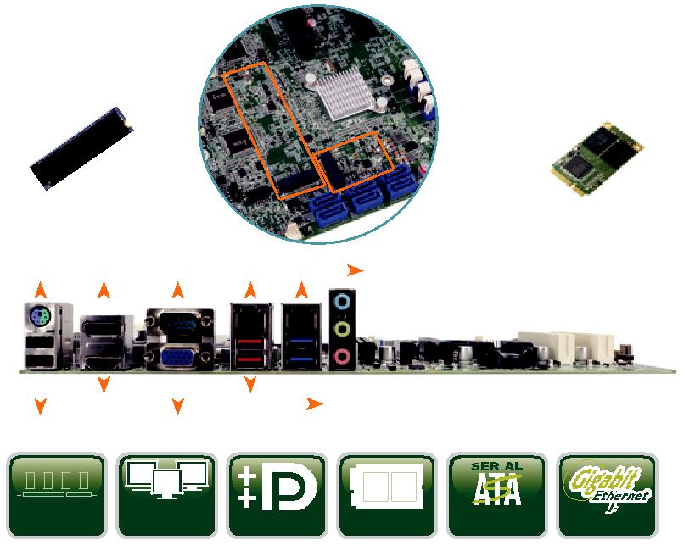

特征

- 第8代LGA1151英特尔®酷睿™i7 / i5 / i3，赛扬®和奔腾®处理器

- 双通道DDR4 2666MHz

- 支持 VGA, HDMI & DP++

- 支持 M.2 A key for WLAN 扩展, M key 存储

- IEI 一键恢复解决方案可快速创建 OS 备份和恢复

包装清单

1 x IMBA-Q370 single board computer | 2 x SATA cable
1 x I/O shielding | 1 x QIG

尺寸 (Unit: mm)
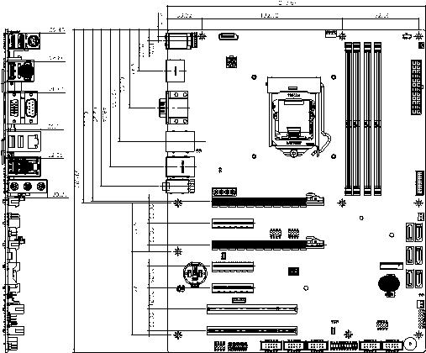

订购信息
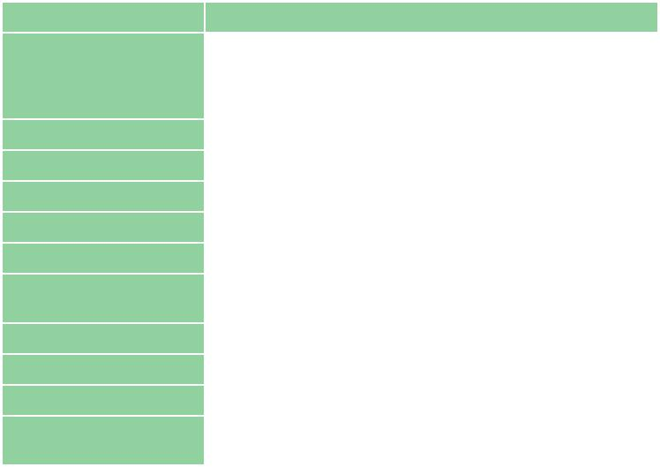

料号. | 描述
 | ATX motherboard supports 14nm LGA1151 Intel® 8th
IMBA-Q370-R10 | Generation Core™ i7/i5/i3, Celeron® and Pemtium®
 | processor, DDR4, triple independent displays, dual GbE LAN,
 | M.2, USB 3.1, SATA 6Gb/s, HD Audio and RoHS
19800-000075-RS | PS/2 KB/MS cable with bracket, 220mm, P=2.0
19800-003100-100-RS | Dual port USB cable with bracket, 30mm, P=2.54
19800-010500-200-RS | USB 3.1 Gen 1 (5Gb/s) cable 457mm with bracket
32102-000100-200-RS | SATA power cable, MOLEX 5264-4P to SATA15P
32205-000702-100-RS | RS-232 cable, 230mm, P=2.54
CF1156A-RS-R11 | High-performance LGA1155/1156 cooler kit, 1U chassis
 | compatible 73W
CF-1156C-RS | LGA1155/LGA1156 cooler kit, 1U chassis compatible, 45W
CF-1156D-RS | LGA1155/LGA1156 cooler kit, 1U chassis compatible, 65W
CF-1156E-R11 | High-performance LGA1155/1156 cooler kit, 95W
TPM-IN02-R20 | 20-pin Infineon TPM 2.0 module, software management tool,
 | firmware v5.

IMBA-Q370-2019-V10

