单板计算机
工业主板

w w w . i e i w o r l d . c o m . c n

IMBA-H610

ATX 主板支持 LGA1155 Intel® Core™ i 7/i5/i3/Pentium®/Celeron® CPU 以及 Intel® H61, DDR3, VGA/DVI-D, dual Realtek PCIe GbE, SATA 3Gb/s, USB 2.0, HD 音频
- RoHS

双通道 DDR3 |  |  |  |  | I²C |  | 4 x SATA 3Gb/s
1333/1066 MHz
 |  |  |  |  |  |  |  |  |  |  |  |  |  |  |  |  |  | 前面板
 |  |  |  |  |  |  |  |  |  |  |  |  |  |  |  |  |  | SMBus
 |  |  |  | Intel®
 |  |  |  |  |  |  |  |  |  |  |  |  |  |  |  |  |  | TPM
 |  |  |  | H61 |  |  |  |  |  |  |  |  |  |  |  |  |  | RS-422/485
 |  |  |  |  |  |  |  |  |  |  |  |  |  |  |  |  |  | 6 x USB 2.0
 |  |  |  |  |  |  |  |  |  |  |  |  |  |  |  |  |  | 3 x RS-232
 |  |  |  |  |  |  |  |  |  |  |  |  |  |  |  |  |  | 2 x PCIe x1 |  |  |  |  |  | VGA
 |  |  |  |  |  |  |  |  |  |  |  |  |  |  |  |  |  | LPT |  |  |  |  |  |  |  |  |  |  |  |  |  | 支持 TPM 1.2
 |  |  |  |  |  |  |  |  |  |  |  |  |  |  |  |  |  |  |  | RS-232 |  |  |  |  |  |  | 双局域网
 | LAN1 |  |  |  |  |  |  |  |  |  |  |  |  |  |  |  |  | DIO
产品特征 |  | PCIe x16 4 x PCI |  |  |  |  |  | 前置音频
 |  |  |  |  |  |  |  |  |  |  |  |  |  |  |  |  |  |  |  |  |  |  |  |  | 4 x USB 2.0
 |  |  |  |  |  |  |  |  |  |  |  |  |  |  |  |  |  | KB/MS |  |  |  |  |  | DVI-D |  |  |  | 音频
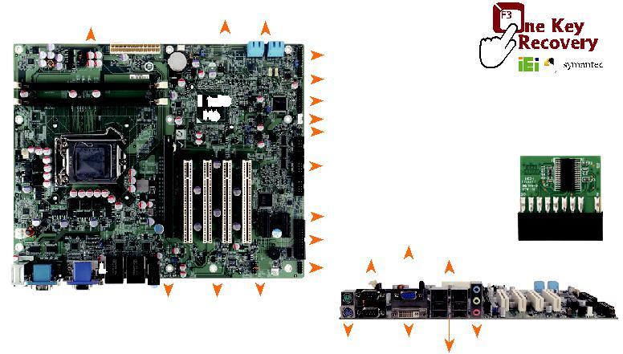

- 支持 LGA1155 Intel® Core™ i7/i5/i3/Pentium®/Celeron® 处理器
- 高达 32GB 1333 MHz 双通道 DDR3 SDRAM

- Intel® HD 显卡技术集成了高性能的图形和媒体处理器
- TPM 模块硬件加密支持TPM V1.2

- IEI 一键恢复解决方案可快速创建 OS 备份和恢复

产品规格

CPU | 外部 I/O 接口
LGA1155 插槽支持 Intel® Core™ i7/i5/i3/ | 1 x KB/MS 2 x RS-232 4 x USB 2.0
Pentium®/Celeron® 处理器 | 内部 I/O 接口
芯片组: Intel® H61 | 1 x KB/MS (1x6 pin)
内存 | 1 x LPT(2x13 pin, P=2.54)
两个 240-pin 1333/1066 MHz 双通道 DDR3 | 1 x RS-422/485 (1x4 pin, P=2.0)
SDRAM 无缓冲 DIMMs 最高支持 16 GB | 4 x RS-232 (2x5 pin, P=2.54)
BIOS: UEFI BIOS | 4 x SATA 3Gb/s (AHCI supported)
网络 | 6 x USB 2.0 (2x4 pin, P=2.54)
LAN1: 支持 Realtek RTL8111E PCIe GbE 控制器 | 前面板
以及 ASF 2.0 | 1 x 前面板 (2x7 pin, 电源 LED, HDD LED, 扬声器,
LAN2: 支持 Realtek RTL8111E PCIe GbE 控制器 | 电源按钮, 复位按钮)
图形引擎 | 扩展
Intel® HD Graphics 2000/3000 (基于 CPU型号) | 1 x PCIe x16 插槽2 x PCIe x1插槽
支持 DX10.1 以及 OpenGL 3.0 | 4 x PCI 插槽
Full MPEG2, VC1, AVC 解码 | 看门狗定时器: 看门狗定时器
显示输出 | 软件可编程支持 1~255 秒系统复位
支持双显 | 风扇接口
1 x VGA (最高达 2048x1536@75Hz) | 1 x CPU 智能风扇 (1x4 pin)
1 x DVI-D (最高达 1920x1200@60Hz) | 2 x 系统风扇 (1x3 pin)
音频 | 电源 : ATX 电源
Realtek ALC662 HD 编解码器支持 5.1-channel | 功耗
3 x 音频插孔 (音频输出, 音频输入, 麦克风输入) | 3.3V@1.27A, 5V@3.87A, 12V@0.54A,
on rear IO | Vcore@7.67A, 5VSb@0.15A (Intel® Core™ i7-
1 x 前置音频 (2x5 pin) | 2600K 3.40GHz CPU 以及两个 1333 MHz 2 GB
TPM: 1 x TPM (2x10 pin) | DDR3 内存)
SMBus: 1 x SMBus (1x4 pin) | 工作温度 : -10°C ~ 60°C
I²C: 1 x I²C (1x4 pin) | 存储温度: -20°C ~ 70°C
数字 I/O: 8-bit 数字 I/O (2x5 pin) | 工作湿度: 5% ~ 95%, 无冷凝
 | 尺寸: 244 mm x 305 mm
包装清单 | 重量 : GW: 1200g / NW: 700g
 | CE/FCC 标准
1 x IMBA-H610 single board computer
4 x SATA cable | 1 x Mini jumper pack
1 x I/O shielding | 1 x QIG

IMBA-Q670-R30

ATX 主板支持 LGA1155 Intel® Core™ i7/i5/i3/Pentium®/Celeron® CPU 以及 Intel®
Q67, DDR3, VGA/DVI-D/HDMI, dual Intel® PCIe GbE, USB 3.1Gen 1 (5Gb/s), SATA 6Gb/s, HD 音频和 RoHS

 | 双通道 DDR3 |  |  |  |  |  |  | 4 x SATA 3Gb/s
 | 1333/1066 MHz |  |  |  | 2 x SATA 6Gb/s |  |  |  |  |  |  |  |  |  |  | 前面板
 |  |  |  |  |  |  |  |  |  |  |  |  |  |  |  |  |  | SMBus
 |  |  |  |  |  |  |  |  |  |  |  |  |  |  |  |  |  | I²C
 |  |  |  |  |  | Intel® |  |  |  |  |  |  |  |  |  |  |  | 8 x USB 2.0
 |  |  |  |  |  |  |  |  |  |  |  |  |  |  |  |  |  | TPM
 |  |  |  |  |  |  | Q67
 |  |  |  |  |  |  |  |  |  |  |  |  |  |  |  |  |  | RS-232
 |  |  |  |  |  |  |  |  |  |  |  |  |  |  |  |  |  | RS-422/485
 |  |  |  |  |  |  |  |  |  |  |  |  |  |  |  |  |  | 3 x RS-232 |  |  |  |  |  |  |  | TPM 1.2 Support
 |  |  |  |  |  |  |  |  |  |  |  |  |  |  |  |  |  |  | RS-232 VGA
 |  |  |  |  |  |  |  |  |  |  |  |  |  |  |  |  |  |  |  |  |  | 双局域网
 |  |  |  |  |  |  |  |  |  |  |  |  |  |  |  |  |  | LPT
 |  |  | LAN1 |  |  |  |  |  |  |  |  |  |  |  |  |  |  | DIO |  |  |  |  |  |  |  | 音频
 |  |  |  | PCIe x16 |  |  | 前置音 |  |  |  |  |  |  |  |  | PCIe x1 |  | KB/MS HDMI DVI-D |  |  |  |  |  | 2 x USB 3.1
 |  |  |  |  |  |  |  | 频
产品特征 |  |  |  |  | 4 x PCI |  |  |  |  |  |  | PCIe x4 |  |  |  |  |  |  |  |  | 2 x USB 2.0
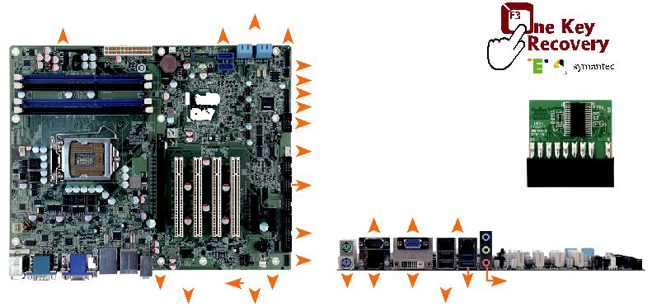

- 支持 LGA1155 Intel® Core™ i7/i5/i3/Pentium®/Celeron® 处理器
- 高达 32 GB 1333 MHz 双通道 DDR3 SDRAM
- 支持 Intel® PCIe GbE 以及 Intel® AMT 7.0
- 支持 USB 3.0 以及 SATA 6Gb/s

- IEI 一键恢复解决方案可快速创建 OS 备份和恢复

产品规格

 | CPU |  | 1 x KB/MS | 2 x USB 2.0
 |  |  | 1 x RS-232 | 2 x USB 3.1
 | LGA1155 插槽支持 Intel® Core™ i7/i5/i3/
 |  |  | 内部 I/O 接口
 | Pentium®/Celeron® 处理器
 |  |  | 1 x KB/MS (1x6 pin)
 | 芯片组: Intel® Q67
 |  |  | 1 x LPT (2x13 pin, P=2.54)
 | 内存
 |  |  | 1 x RS-422/485 (1x4 pin, P=2.0)
 | 四个 240-pin 1333/1066 MHz | 双通道 DDR3
 |  |  | 2 x SATA 6Gb/s (RAID 0/1/5/10 supported)
 | SDRAM 无缓冲 DIMMs最高支持 32 GB
 |  |  | 4 x RS-232 (2x5 pin, P=2.54)
 | BIOS: UEFI BIOS
 |  |  | 4 x SATA 3Gb/s (RAID 0/1/5/10 supported)
 | 网络
 |  |  | 8 x USB 2.0 (2x4 pin, P=2.54)
 | LAN1: Intel® 82583V PCIe 控制器
 |  |  | 扩展
 | LAN2: 支持 Intel® 82579 PHY with Intel® AMT
 |  |  | 1 x PCIe x16 插槽
7.0
 |  |  | 1 x PCIe x1 插槽
 | 图形引擎
 |  |  | 1 x PCIe x4 插槽
 | 支持 DX10.1 以及 OpenGL3.0
 |  |  | 4 x PCI 插槽
 | Full MPEG2, VC1, AVC解码
 |  |  | 看门狗定时器: 软件可编程并支持1~255 秒系
 | 显示输出
 |  |  | 统复位
 | 独立双显
 |  |  | 风扇接口
 | 1 x VGA (最高达 2048x1536@75Hz)
 |  |  | 1 x CPU 智能风扇 (1x4 pin)
 | 1 x HDMI (最高达 1920x1200@60Hz)
 |  |  | 2 x 系统风扇 | (1x3 pin)
 | 1 x DVI-D (最高达1920x1200@60Hz)
 |  |  | 电源 : ATX/AT 电源
 | 音频: Realtek ALC662 HD 音频编解码器
 |  |  | 功耗
 | 3 x 音频插孔 (音频输出, 音频输入,麦克风输入)
 |  |  | 3.3V@1.65A, 5V@6.31A , 12V@0.18A,
 | on rear IO
 |  |  | Vcore@7.88A, 5VSb@0.15 (Intel® Core™ i5-
 | 1 x 前置音频 (2x5 pin)
 |  |  | 2400 3.10GHz CPU 以及四个 4 GB 1333 MHz
 | TPM: 1 x TPM (2x10 pin)
 |  |  | DDR3 内存)
 | SMBus: 1 x SMBus (1x4 pin)
 |  |  | 工作温度 : -10°C ~ 60°C
 | I²C: 1 x I²C (1x4 pin)
 |  |  | 存储温度: -20°C ~ 70°C
 | 数字 I/O: 8-bit 数字 I/O (2x5 pin)
 |  |  | 工作湿度: 5% ~ 95%, 无冷凝
 | 外部 I/O 接口
 |  |  | 尺寸: 244mm x 305mm
包装清单
 |  |  | 重量 : GW: 1200g / NW: 700g
 |  |  | CE/FCC 标准
 | 1 x IMBA-Q670 single board computer
 | 1 x I/O shielding |  | 1 x Mini jumper pack
 | 4 x SATA cable |  | 1 x QIG

订购信息
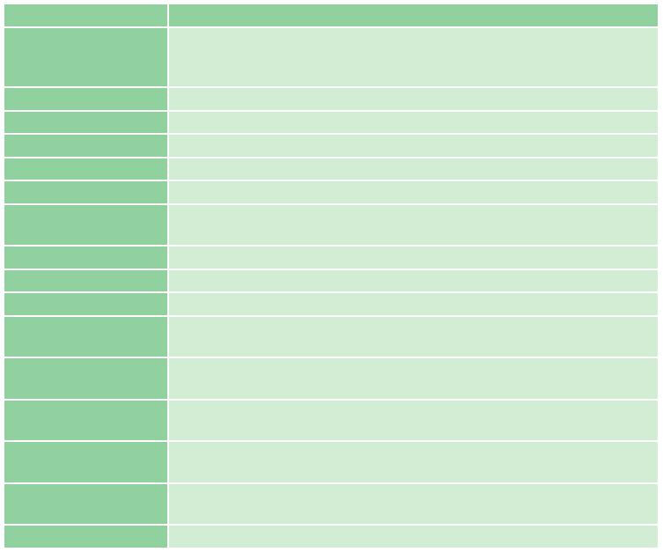

料号 | 描述
 | ATX motherboard supports LGA1155 Intel® Core™ i7/i5/i3/Pentium®/
IMBA-H610-R10 | Celeron® CPU with Intel® H61, DDR3, VGA/DVI-D, dual Realtek PCIe
 | GbE, USB 2.0, SATA 3Gb/s, HD Audio and RoHS
19800-000049-RS | LPT flat cable, 240mm, P=2.54
19800-003100-100-RS | Dual port USB cable with bracket, 300mm, P=2.54
19800-020100-100-RS | RS-232 cable with bracket, Dual 10-pin to dual DB-9, 230mm, P=2.54
32102-000100-200-RS | SATA power cable, MOLEX 5264-4P to SATA15P
32205-003800-300-RS | RS-422/485 cable, 200mm, P=2.0
CF-115XA-R10 | High-performance LGA1155/LGA1156 cooler kit, 1U chassis compatible,
 | 73W
CF-1156C-R20 | LGA1155/LGA1156 cooler kit, 1U chassis compatible, 45W
CF-1156D-R20 | LGA1155/LGA1156 cooler kit, 1U chassis compatible, 65W
CF-115XE-R10 | High-performance LGA1155/LGA1156 cooler kit, 95W
CPU-DT-C-G440 | Intel® Celeron® G440 processor, LGA1155, single core 1.6GHz, 1M cache,
 | 35W, compatible with CF-1156C-R20 CPU cooler
CPU-DT-i3-2120T | Intel® Core™ i3-2120T processor, LGA1155, dual core 2.6GHz, 3M cache,
 | 35W, compatible with CF-1156C-R20 CPU cooler
CPU-DT-i5-2390T | Intel® Core™ i5-2390T processor, LGA1155, dual core 2.7GHz, 3M cache,
 | 35W, AMT, compatible with CF-1156C-R20 CPU cooler
CPU-DT-i5-2500T | Intel® Core™ i5-2500T processor, LGA1155, quad core 2.3GHz, 6M cache,
 | 45W, compatible with CF-1156C-R20 CPU cooler
CPU-DT-P-G630T | Intel® Pentium® G630T processor, LGA1155, dual core 2.3GHz, 3M cache,
 | 35W, compatible with CF-1156C-R20 CPU cooler
TPM-IN01-R20 | 20-pin Infineon TPM module, software management tool, firmware v3.17

订购信息
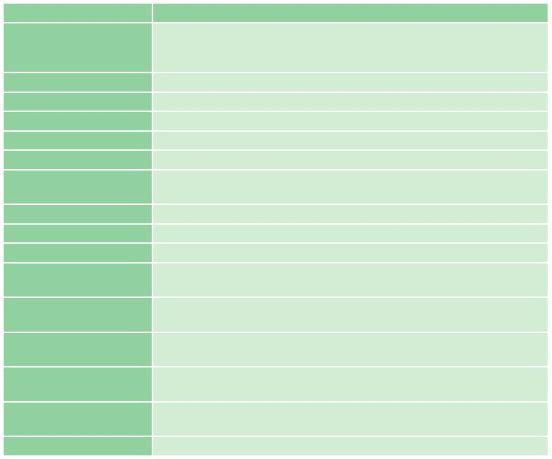

料号 | 描述
 | ATX motherboard supports LGA1155 Intel® Core™ i7/i5/i3/Pentium®/
IMBA-Q670-R30 | Celeron® CPU with Intel® Q67, DDR3, VGA/DVI-D/HDMI, dual Intel®
 | PCIe GbE, USB 3.0, SATA 6Gb/s, HD Audio and RoHS
19800-000049-RS | LPT flat cable, 240mm, P=2.54
19800-003100-300-RS | Dual port USB cable with bracket, 300mm, P=2.54
19800-020100-100-RS | RS-232 cable with bracket, Dual 10-pin to dual DB-9, 230mm, P=2.54
32102-000100-200-RS | SATA power cable, MOLEX 5264-4P to SATA15P
32205-003800-300-RS | RS-422/485 cable, 200mm
CF-115XA-R10 | High-performance LGA1155/LGA1156 cooler kit, 1U chassis compatible,
 | 73W
CF-1156C-R20 | LGA1155/LGA1156 cooler kit, 1U chassis compatible, 45W
CF-1156D-R20 | LGA1155/LGA1156 cooler kit, 1U chassis compatible, 65W
CF-115XE-R10 | High-performance LGA1155/LGA1156 cooler kit, 95W
CPU-DT-C-G440 | Intel® Celeron® G440 processor, LGA1155, single core 1.6GHz, 1M
 | cache, 35W, compatible with CF-1156C-R20 CPU cooler
CPU-DT-i3-2120T | Intel® Core™ i3-2120T processor, LGA1155, dual core 2.6GHz, 3M
 | cache, 35W, compatible with CF-1156C-R20 CPU cooler
CPU-DT-i5-2390T | Intel® Core™ i5-2390T processor, LGA1155, dual core 2.7GHz, 3M
 | cache, 35W, AMT, compatible with CF-1156C-R20 CPU cooler
CPU-DT-i5-2500T | Intel® Core™ i5-2500T processor, LGA1155, quad core 2.3GHz, 6M
 | cache, 45W, compatible with CF-1156C-R20 CPU cooler
CPU-DT-P-G630T | Intel® Pentium® G630T processor, LGA1155, dual core 2.3GHz, 3M
 | cache, 35W, compatible with CF-1156C-R20 CPU cooler
TPM-IN01-R20 | 20-pin Infineon TPM module, software management tool, firmware v3.17

IMBA-H610-2019-V10

