单板计算机
工业主板
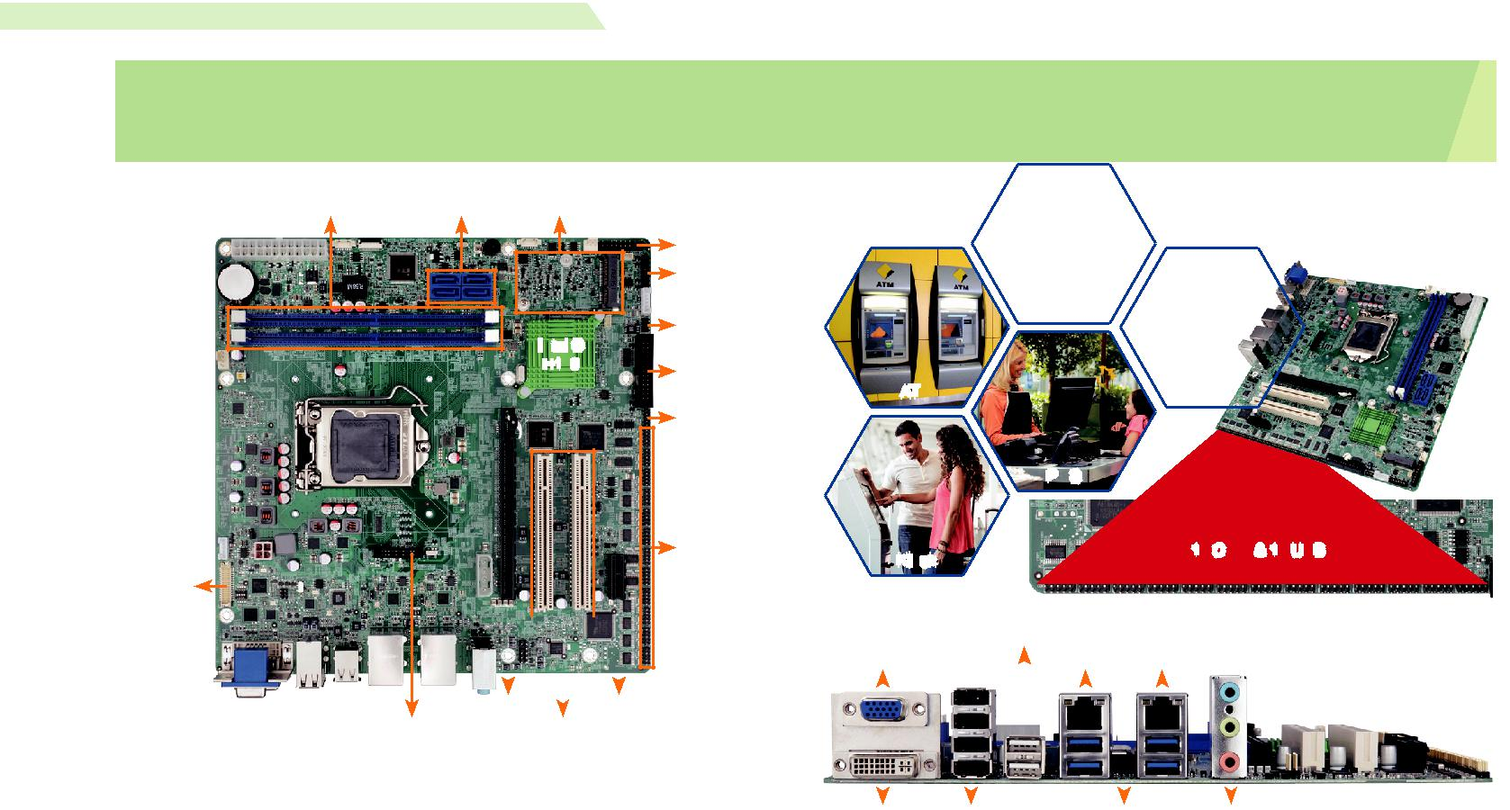

w w w . i e i w o r l d . c o m . c n

IMB-H110 | SATA 6Gb/s, HD 音频和 RoHS | Intel® Core™ i7/i5/i3, Pentium® or Celeron® processor,
 | microATX主板支持 14nm LGA1151
DDR4, Dual Independent Displays VGA/ DVI-I/LVDS, Dual GbE LAN, USB 3.1Gen 1 (5Gb/s),

双通道 DDR4 2133 | 4 x SATA 6Gb/s 全尺寸PCIe Mini
MHz

TPM

前面板

USB

Intel ®
H110 _{LPT}

DIO

12 x COM

LVDS

 | 1 x PCIe x16 |  |  |  | 1 x PCIe x1
iDP |  |  | 2 x PCI
产品规格

CPU

LGA1151 插槽支持 第六代 Intel® Core ™ i7/i5/i3, Celeron®, and Pentium® 处理器

芯片组
Intel® skylake H110

内存
Two 288-pin 2133MHz 双通道 DDR4 SDRAM 无缓冲 DIMM 最高支持 64GB BIOS
UEFI BIOS

图形引擎
Intel® HD 显卡 Gen 9 Engines with 16 低功耗执行单元 , 支持 DX2015, OpenGL 5.X 以

- OpenCL2.x, ES 2.0

显示输出

独立双显

1 x VGA ( 最高达 1920x1200@60Hz)

1 x DVI-I ( 最高达 1920x1200@ 60Hz)

1 x 18/24-bit 双通道 LVDS ( 最高达 1920x1200@60Hz)

1 x iDP 接口用于 HDMI, LVDS, VGA, DVI, DP ( 最高达 1920x1200@60Hz)

网络

LAN1: RTL 8111GN 控制器

LAN2: RTL 8111GN 控制器外部 I/O 接口
4 x USB 3.1

6 x USB 2.0

内部 I/O 接口
1 x KB/MS (1x6 pin) 2 x RS-232/422/485 (2x5 pin, P-=2.0)
1 x LPT (2x13 pin, P=2.54) 2 x USB 2.0 (2x4 pin, P=2.0)
4 x SATA 6Gb/s 10 x RS-232 (2x5 pin, P=2.0)

SMBus
1 x SMBus (1x4 pin)

TPM
1 x TPM (2x10 pin)

音频
Realtek ALC662 HD 音频编解码器支持 5.1-channel

3 x 音频插孔 ( 音频输出 , 音频输入 , 麦克风输入）on rear IO

1 x 前置音频 (2x5 pin)

前面板
1 x 前面板 (2x7 pin, 电源 LED, HDD LED, 扬声器 , 电源按钮 , 重启按钮 )

LAN LED
2 x LAN LED (1x2 pin)

I²C
1 x I²C (1x4 pin)

扩展
1 x PCIe x16 插槽 (Gen3) 1 x 全 / 半长 PCIMini 卡插槽

1 x PCIe x1 插槽 (Gen2) 2 x PCI 插槽

看门狗定时器
软件可编程并支持 1~255 秒系统复位

数字 I/O: 8-bit 数字 I/O (2x5 pin)

风扇接口
1 x CPU 智能风扇 (1x4 pin)

1 x 系统风扇 (1x3 pin)

电源 : ATX/AT 电源

功耗
3.3V@ 0.93A, 5V@2.99A, 12V@6.88A, 5VSB@0.02A (Intel® Core ™ i7-6700K 4.0GHz CPU 以及 16GB ( 两个 8GB) 2133 MHz DDR4 内存 )
工作温度 : -20°C ~ 60°C

存储温度 : -30°C ~ 70°C

工作湿度 : 5% ~ 9%, 无冷凝

重量 : GW: 1200g / NW: 700g

CE/FCC 标准

支持多个PCI 扩展卡

 | ATM
 |  |  | POS
 | Kiosk |  |  |  |  |  |  | 12 COM & 12 USB
 |  | 2 x USB 2.0
VGA |  |  |  | LAN1 |  | LAN2

DVI-I 4 x USB 2.0 4 x USB 3.1 Gen 1 音频

Native | 3 |  |  | USB
PCIe |  |  | 4 2133 |  | 6
Gen. |  |  |  | Dual Display USB 3.1
 |  | DDR |  |  | SATA Gb/s PCIe GbE

产品特征

- 支持第六/七代 LGA1151 Intel® Core™ i7/i5/i3, 奔腾®或赛扬®处理器

- 双通道 DDR4 2133MHz 最高支持 64GB

- 支持双显 VGA/DVI-I/LVDS

- 支持 USB 3.0 and SATA 6Gb/s

- 12 COM & 12 USB

- IEI 一键恢复解决方案可快速创建 OS 备份和恢复

包装清单

1 x IMB-H110 motherboard | 2 x SATA cable
1 x I/O shielding | 1 x QIG

订购信息
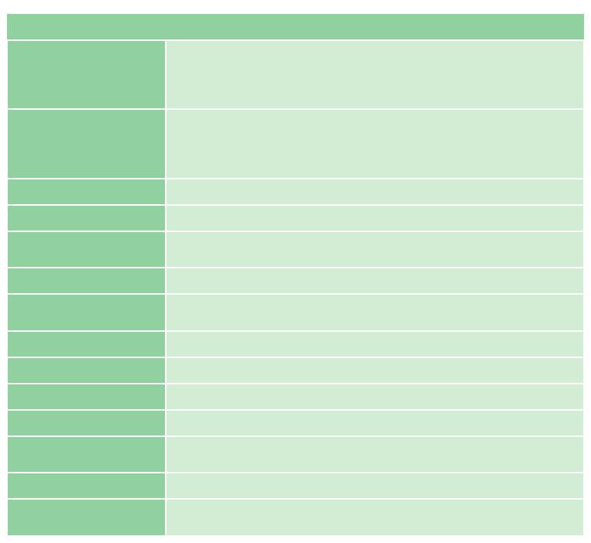

料号. | 描述
 | microATX motherboard supports 14nm LGA1151 Intel® Core™
IMB-H110-R10 | i7/i5/i3, Pentium® or Celeron® processor supported, DDR4, Dual
 | independent displays VGA/DVI-I/LVDS, Dual GbE LAN, USB 3.1
 | Gen 1 (5Gb/s), SATA 6Gb/s, HD Audio and RoHS
 | microATX Motherboard supports 14nm LGA1151 6th Generation
IMB-H110-ECO-R10 | Intel® Core™ i7/i5/i3, Pentium® or Celeron® processor per
 | Intel® H110, DDR4, VGA/DVI-I/LVDS, Dual GbE LAN, USB 3.1
 | Gen 1 (5Gb/s), SATA 6Gb/s, HD Audio, ECO Packing and RoHS
19800-000049-RS | LPT flat cable, 240mm, P=2.54
19800-000075-RS | PS/2 KB/MS cable with bracket, 220mm, P=2.0
19800-000200-100-RS | RS-232 cable with bracket, Dual 10-pin to dual DB-9, 300mm,
 | P=2.0
32102-000100-200-RS | SATA power cable, MOLEX 5264-4P to SATA15P
CF-115XA-R10 | High performance LGA1155/LGA1156 cooler kit, 1U chassis
 | compatible, 73W
CF-115XE-R10 | High performance LGA1155/LGA1156 cooler kit, 95W
DP-DP-R10 | DisplayPort to DisplayPort converter board (for IEI iDP connector)
DP-DVI-R10 | DisplayPort to DVI-D converter board (for IEI iDP connector)
DP-HDMI-R10 | DisplayPort to HDMI converter board (for IEI iDP connector)
DP-LVDS-R10 | DisplayPort to 24-bit dual-channel LVDS converter board (for IEI
 | iDP connector)
DP-VGA-R10 | DisplayPort to VGA converter board (for IEI iDP connector)
TPM-IN02-R20 | 20-pin Infineon TPM 2.0 module, software management tool,
 | firmware v5.5

IMB-H110-2019-V10

