显示系统
w w w . i e i w o r l d . c o m

15" Industrial Panel PC

PPC-5150A-H61

Intel® Core™ i7/ i5/ i3, Pentium® and Celeron® 处理器
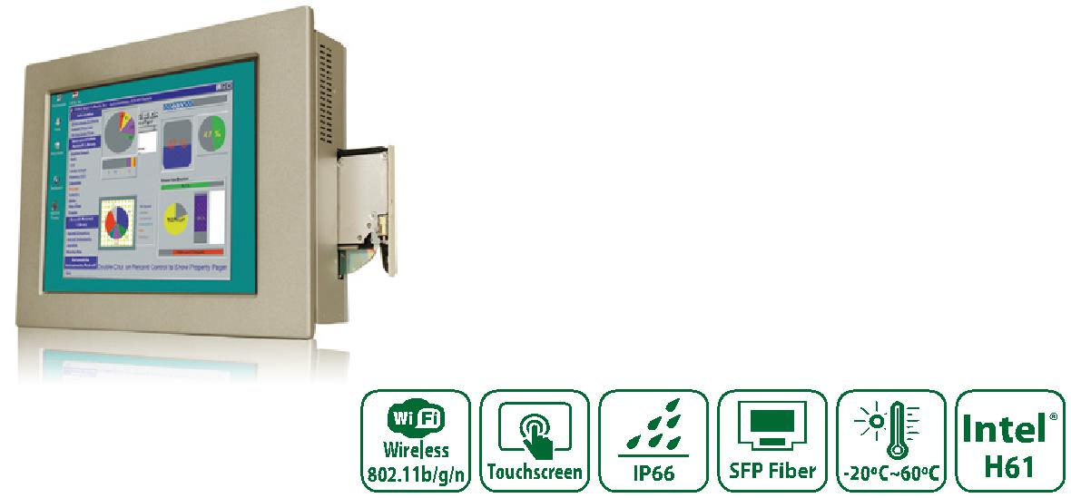

特征

●高亮度TFT-LCD面板采用LED背光
●多个存储选项:2.5“SATA硬盘,CF插槽和mSATA
●双以太网提供了连续的网络服务,并允许分享不同的工作组中两个不同的子网
●可选的PCI扩展槽/作为PCIe x 1
●可选的cd - rom驱动器湾苗条的类型
●强大的铝边框和金属套管
●ip 66兼容的前面板

●威强电一键恢复（one key recovery)快速恢复解决方案允许您创建操作系统备份和恢复(超过4GB存储容量)

规格

型号 |  | PPC-5150A-H61
 | LCD 尺寸 | 15 "
 | 最大分辨率 | 1024(W) x 768(H)
 | 亮度(cd/m²) | 450
显示 | 对比率 | 800 : 1
 | LCD 颜色 | 16.2M
 | 像素间距(mm) (HxV) | 0.297(H) x 0.297(V)
 | 可视角度 (V/H) | 150°/160°
 | 背光灯 (hrs) | 50000
触摸 | 触摸屏 | 5-wire resistive type with RS-232 interface
 | 触摸屏控制器 | DMC 9000
 | SBC | POS-H61
 | CPU | 2nd/3rd generation Intel® Core™ i7/ i5/ i3, Pentium® and Celeron® processor, up to TDP 65W CPU
主板 | 芯片组 | Intel® H61
 | RAM | Two 204-pin DDR3 SO-DIMM slots (max. 16GB)
 | 以太网 | Realtek RTL8111E PCIe GbE controller supporting ASF 2.0
 | 音频解码器 | Realtek ALC662 audio codec
 |  | 4 x RS-232 COM port | 1 x Audio (Line-out, MIC-in)
 |  | 1 x RS-232/422/485 port | 2 x SFP fiber LAN
I/O 接口和开关 |  | 2 x RJ-45 for LAN port | 1 x Power switch
 |  | 4 x USB 2.0, 2 x USB 3.1 Gen 1 (5Gb/s) on rear | 1 x AT / ATX switch
 |  | 1 x VGA port | 1 x PCI/PCIe slot
 | HDD 驱动支架 | 1 x 2.5” SATA/IDE HDD bay with anti-shock
硬盘支架 | SSD | CF Type II, mSATA (SATA2 signal)
 | CD-ROM 驱动支架 | SATA slim type CD-ROM bay
扩展插槽 |  | Either 1 x PCI slot or 1 x PCIe slot,
 |  | 1 x PCIe Mini card
 | 前面板材质 | Aluminum
 | 机身材质 | Heavy-duty steel
 | 安装方式 | Panel, wall, rack, stand and arm (VESA 100 mm x 100 mm)
物理 | 前面板颜色 | Silver (Pantone 8001C)
 | 开孔尺寸(WxHxD) (mm) | 410 x 309 x 110.5
 | 尺寸 (WxH) (mm) | 387 x 286
 | 净重毛重 | 7 kg / 11 kg
 | 操作稳度 | -20°C ~ 60°C
 | 存储温度 | -30°C ~ 70°C
环境 | 系统散热 | Active with fan
 | 振动 测试 | 5~17Hz, 0.1 double amplitude displacement 17~640Hz 1.5G acceleration peak to peak
 | 冲击测试 | 10G acceleration part to part (11ms)
 | IP 等级 | Front IP66 Compliant
 |  | AC input ATX power supply
 |  | - P/N: 63030-010220-100-RS
 | AC输入 | - 220W power supply
 |  | - Input: 90VAC~264VAC, 50/60Hz
电源 |  | - Output (max.): 3.3V@10A, 5V@14A, 12V@14A, -12V@0.3A
 |  | DC input ATX power supply
 |  | - P/N: ACE-4520C-RS
 | DC 输入 | - 200W power supply
 |  | - Input: 24 VDC (18~36 VDC)
 |  | - Output (max.): 3.3V@12A, 5V@12A, 12V@15.4A, -12V@0.5A

PPC-5150A-H61-2019-V10

显示系统
w w w . i e i w o r l d . c o m

订购信息

Part No. | Description
PPC-5150A-H61-P/R-R20 | 15” 450 cd/m² XGA panel PC with POS-H61, Intel® Pentium® G6xxT dual-core CPU (above 2.2GHz), TDP 35W, 2GB DDR3 RAM*2, Silver color, AC input
 | PSU, touch screen, R20
PPC-5150AD-H61-P/R-R20 | 15” 450 cd/m² XGA panel PC with POS-H61, Intel® Pentium® G6xxT dual-core CPU (above 2.2GHz), TDP 35W, 2GB DDR3 RAM*2, Silver color, PSU ACE-
 | 4520C, touch screen, R20
PPC-5150A-H61-i3/R-R20 | 15” 450 cd/m² XGA panel PC with POS-H61, Intel® Core™ i3 2xxxT dual-core CPU (above 2.5GHz), TDP 35W, 2GB DDR3 RAM*2, Silver color, AC input
 | PSU, touch screen, R20
PPC-5150AD-H61-i3/R-R20 | 15” 450 cd/m² XGA panel PC with POS-H61, Intel® Core™ i3 2xxxT dual-core CPU (above 2.5GHz), TDP 35W, 2GB DDR3 RAM*2, Silver color, PSU ACE-
 | 4520C, touch screen, R20
PPC-5150A-H61-i5/R-R20 | 15” 450 cd/m² XGA panel PC with POS-H61, Intel® Core™ i5 2xxxT dual-core CPU (above 2.7GHz), TDP 35W, 2GB DDR3 RAM*2, Silver color, AC input
 | PSU, touch screen, R20
PPC-5150AD-H61-i5/R-R20 | 15” 450 cd/m² XGA panel PC with POS-H61, Intel® Core™ i5 2xxxT dual-core CPU (above 2.7GHz), TDP 35W, 2GB DDR3 RAM*2, Silver color, PSU ACE-
 | 4520C , touch screen, R20
PCIR-01H-R10 | One PCI slot riser card
PCIER-101H-R10 | One PCIe x1 slot riser card

IQ 安装选项

Item | Part No.
Rack Mount Kit | RK-150MS-R10
Arm | ARM-31-RS
Stand | STAND-210-R11

可选配件

料号 描述

EMB-WIFI-KIT01-R20 Wi-Fi module with RF cable and antenna, 1T1R, 802.11b/g/n 73400-AD7760H01-RS Slim type SATA DVD-ROM

包装清单
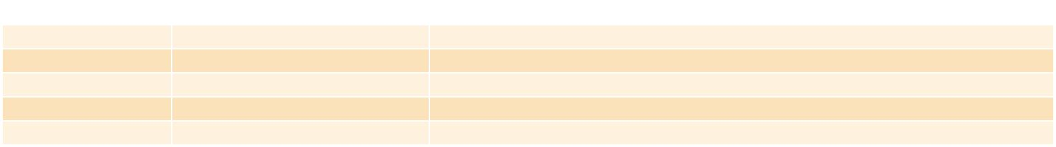

 | 名称 | 料号 |  | 描述
 | SATA CD-ROM Cable | 32803-000300-100-RS |  | Slim-line SATA 7+6P to SATA 7P/4P power, L=200/150 mm
 | Power Cord | 32000-000002-RS |  | European standard, 1830 mm, plug (16A, 250V), connector (10A, 250V)
 | Panel Mount Kit | 19Z00-000024-RS |  | 19Z00-000024-RS x8
 | Wall Mount Kit | 41020-016102-00-RS
 | Touch Pen
 |  |  |  |  |  | AT/ATX Switch
 |  | AC Inlet |  |  |  |  |  |  |  |  |  |  | 2 x USB 2.0
 |  |  | Power Switch |  |  |  |  |  | CMOS |  |  |  |  |  |  |  |  |  |  |  |  | Either 1 x PCI slot or 1 x PCIe x1 Slot
 |  |  |  |  |  |  |  |  |  |  |  |  |  |  |  |  |  |  |  |  |  | (Optional Riser Card)
完整的集成I/O |  |  |  |  |  |  |  |  |  |  |  |  |  |  |  |  |  |  |  |  |  |  |  |  |  |  | 1 x RS-232/422/485
 |  |  |  |  |  |  |  |  |  |  |  |  |  |  |  |  |  |  |  |  |  |  |  |  |  |  | 1 x Mic-in
 |  |  |  |  |  |  |  |  |  |  |  |  |  |  |  |  |  |  |  |  |  |  |  |  |  |  | 1 x Line-out
 |  |  |  |  |  |  |  |  |  |  |  |  |  |  |  |  |  |  |  |  |  |  |  |  |  |  | 1 x VGA
 |  |  | 2 x USB 2.0 2 x SFP |  |  |  |  |  |  |  |  | 2 x USB 3.1 Gen 1 ^{4 x RS-232}
 |  |  |  |  |  |  |  |  |  | 2 x LAN
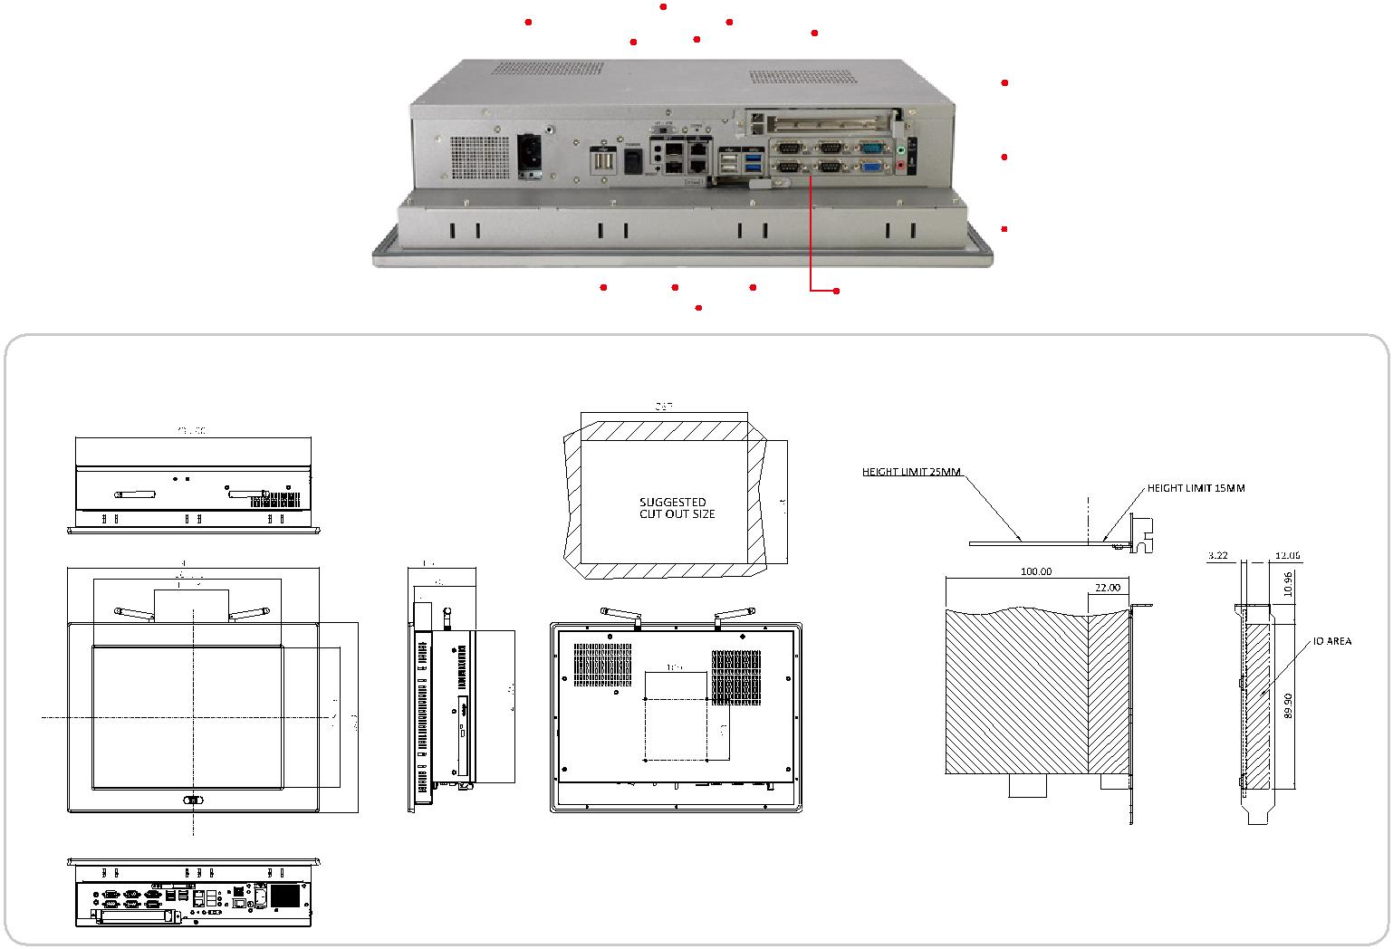

PPC-5150A-H61 尺寸 (单位: mm)

PPC-5150A-H61-2019-V10

