工业电脑机箱

w w w . i e i w o r l d . c o m . c n

RACK-360G 4U 14个插槽全长卡 机架式机箱

12 cm Fan |  | 3.5” FDD
 |  | Filter | Card Clamp
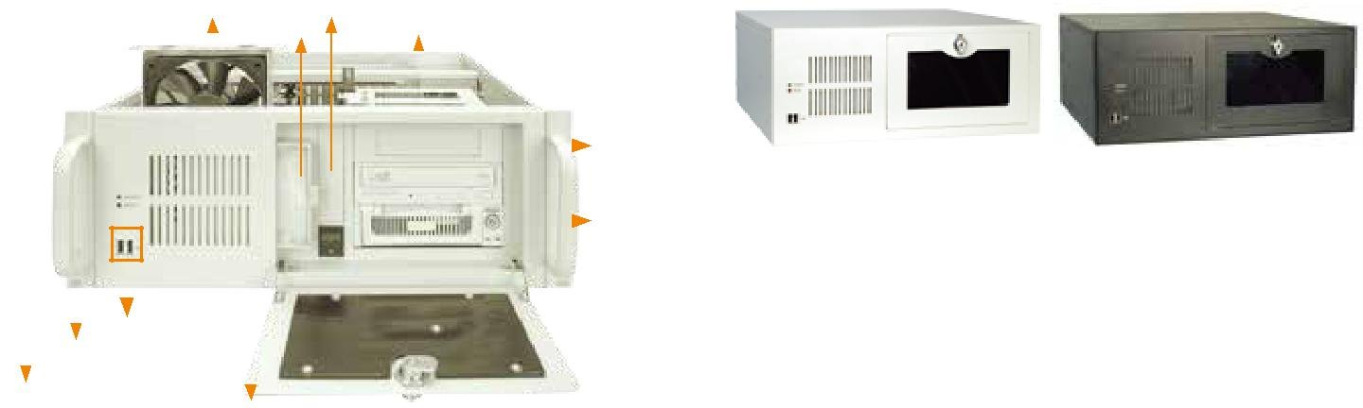

 |  |  |  |  |  |  |  |  |  | 5.25”或
 |  |  |  |  |  |  |  |  |  | 3.5”驱动器 |  | RACK-360GW |  |  | RACK-360GB
 |  |  |  |  |  |  |  |  |  | 2 x 5.25”
 |  |  |  |  |  |  |  |  |  |  |  |  |  |  | Shock Absorber
 |  |  |  |  |  |  |  |  |  | Drive Bay
 |  |  |  |  |  |  |  |  |  |  |  |  |  |  |  | Hold-down Clamp
 |  | 2 x USB
 | HDD LED
电源 LED
 |  |  |  | 电源开关 |  |  |  | 灵活的驱动器组合 |  |  | 可更换风扇过滤器 |  | 前置 I/O | 抗震动卡架
特性 |  |  |  |  |  |  |  |  |  |  | 尺寸 ( 单位 : mm)
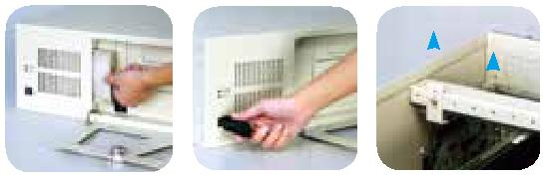

● 经济实用型，符合 RoHS 标准
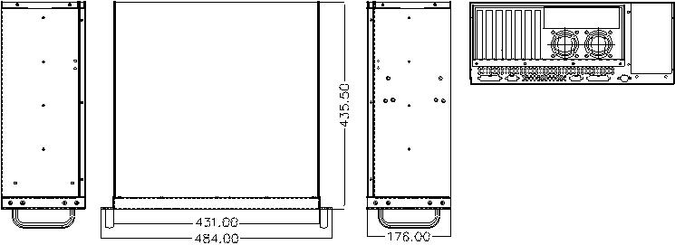

● 灵活的驱动器组合

● 前面板设有 2 个 USB 接口

● 12 cm 冷却风扇可简单地更换风扇过滤器
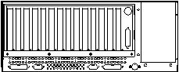

● 带锁设置防止未授权访问

规格
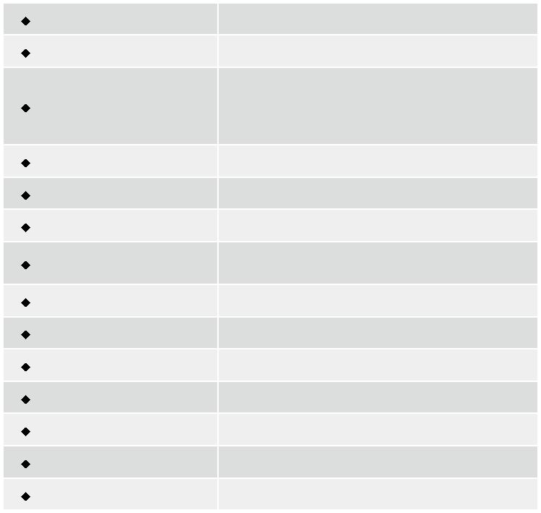

材质 | 重型金属
主板规格 | 全长CPU卡
 | 3 x 5.25” + 1 x 3.5” HDD
驱动器组合 | or 2 x 5.25” + 2 x 3.5” HDD
 | or 2 x 5.25” + 1 x 3.5” HDD + 1 x front accessible
 | 3.5” or 2 x 5.25” + 2 x front accessible 3.5”
散热风扇 | 1 x 12 cm
I/O 接口 | 2 x USB
I/O 开口 | 2 x COM, 2 x LPT
扩展槽 | 14 slots for RACK-360G
 | 7 slots for RACK-360GATX
指示灯 | Power, HDD
按钮 | 电源开关, 重启键
操作温度 | 0°C ~ 50°C
操作湿度 | 10% ~ 90%
颜色 | B: 黑色/W: 白色
净重/毛重 | 11 kg/15.4 kg
尺寸(DxWxH) | 435.5 mm x 431 mm x 176 mm

订购信息
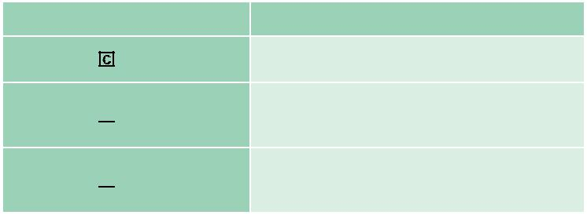

料号 |  | 描述
RACK-360G | -R23/ACE-935AL | 4U 14-slot rackmount chassis, USB, (black/white),
 |  | with ACE-935AL-RS PSU (300W), RoHS

4U 14-slot rackmount chassis, (black/white),

RACK-360G -R23/A130B 1 x 12 cm fan, with ACE-A130B-R10 (300W ATX model), RoHS

4U ATX motherboard rackmount chassis, (black/

RACK-360G ATX-R23/A130B white), 1 x 12 cm fan, with ACE-A130B-R10 (300W ATX model), RoHS

颜色 Code: B-黑色 W-白色

底板 ( 选配 )
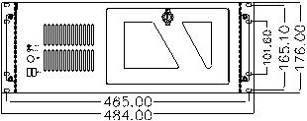

型号 | SBC 类型 | PCI | ISA | PCIX |  | PCle |  | PSU 接口
 |  |  |  |  | x1 | x4 | x16
PCI-13SD-RS | PICMG 1.0 | 3+4 | 3+3 | 0 | 0 | 0 | 0 | AT/ATX
PCI-14S2-RS | PICMG 1.0 | 4 | 8 | 0 | 0 | 0 | 0 | AT/ATX
PCI-14S3-RS | PICMG 1.0 | 4 | 9 | 0 | 0 | 0 | 0 | AT/ATX
PX-14S3-RS | PICMG 1.0 | 12 | 2 | 0 | 0 | 0 | 0 | AT/ATX
PX-14S5-RS | PICMG 1.0 | 7 | 6 | 0 | 0 | 0 | 0 | AT/ATX
BP-14S-RS | ISA | 0 | 14 | 0 | 0 | 0 | 0 | AT
PE-6S | PICMG 1.3 | 2 | 0 | 0 | 2 | 0 | 1 | ATX
PE-10S | PICMG 1.3 | 4 | 0 | 0 | 4 | 0 | 1 | ATX
PE-10S2 | PICMG 1.3 | 4 | 0 | 0 | 4 | 0 | 1 | ATX
PXE-12S | PICMG 1.3 | 4 | 0 | 6 | 0 | 0 | 1 | ATX
PE-13SD | PICMG 1.3 | 4 | 0 | 0 | 4 | 1 | 2 | ATX
PXE-13S | PICMG 1.3 | 8 | 0 | 0 | 3 | 0 | 1 | ATX
SPXE-14S | PICMG 1.3 | 0 | 0 | 0 | 12 | 0 | 0 | ATX

电源 ( 选配 )

类型 | 型号 | 功率
AT | ACE-935AL-RS | 300W
 | ACE-T140A-RS | 400W
 | ACE-A130B-R10 | 300W
ATX | ACE-A140A-S-R11 | 400W
 | ACE-A160A-R11 | 600W
ATX Redundant | ACE-R4130AP-RS | 300W
 | ACE-R4140AP-RS | 400W

RACK-360G 支持单个 PS/2 PSU。想了解威强电更多的电源产品，请参考章节 5 或直接访问 www.ieiworld.com.cn

RACK-360G-2019-V10

