工业电脑机箱

w w w . i e i w o r l d . c o m . c n

EBC-3100 Mini-ITX 机箱, 适用于高功耗工作环境应用
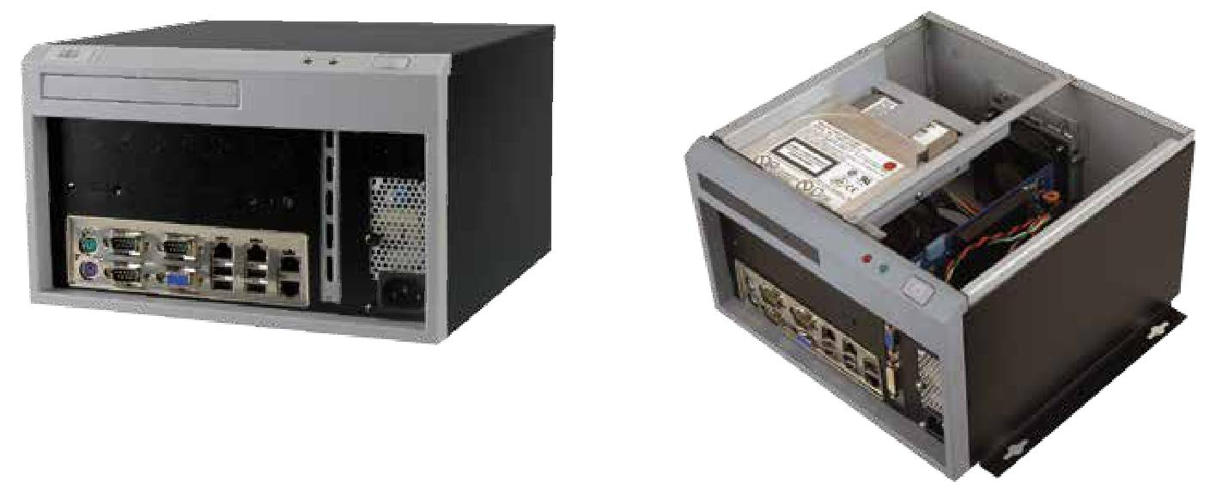

特性

- 高性能应用设计提供 270 W 高功率 ATX 电源

- 前面板 I/O 设计

- 支持 1 个扩展插槽

- 1 个 3.5”硬盘驱动, 1 个超薄光驱驱动

规格 |  |  | 尺寸 ( 单位 : mm)
型号 |  | EBC-3100
平台 |  | 仅机箱
 | 颜色 | 黑色
机箱 | 尺寸 ( (WxDxH) (mm) | 260 x 250 x 156 |  | 00160.
 | 系统风扇 (WxDxH) (mm) | 80 x 80 x 25
 | 机箱材质 | 重型金属，塑料前面板 |  | 20.00
主板 | 主板型号 | Refer to KINO Series
 | 主板尺寸 (mm) | Mini-ITX (170 x 170)
存储 | 硬盘驱动器 | 1 x 3.5" SATA HDD space |  | 276.00
 | ODD | 1 x 5.25" slim type
 |  | 1 x Full- 高度 扩展 slot
扩展 |  | Max. dimensions:
 |  | 220 mm (L) x 27 mm (D) |  | 156.00162.00
电源 | 电源输入 | 90 V~264 V AC
 | Power Model | ACE-A618A 180W, ACE-A627A 270W
 | 安装方式 | Desktop, wall mount |  | 260.00
 |  | 0°C ~ 50°C | 250.00
可靠性 | 操作温度 |  |  | 292.00
 | 净重 / 毛重 | 2.5 kg/3.9 kg
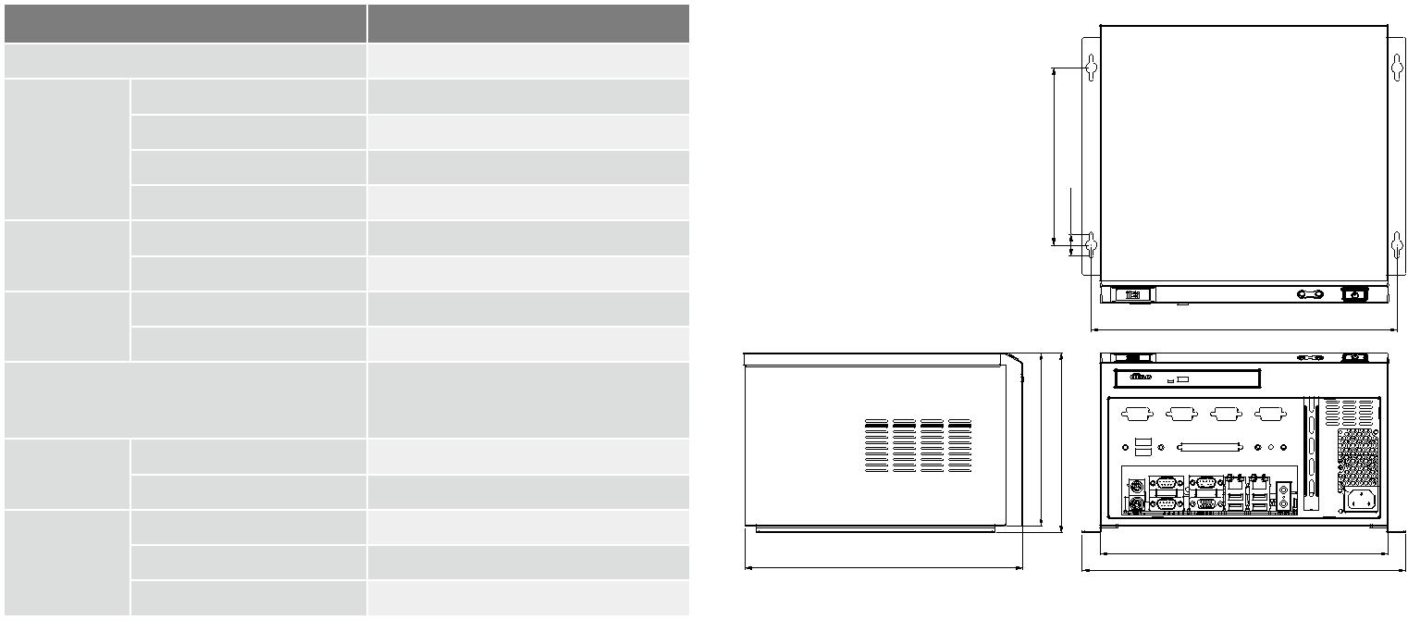

兼容 SBC
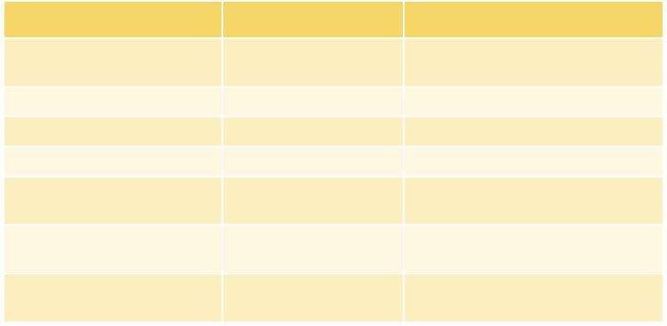

料号 | 扩展 类型 | 推荐 CPU 风扇
KINO-AQ170 | 1 x PCIe x16 | CF1156A-RS, CF-1156C-RS,
 |  | CF-1156D-RS
KINO-ABT | 1 x PCIe x4 | 无风扇
KINO-AA750-i2 | 1 x PCIe x8 | CF-989B-RS
KINO-AQ870 | 1 x PCIex4 | CF-1150SC-RS
KINO-AQ670 | 1 x PCIe x16 | CF1156A-RS, CF-1156C-RS,
 |  | CF-1156D-RS
KINO-AH611 | 1 x PCIe x16 | CF1156A-RS,CF-1156C-RS,
 |  | CF-1156D-RS
KINO-AH612 | 1 x PCIe x4 | CF1156A-RS, CF-1156C-RS,
 |  | CF-1156D-RS
订购信息

1U AC 输入

 |  | 功率 |  |  | 输出电流范围
 |  | AT/
产品 | 型号 |  | 输入电压 |  |  |  |  |  | 效率
 |  | ATX |  |  |  |  |  | +5
 |  |  |  | +3.3 V | +5 V | +12 V | -12 V
 |  | PFC |  |  |  |  |  | Vsb
 | ACE- | 300W | 90~265 | 16A | 18A | 15A
 |  |  |  | (0.5A | (0.5A |  | 0.5A | 3A | 82%
 | A630B | ATX | VAC |  |  | (0.5A min)
 |  |  |  | min.) | min.)
 | ACE- | 180W | 90~264 | 10A | 14A | 10A
 |  |  |  |  | (0.2A | (0.6A | 0.3A | 2.5A | 85%
 | A618B | ATX | VAC | (0.1A min)
 |  |  |  |  | min.) | min.)

料号 | 描述
EBC-3100-R12/ACE-A618B | Mini-ITX embedded chassis, one 3.5” hard driver bay, with ACE-A618B-RS 180W ATX power supply, black
EBC-3100-R12/ACE-A630B | Mini-ITX embedded chassis, one 3.5” hard driver bay, with ACE-A630B-RS 300W ATX power supply, black

包装清单

1 x system fan | 1 x Screw set | 1 x QIG
1 x Power cord | 1 x Wall mount kit | 1 x SATA slim ODD cable

EBC-3100-2019-V10

