工业电脑机箱

EBC-2200 EPIC SBC 嵌入式机箱
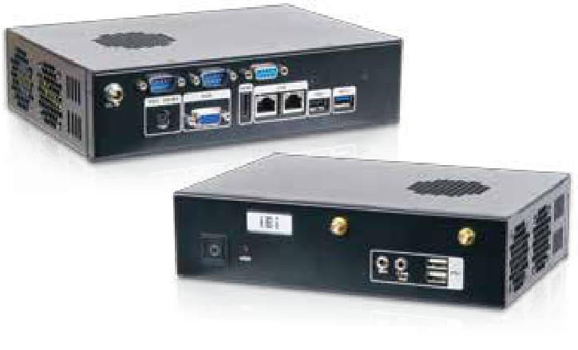

规格

型号 |  | EBC-2200-BT | EBC-2200-QM87
平台 |  | 仅机箱
 | 颜色 | 黑色
 | 尺寸 | 215 x 150 x 55 | 215 x 150 x 55
 | (WxDxH) (mm)
机箱
 | 系统风扇
 |  | 40 x 40 x 10 (optional)
 | (WxDxH) (mm)
 | 机箱材质 | 铝合金重型金属
 | 主板型号 | NANO-BT-i1 | NANO-QM871
 |  | NANO-BTW2
 | SBC 尺寸 | EPIC SBC (165 mm x 115 mm)
主板 | 处理器 | Refer to SBC | Refer to SBC
 | 芯片组 | SoC | Intel® QM87
 |  | 1 x 204-pin 1066/1333 MHz | 1 x 204-pin 1600/1333 MHz
 | 系统内存 | DDR3L SO-DIMM | DDR3 SO-DIMM
 |  | (system max. 8GB) | (system max. 8GB)
存储 | 硬盘驱动器 | 1 x 2.5'' SATA 6Gb/s HDD/SSD drive bay
 | PS2 (KB/MS) | 1 | N/A
 | USB 3.0 | 1 | 2
 | USB 2.0 | 3 | 4
 |  | LAN1: Intel® I210-AT | LAN1: Intel® I217LM PHY
 |  | PCIe controller with
 |  |  | with Intel® AMT 9.0 support
 | 网络 | NCSI support
 |  |  | LAN2: Intel® I210-AT
 |  | LAN2: Intel® I211-AT
 |  |  | PCIe controller
系统功能 |  | PCIe controller
 | COM 口 | 2 x RS-232 | 1 x RS-232
 |  | 1 x RS-232/422/485 | 1 x RS-232/422/485
 | 数字I/0 | N/A | 1
 | 显示 | 1 x HDMI, 1 x VGA | 2 x HDMI, 1 x VGA
 | 音频 | 1 x Line out, 1 x Mic-in | 1 x Line out, 1 x Mic-in
 | 无线 | 1 x 802.11b/g/n (optional) | 1 x 802.11b/g/n (optional)
扩展 | PCIe Mini | 1 x full-size PCIe Mini card slot
 | 电源输入 | 12 V DC | 12 V DC
电源 |  | 12V@1.52A | 12V@4.78A
 |  | (Intel® Atom™ J1900 | (Intel® Core™ i7-4770EQ
 | 功耗
 |  | CPU with 8GB 1333MHz | CPU with 4GB 1333MHz
 |  | DDR3 memory) | DDR3 memory)
 | 安装方式 | Wall mount, VESA 75 | Wall mount, VESA 75
 | 操作温度 | -20°C ~60°C
可靠性 | 冲击 | Half-sine wave shock 5G, 11ms, 3 shocks per axis
 | 振动 | MIL-STD-810F 514.5C-1 (with SSD)
 | 净重/毛重 | 1.1 kg/2 kg | 1.1 kg/2 kg

w w w . i e i w o r l d . c o m . c n

特性

- 搭配单电压输入 EPIC SBC

- 一个 2.5" 硬盘空间

- 支持一个 PCIe Mini 扩展插槽

- 丰富的 I/O 接口, 包含双 GbE, 双显接口

PCIe Mini 扩 | USB
 | USB 3.0 | Dual GbE | mSATA
展

尺寸 ( 单位 : mm)

 | 200
 | 75
 |  | 4-M3
100 |  | 75
 | 215
6455
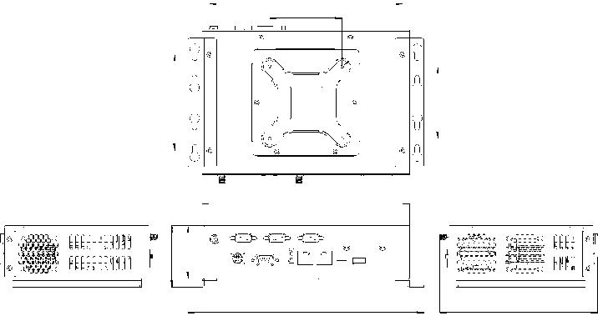

244.6 163.57

R5

52112150

R2.5

230.6

订购信息

料号 | 描述
 | Embedded chassis for NANO-BT Series SBC with one 2.5"
EBC-2200-BT-R10 | SATA hard driver bay, IO bracket, one LED cable, one power
 | switch cable, one USB cable, RoHS, R10
 | Embedded chassis for NANO-QM87 Series SBC with one 2.5"
EBC-2200-QM87-R10 | SATA hard driver bay, IO bracket, one LED cable, one power
 | switch cable, one USB cable, RoHS, R10
可选配件
料号 | 描述
32231-000100-200-RS | DIO cable, 150 mm, 2x5 pin
32205-001400-200-RS | RS-232 cable, 200 mm, 2x5 pin
32107-004000-100-RS | audio cable, 250 mm, two 3.5 mm phone jacks with nut
63040-010060-120-RS | Power adapter, FSP060-DIBAN2, 90 V~264 V AC, 60 W, 12 V
 | DC, ErP
31100-000272-RS | Fan, +12 V DC, 4-pin, YEN SUN, 40 mm x 40 mm x 15 mm,
 | 6000 RPM

包装清单

1 x QIG | 2 x Wall mount bracket | 1 x Screw set

EBC-2200-2019-V10

