工业电脑机箱

EBC-1100 3.5“SBC系列嵌入式机箱
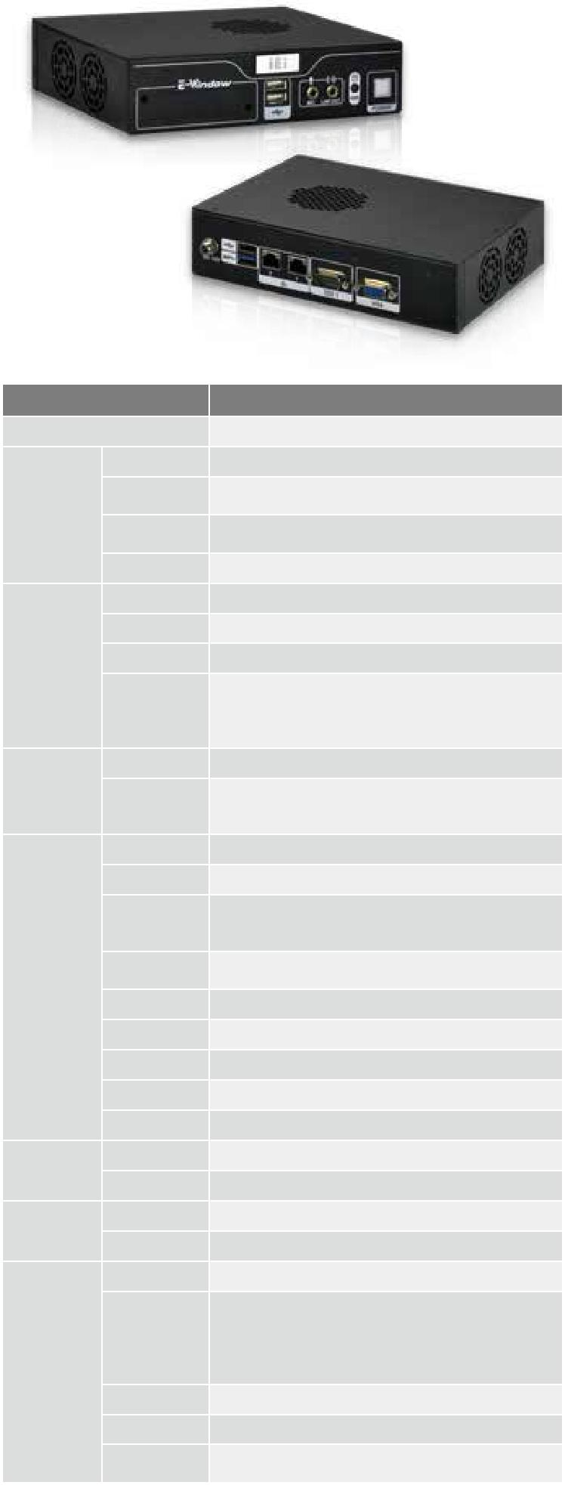

规格

型号 |  | EBC-1100
平台 |  | 机箱
 | 颜色 | 黑色
 | 尺寸( (WxDxH) | 190 x 140 x 46
 | (mm)
机箱
 | 系统风扇
 |  | Refer to MB
 | (WxDxH) (mm)
 | 机箱材质 | 铝合金重型金属
 | 主板型号 | WAFER-BT-E38001W2
 | 处理器 | Intel® Atom™ E3800 series on-board SoC
主板 | 芯片组 | SoC
 |  | 4GB solder-down 1066/1333 MHz DDR3L
 | 系统内存 | memory for E3845
 |  | 2GB solder-down 1066/1333 MHz DDR3L
 |  | memory for other SKUs
 | 硬盘驱动器 | 1 x 2.5’’ SATA 6Gb/s HDD/SSD drive bay
存储 |  | On-board SSD colay SATA1 (optional)
 | 存储 | 1 x mSATA colay SATA2
 |  | 1 x microSD socket
 | USB 3.0 | 1
 | USB 2.0 | 3
 |  | 2 x RJ-45
 | 网络 | LAN1: Intel® I210-IT PCIe controller
 |  | LAN2: Intel® I210-IT PCIe controller
 | COM 口 | 2 x RS-232 (RS-232 pin header is optional)
 |  | 1 x RS-422/485 (pin header, optional)
系统功能
 | 显示 | 1 x VGA
 | 分辨率 | VGA (up to 2560x1600@60Hz)
 | 音频 | 1 x Line-out, 1 x Mic-in
 | LED 指示灯 | Power, HDD
 | 无线 | 802.1b/g/n 2T2R (optional)
扩展 | PCIe Mini | 2 x full-size PCIe Mini slot
 | E-Window
 |  | 1
电源 | 电源输入 | DC jack: 12 V DC
 |  | 12 V @ 1.32 A (Intel® Atom™ E3845 processor)
 | 功耗
 | 安装方式 | Wall mount, VESA 75
 |  | E3845 (10W):
 |  | -40°C ~ 50°C without fan module/
 | 操作温度 | -40°C ~ 75°C with fan module
 |  | E3825 (6W):
可靠性 |  | -40°C ~ 65°C without fan module
 | 冲击 | Half-sine wave shock 5G, 11ms, 3 shocks per axis
 | 振动 | MIL-STD-810F 514.5C-1 (with SSD)
 | 净重/毛重 | 1.2 kg/2.2 kg

w w w . i e i w o r l d . c o m . c n

特性

- WAFER-BT-E38001W2 SBC 单电压输入设计

- 一个 2.5”硬盘和两个 PCIe Mini 扩展槽

- 可选板载内存和板载 SSD

- 支持灵活 E-Window 工具包

- 支持 -40°~ 75°C 宽温环境

PCIe Mini 扩 | USB
 | USB 3.0 | Dual GbE | mSATA | 40 75
展 |  |  |  | - °C~ °C

尺寸 ( 单位 : mm)
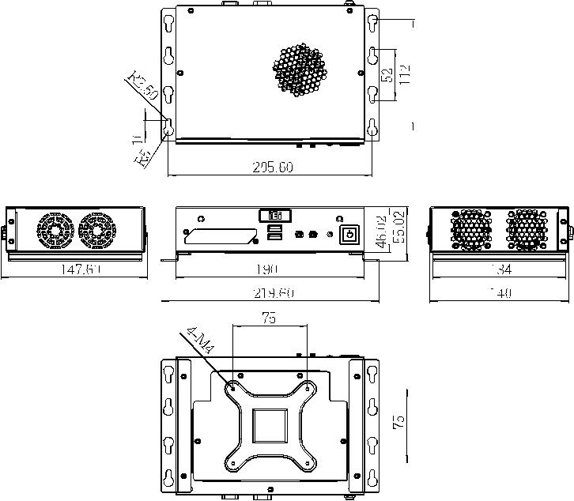

订购信息

料号 | 描述
 | Embedded chassis for WAFER-BT-E38001W2 Series MB
EBC-1100-BTW2-R10 | with one 2.5” SATA hard driver bay, IO bracket, one LED
 | cable, one power switch cable, one USB cable, one audio
 | cable, RoHS, R10

可选配件
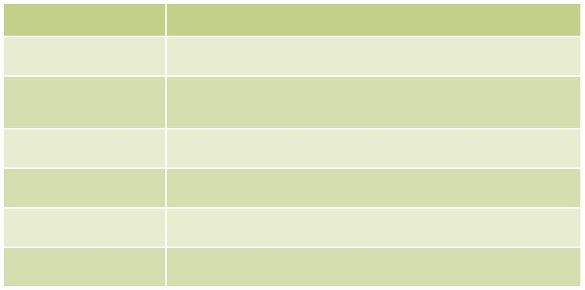

料号 | 描述
63040-010060-120-RS | FSP060-DIBAN2, 90 V ~ 264 V AC, 60 W, 12 V DC, ErP
19FR124010BL-000001- Fan module, +12 V DC, 3-pin, 40 mm x 40 mm x 10 mm,
RS | EVERFLOW, 5000 RPM, two ball bearing, L=250 mm
32205-004700-100-RS | RS-422/485 cable, 100 mm, P=2.0
32200-074500-RS | RS-232 cable, 150 mm, P=2.0
32801-003608-100-RS | SATA power cable kit, 150 mm
DK-75-R10 | VESA 75 to DIN-rail mounting kit

包装清单

1 x QIG | 1 x Wall mount bracket | 1 x Screw set

EBC-1100-2019-V10

