工业电脑机箱

w w w . i e i w o r l d . c o m . c n

ECW-281B-BT | Intel® Celeron® J1900 处理器无风扇嵌入式系统
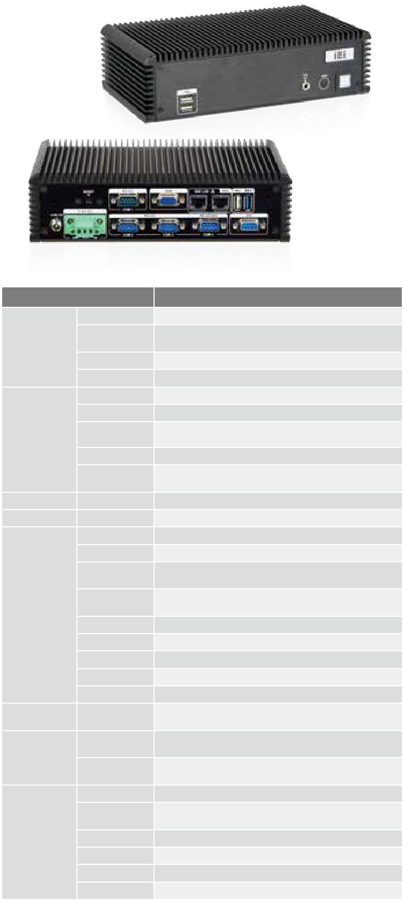

规格

型号 |  | ECW-281B-BT
 | 颜色 | 黑色
 | 尺寸 (WxHxD) | 229 x 132 x 64
机箱 | (mm)
 | 系统风扇 | 无风扇
 | 机箱材质 | 铝合金重型金属
 | 主板型号 | WAFER-BT-i1
 | 主板尺寸 (mm) | 3.5", 146 x 102
 | CPU | Intel® Celeron® J1900 processor
主板 |  | (quad-core, 2 MB cache, TDP=10W, up to 2.42GHz)
 | 芯片组 | SoC
 | 系统内存 | 1 x 204-pin 1066/1333 MHz single-channel DDR3L
 |  | SO-DIMM (system max. 8 GB)
IPMI | iRIS 解决方案 | 1 x iRIS-1010-R10 (optional)
存储 | 硬盘驱动器 | 1 x 2.5” SATA 3Gb/s HDD bay
 | USB 3.0 | 1
 | USB 2.0 | 3
 | 网络 | LAN 1: PCIe GbE by Intel® I210 controller
 |  | LAN 2: PCIe GbE by Intel® I211 controller
 | COM 口 | 3 x RS-232
I/O 接口 |  | 1 x RS-422/485
 | 数字 I/0 | 8-bit 数字 I/0
 | 显示 | 1 x VGA
 | 分辨率 | VGA: Up to 2560x1600@60Hz
 | 音频 | 1 x Line out
 | 无线 | 1 x 802.11b/g/n (optional)
扩展 | PCIe Mini | 1 x full-size PCIe Mini card slot (supports mSATA)*
 |  | 1 x half-size PCIe Mini card (only for iRIS)
 | 电源输入 | DC jack: 12 V DC
 |  | 3-pin terminal: 9 V~36 V DC
电源
 |  | 12V@1.45A (with Intel® Celeron® J1900 CPU and one 8
 | 功耗
 |  | GB 1333 MHz DDR3 memory)
 | 安装方式 | Wall mount, VESA 100
 | 操作温度 | -20°C~60°C with air flow (SSD),
 |  | 10% ~ 95%, non-condensing
可靠性 | 存储 温度 | -20°C ~ 60°C
 | 冲击 | Half sine wave 5G, 11ms 3-axis (non-operational)
 | 振动 | MIL-STD-810F 514.5C-1 (HDD)
 | 净重 / 毛重 | 2.1 kg / 3.9 kg

*ECW-281BWD-BTi-QGW without full-size PCIe Mini Card slot 扩展

特性

- 无风扇系统支持Intel® Celeron® J1900 处理器

- 支持 4 COM 口(3 x RS-232, 1 x RS-422/485)

- 12V DC 和 9~36V DC 模块可用

- 可在 -20° C ~ 60° C 宽温环境下工作(SSD)

 | PCIe Mini 扩 | USB
无风扇 |  | USB 3.0 | Dual GbE | mSATA
 | 展

尺寸 ( 单位 : mm)
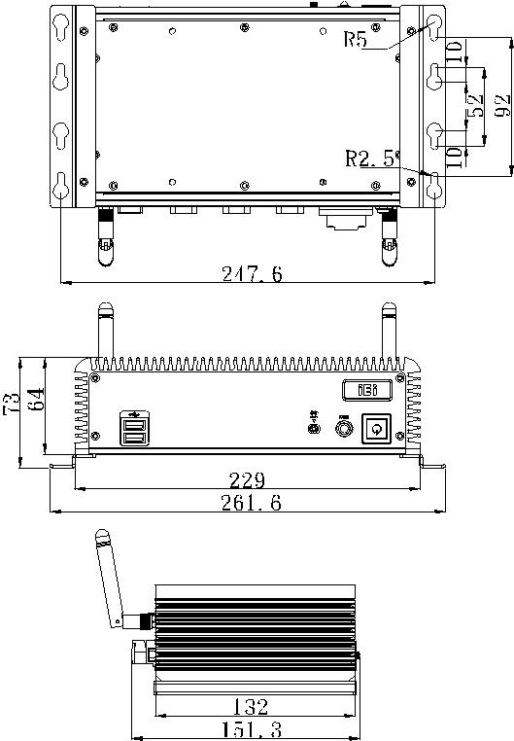

可选配件

料号 | 描述
iRIS-1010-R10 | IPMI 2.0 adapter card with AST1010 BMC chip (W/O KVM
 | over IP function) for PCIe Mini socket interface
ECW-281B-BTi-WES7E64-R10 | OS Image with Windows® Embedded Standard 7 E 64Bit
 | for ECW-281BTi Series, with DVD-ROM, RoHS, R10
DK-100-R10 | VESA 100 to DIN-Rail mounting kit

包装清单

1 x Power cord only for 12V | 1 x Wall mount bracket
1 x 12V 60W power adapter only for 12V | 1 x Utility CD
1 x Screw set | 1 x One Key Recovery CD

订购信息

 | 料号 |  | 描述
 | 12V DC Input | ECW-281B-BTi-J1/2GB-R10 | Fanless embedded system with WAFER-BTi, Intel® Celeron® J1900 2.42 GHz processor, four serial ports, pre-installed 2GB DDR3L SO-
 |  |  | DIMM, 12 V DC-in, 60 W power adapter, black, RoHS
 | 9 V~36 V DC | ECW-281BWD-BTi-J1/2GB-R10 | Fanless embedded system with WAFER-BTi, Intel® Celeron® J1900 2.42 GHz processor, four serial ports, pre-installed 2GB DDR3L SO-
 | Input |  | DIMM, 9 V ~ 36 V DC-in, black, RoHS
 | ECW-281BWD-BTi-QGW-R10 |  | Fanless embedded system with WAFER-BTi-R10,with Intel® Celeron J1900 2GHz, 4 serial ports,with 4GB DDR3L pre-installed SO-
 |  |  | DIMM memory, with QTS-Gateway, 9~36VDC in, w/o adapter, black, RoHS
 |  |  | ECW-281B-BT-2019-V10

