工业电脑机箱

w w w . i e i w o r l d . c o m . c n

ECN-380-QM87
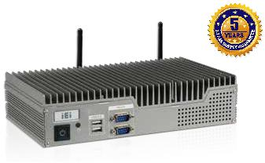

- Intel® Core™ i5/Celeron® CPU

- 支持独立三显

特性

- Intel® Core™ i5/Celeron® CPU
  - Intel® Core™ i5-4400E 2.7 GHz/Celeron® 2000E 2.2 GHz

- 支持独立三显

  - 2 x HDMI + VGA

- 两个 2.5'' SATA 6Gb/s HDD/SSD 驱动器插槽

 |  | 无风扇 | Dual LAN | Dual HDD | Triple 显示
规格
型号 |  | ECN-380-QM87
 | 颜色 | 银色
机箱 | 尺寸( (WxDxH) (mm) | 265 x 134 x 56.7
 | 系统风扇 | 无风扇
 | 机箱材质 | 铝合金重型金属
 | 主板型号 | NANO-QM871-i1
 | 主板尺寸 (mm) | EPIC, 165 x 115
主板 | CPU | Intel® mobile Core™ i5-4400E with AMT 9.0 support (up to 2.7GHz, dual-core, 3MB cache, TDP=37W)
 |  | Intel® mobile Celeron® 2000E (up to 2.2GHz, dual-core, 2MB cache, TDP=37W)
 | 芯片组 | Intel® QM87
 | 系统内存 | One 204-pin 4GB DDR3 SO-DIMM pre-installed (system max: 8GB)
IPMI | iRIS 解决方案 | 1 x iRIS-1010 (optional)
存储 | 硬盘驱动器 | 2 x 2.5'' SATA 6Gb/s HDD/SSD drive bay
 | USB 3.0 | 2
 | USB 2.0 | 4
 |  | 2 x RJ-45
 | 网络 | LAN1: Intel® I217LM PHY with Intel® AMT 9.0 support
 |  | LAN2: Intel® I210-AT PCIe controller
I/O 接口 | COM 口 | 2 x RS-232
 | 显示 | 2 x HDMI, 1 x VGA
 | 分辨率 | VGA: Up to 1920 x 1200@60Hz
 |  | HDMI: Up to 2500 x 1600@60Hz
 | 音频 | 1 x Line-out, 1 x Mic-in
 | 无线 | 1 x 802.11b/g/n (optional)
扩展 | PCIe Mini | 1 x full-size PCIe Mini (supports mSATA, SATA 6Gb/s signal only)*
 |  | 1 x half-size PCIe Mini (only for iRIS-1010)
 | 电源输入 | DC jack: 12 V DC
 |  | 3-pin terminal: 9 V~36 V DC
电源
 |  | 12 V@4.6 A
 | 功耗
 |  | (Intel® mobile Core™ i5-4400E with 4GB 1333MHz DDR3 memory)
 | 安装方式 | Wall mount, VESA 100
 | 操作温度 | -20°C ~60°C with air flow (SSD), 10% ~ 95%, non-condensing
可靠性 | 存储 温度 | -30°C ~70°C with air flow (SSD), 10% ~ 95%,non-condensing
 | 冲击 | Half-sine wave shock 5G, 11ms, 3 shocks per axis
 | 振动 | MIL-STD-810F 514.5C-2 (with SSD)
 | 净重/毛重 | 2.4 kg/4.2 kg
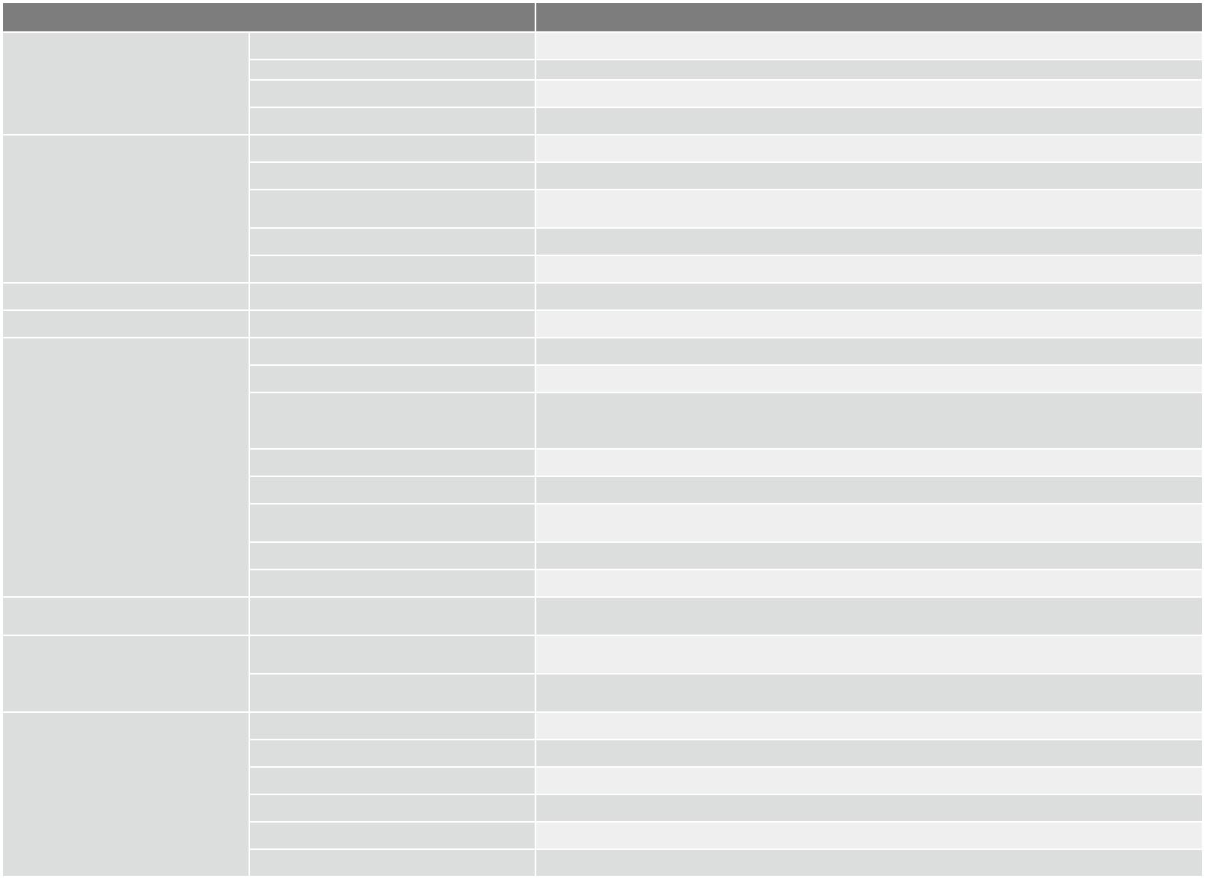

- ECN-380-QM87i-WD-QGW without full-size PCIe Mini Card slot 扩展

可插拔 2.5" SATA HDD/SSD bay 三组视频输出

ECN-380 系列配有两个 2.5" SATA HDD 槽。其中之一可以插 ECN-380-QM87 有 2 个 HDMI 和 1 个 VGA。所有的显示输出
拔，便于安装 。 都支持高分辨率视频，可广泛应用于多个显示器的应用中。
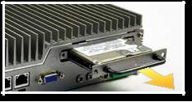

Dual HDD Triple 显示
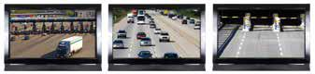

ECN-380-QM87-2019-V10

工业电脑机箱

全集成 I/O 接口

●ECN-380-QM87 前 I/O

2 x USB 2.0
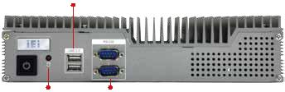

HDD LED | 2 x RS-232

尺寸 ( 单位 : mm)

R2.5

R5
52

w w w . i e i w o r l d . c o m . c n

●ECN-380-QM87 后 I/O

电源1
2 x USB 3.0 2 x LAN 音频 (接线端子)
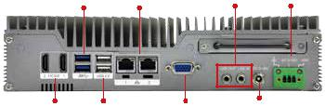

2 x HDMI 2 x USB 2.0 | VGA | 电源2
 |  | (DC 插孔)

112 10 10

289.3
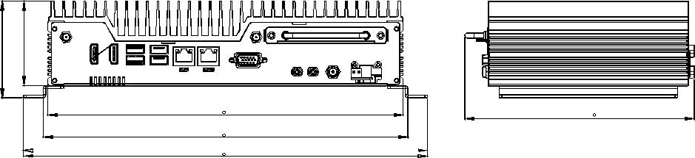

 | 7364
134 | 266.7 | 172.12
150 | 273.7
 | 303.3
4- 3.5
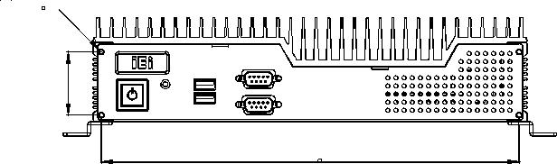

 |  | 39
 |  |  | 256.7
订购信息
料号 | 描述
ECN-380-QM87i-i5/4G-R11 | Fanless embedded system with Intel® Core™ i5-4400E 2.7 GHz CPU, TDP 37W, 2 x HDMI, 1 x VGA, 2 x 2.5'' SATA HDD bay, 4GB memory
 | pre-installed, iRIS-1010, 12 V DC, RoHS
ECN-380-QM87i-C/4G-R11 | Fanless embedded system with Intel® Celeron® 2000E 2.2 GHz CPU, TDP 37W, 2 x HDMI, 1 x VGA, 2 x 2.5'' SATA HDD bay, 4GB memory
 | pre-installed, iRIS-1010, 12 V DC, RoHS
ECN-380-QM87i-i5/WD/4G-R11 | Fanless embedded system with Intel® Core™ i5-4400E 2.7 GHz CPU, TDP 37W, 2 x HDMI, 1 x VGA, 2 x 2.5'' SATA HDD bay, 4GB memory
 | pre-installed, iRIS-1010, 9 V~36V DC, RoHS
ECN-380-QM87i-C/WD/4G-R11 | Fanless embedded system with Intel® Celeron® 2000E 2.2 GHz CPU, TDP 37W, 2 x HDMI, 1 x VGA, 2 x 2.5'' SATA HDD bay, 4GB memory
 | pre-installed, iRIS-1010, 9 V~36 V DC, RoHS
ECN-380-QM87i-WD-QGW-R10 | Fanless embedded system with Intel® Core™ i5-4400E 2.7 GHz, TDP 37W, 2 x HDMI, 1 x VGA, 2 x 2.5’’ SATA HDD bay, 8GB memory pre-installed,
 | iRIS-1010, with QTS-gateway, 9 V~36V DC, RoHS
可选配件
料号 | 描述
iRIS-1010-R10 | IPMI 2.0 adapter card with AST1010 BMC chip (W/O KVM over IP function) for PCIe Mini socket interface
ECN380VK-100-R10 | VESA 100 mount kit for ECN-380
ECN-380-QM87i-WES7E-R10 | OS image with Windows Embedded Standard 7 E for ECN-380-QM87i Series, WES7E license label, with DVD ROM
包装清单
1 x Power cord |  | 1 x Chassis screw set | 1 x Utility CD
1 x Power adapter (with PSE/ErP certified) |  | 1 x Wall mount bracket | 1 x One Key Recovery CD

ECN-380-QM87-2019-V10

