工业电脑机箱

ECN-360A-ULT3
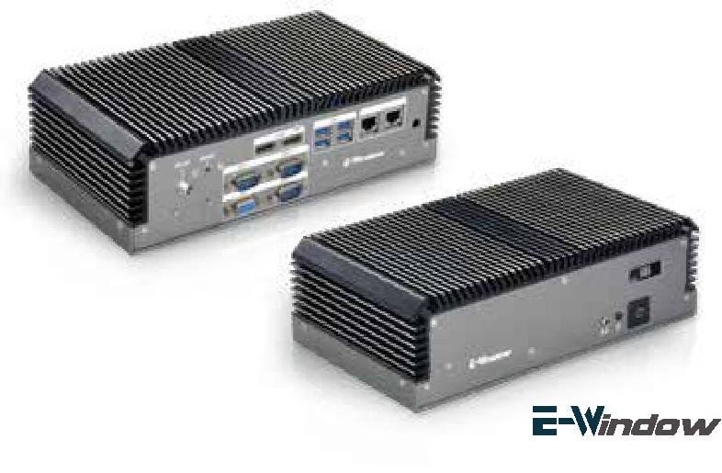

w w w . i e i w o r l d . c o m . c n

Intel® 无风扇嵌入式系统解决方案

特性

- 板载 CPU

  - i5-6300U dual-core up to 3.0GHz

  - 3855U dual-core up to 1.6GHz

- 两个 2.5’’ SATA 6Gb/s HDD/SSD 驱动器插槽

- 操作温度: -20°C ~ 60 °C

- 两个灵活的E-Window用于模块化扩展I / O

USB

无风扇 | PCIe Mini 扩 | USB 3.0 | Dual GbE | 双显
 | 展

规格
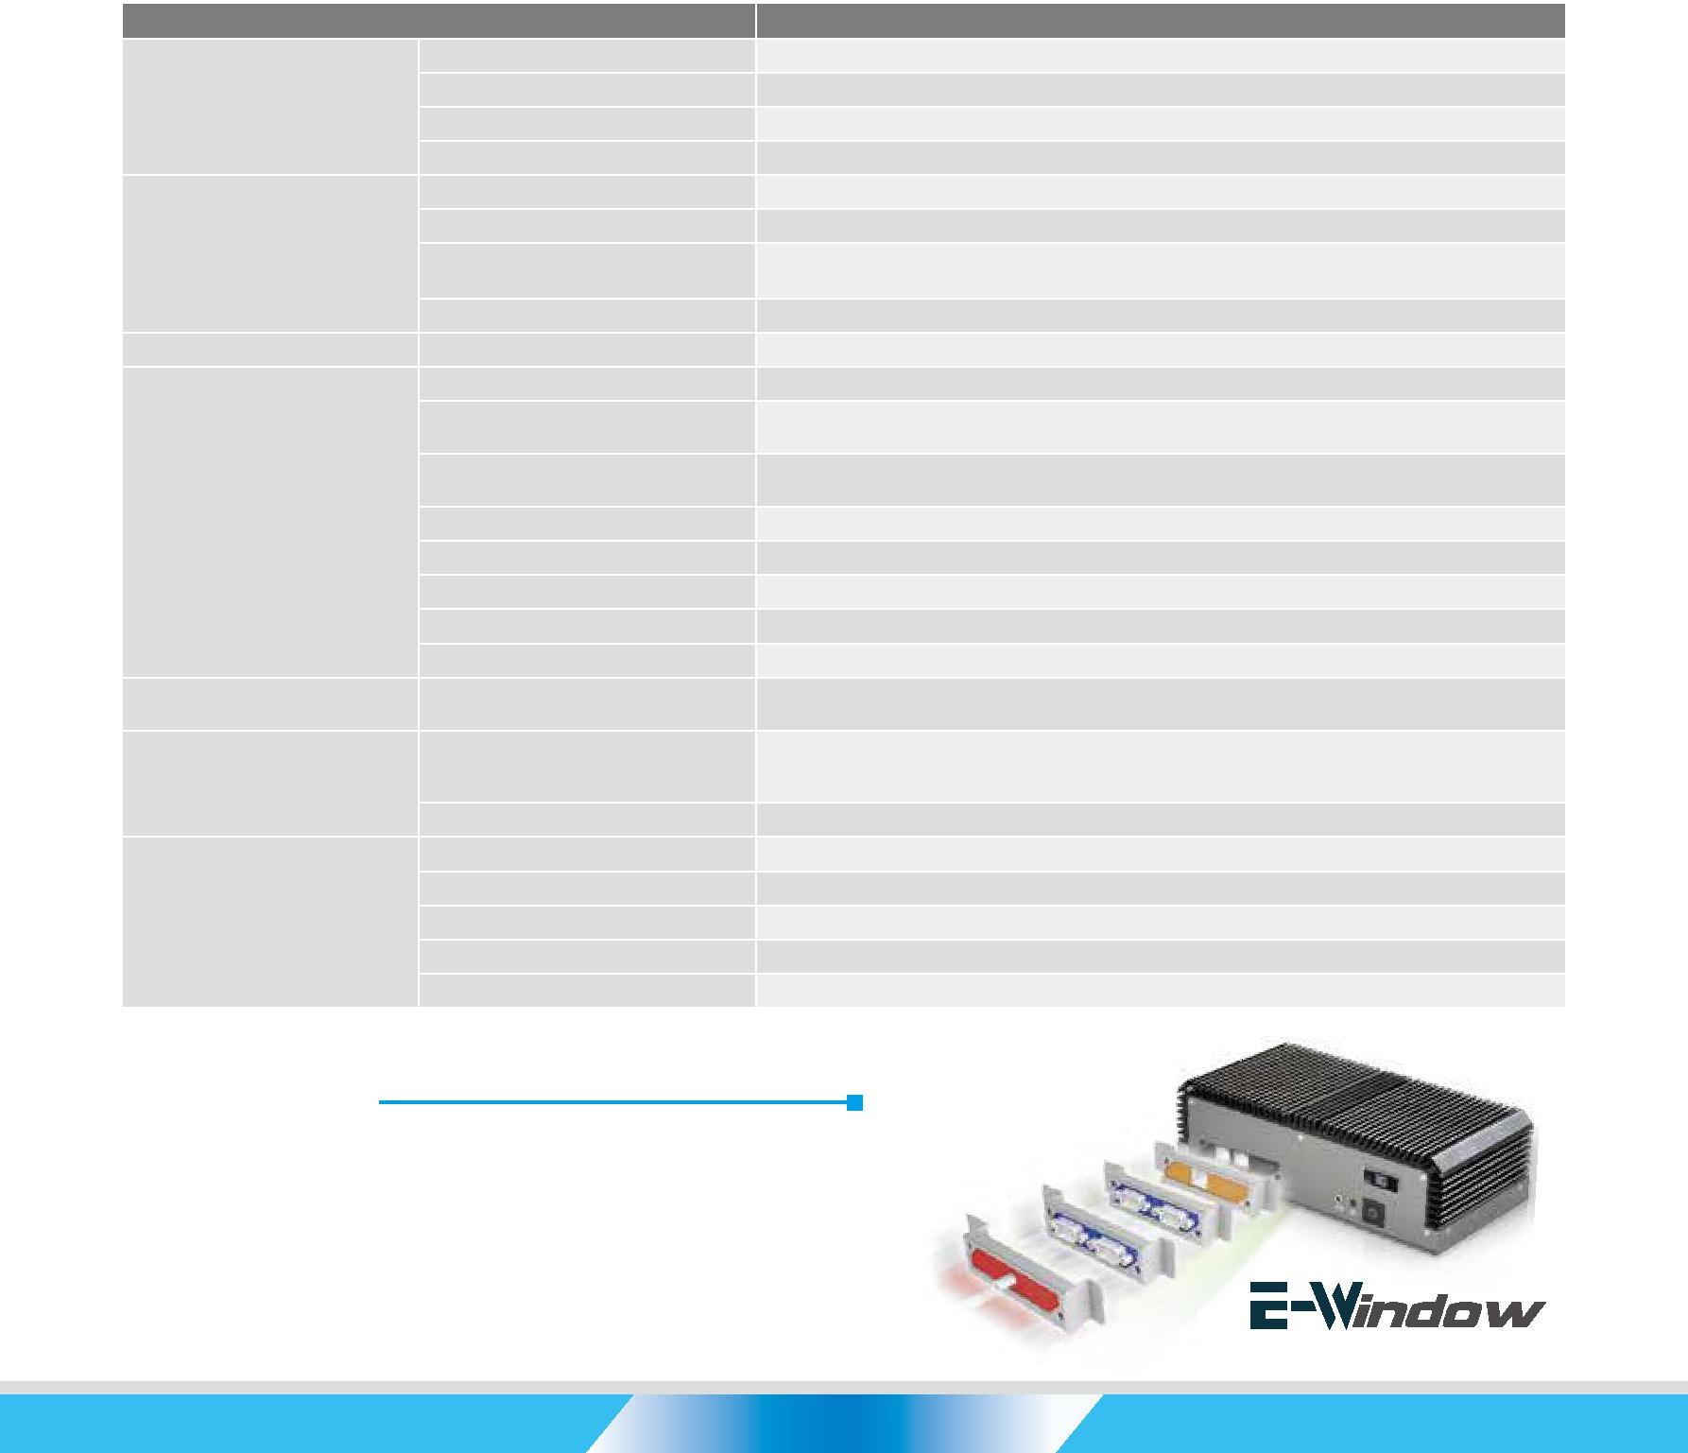

型号 |  | ECN-360A-ULT3
 | 颜色 | 黑色
机箱 | 尺寸 ( (WxDxH) (mm) | 255 x 130 x 75
 | 系统风扇 | 无风扇
 | 机箱材质 | SECC
 | 主板型号 | NANO-ULT3
 | 主板尺寸 (mm) | EPIC, 165 x 115
主板 | 处理器 | Intel® Core™ i5-6300U
 |  | Intel® Celeron® 3855U
 | 系统内存 | 2 x 260-pin 2133/1866 MHz dual-channel DDR4 SO-DIMMs support up to 32GB Pre-install 4GB DDR4
存储 | 硬盘驱动器 | 2 x 2.5” SATA HDD bay(No RAID support)
 | USB 3.0 | 4
 | 网络 | LAN1: Intel® I219-LM
 |  | LAN2: Intel® I211-AT
 | COM 口 | 1 x RS-232/422/485
 |  | 2 x RS-232
I/O 接口 | 数字 I/0 | 8-bit 数字I/0
 | 显示 | 2 x HDMI
 | 分辨率 | HDMI: up to 4096x2160@24Hz
 | 音频 | 1 x Line-out
 | 无线 | 2 x 802.11b/g/n (optional)
扩展 | PCIe Mini | 1 x full-size PCIe Mini card slot (with SIM holder & mSATA support)
 |  | 1 x half-size PCIe Mini card slot
 |  | DC 12V (Optional 9~36V)
电源 | 电源输入 | Power 1: DC jack
 |  | Power 2: Terminal block( for optional 9~36V only)
 | 功耗 | 12 V@2.4 A (Intel® i5-6300U with 4GB DDR4 memory)
 | 安装方式 | Wall mount, VESA 100
 | 操作温度 | -20°C~60°C with air flow (SSD), 5% ~ 95%, non-condensing
可靠性 | 冲击 | Half-sine wave shock 5G, 11ms, 3 shocks per axis
 | 振动 | MIL-STD-810F 514.5C-2 (SSD)
 | 净重 / 毛重 | 2.2 kg/3 kg

*3855U belongs to Skylake ULT Base series CPU, PCIe signal support only PCIe Gen 2

易于使用

易于安装

- 灵活的 I/O 功能用于扩展需求

- 使用 IEI E-windows 工具包轻松组装和集成

 |  | EtherCAT
 | GbE
 | GPIO | LAN
COM
3G

ECN-360A-ULT3-2019-V10

工业电脑机箱

w w w . i e i w o r l d . c o m . c n

全集成 I/O 接口

正视图 |  |  | 后视图 |  |  |  |  |  |  |  |  |  |  | 4 x USB 3.0
 |  |  | 电源接口 |  |  | RS-232/422/485 |  |  |  |  |  |  |  |  |  |  |  | 2 x Gigabit LAN
 |  |  |  | 重启 |  |  |  | 2 x HDMI
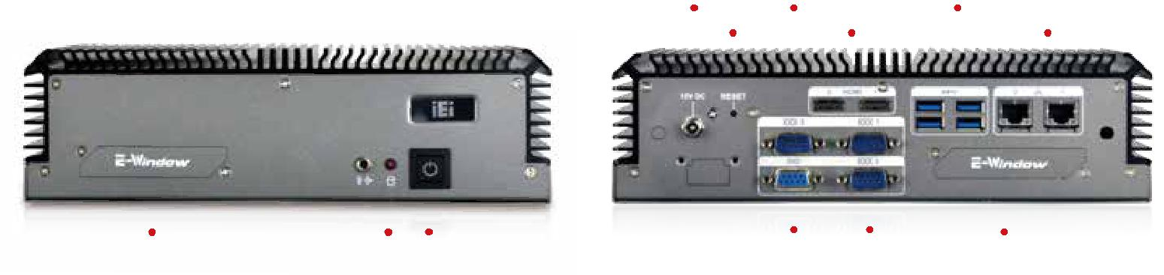

E-Window | HDD LED | Power LED | DIO | 2 x RS-232 | E-Window

尺寸 ( 单位 : mm)
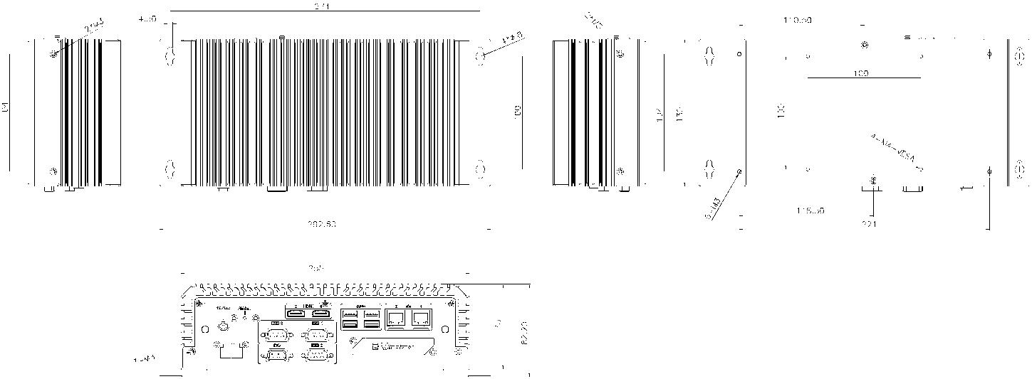
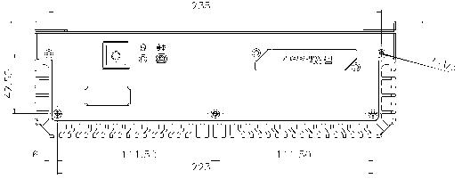

订购信息

料号 | 描述
ECN-360A-ULT3-i5/4G-R10 | Embedded system withIntel® Core™ i5-6300U up to 3.0GHz , TDP 15W, 2 x GbE LAN port , 2 x HDMI, 2 x 2.5’’ SATA HDD bay,
 | 4GB memory pre-installed,12V DC, RoHS
ECN-360A-ULT3-CE/4G-R10 | Embedded system withIntel® Celeron® 3855U up to 3.0GHz/1.6GHz , TDP 15W, 2 x GbE LAN port , 2 x HDMI, 2 x 2.5’’ SATA HDD bay,
 | 4GB memory pre-installed, 12V DC, RoHS
ECN-360A-ULT3-i5/WD/4G-R10** | Embedded system withIntel® Core™ i5-6300U up to 3.0GHz , TDP 15W, 2 x GbE LAN port , 2 x HDMI, 2 x 2.5’’ SATA HDD bay,
 | 4GB memory pre-installed, 9~36V DC, RoHS
ECN-360A-ULT3-CE/WD/4G-R10** | Embedded system withIntel® Celeron® 3855U up to 1.6GHz , TDP 15W, 2 x GbE LAN port , 2 x HDMI, 2 x 2.5’’ SATA HDD bay,
 | 4GB memory pre-installed, 9~36V DC, RoHS
FSP060-DIBAN2 | 12V 60W AC/DC Adapter
E-MPCIE-LAN03-R10 | PCIe mini card supports 1-port GbE with REALTEK RTL8111E controller, with PMS 194C I/O bracket and 150 mm cable
E-MPCIE-DLAN03-R10 | PCIe mini card supports PCIe mini card supports 2-port GbE with Intel® I211 controller, with PMS 194C I/O bracket and 150mm cable
**By order production, MOQ: 50

包装清单

1 x Screw set | 1 x Utility CD | 1 x Wall mount bracket | 1 x One Key Recovery CD

ECN-360A-ULT3-2019-V10

