工业系统
w w w . i e i w o r l d . c o m

TANK-801-BT ■ Intel® Celeron® J1900 2 GHz, 10W ■ 支持 3 种不同类型的扩展底板
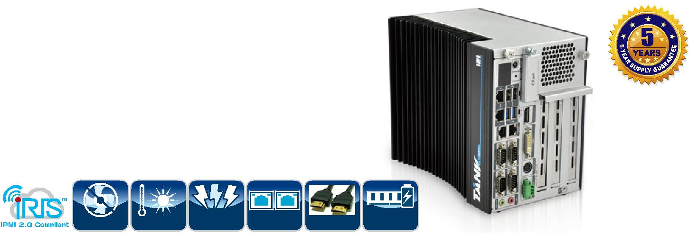

特征

● Intel® Celeron® J1900 2 GHz, 10W

● 16-bit 数字 I/O, 8-bit 输入/8-bit 输出

● 1 x DVI-I
1 x DisplayPort

● 多种扩展类型：

  - 3A : 1个 PCIe x1 + 2个 x PCI

  - 3B: 2个 PCIe x1 + 1个 x PCI

  - 3C: 3个 x PCI

- Dual DC 电源输入

Fanless -20°C~60°C | 9~36V | Dual LAN DisplayPort | 1.35V
 | DV Input |  | DDR3L

加强视觉体验
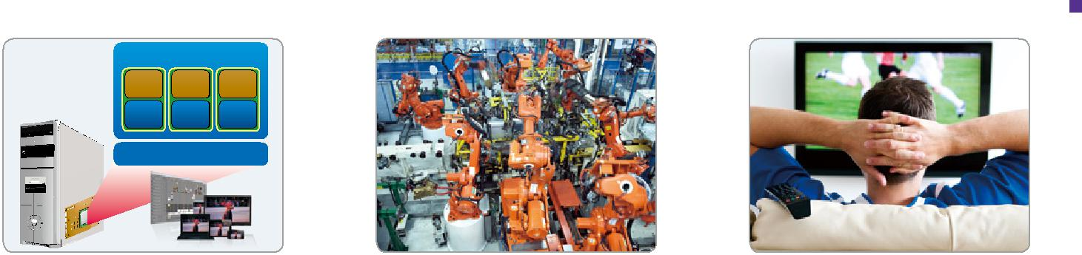

Virtual Machines

App App App

OS OS OS

Intel® VT-x

支持 Intel® Virtualization 技术 | 自动化 | Video HD Technology
 |  | Spectacular HD Playback

Intel® Bay Trail 解决方案

Intel® Bay-Trail SoC ( 系统芯片 ) 集成 CPU 和显卡。有了 Gen 7 显卡和 DX11 全高清支持，TANK-801-BT 是视觉应用的理想解决方案。

- Intel® Bay Trail 平台转换

Intel® Celeron® Processor 807E/847E/1007UE

Intel® Atom™

Processor

D2xxx/N2xxx

Key Platform Transition

SoC platform (2 chip to 1 chip)

22nm processor technology

NEW:

Quad-core CPU with Intel® Turbo Burst Technology

NEW:

Intel® Gen7 Graphics (based on 3rd generation Intel® Core™ processor with Intel® HD Graphics 4000) with HW encode support

Bay Trail SoC | Bay
 | Trail
Productivity | Up to
Workload | 2x
3D | Up to
Performance | 3x

- Intel® Bay Trail 显卡和媒体特征

3D Graphics | DX11.1, OGL 4.0, OGL ES 2.0, OVG 1.1
Video Decode
 | H.264, MPEG2, MPEG4, VC1/WMV9, VP8 up to 1080p decode
Video Encode | H.264, MPEG2

多元化的扩展接口 |  |  |  |  |  |  | 易安装
TANK-801 系列有三种不同的 PCI 和 PCIe 插槽可供扩展选择。用 |  |  |  |  |  |  | 用户通过移动 TANK-801 的顶盖可以便捷地安装 SO-DIMM，PCIe
户可以根据自己的应用选择合适的型号。 |  |  |  |  |  |  | Mini 卡 和扩展卡。顶盖上有一个 2.5" SATA HDD/SSD bay，方便
 |  |  |  |  |  |  | 用户维护系统。
Backplane |  |  | TANK-801
 |  | Slot type |  | Signal
HPE-3S6 (2P1E) |  | PCI |  | PCI
 |  | PCIe x16 |  | PCIe x1
 |  | PCI |  | PCI
HPE-3S7 (1P2E) |  | PCIe x4 |  | PCIe x1 |  |  | 2.5'' SATA 6Gb/s
 |  | PCIe x16 |  | PCIe x1
HPE-3PCI |  | PCI |  | PCI |  |  | HDD/SSD bay
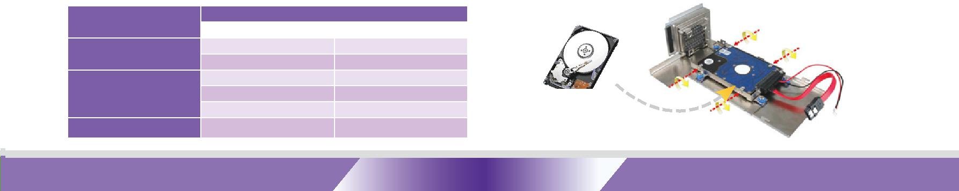

TANK-801-BT-2019-V10 ¹⁰⁻⁴⁷

工业系统
规格
型号
 | 颜色
 | 尺寸 (WxDxH) (mm)
机身 | 系统风扇
 | 材质
 | CPU
主板 | 芯片组
 | 系统内存
IPMI | iRIS 解决方案
存储 | Hard Drive
 | CF Card/CFast
 | USB 3.1 Gen 1
 | (5Gb/s)
 | USB 2.0
 | Ethernet
I/O 接口 | COM Port
 | 数字 I/O
 | 显示
 | 分辨率
 | 音频
 | Wireless
 | PCI/PCIe
扩展
 | PCIe Mini
 | 电源输入
电源
 | 功耗
 | 安装方式
 | 操作温度
 | 存储温度
可靠性 | 冲击测试
 | 振动测试
 | 重量(净重/毛重)
 | Safety/EMC
OS | 支持的 OS

订购信息

TANK-801-BT
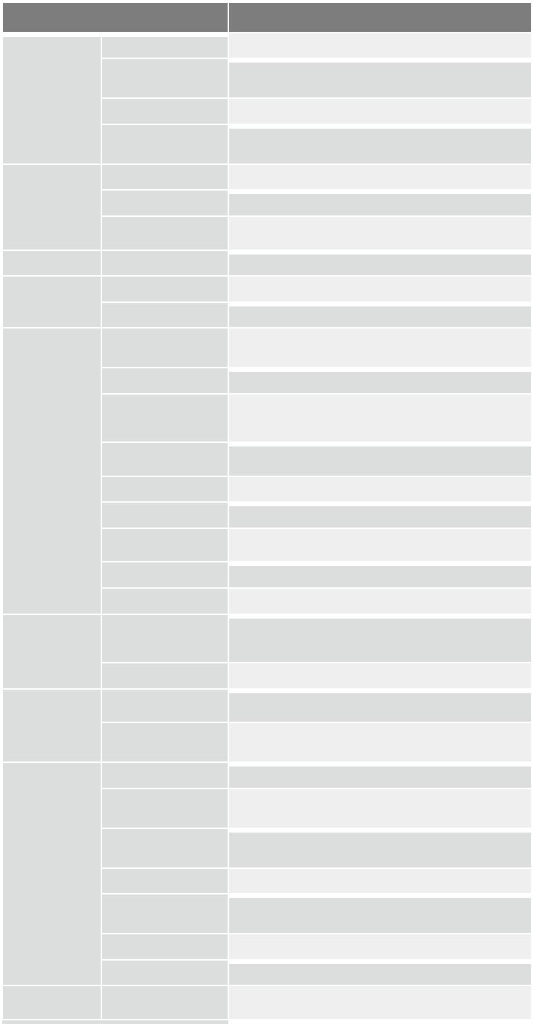

Black C + Silver

136 x 219 x 188

Fanless

Extruded aluminum alloys

Intel® Celeron® J1900 2 GHz

SoC

1 x 204-pin DDR3L SO-DIMM,

2GB pre-installed (system max: 8 GB)

1 x iRIS-2400 (optional)

1 x 2.5'' SATA 3Gb/s HDD/SSD bay

1 x CFast

2

2

2 x RJ-45

1 x PCIe GbE by Intel® I210

1 x PCIe GbE by Intel® I211

2 x RS-232 (DB-9)

2 x RS-232/422/485 (DB-9, with isolation)

16-bit digital I/O, 8-bit input/8-bit output

1 x DisplayPort, 1 x DVI-I

DisplayPort: Up to 2560 x 1600 MHz

DVI-I: Up to 2560 x 1600 MHz

1 x Line-out, 1 x Mic-in

1 x 802.11b/g/n (optional)

3A: One PCIe x1 + Two x PCI

3B: Two PCIe x1 + One x PCI

3C: Three x PCI

1 x Full-size PCIe Mini

DC Jack: 9 V~36 V DC

Terminal Block: 9 V~36 V DC

19 V@1.8 A

(Intel® Celeron® J1900 with 2 GB DDR3 memory) Wall mount
-20°C ~ 60°C with air flow (SSD)

5% ~ 95%, non-condensing

-40ºC ~ 85ºC with air flow (SSD)

5% ~ 90%, non-condensing

Half-sine wave shock 5G, 11ms, 3 shocks per axis

MIL-STD-810F 514.5C-2 (with SSD)

2.8 kg/4.3 kg

CE/FCC

Microsoft® Windows® 8 Embedded, Microsoft® Windows® Embedded Standard 7 E

w w w . i e i w o r l d . c o m

丰富的 I/O

电源开关
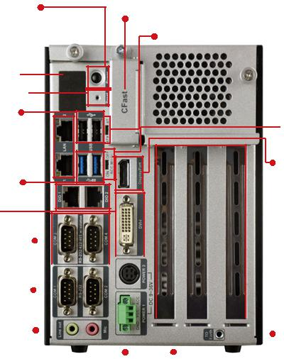
1. Long-press 2 sec. to power on
2. Long-press 5 sec. to power ^{off AT/ATX} Mode

LED

Reset

2 x USB 2.0

ACC Mode

2 x GbE LAN

DisplayPort
2 x USB 3.1

Gen 1

2 x DIO
DVI-I

2 x RS-232/ |  |  |  |  |  |  |  |  |  |  |  |  |  |  |  | 3 x Expansion
422/485 |  |  |  |  |  |  |  |  |  |  |  |  |  |  |  |  |  | Slots
2 x RS-232
Audio |  |  |  |  |  |  |  |  |  |  |  |  |  |  |  |  | To Ground
 |  |  |  |  | Power1 |  |  |  |  |  |  |  | Power2
 |  |  |  |  | (Terminal Block) |  |  |  |  |  |  |  | (DC Jack)

尺寸 (单位: mm)
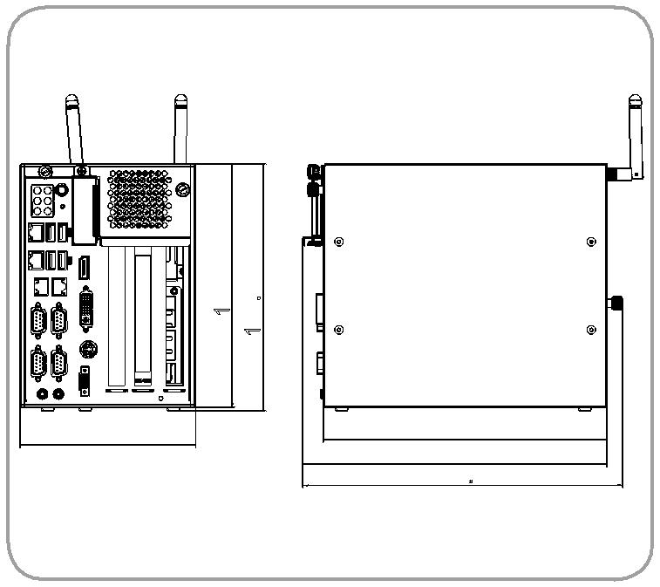

188 | 190.70
136 | 219
 | 235
247.29

TANK-801-BT

Part No.

TANK-801-BTi-J1/2G/3A-R12

TANK-801-BTi-J1/2G/3B-R12

TANK-801-BTi-J1/2G/3C-R12

Description

Fanless embedded system with two PCI and one PCIe x1 expansion, Intel® Bay-Trail J1900 2 GHz, TDP 10W, 2GB DDR3L pre-installed memory, 1 x DVI-I, 1 x DisplayPort, iRIS-2400 optional, 9 V~36 V DC, RoHs

Fanless embedded system with one PCI and two PCIe x1 expansions, Intel® Bay-Trail J1900 2 GHz, TDP 10W, 2GB DDR3L pre-installed memory, 1 x DVI-I, 1 x DisplayPort, iRIS-2400 optional, 9 V~36 V DC, RoHs

Fanless embedded system with three PCI expansion, Intel® Bay-Trail J1900 2 GHz, TDP 10W, 2 GB DDR3L pre-installed memory, 1 x DVI-I, 1 x DisplayPort, iRIS-2400 optional, 9 V~36 V DC, RoHs

可选配件

Part No. | Description
iRIS-2400-R10 | IPMI 2.0 adapter card with AST2400 BMC chip for DDR3 SO-DIMM socket interface
EMB-FAN-KIT02-R10 | Fan Module;MODIFY 31100-000272-RS;+12V DC;4PIN;40*40*15mm ;STANDARD;;FD124015LB2W3;; L= 400mm MOLEX 5051-04P
 | P=2.54;CCL;RoHS
EMB-WIFI-KIT01-R20 | 1T1R wifi module kit for embedded system, IEEE802. 1a/b/g/n/ac WiFi with Bluetooth 4.0/3.0+HS, 1 x wifi module, 2 250mm RF cable, 2 x Antenna,
 | RoHS
TPM-IN01-R20 | 20-pin INFINEON TPM Module,S/W managementTool,Firmware V4.4
TANK-801-BT-WES7E-R10 | OS Image with Windows® Embedded Standard 7 E for TANK-801 Series, CD-ROM, RoHS

包装清单
1 x Power Adapter (With PSE & ErP Certified | 1 x Chassis Screw
1 x Power Cord | 1 x Mounting Bracket

¹⁰⁻⁴⁸ TANK-801-BT-2019-V10

