

***工业系统***

***w w w . i e i w o r l d . c o m***



TANK-610-BW 无风扇嵌入式系统

*特征*

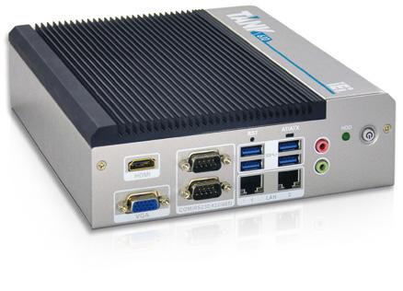

* Intel® Celeron® N3160 处理器
* 多个 COM 口： 6 个 RS-232 和 2 个 RS-232/422/485
* VGA 和 HDMI 独立双显
* mSATA 和 1 x 2.5" SATA 存储设备
* 宽温



|  |  |  |  |  |  |
| --- | --- | --- | --- | --- | --- |
|  |  | **PCIe Mini** | ***USB*** |  |  |
| **Fanless** | **-40**°**C~60**°**C** | **USB 3.1** | **Dual GbE** |  |
| **Expansion** | **Gen 1** |  |

*规格*

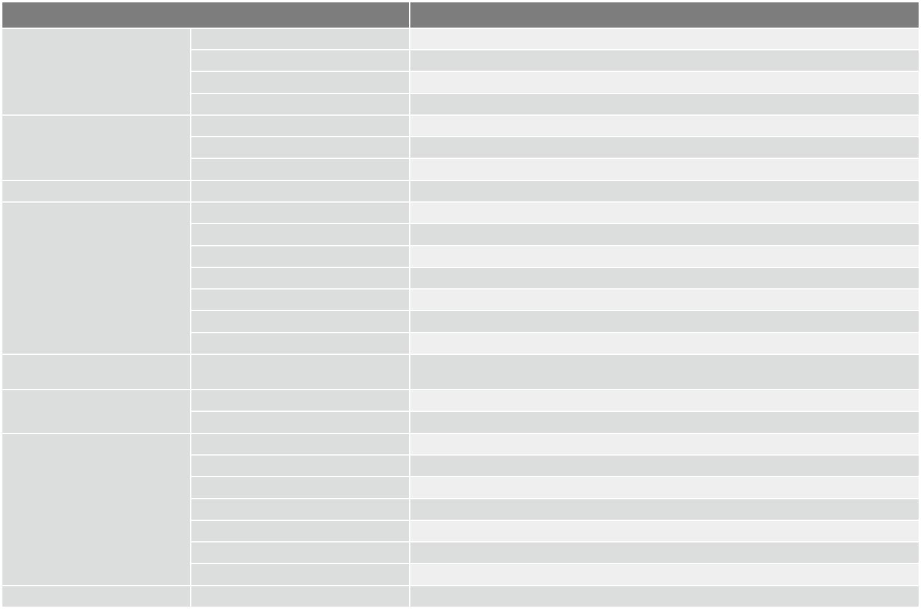

|  |  |  |  |
| --- | --- | --- | --- |
| **Model Name** |  | **TANK-610-BW** |  |
|  | 颜色 | Black C + Silver |  |
| 机身 | 尺寸 (WxDxH) (mm) | 184 x 200.6 x 58.2 |  |
| 系统风扇 | Fanless |  |
|  |  |
|  | 材质 | Extruded aluminum alloy |  |
|  | **CPU** | Intel® Celeron® N3160 processor (up to 2.24GHz, quad-core, 2MB cache, TDP=6W) |  |
| 主板 | 芯片组 | SoC |  |
|  | 系统内存 | 2 x 204-pin DDR3L SO-DIMM, one 2GB pre-installed (system max: 8 GB) |  |
| 存储 | **Hard Drive** | 1 x 2.5'' SATA 6Gb/s HDD/SSD Bay |  |
|  | **USB 3.1 Gen 1 (5Gb/s)** | 4 |  |
|  | **Ethernet** | 2 x RJ-45 PCIe GbE by Intel® I210-IT controller |  |
|  | **COM Port** | 6 x RS-232, 2 x RS-232/422/485 |  |
| I/O 接口 | 显示 | 1 x VGA, 1 x HDMI |  |
|  | 分辨率 | VGA: Up to 1920 x 1200@60HZ, HDMI: Up to 3840 x 2160@30Hz |  |
|  | 音频 | 1 x Line-out, 1 x Mic-in |  |
|  | **Wireless** | 1 x 802.11 b/g/n (optional) |  |
| 扩展 | **PCIe Mini** | 1 x Full-size PCIe Mini (support mSATA, co-lay SATA, w/o USB Signal), |  |
| 1 x Half-size PCIe Mini |  |
|  |  |  |
| 电源 | 电源输入 | DC Jack: 9 V~36 V DC |  |
| 功耗 | 12 V@1.49 A (Intel® Celeron® N3160 with 4 GB DDR3L memory) |  |
|  |  |
|  | 安装方式 | Wall mount, VESA 100 |  |
|  | 操作温度 | -40°C ~ 60°C with air flow (SSD), 10% ~ 95%, non-condensin |  |
|  | 存储温度 | -40°C ~ 80°C |  |
| 可靠性 | 冲击测试 | Half-sine wave shock 5G, 11ms, 100 shocks per axis |  |
|  | 振动测试 | MIL-STD-810G 514.6C-1 (with SSD) |  |
|  | 重量(净重/毛重) | 2.2 kg/3 kg |  |
|  | **Safety/EMC** | CE/FCC |  |
| **OS** | 支持的 OS | Microsoft® Windows 8 Embedded, Microsoft® Windows® Embedded Standard 7 E |  |

*各种应用*

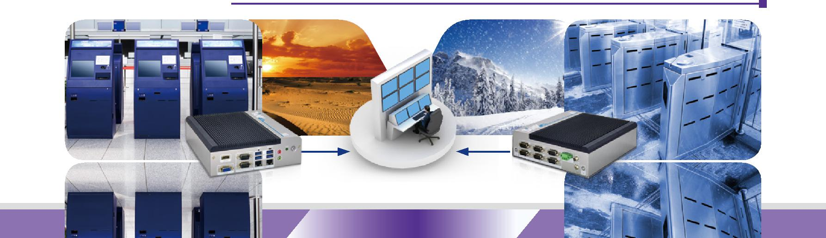

3 x Kiosk 控制中心 3 x AFC

**10-54** **TANK-610-BW-2019-V10**



|  |  |  |  |  |  |  |  |  |  |  |  |  |  |  |  |  |  |  |  |  |  |  |
| --- | --- | --- | --- | --- | --- | --- | --- | --- | --- | --- | --- | --- | --- | --- | --- | --- | --- | --- | --- | --- | --- | --- |
| ***工业系统*** | |  |  |  |  |  |  |  |  |  |  |  |  |  | ***w w w . i e i w o r l d . c o m*** | | | | | | |  |
|  |  |  |  |  |  |  |  |  |  |  |  |  |  |  |  |
| *丰富的 I/O* | |  |  |  |  |  |  |  |  |  |  |  |  |  |  |  |  |  |  |  |  |  |
|  |  |  |  |  |  |  |  |  |  |  |  |  |  |  |  |  |  |  |  |  |
| *正视图* | |  |  |  |  |  |  |  |  |  |  | *后视图* | | |  |  |  |  |  |  |  |  |
|  |  |  |  |  | AT/ATX Mode | | | | | | |  |  |  |  |  |  |  |  |  |  |  |
| HDMI | |  | Reset | |  |  |  |  |  | Power Switch | |  |  | Terminal Block: |  |  |  | DC Jack: | | | |  |
|  |  |  |  |  |  |  |  |  |  |  |  |
|  |  |  |  |  |  |  |  |  |  |  |  |  |  | 9 V~36 V |  |  |  | 9 V~36 V | | | |  |
|  |  |  |  |  |  |  |  |  |  |  |  |  |  |  |  |
|  |  |  |  |  |  |  |  |  |  |  |  |  |
|  |  |  |  |  |  |  |  |  |  |  |  |  |  |  |  |  |  |  |  |  |  |  |
|  |  |  |  |  |  |  |  |  |  |  |  |  |  |  |  |  |  |  |  |  |  |  |
|  |  |  |  |  |  |  |  |  |  |  |  |  |  |  |  |  |  |  |  |  |  |  |
|  |  |  |  |  |  |  |  |  |  |  |  |  |  |  |  |  |  |  |  |  |  |  |
|  |  |  |  |  |  |  |  |  |  |  |  |  |  |  |  |  |  |  |  |  |  |  |
|  |  |  |  |  |  |  |  |  |  |  |  |  |  |  |  |  |  |  |  |  |  |  |
|  |  |  |  |  |  |  |  |  |  |  |  |  |  |  |  |  |  |  |  |  |  |  |
|  |  |  |  |  |  |  |  |  |  |  |  |  |  |  |  |  |  |  |  |  |  |  |

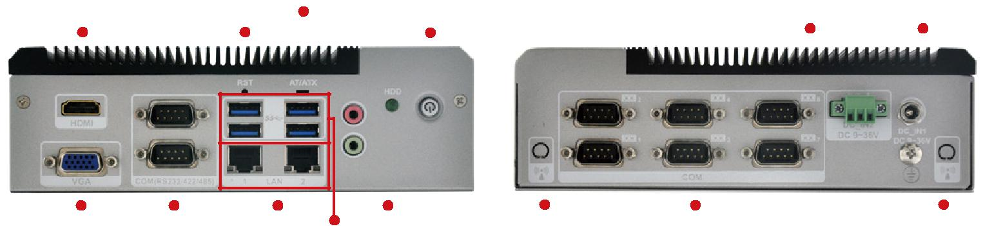

|  |  |  |  |  |  |  |
| --- | --- | --- | --- | --- | --- | --- |
| VGA | 2 x RS-232/422/485 | 2 x LAN | Audio | Wi-Fi | 6 x RS-232 | Wi-Fi |
|  |  | 4 x USB 3.1 Gen 1 | |  |  |  |

*尺寸 ( 单位：mm)*

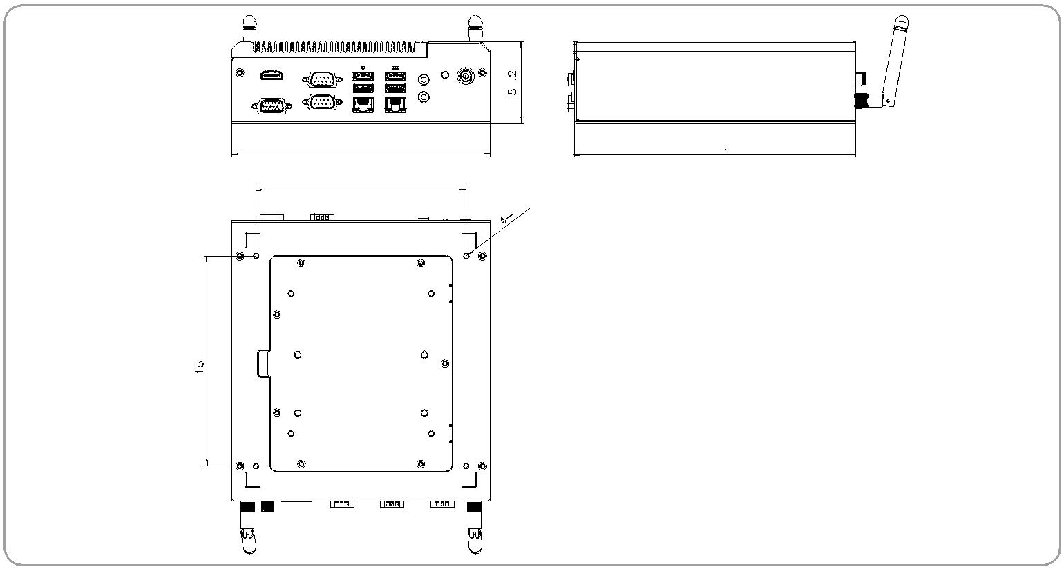

|  |  |
| --- | --- |
|  | 58.2 |
| 184 | 200.5 |
| 150 |  |

|  |
| --- |
| 150 |

*TANK-610-BW*

***订购信息***



|  |  |  |
| --- | --- | --- |
| **Part No.** | **Description** |  |
|  |  |  |
| **TANK-610-BW-N3/2G-R10** | Fanless wide temperature embedded system with Intel® Celeron® N3160 1.6GHz, (up to 2.24 GHz, quad-core, TDP 6W), 2GB DDR3L pre-installed |  |
| memory, 9 V~36 V DC, with RS-232/422/485, USB 3.1 Gen 1 (5Gb/s), VGA/HDMI, dual Intel® PCIe GbE, RoHS |  |
|  |  |
|  |  |  |

***可选配件***



|  |  |  |
| --- | --- | --- |
| **Part No.** | **Description** |  |
| **AFLWK-19** | VESA 100 mount kit |  |
| **EMB-WIFI-KIT11-R20** | 1T1R wifi module kit for embedded system, IEEE802. 1a/b/g/n/ac WiFi with Bluetooth 4.0/3.0+HS, 1 x wifi module, 2 x 350mm RF cable, 2 x Antenna, |  |
| RoHS |  |
|  |  |
| **TANK-610-BW-WES7E64-R10** | OS Image with Windows® Embedded Standard 7 E 64-bit for TANK-610 BW Series, with DVD-ROM, RoHS, R10 |  |
| **DK-100-R10** | VESA 100 to DIN-Rail mounting kit |  |

***包装清单***

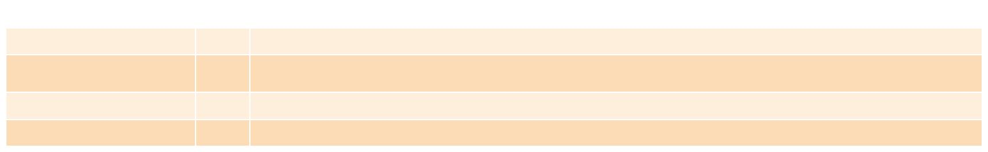

|  |  |  |  |
| --- | --- | --- | --- |
| **Item** | **Qty** | **Description** |  |
| **Power cord** | 1 | 1500 mm, European Standard |  |
| **Power adapter** | 1 | FSP065-REBN2, 90 V~264 V AC input, 65 W, 19 V DC output, ErP |  |
| **(Meet PSE & ErP)** |  |
|  |  |  |
| **Wall mount bracket** | 1 | Wall mount bracket/holder |  |
| **Screw set** | 1 |  |  |



**TANK-610-BW-2019-V10** **10-55**



***工业系统***

***w w w . i e i w o r l d . c o m***



DIN-Rail Embedded System

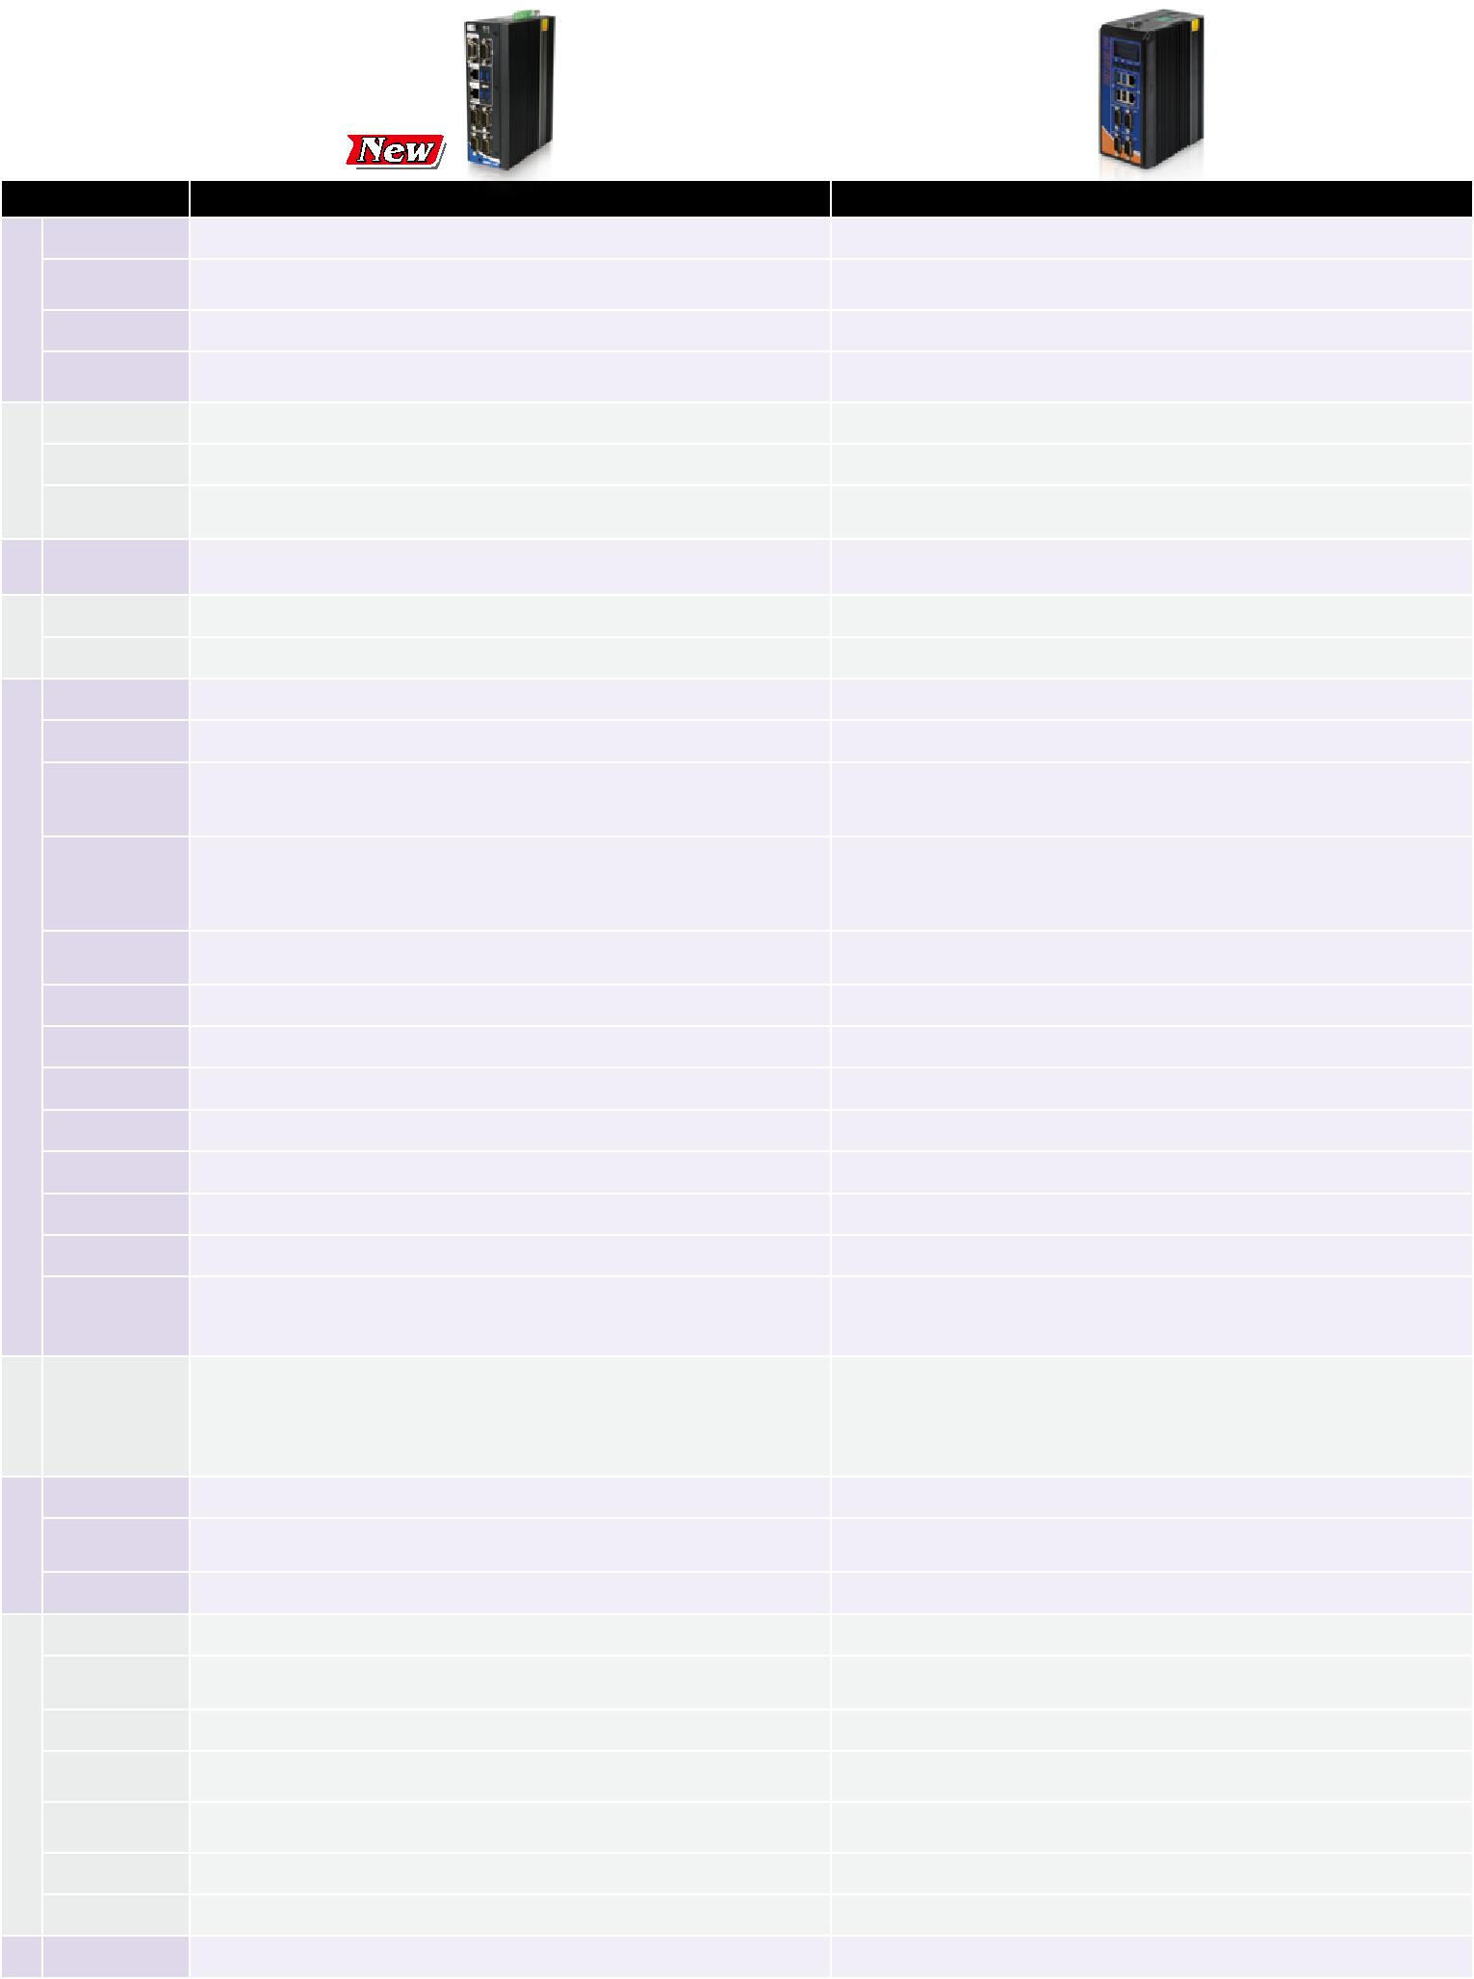

**Model Name**

身 颜色

机 尺寸

(WxDxH) (mm)

系统风扇

材质

板

* **CPU**

芯片组

系统内存

**IPMI** 储 iRIS 解决方案

存

**Hard Drive**

**eMMC**

**USB 3.1 Gen 1**

**USB 2.0**

**Ethernet**

**COM Port**

|  |  |  |
| --- | --- | --- |
| I/O | 口 |  |
| 接 |  |
|  |  |

**数字 I/O**

**CAN-bus**

显示

分辨率

**SIM**

音频

**Wireless**

**TPM**

**其他**

展

扩

**PCIe Mini**

源 电源输入

电

功耗

**Remote PWR**

安装方式

性 操作温度

靠

可

冲击测试

振动测试

重量

(净重/毛重)

**Safety/EMC Watchdog Timer OS 支持的操作系统**

|  |  |  |  |
| --- | --- | --- | --- |
| **DRPC-130-AL** | | **DRPC-120-BT** |  |
|  | Black | Black |  |
| 58.75 x 130 x 174 | | 74.08 x 140 x 171.5 |  |
|  | Fanless | Fanless |  |
| Extruded aluminum alloys | | Extruded aluminum alloys |  |
| Intel® Atom™ x5-E3930 1.3GHz (up to 1.8 GHz, dual core, TDP=6.5W) | | Intel® Atom™ E3845 1.91 GHz |  |
|  | SoC | SoC |  |
| 1x 204-pin DDR3L SO-DIMM slot (system max. 8 GB) | | 1 x 204-pin DDR3L SO-DIMM 2 GB pre-installed (system max: 8GB) |  |
| (DRPC-130-AL-E1/4GB SKU is pre-installed with 4 GB memory) | |  |
|  |  |
|  | N/A | 1 x iRIS-2400 (optional) |  |
| 1 x 2.5’’ SATA 6Gb/s HDD/SSD bay | | 1 x 2.5'' SATA 3Gb/s HDD/SSD bay |  |
| 1 x eMMC 5.0 support (up to 32GB, optional) | | N/A |  |
|  | 4 | 2 |  |
| 1 by pin header | | 2 |  |
|  | 2 x RJ-45 | 2 x RJ-45 |  |
|  | 1 x PCIe GbE by Intel® I210 controller |  |
| PCIe GbE by Intel® I211 controller | |  |
| 1 x PCIe GbE by Intel® I211 controller |  |
|  |  |  |
|  |  | 2 x RS-232 |  |
| 4 x RS-232/422/485 (DB-9) | | (DB-9 w/ 3kV isol ation protection*) |  |
| 2 x RS-422/485 |  |
|  |  |  |
|  |  | (DB-9 w/ 3kV isolation protection*) |  |
| 8-bit digital I/O, | | 8-bit digital I/O, |  |
| 4-bit input/4-bit output (DB-9) | | 4-bit input/4-bit output |  |
| 1 x DB-9 w/ 2.5kV Isolation protection, supporting 2-port CAN-bus | | N/A |  |
| 2 x HDMI 1.4b | | 1 x VGA, 1 x HDMI |  |
| Up to 3840 x 2160@30Hz | | Up to 1920 x 1200 @ 60Hz |  |
| 1 x Internal on-board SIM slot (optional) | | N/A |  |
|  | N/A | N/A |  |
| 1 x 802.11a/b/g/n/ac (optional) | | 1 x 802.11a/b/g/n/ac (optional) |  |
| 1 x TPM 2.0 (2x10 pin) (optional) | | N/A |  |
| 1 x Power Button | 1 x LED for HDD (Yellow) |  |  |
| 1 x Reset Button | 1 x LED for Power (Green) | N/A |  |
| 1 x AT/ATX Switch | |  |  |
| 1 x Half-size PCIe Mini slot | | 1 x Half-size PCIe Mini slot |  |
| (w/o USB signal) |  |
| 1 x Full-size PCIe Mini slot (supports mSATA, colay with SATA) | | 1 x Full-size PCIe Mini slot |  |
|  |  | (supports mSATA, colay with SATA) |  |
| 3-pin terminal block: 12 V ~ 24 V DC | | 3-pin terminal block: 9 V ~ 30 V DC |  |
| 12V @ 2.88 A | | 12 V@ 2.1 A |  |
| (Intel® Atom™ x5-E3930 CPU with 4GB 1600 MHz DDR3L memory) | | (Intel® Atom™ E3845 with 2 GB memory) |  |
| PSON 2-pin terminal block | | N/A |  |
| DIN-rail / Wall mounting | | DIN-rail |  |
| -20°C ~ 60°C with air flow (SSD), | | -20ºC ~ 60ºC with air flow (mS TA), |  |
| 10% ~ 95%, non-condensing | | 5% ~ 95%, non-condensing |  |
| Half-sine wave shock 5G, 11ms, 100 shocks per axis, IEC68-2-27 | | Half-sine wave shock 5G, 11ms, 3 shocks per axis |  |
| MIL-STD-810G 514.6C-1 (SSD) | | MIL-STD-810F 514.5C-2 (with SSD) |  |
|  | 1.4Kg/2.5Kg | 1.4 kg/2.5 kg |  |
|  | CE/FCC | CE/FCC |  |
| Programmable 1~255 sec/min | | N/A |  |
| Microsoft® Windows 10 / Linux | | Microsoft® 8, Microsoft® Windows® Embedded Standard 7 E |  |



**10-56** **DIN导轨安装嵌入式系统-2019-V10**