单板电脑
嵌入式主板

w w w . i e i w o r l d . c o m

NANO-QM770

EPIC SBC Supports 插槽G2 for Intel® 22nm Mobile CPU, DVI-I/Dual HDMI/LVDS, Dual PCIe GbE, USB 3.0, PCIe Mini, SATA 6Gb/s and Audio

12V DC输入 |  |  |  |  |  |  | SATA 6Gb/s
 |  |  |  |  |  |  |  |  |  |  |  |  |  | 前面板l
 |  |  |  |  |  |  |  |  |  |  |  |  |  |  |  |  |  |  |  |  |  |  |  | KB/MS
 |  |  |  | Socket G2 |  |  |  |  |  |  |  |  |  |  |  |  |  |  |  |  |  |  |  | DIO
 |  |  |  | PGA988B |  |  | QM77 |  |  |  |  |  |  |  |  |  |  |  |  |  |  |  |  | 2 x RS-232
 |  |  |  |  |  |  |  |  |  |  |  |  |  |  |  |  |  |  |  |  |  |  |  | 2 x USB 2.0
 |  |  |  |  |  |  |  |  |  |  |  |  |  |  |  |  |  |  |  |  |  |  |  | RS-422/485
 |  |  |  |  |  |  |  |  |  |  |  |  |  |  |  |  |  |  |  |  |  |  |  | TPM
 |  |  |  |  |  |  |  |  |  |  |  |  |  |  |  |  |  |  |  |  |  |  |  | SMBus
 |  |  |  |  |  |  |  |  |  |  |  |  |  |  |  |  |  |  |  |  |  |  |  | Audio I/F
PCIe 迷你 |  |  |  | DDR3 SO-DIMM |  |  |  |  |  |  |  |  |  |  |  |  |  |  |  |  |  |  |  |  |  |  |  |  |  |  |  | TPM 1.2 Support
卡插槽 |  |  |  | 支持高达 8 GB |  |  |  | LVDS Inverter
 |  |  |  |  |  |  |  |  |  |  |  |  |  |  | LAN2: PHY 支持 Intel® AMT 8.0
 | Solder side
 |  |  |  |  |  | 4 x USB 3.1 Gen 1 |  |  |  |  |  |  |  |  |  |  |  |  |  |  |  |  |  | LAN1 HDMI DVI-I (DVI+VGA)
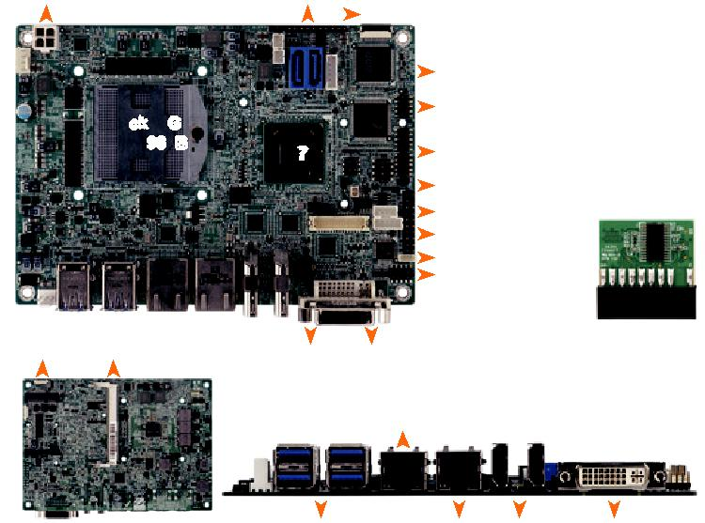

产品特征

● EPIC SBC 支持G2-插槽 Intel® 22nm 移动处理器
● 三个独立显示器支持双 HDMI+DVI/双 HDMI+LVDS (兼容HDMI V1.3a)
● 1066/1333/1600 MHz DDR3 SDRAM 支持高达 8 GB
● 支持三个 COM, 四个 USB 3.0, 两个 SATA 6Gb/s 以及音频
● Intel® GbE LAN 支持 Intel® AMT 8.0

NANO-HM651
EPIC SBC with on-board Intel® Celeron® Dual Core 847E 1.1GHz CPU, Dual HDMI/ VGA/ LVDS, Dual GbE, USB 3.1 Gen 1 (5Gb/s), PCIe Mini, SATA 6Gb/s and Audio
 |  |  | 双通道 DDR3 |  |  |  |  |  |  |  |  |  |  | PCIe迷你卡插槽
 | SO-DIMM 1333/1066 MHz (compatible with mSATA)
12V DC 输入 |  |  |  |  |  |  |  | 前面板 |  |  |  |  | SATA 6Gb/s 5V SATA power
 |  |  |  |  |  |  |  |  |  |  |  |  |  |  |  |  |  |  |  |  |  |  |  |  |  |  |  |  |  |  |  |  |  |  |  |  |  | Inverter
 |  |  |  |  |  |  |  |  |  |  |  |  |  |  |  |  |  |  |  |  |  |  |  |  |  |  |  |  |  |  |  |  |  |  |  |  |  | LVDS
 |  |  |  |  |  |  |  |  |  |  |  |  |  |  |  |  |  |  |  |  |  |  |  |  |  |  |  |  |  |  |  |  |  |  |  |  |  | 2 x RS-232
 |  |  |  |  |  |  |  |  |  |  |  |  |  |  |  |  |  |  |  |  |  |  |  |  |  |  |  |  |  |  |  |  |  |  |  |  |  | DIO
 |  |  |  |  |  |  |  |  |  |  |  |  |  |  |  |  |  |  |  |  |  |  |  |  |  |  |  |  |  |  |  |  |  |  |  |  |  | RS-422/485 |  |  |  |  |  | 2 x USB 2.0
 |  |  |  |  |  |  |  |  |  |  |  |  |  |  |  |  |  |  |  |  |  |  |  |  |  |  |  |  |  |  |  |  |  |  |  |  |  | 2 x USB 2.0
 |  |  |  |  |  |  |  |  |  |  |  |  |  |  |  |  |  |  |  |  |  |  |  |  |  |  |  |  |  |  |  |  |  |  |  |  |  | VGA |  |  |  | Dual LAN |  |  |  |  |  |  |  | 2 x HDMI
PS/2 KB/MS |  |  |  |  |  |  |  |  |  |  |  |  |  |  |  |  |  |  |  |  |  |  |  |  | Audio I/F |  |  |  |  |  |  |  |  |  |  |  |  |  |  |  |  |  |  |  | 2 x USB 3.1 Gen 1
 |  |  |  |  |  |  |  |  |  |  |  |  |  | DDR3
 |  |  |  |  |  |  |  |  |  |  |  | 1333 |  |  |  |  |  |  |  |  |  |  |  |  |  |  | Fanless |  |  |  |  |  |  |  |  |  |  |  |  |  | PCIe GbE |  |  |  |  |  |  | Heat Spreader
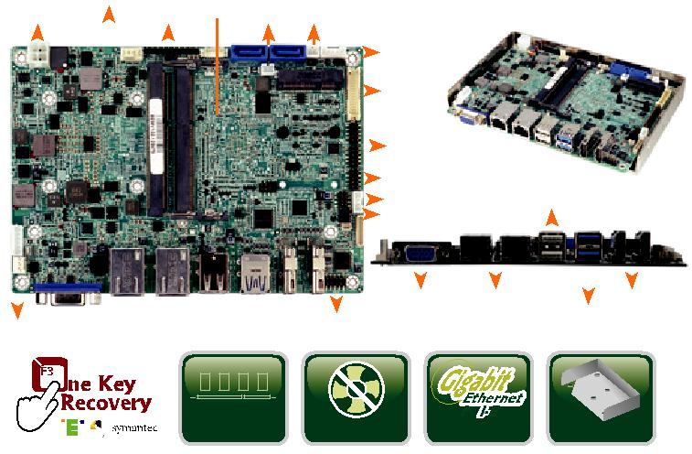

产品特征

- EPIC SBC 支持板载移动 32nm Intel® Celeron® 双核 847E 1.1GHz 处理器

- 支持双 HDMI/VGA 以及双显示器

- 双通道 204-pin 1333/1066 MHz DDR3 SO-DIMMs 最大支持 8 GB

- 易于装配的散热片的散热设计

- 支持三个 COM, 四个 USB 3.0, 两个 SATA 6Gb/s 和音频

- IEI 一键恢复解决方案可快速创建 OS 备份以及恢复

● IEI 一键恢复解决方案可快速创建 OS 备份以及恢复

产品规格

产品规格

CPU
1.1GHz Intel® Celeron® 847E 双核处理器

processor

外部I/O Interface
2 x USB 2.0

2 x USB 3.1 Gen 1 (5Gb/s)

CPU
ocket G2 第三代 22nm Intel® 移动处理器

芯片组: Intel® QM77
BIOS: UEFI BIOS
内存
一个 204-pin 1600/1333 MHz 单通道 DDR3 & DDR3L SDRAM 无缓冲 SO-DIMM slot 支持高达 8 GB
显卡
ntel® HD 显卡 Gen 7 with 12 execution units DirectX 11, OpenGL 3.1, OpenCL 1.1
显示输出
1 x DVI-I (up to 2048x1536@75Hz)
1 x 18/24-bit 双通道 LVDS (最高
1920x1200@60Hz)

2 x HDMI (最高 1920x1200@60Hz)
以太网
LAN1: Intel® 82583V PCIe 控制器

LAN2: Intel® 82579 PHY 支持 Intel® AMT 8.0

外部 I/O 接口: 4 x USB 3.1 Gen 1 (5Gb/s)
内部 I/O I接口
1 x KB/MS (1x6 pin)

2 x USB 2.0 (2x4 pin, P=2.54)

1 x RS-422/485 (1x4 pin, P=2.0)

2 x RS-232 (2x5 pin, P=2.0)

2 x SATA 6Gb/s with 5V SATA电源接口 (支持RAID

0,1 )

TPM: 1 x TPM (2x10 pin)
音频
Realtek ALC662 HD 解码器
1 x前置音频(2x5 pin)
前面版

1 x前面板(1x10 pin)
扩展

1×全长PCIe 迷你卡插槽 (支持 mSATA)

看门狗定时器
软件可编程支持 1~255 秒系统复位

可编程 I/O: 8-bit 数字 I/O
风扇接口
1 x CPU智能风扇 (1x4 pin)
1 x 系统风扇(1x3 pin)
电源
12V only DC 输入

1 x 内置电源接口 (2x2 pin) 支持 AT/ATX 模式功耗
12V@4.89A (Intel® 1.8GHz CPU with one 1333 MHz 4 GB DDR3 SO-DIMM)
操作温度: -10°C ~ 60°C
存储温度: -20°C ~ 70°C
工作湿度: 5% ~ 95%, 无冷凝
尺寸： 115 mm x 165 mm 重量: GW: 850g / NW: 350g CE/FCC compliant

芯片组
Intel® HM65

BIOS
UEFI BIOS

Memory
wo 204-pin 1333/1066 MHz 双通道 DDR3 SO-DIMMs 最高支持 16 GB
显卡
Intel® HD 显卡 Gen 6 supports DX10.1 and OpenGL 3.0
Full MPEG-2, VC1, AVC Decode

显示输出
1 x VGA (高达 2048x1536@75Hz)
1 x 18/24-bit 双通道 LVDS (高达
1920x1200@60Hz)

2 x HDMI (高达 1920x1200@60Hz)

以太网
双网络: Realtek RTL8111E PCIe GbE 控制器支

- ASF 2.0

音频
Realtek ALC662 HD 音频解码器
1 x 前面板音频 (2x5 pin)

前面板
1 x 前面板 (1x10 pin)

扩展
1 x 全长

PCIe 迷你卡插槽 ( (supports mSATA)
数字 I/O

内部 I/O 接口
1 x KB/MS (1x6 pin)

1 x RS-422/485 (1x4 pin, P=2.0)

2 x RS-232 (2x5 pin, P=2.0)

2 x USB 2.0 (2x4 pin, P=2.0)

2 x SATA 6Gb/s with 5V SATA 电源接口 (支持 RAID 0,1 )

看门狗定时器
软件可编程支持 1~255 秒系统复位

风扇接口
1 x CPU 风扇 (1x4 pin)

1 x 系统风扇 (1x4 pin)

电源
- 12V DC 输入
1 x 内置电源接口 (2x2 pin)
支持 AT/ATX 模式

功耗

12V@1.88A (Intel® Celeron® with two 1333 MHz 4 GB DDR3 SO-DIMM)
操作温度

-10°C ~ 60°C

存储温度
-20°C ~ 70°C

工作湿度
5% ~ 95%, 无冷凝

尺寸

115 mm x 165 mm

包装清单

8-bit 数字 I/O (2x5 pin)

重量
GW: 850g / NW: 350g

CE/FCC compliant

1 x NANO-QM770 single board computer
1 x Audio cable | 2 x SATA with power cable kit
1 x Power cable | 1 x Mini jumper pack
2 x RS-232 cable | 1 x QIG

订购信息

Part No. | Description
 | EPIC SBC supports Socket G2 for Intel® 22nm mobile CPU,
NANO-QM770-R10 | DVI-I/dual HDMI/LVDS, dual PCIe GbE, PCIe Mini, USB 3.1
 | Gen 1 (5Gb/s), SATA 6Gb/s and Audio
32000-023800-RS | PS/2 KB/MS cable, 135mm/110mm, P=2.0
32000-044300-RS | Dual port USB cable, 210mm, P=2.54
32205-003800-300-RS | RS-422/485 cable, 200mm, P=2.0
CF-989A-RS-R12 | CPU cooler for mobile socket-G (PGA988) up to 55W
 | processor, copper, 60 x 60 x 27.6mm, RoHS
TPM-IN01-R20 | 20-pin Infineon TPM module, software management tool,
 | firmware v3.17

包装清单

1 x NANO-HM651 single board computer
1 x Audio cable | 2 x RS-232 cable
1 x Power cable | 1 x Heat spreader
1 x SATA with power cable kit | 1 x Mini jumper pack
2 x Plastic shaft for securing half-size PCIe Mini card | 1 x QIG

订购信息

Part No. | Description
 | EPIC SBC supports Intel® Celeron® dual core 847E 1.1GHz
NANO-HM651-847E-R10 | CPU, dual HDMI/VGA/LVDS, dual GbE, PCIe Mini, USB 3.1
 | Gen 1 (5Gb/s), SATA 6Gb/s and Audio
32001-008600-200-RS | Dual-port USB cable, 210mm, P=2.0

NANO-QM770-2019-V10 ⁸⁻⁹⁵

