单板电脑
嵌入式主板

NANO-SE-i1/KBN-i1

EPIC SBC supports AMD® Embedded G-Series SoC with VGA/HDMI/LVDS, Dual PCIe GbE, USB 3.0, PCIe Mini, SATA 6Gb/s, mSATA, COM, iRIS-1010 and RoHS
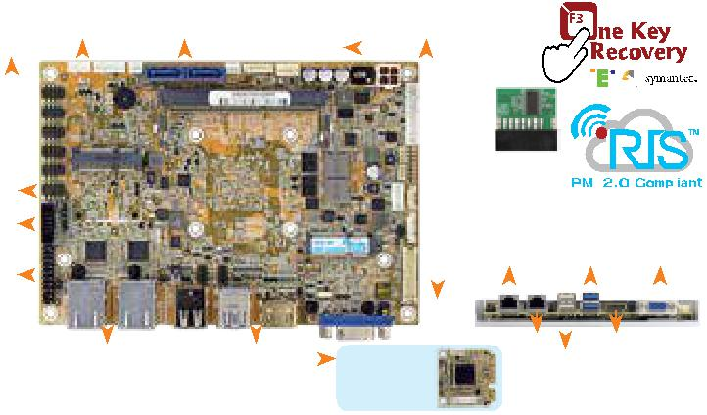

 |  |  |  |  |  |  |  |  |  |  |  |  |  |  | 单通道 DDR3 1600/1333 MHz
 |  |  |  |  | RS-422/485 SATA 6Gb/s |  |  |  |  |  |  |  |  |  |  |  |  |  |  |  |  |  |  |  |  |  |  | 前面板
5 x RS-232 |  |  |  |  |  |  |  |  |  |  |  |  |  |  |  |  |  | 12V 电源输入 |  |  |  |  |  |  |  |  |  |  |  |  |  |  | 支持TPM
DIO |  |  |  |  |  |  |  |  |  |  |  |  |  |  |  |  |  |  |  |  |  |  | 1.2
音频 |  |  |  |  |  |  |  |  |  |  |  |  |  |  |  |  |  |  |  |  |  |  |  |  |  |  |  |  |  |  |  |  | Combo RJ-45: |  | 2 x USB 3.0 VGA
TPM |  |  |  |  |  |  |  |  |  |  |  |  |  |  |  |  |  |  |  |  |  |  |  |  |  |  |  |  |  |  |  |  | LAN1 / IPMI
 |  |  |  |  |  |  |  |  |  |  |  |  |  |  |  |  |  |  |  |  |  |  |  |  |  |  |  |  |  | LVDS
 |  |  |  |  |  |  |  |  |  |  |  |  |  |  |  |  |  |  |  |  |  |  |  |  |  |  |  |  |  |  |  |  |  | LAN2 |  |  |  |  | HDMI
 |  | PCIe Mini (支持 mSATA) |  |  |  |  |  |  |  |  |  |  |  |  | 4 x USB 2.0
 |  |  |  |  |  |  |  |  |  |  |  |  |  |  |  |  |  |  |  |  |  |  |  |  |  |  |  |  |  |  |  |  |  | 2 x USB 2.0
产品规格 |  |  |  |  |  |  |  |  |  |  |  |  |  |  |  |  |  |  |  |  |  |  | Slot for iRIS-
 |  |  |  |  |  |  |  |  |  |  |  |  |  |  |  |  |  |  |  |  |  |  | 1010 module

w w w . i e i w o r l d . c o m . c n

NANO-QM871-i1

EPIC SBC supports 4th Generation Intel® Mobile Processor with VGA/ Dual HDMI/LVDS, Dual PCIe GbE, USB 3.0, PCIe Mini, iRIS-1010
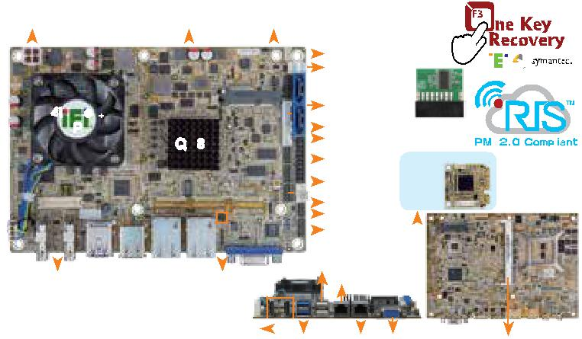

12V DC 输入 |  |  | PCIe 迷你卡插槽
 |  |  | (compatible with mSATA) |  |  | 前面板
 |  |  |  |  |  |  |  |  |  |  |  |  | SMBus
 |  |  |  |  |  |  |  |  |  |  |  |  | 5V SATA power
 | 4th Gen. |  |  |  |  |  |  |  |  |  |  |  | 2 x SATA 6Gb/s
 |  | CPU |  |  |  |  |  |  |  |  |  |  | KB/MS | 支持 TPM
 |  |  | QM87 |  |  |  |  |  |  |  |  |  | RS-422/485 | 1.2
 |  |  |  |  |  |  |  |  |  |  |  |  | TPM | Slot for iRIS-
 |  |  |  |  |  |  |  |  |  |  |  |  | 2 x RS-232 | 1010 module
 |  |  |  |  |  |  |  |  |  |  |  |  |  |  |  |  |  |  |  |  |  |  | Solder Side
 |  |  |  |  |  |  |  |  |  |  |  |  | DIO
 |  |  |  |  |  |  |  |  |  |  |  |  | 2 x USB 2.0
 |  |  |  |  |  |  |  |  |  |  |  |  | Audio I/F
 |  |  |  |  |  |  |  | 2 x USB 2.0
 | LVDS |  |  | 2 x LAN LED |  |  |  |  |  |  |  |  | LAN2 / IPMI

1

工业电脑

解决方案

SoC
- AMD® 嵌入式 G-系列 "Steppe Eagle" SoC GX-424CC 板载 Soc (2.4GHz, 四核, 2MB 缓存, TDP=25W)
GX-412HC 板载 Soc (1.2GHz, 四核, 2MB 缓存, TDP=7W)
GX-212JC 板载 Soc (1.2GHz, 双核, 1MB 缓存, TDP=6W)
GX-411GA 板载 Soc (1.0GHz, 四核, 2MB 缓存, TDP=15W)
GX-209HA 板载 Soc (1.0GHz, 双核, 1MB 缓存, TDP=9W)
- AMD® 嵌入式 G-系列 "eKabini" SoC GX-415GA 板载 Soc (1.5GHz, 四核, 2MB 缓存, TDP=15W)
GX-210HA 板载 Soc (1.0GHz, 双核, 1MB 缓存, TDP=9W)
GX-420CA 板载 Soc (2.0GHz, 四核, 2MB 缓存, TDP=25W)
GX-217GA 板载 Soc (1.65GHz, 双核, 1MB 缓存, TDP=15W)
- AMD® 嵌入式 G-系列 "LX" SoC GX-218GL 板载 Soc (1.8GHz, 双核, 1MB 缓存, TDP=15W)
GX-215GL 板载 Soc (1.5GHz, 双核, 1MB 缓存, TDP=15W)
GX-210KL 板载 Soc (1.5GHz, 双核, 1MB 缓存,
TDP=4.5W)
BIOS: AMI UEFI BIOS
内存: 一个 204-pin 1600/1333 MHz 单通道 DDR3
- DDR3L SDRAM 无缓冲 SO-DIMM 插槽，支持高达 8 GB
图形引擎
支持 DX11.1, OpenGL 4.1 and OpenCL1.2 UVD4.2 decode for H.264, MPEG2/4, VC1, MVC VCE 2.0 encode for H.264, VCE
显示输出

独立双显
1 x VGA (分辨率最高达 2048x1536@60Hz)
1 x HDMI (高达 3840x2160@60Hz)
1 x 18/24-bit 双通道 LVDS (高达 1920x1200@60Hz)

LAN LED: 2 x LAN LED (1x2 pin)
以太网

包装清单

LAN1: Intel® I210-AT PCIe 控制器支持 NCSI
LAN2: Intel® I211-AT PCIe 控制器
外部 I/O 接口
2 x USB 2.0 2 x USB 3.0 内部 I/O 接口
1 x KB/MS (1x6 pin)
4 x USB 2.0 (2x4 pin, P=2.0)
1 x RS-422/485 (1x4 pin, P=2.0)
5 x RS-232 (2x5 pin, P=2.0)
2 x SATA 6Gb/s with 5V SATA 电源接口 (不支持RAID)
iRIS 远程管理模块
1 x iRIS-1010 插槽 (NANO-GLX-2101-R10 support by request)
TPM: 1 x TPM (2x10 pin)
SMBus: 1 x SMBus (1x4 pin)
I²C: 1 x I²C (1x4 pin)
音频
Realtek ALC892 HD 音频解码器
1 x 前面板音频 (2x5 pin)

1 x S/PDIF (1x4 pin)
前面板
1 x 电源 LED & HDD LED (1x6 pin)
1 x 电源按键 (1x2 pin)
1 x 复位按键 (1x2 pin)
扩展: 1×全长PCIe 迷你卡插槽 (支持 mSATA co-lay SATA port 2)
看门狗定时器: 软件可编程，支持 1~255 秒系统复位
数字 I/O: 8-bit 数字 I/O (2x5 pin)
风扇接口: 1 x 系统风扇 (1x4 pin)
电源: 仅 12V DC 输入
1 x 内置电源接口 (2x2 pin)
支持 AT/ATX 模式
功耗
12V@1.02A (AMD GX-415GA 1.5GHz CPU with

1600 MHz 8 GB DDR3 内存)
操作温度: 0°C ~ 60°C
存储温度: -10°C ~ 70°C
工作湿度: 5% ~ 95%, 无冷凝
尺寸: 115mm x 165mm
重量: GW: 850g / NW: 350g CE/FCC compliant

产品规格 | 2 x HDMI
 |  |  | 2 x USB 3.0 LAN1 VGA |  |  |  |  | DDR3 SO-DIMM
 |  |  |  |  |  |  |  | 1333/1066 MHz
CPU |  |  |  | 2 x USB 2.0 |  |  |  | 2 x USB 3.0
Intel® mobile Core™ i7-4700EQ 板载处理器 |  |  |  | 内部 I/O 接口
支持 Intel® AMT 9.0 |  |  |  | 1 x KB/MS (1x6 pin)
(2.4GHz, 四核, 6MB 缓存, TDP=47W) |  |  |  | 1 x RS-422/485(1x4 pin, P=2.0)
Intel® mobile Core™ i5-4400E 板载处理器支 |  |  |  | 2 x RS-232 (2x5 pin, P=2.0)
持 Intel® AMT 9.0 |  |  |  | 2 x SATA 6Gb/s with 5V SATA 电源接口 (支持RAID
(2.7GHz, 双核, 3MB 缓存, TDP=37W) |  |  | 0,1 )
Intel® mobile Core™ i3-4100E 板载处理器 |  |  |  | 2 x USB 2.0 (2x4 pin, P=2.0)
(2.4GHz, 双核, 3MB 缓存, TDP=37W) |  |  |  | iRIS 远程管理模块: 1 x iRIS-1010 插槽
Intel® mobile Celeron® 2000E 板载处理器 |  |  |  | 音频
(2.2GHz, 双核, 2MB 缓存, TDP=37W) |  |  |  | Realtek ALC662 HD 音频解码器
Intel® mobile Core™ i5-4402E 板载处理器支 |  |  |  | 1 x 前面板音频 (2x5 pin)
持 Intel® AMT 9.0 |  |  |  | 前面板: 1 x 前面板 (2x5 pin)
(1.6GHz, 双核, 3MB 缓存, TDP=25W) |  |  |  | LAN LED: 2 x LAN LED (1x2 pin)
Intel® mobile Core™ i3-4102E 板载处理器 |  |  |  | 扩展
(1.6GHz, 双核, 3MB 缓存, TDP=25W) |  |  |  | 1×全长PCIe 迷你卡插槽 (支持 mSATA)
Intel® mobile Celeron® 2002E 板载处理器 |  |  |  | 1 x PCIe/104 Type 2 插槽 (可选)
(1.5GHz, 双核, 2MB 缓存, TDP=25W) |  |  |  | 看门狗定时器: 软件可编程，支持 1~255 秒系统复位
芯片组: Intel® QM87 |  |  |  | 数字 I/O: 8-bit 数字 I/O (2x5 pin)
BIOS: UEFI BIOS |  |  |  | 风扇接口
内存: 一个 204-pin 1600/1333 MHz 双通道 |  |  |  | 1 x CPU 风扇 (1x4 pin)
DDR3 & DDR3L SDRAM unbuffered DIMM |  |  |  | 1 x 系统风扇 (1x4 pin)
支持高达 8 GB |  |  |  | 电源
图形引擎 |  |  |  | 仅 12V DC 输入
Intel® HD 显卡 Gen 7.5 supports DX11.1 |  |  |  | 1 x 内置电源接口 (2x2 pin)
and OpenCL 1.2, OpenGL 3.2 |  |  |  | 支持 AT/ATX 模式
Full MPEG2, VC1, AVC Decode |  |  |  | 功耗
显示输出 |  |  |  | 12V@4.78A (Intel® Core™ i7-4770EQ 2.4GHz CPU
1 x VGA (高达 1920x1200@60Hz) |  |  |  | with 4 GB 1333 MHz DDR3 内存)
1 x 18/24-bit 双通道 LVDS (高达 |  |  |  | 操作温度: -10°C ~ 60°C
1920x1200@60Hz) |  |  |  | 存储温度: -20°C ~ 60°C
2 x HDMI (高达 2500x1600@60Hz) |  |  |  | 工作湿度: 5% ~ 95%, 无冷凝
TPM: 1 x TPM 接口 (2x10 pin) |  |  |  | 尺寸: 115 mm x 165 mm
SMBus: 1 x SMBus (1x4 pin) |  |  |  | 重量: GW: 850g / NW: 350g
以太网 |  |  |  | CE/FCC compliant
LAN1: Intel® I217-LM PHY 支持 Intel®
AMT 9.0
LAN2: Intel® I210-AT PCIe 控制器
外部 I/O 接口
包装清单
1 x NANO-QM871-i1 single board computer
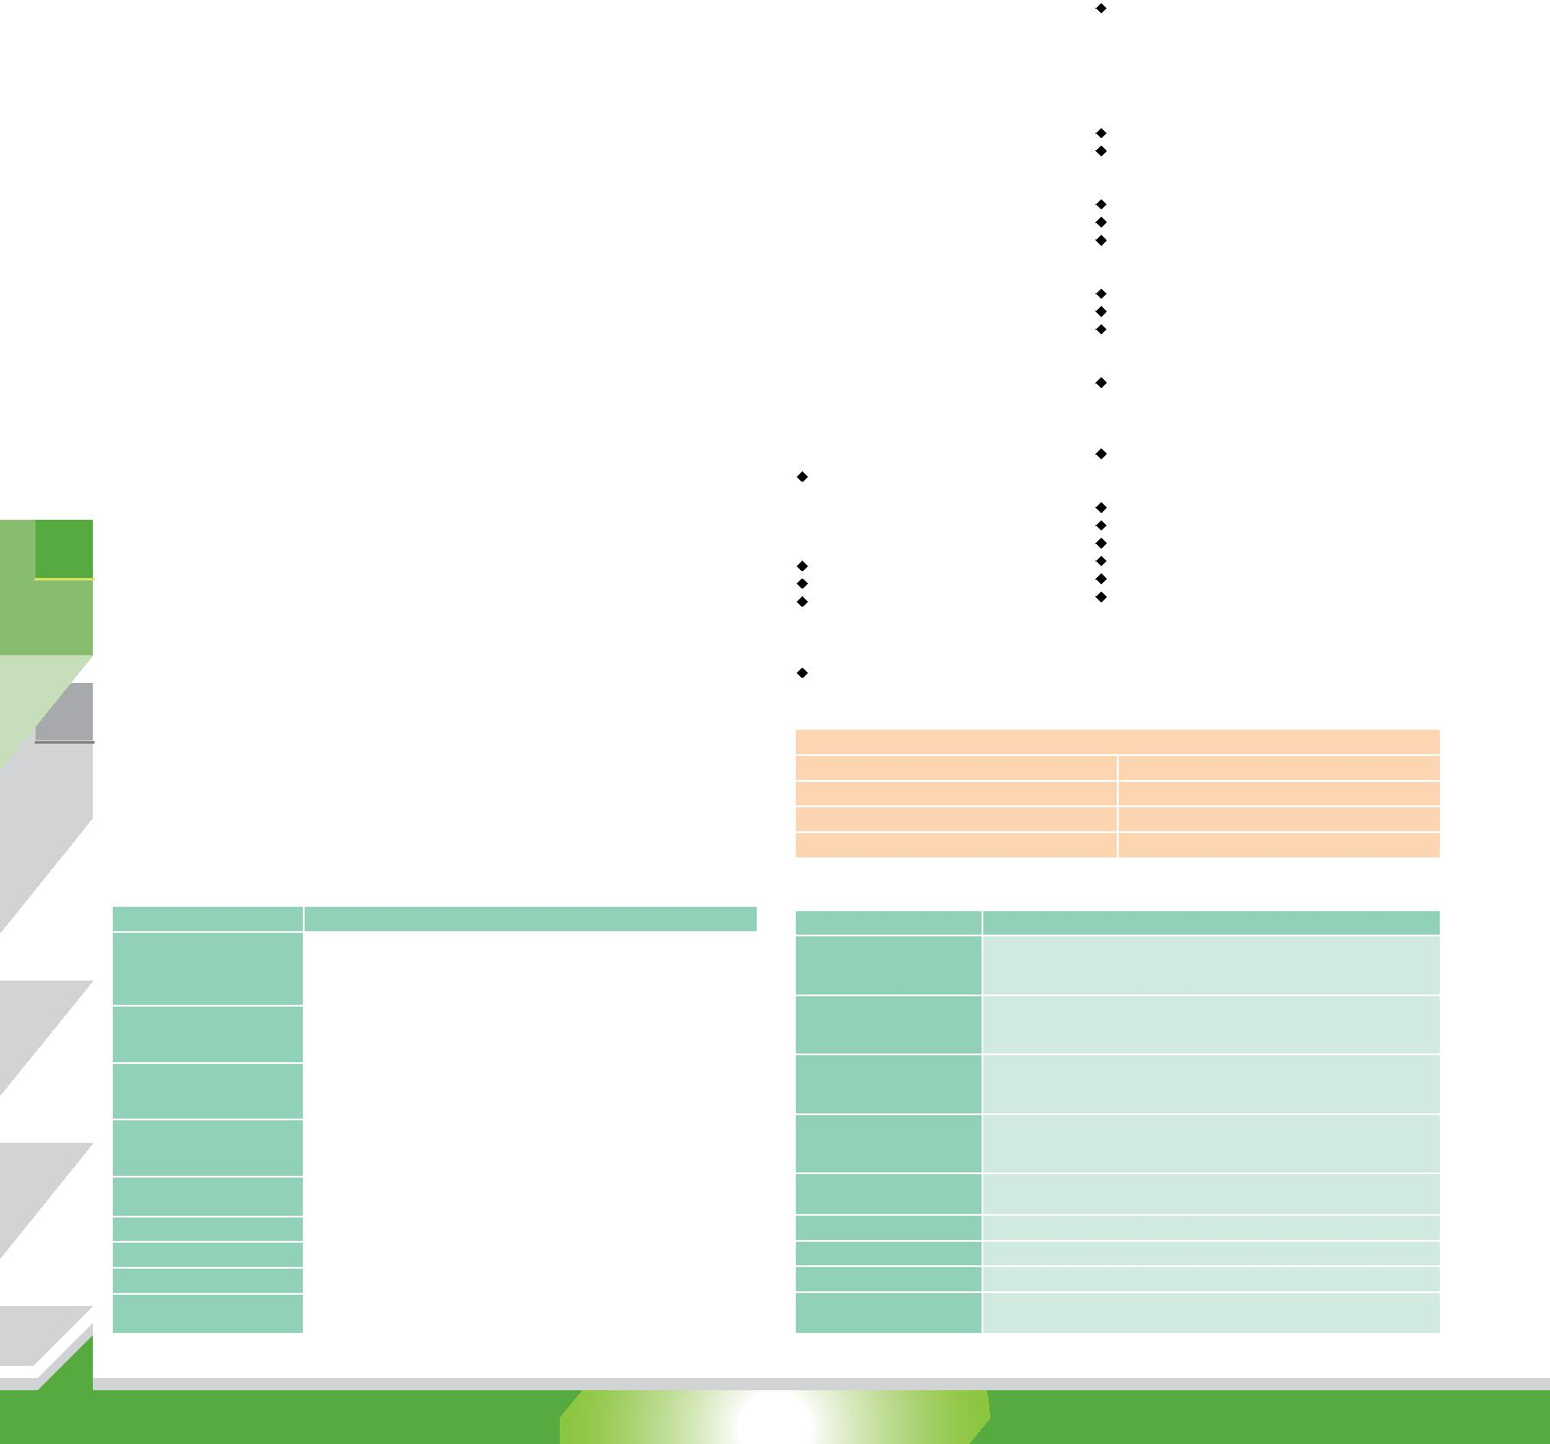

 | 视频采集 |  | 1 x NANO-KBN/SE-i1 single board computer with heatspreader |  | 1 x Audio cable
 | 解决方案
 |  |  | 1 x Power cable |  | 1 x One Key Recovery CD
 |  |  | 2 x RS-232 cable |  | 1 x QIG
 |  |  | 2 x SATA with power cable kit |  | 1 x Utility CD
 |  | 订购信息
 | 工业系统 |  | 料号 | 描述
 |  |  |  | EPIC SBC supports AMD® 28nm quad core GX-424CC 2.4GHz (25W)
 |  |  | NANO-SE-i1-4241-R10 | on-board SoC with VGA/HDMI/LVDS, Dual PCIe GbE, USB 3.0, Dual
 |  |  |  | PCIe Mini, SATA 6Gb/s, mSATA , COM and Audio, iRIS-1010 and
 |  |  |  | RoHS
 |  |  |  | EPIC SBC supports AMD® 28nm quad-core GX-415GA 1.5GHz (15W)
 |  |  | NANO-KBN-i1-4151-R10 | on-board SoC with VGA/HDMI/LVDS, Dual PCIe GbE, USB 3.0, PCIe
 |  |  |  | Mini, SATA 6Gb/s, mSATA, COM, iRIS-1010, HD Audio and RoHS
 |  |  |  | EPIC SBC supports AMD® 28nm dual-core GX-210HA 1.0GHz (9W)
工业电脑机箱
 |  |  | NANO-KBN-i1-2101-R10 | on-board SoC with VGA/HDMI/LVDS, Dual PCIe GbE, USB 3.0, PCIe
 |  |  |  | Mini, SATA 6Gb/s, mSATA, COM, iRIS-1010, HD Audio and RoHS
 |  |  |  | EPIC SBC supports AMD® 28nm dual core GX-210KL 1.0GHz (4.5W)
 |  |  | NANO-GLX-2101-R10 | on-board SoC with VGA/HDMI/LVDS, Dual PCIe GbE, USB 3.0, Dual
 |  |  |  | PCIe Mini, SATA 6Gb/s, mSATA , COM and Audio and RoHS
 |  |  | iRIS-1010-R10 | IPMI 2.0 adapter card with AST1010 BMC chip (w/o KVM over
 |  |  |  | IP function) for PCIe Mini socket interface
 |  |  | 32000-023800-RS | PS/2 KB/MS cable, 135mm/110mm, P=2.0
 | 电源/外设
 |  |  | 32001-008600-200-RS | Dual-port USB cable, 210mm, P=2.0
 |  |  | 32205-003800-300-RS | RS-422/485 cable, 200mm, P=2.0
 |  |  | TPM-IN01-R20 | 20-pin Infineon TPM module, software management tool,
 |  |  |  | firmware v3.17

Note: Models with other CPUs not listed in the table are requested by MOQ - 100 pcs/lot.

1 x Audio cable 1 x CPU cooler

1 x Power cable 1 x One Key Recovery CD

2 x RS-232 cable 1 x QIG

2 x SATA with power cable kit 1 x Utility CD

订购信息

料号 | 描述
 | EPIC SBC supports Intel® 22nm Mobile Core™ i7-4700EQ on-board
NANO-QM871-i1-i7-R10 Processor with VGA/Dual HDMI/LVDS, Dual PCIe GbE, AMT 9.0, PCIe
 | Mini, USB 3.0, SATA 6Gb/s, iRIS-1010, Audio and RoHS
 | EPIC SBC supports Intel® 22nm Mobile Core™ i5-4400E on-board
NANO-QM871-i1-i5-R10 Processor with VGA/Dual HDMI/LVDS, Dual PCIe GbE, AMT 9.0, PCIe
 | Mini, USB 3.0, SATA 6Gb/s, iRIS-1010, Audio and RoHS
 | EPIC SBC supports Intel® 22nm Mobile Core™ i3-4100E on-board
NANO-QM871-i1-i3-R10 Processor with VGA/Dual HDMI/LVDS, Dual PCIe GbE, USB 3.0, PCIe
 | Mini, SATA 6Gb/s, iRIS-1010, Audio and RoHS
 | EPIC SBC supports Intel® 22nm Celeron 2000E on-board Processor
NANO-QM871-i1-C-R10 (37W) with VGA/Dual HDMI/LVDS, Dual PCIe GbE, USB 3.0, PCIe
 | Mini, SATA 6Gb/s, iRIS-1010, Audio and RoHS
iRIS-1010-R10 | IPMI 2.0 adapter card with AST1010 BMC chip (W/O KVM over
 | IP function) for PCIe Mini socket interface
32000-023800-RS | PS/2 KB/MS cable, 135mm/110mm, P=2.0
32001-008600-200-RS | Dual-port USB 2.0 cable, 210mm. P=2.0
32205-003800-300-RS | RS-422/485 cable, 200mm, P=2.0
TPM-IN01-R20 | 20-pin Infineon TPM module, software management tool,
 | firmware v3.17

Note: Models with other CPUs not listed in the table are requested by MOQ - 100 pcs/lot.

¹⁻¹⁰⁹ NANO-SE-i1/NANO-KBN-i1-2018-V10

