

*单板电脑*

*嵌入式主板*

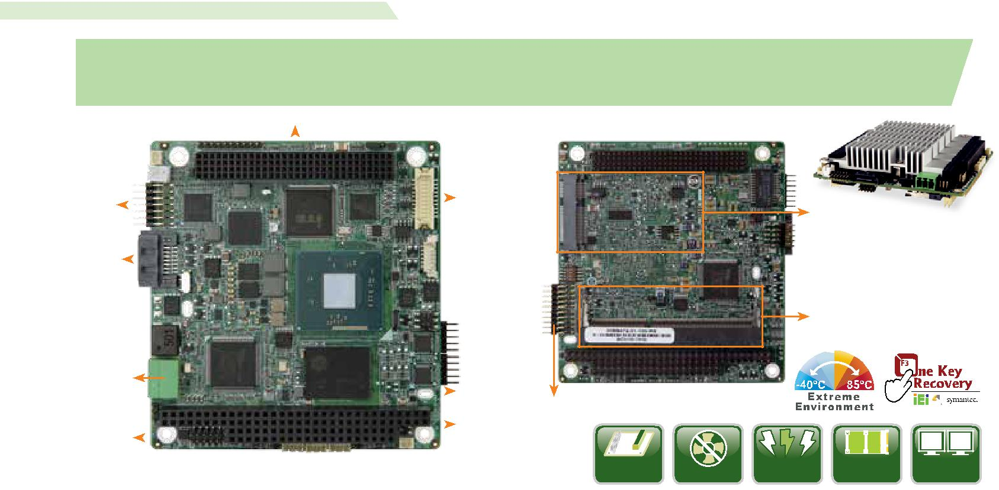

*w w w . i e i w o r l d . c o m . c n*

|  |  |  |
| --- | --- | --- |
| PM-BT | PC/104-Plus SBC with Intel® Atom™/Celeron® on-board SoC with DDR3L, VGA, LVDS, GbE, USB |  |
| 2.0, SATA 3Gb/s, RS-232/422/485 and 5V DC input, RoHS |  |

|  |  |  |  |  |  |  |  |  |
| --- | --- | --- | --- | --- | --- | --- | --- | --- |
|  |  |  |  | PC/104-Plus (支持ISA & PCI) | | | |  |
| LAN I/F |  |  |  |  |  |  | 18-bit LVDS |  |
|  |  |  |  |  |  |  |
|  |  |  |  |  |  |  |
|  |  |  |  |  |  |  |
|  |  |  |  |  |  |  |  |
| SATA |  |  |  |  |  |  |  |  |
|  |  |  |  |  |  |  |  |

5V 输入

|  |  |  |  |  |  |  |
| --- | --- | --- | --- | --- | --- | --- |
|  |  |  |  |  | 板载 SSD (可选) |  |
|  |  |  |  |  | PC/104-Plus |  |
|  |  |  |  |  |  |
| VGA |  |  |  |  | (支持ISA & PCI) |  |
|  |  |

*产品规格*

SoC



Intel® Atom™ E3845 板载 SoC (1.91GHz, 四核 , 2MB 缓存 , TDP=10W)

Intel® Atom™ E3827 板载 SoC (1.75GHz, 双核 , 1MB 缓存 , TDP=8W)

Intel® Atom™ E3826 板载 SoC (1.46GHz, 双核 , 1MB 缓存 , TDP=7W)

Intel® Atom™ E3825 板载 SoC (1.33GHz, 双核 , 1MB 缓存 , TDP=6W)

Intel® Atom™ E3815 板载 SoC (1.46GHz, 单核 , 512KB 缓存 , TDP=5W)

Intel® Celeron® J1900 板载 SoC (2GHz, 四核 , 2MB 缓存 , TDP=10W)

Intel® Celeron® N2930 板载 SoC (1.83GHz, 四核 , 2MB 缓存 , TDP=7.5W)

Intel® Celeron® N2807 板载 SoC (1.58GHz, 双核 , 2MB 缓存 , TDP=4.3W)

BIOS



AMI UEFI BIOS

内存



一个 204-pin 1333/1066 MHz 单通道 DDR3L SO-DIMM 支持高达 8 GB (J1900, N2930, E3845, E3827, E3826, E3825, E3815) or 4 GB (N2807)

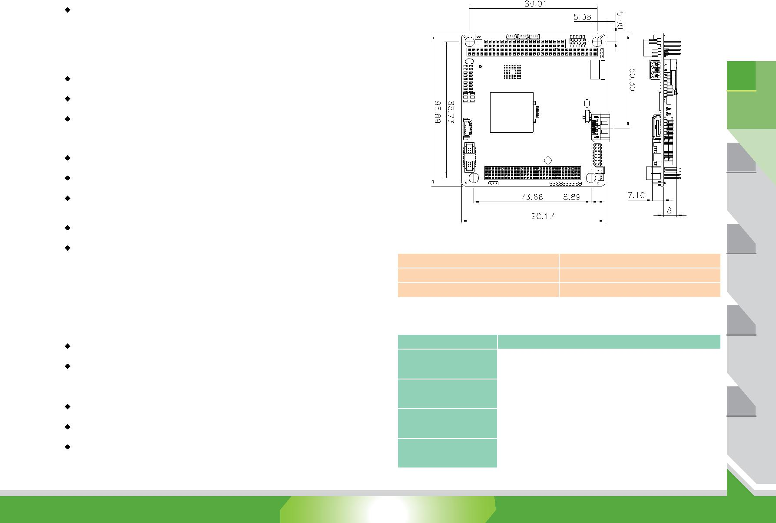

图形引擎

Intel® HD 显卡 Gen 7 Engine with four execution units, 支持 DX11.1, OpenGL 4.2 and OpenCL1.2

 显示输出

独立双显

1 x VGA ( 高达 2560x1600@60 Hz)

1 x 18/24-bit 单通道 LVDS (2x10 pin)

以太网

1 x Intel® I210

Super I/O

Fintek F81866

内部 I/O 接口

1 x SATA 3Gb/s with 5V SATA 电源接口

3 x USB 2.0 (1x4 pin, P=1.25)

2 x RS-232/422/485 (2x5, P=2.0)

存储

板载 SSD ( 可选 )

前面板

1 x 10-pin header, P=2.0 ( 电源 LED, HDD LED, 电源按键和复位按键 )

扩展

1× 全长 PCIe 迷你卡插槽 ( 支持 mSATA)

1 x PC/104-Plus (ISA+PCI)

数字 I/O

1 x 8-bit 数字 I/O (2x5 pin, P=2.0)

电源

5V DC 输入

12V for fan, LVDS and PCI-104 plus

* 5V for PCI-104 plus (1x3 pin, P=2.0)
* 12V for PCI-104 plus (1x3 pin, P=2.0) 3/5V jumper for PCI-104 plus

支持 AT/ATX 模式 ErP/EuP Compliant

 看门狗定时器

软件可编程，支持 1~255 秒系统复位

操作温度 -20°C ~ 60°C (for J1900/N2930/N2807)

-40°C ~ 85°C (for E38xx)

存储温度

-40°C ~ 85°C

Thermal

散热片

工作湿度

5% ~ 95%, 无冷凝

尺寸

96 mm x 90 mm

重量

GW: 500g / NW 120g

 CE/FCC compliant

PCIe Mini

DDR3L SO-DIMM

RS-232/422/485

|  |  |  |  |  |  |
| --- | --- | --- | --- | --- | --- |
| PC/104-Plus | Fanless | 5V | PCIe Mini 扩 | Dual Display |  |
| DC Input | 展 |  |

*产品特征*

* PC/104 form factor SBC 支持 22nm Intel® Atom™ 板载 SoC
* 支持PC/104-Plus (ISA 和 PCI 信号) 功能
* 5V DC 输入解决方案
* 支持两个 COM, PCIe Mini, USB 和可选板载 SSD
* 支持 VGA 和 LVDS 双显
* 支持宽温-40°C ~ 85°C (for E38xx series CPU)
* IEI 一键恢复解决方案可快速创建 OS 备份以及恢复

*尺寸 (单位: mm)*

*包装清单*

|  |  |
| --- | --- |
| 1 x PM-BT single board computer | 1 x SATA cable kit |
| 1 x COM port cable | 1 x Single-port USB cable |
| 1 x LAN cable | 1 x VGA cable |

*订购信息*

|  |  |
| --- | --- |
| 料号 | 描述 |
|  |  |
|  | PC/104-Plus Single Board Computer with Intel® Atom™ J1900 |
| PM-BT-J19001-R10 | SoC with DDR3L, VGA, LVDS, USB 2.0, SATA 3Gb/s, GbE, |
|  | RS-232/422/485 and 5V DC input, RoHS |
|  | PC/104-Plus Single Board Computer with Intel® Atom™ |
| PM-BT-N28071-R10 | N2807 SoC with DDR3L, VGA, LVDS, USB 2.0, SATA 3Gb/s, |
|  | GbE, RS-232/422/485 and 5V DC input, RoHS |
|  | PC/104-Plus Single Board Computer with Intel® Atom™ |
| PM-BT-E38451W2-R10 | E3845 SoC with DDR3L, VGA, LVDS, USB 2.0, SATA 3Gb/s, |
|  | GbE, RS-232/422/485 and 5V DC input, RoHS,-40°C ~ 85°C |
|  | PC/104-Plus Single Board Computer with Intel® Atom™ |
| PM-BT-E38251W2-R10 | E3825 SoC with DDR3L, VGA, LVDS, USB 2.0, SATA 3Gb/s, |
|  | GbE, RS-232/422/485 and 5V DC input, RoHS,-40°C ~ 85°C |

**Note: Models with other CPUs not listed in the table are requested by MOQ - 100 pcs/lot.

*1*

工业电脑

解决方案

视频采集

解决方案

工业系统

工业电脑机箱

电源/外设

PM-BT-2018-V10 1-130