

*单板计算机*

*工业主板*

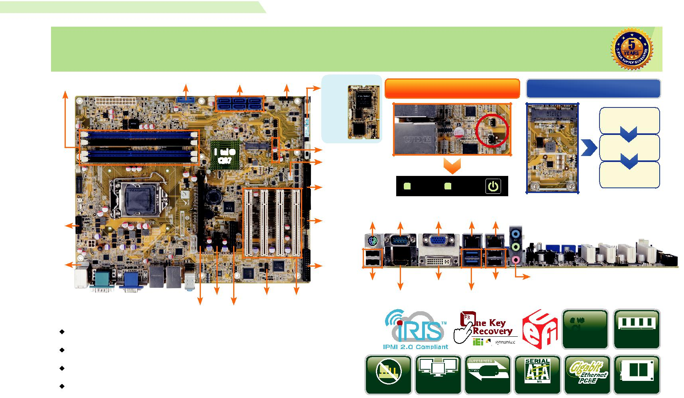

*w w w . i e i w o r l d . c o m . c n*

IMBA-Q870-i2

ATX 主板支持 22nm LGA1150 Intel® Core™ i7/i5/i3, Pentium® 和Celeron® CPU per Intel® Q87, DDR3, 独立三显 VGA, DVI-D, HDMI, iDP, USB 3.1 Gen 1 (5Gb/s), SATA 6Gb/s, iRIS-2400

|  |  |  |  |  |  |  |  |  |  |  |  |  |  |
| --- | --- | --- | --- | --- | --- | --- | --- | --- | --- | --- | --- | --- | --- |
| 双通道 DDR3 | 2 x USB 3.0 | SATA 6Gb/s |  | 前面板 | iRIS-2400 模块 | | LAN Link LED 连接器和 LAN 指示灯 | | |  |  |  |  |
| 1600/1333 MHz |  |  |  |  | 插槽 |  | mSATA 插槽用于快速启动技术 | | |  |
|  |  |  |  |  |  |  |  |  |  |  |  | 快速备份 |  |
|  |  | Intel ® |  |  | 4 x USB 2.0 |  |  |  |  |  |  | 省电模式 |  |
|  |  |  |  |  |  |  |  |  |  |  |  |
|  |  | Q87 |  |  | RS-422/485 |  |  |  |  |  |  |  |  |
|  |  |  |  |  |  |  |  |  |  |  |  | 快速恢复 |  |
|  |  |  |  |  | 4 x RS-232 |  |  | LAN1 | LAN2 |  |  |  |  |
|  |  |  |  |  |  |  |  |  | Combo RJ-45: | |  |  |  |
| iDP |  |  |  |  | TPM | KB/MS | RS-232 | VGA | LAN1 LAN2 / IPMI | |  |  |  |
|  |  |  |  |  |  |  |  |  |  |  |  |
|  |  |  |  |  |  |  |  |  |  |  |  |  |
| KB/MS |  |  |  |  | LPT |  |  |  |  |  |  |  |  |
|  |  |  |  |  | 2 x USB 2.0 | | | DVI-D | 2 x USB 2.0 | 音频 |  |  |  |
|  |  |  |  |  |  |  |  |  |
|  | PCIe x1 | | DIO | 4 x PCI |  |  | HDMI |  | 2 x USB 3.1 Gen 1 |  |  |  |  |
|  |  |  |  |  |  |  |  |  |  |
| *产品规格* | PCIe x16 | PCIe x4 |  |  |  |  |  |  |  |  | *3* |  |  |
|  |  |  |  |  |  |  |  |  | *Native* |  |  |
| CPU |  |  |  |  |  |  |  |  |  | PCIe |  |  |
| 支持 LGA1150 4th generation Intel® Core ™ i7/i5/i3, Pentium® or Celeron® 处理器 | | | | | |  |  |  |  | Gen. | DDR3 1600 |  |
| 芯片组 |  |  |  |  |  |  |  |  |  |  |  |  |  |
| Intel® Q87 |  |  |  |  |  |  |  |  |  |  |  |  |  |
| 内存 |  |  |  |  |  |  |  |  | USB |  |  |  |  |
| 四个 240-pin 1600/1333 MHz 双通道 DDR3 & DDR3L SDRAM 无缓冲 DIMMs | | | | | 支持 |  |  | Triple |  |  |  |  |
|  |  |  |  |  |  |  |
| BIOS |  |  |  |  |  |  |  |  |  |  |  |  |
|  |  |  |  |  | Jumper-less | | Display | USB 3.1 | SATA 6Gb/s PCIe GbE | | mSATA |  |
| UEFI BIOS |  |  |  |  |  |  |
|  |  |  |  |  |  |  |  |  |  |  |  |  |



网络

LAN1: 支持 Intel® I217LM with Intel® AMT 9.0

LAN2: 支持 Intel® I210-AT PCIe controller 以及 NCSI 图形引擎



Intel® HD Graphics Gen 7.5 支持 DX11.1 and OpenCL 1.2, OpenGL 3.2 Full MPEG2, VC1, AVC Decode



显示输出

1 x VGA ( 最高达 1920x1200@60 Hz)

1 x DVI-D ( 最高达 2560x1600@60 Hz)

1 x HDMI ( 最高达 2560x1600@60 Hz)

1 x iDP interface for HDMI, LVDS, VGA, DVI, DP ( 最高达 3840x2160@60 Hz)



音频

Realtek ALC662 HD 音频编解码器，支持 5.1-channel

3 x 音频插孔 ( 音频输入 , 音频输出 , 麦克风输入 ) on rear IO

1 x 前置音频 (2x5 pin)



|  |  |  |
| --- | --- | --- |
| 外部 I/O 接口 | 2xUSB3.1 |  |
| 1 x KB/MS |  |
| 1 x RS-232 | 4 x USB 2.0 |  |
| 内部 I/O 接口 | 2 x USB 3.0 (2x10 pin, P=2.0) |  |
| 1 x KB/MS (1x6 pin) |  |
| 1 x LPT (2x13 pin, P=2.54) | 4 x RS-232 (2x20 pin,P=2.54) |  |
| 1 x mSATA (colay SATA 6) | 4 x USB 2.0 (2x4 pin, P=2.54) |  |
| 1 x RS-422/485 (1x4 pin,P=2.54) | 6 x SA TA 6Gb/s (RAID 0/1/5/10 supported) |  |



前面板

1 x 前面板 (2x7 pin, power LED, HDD LED, 扬声器，电源按钮 , 重启按钮 )



LAN LED

2 x LAN LED (1x2 pin)



TPM

1 x TPM (2x10 pin)



SMBus

1 x SMBus (1x4 pin)



I²C

1 x I²C (1x4 pin)



iRIS 远程管理模块 : 1 x iRIS-2400 插槽

扩展

1 x PCIe x16 插槽 (Gen 3) 1 x PCIe x4 插槽

1 x PCIe x1 插槽 4 x PCI 插槽



看门狗定时器

软件可编程 , 支持 1~255 秒系统复位



数字 I/O: 8-bit 数字 I/O (2x5 pin)

风扇接口

1 x CPU 智能风扇 (1x4 pin)

2 x 系统风扇 (1x3 pin)



电源 : ATX 电源

功耗

3.3V@0.66A, 5V@4.34A, 12V@0.16A, Vcore_12V@4.01A, 5VSB@0.21A

(Intel® Core ™ i7-4770K 3.90 GHz CPU 以及 16 GB (4x4 GB) 1333 MHz DDR3 内存 )



工作温度 : -20°C ~ 60°C

存储温度 : -30°C ~ 70°C

工作湿度 : 5% ~ 95%, 无冷凝

尺寸 : 244mm x 305mm

重量 : GW: 1200g / NW: 700g

CE/FCC 标准

*产品特征*

* 支持 LGA1150 4th generation Intel® Core™ i7/i5/i3, Pentium® 或 Celeron® 处理器
* 双通道 DDR3 1600/1333 MHz
* 支持 Intel® PCIe GbE 以及 Intel® AMT 9.0
* 支持独立三显 HDMI，DVI ，VGA 以及 iDP
* 支持 PCI Express generation 3.0 at 8GT/s I/O宽带
* 支持 USB 3.0 和 SATA 6Gb/s mSATA
* IEI 免跳线功能
* IEI 一键恢复解决方案可快速创建 OS 备份和恢复
* 支持 IPMI 2.0 via iRIS-2400 模块

*包装清单*

|  |  |
| --- | --- |
| 1 x IMBA-Q870-i2 single board computer | 2 x SATA cable |
| 1 x I/O shielding | 1 x QIG |

*订购信息*



|  |  |  |
| --- | --- | --- |
| 料号 | 描述 |  |
|  | ATX motherboard supports 22nm LGA1150 Intel® Core™ i7/i5/ |  |
| IMBA-Q870-i2-R10 | i3, Pentium® and Celeron® CPU per Intel® Q87, DDR3, triple |  |
| independent display VGA/DVI-D/HDMI/iDP, dual Intel® GbE, USB |  |
|  |  |
|  | 3.0, SATA 6Gb/s, audio, iRIS-2400 and RoHS |  |
| IMBA-Q870-ECO-R10 | LGA1150 Intel® Core™ i7/i5/i3, Pentium® and Celeron® CPU per |  |
| Intel® Q87, DDR3, triple independent display VGA, DVI-D, HDMI, |  |
|  | iDP, USB 3.0, SATA 6Gb/s, ECO packing, RoHS (10 pce/pack) |  |
| iRIS-2400-R10 | IPMI 2.0 adapter card with AST2400 BMC chip for DDR3 SO- |  |
| DIMM socket interface |  |
|  |  |
| 19800-000049-RS | LPT flat cable, 240mm, P=2.54 |  |
| 19800-000075-RS | PS/2 KB/MS cable with bracket, 220mm, P=2.0 |  |
| 19800-003100-300-RS | Dual port USB cable with bracket, 300mm, P=2.54 |  |
| 19800-010500-200-RS | USB 3.0 cable 457mm with bracket |  |
| 32102-000100-200-RS | SATA power cable, MOLEX 5264-4P to SATA15P |  |
| 32205-001203-200-RS | RS-232 cable, 40-pin to four DB-9, 400mm, P=2.54 |  |
| 32205-003800-300-RS | RS-422/485 cable, 200mm, P=2.0 |  |
| CF-115XA-R10 | High performance LGA1155/LGA1156 cooler kit, 1U chassis |  |
| compatible, 73W |  |
|  |  |
| CF-115XE-R10 | High performance LGA1155/LGA1156 cooler kit, 95W |  |
| DP-DP-R10 | DisplayPort to DisplayPort converter board (for IEI iDP connector) |  |
| DP-DVI-R10 | DisplayPort to DVI-D converter board (for IEI iDP connector) |  |
| DP-HDMI-R10 | DisplayPort to HDMI converter board (for IEI iDP connector) |  |
| DP-LVDS-R10 | DisplayPort to 24-bit dual-channel LVDS converter board |  |
| (for IEI iDP connector) |  |
|  |  |
| DP-VGA-R10 | DisplayPort to VGA converter board (for IEI iDP connector) |  |
| TPM-IN01-R20 | 20-pin Infineon TPM module, software management tool, firmware |  |
| v3.17 |  |
|  |  |



IMBA-Q870-i2-2019-V10