单板计算机
工业主板

w w w . i e i w o r l d . c o m

_{IMB-H810-i2-R11}microATX主板支持22nm LGA1150英特尔®酷睿™i7 / i5 / i3，奔腾®，赛扬®CPU，符合英特尔®H81，DDR3，VGA，
双GbE，LPT，COM，SATA 6Gb / s，iRIS-2400

 |  |  |  |  | COM 7~10 |  |  |  |  | 双通道 DDR3
 |  |  |  |  | COM 3~6 |  |  |  |  | 1600/1333 MHz |  | 4 x SATA |  | iRIS-2400 插槽
TPM |  |  |  |  |  |  |  |  |  |  |  |  |  | 模块
LPT
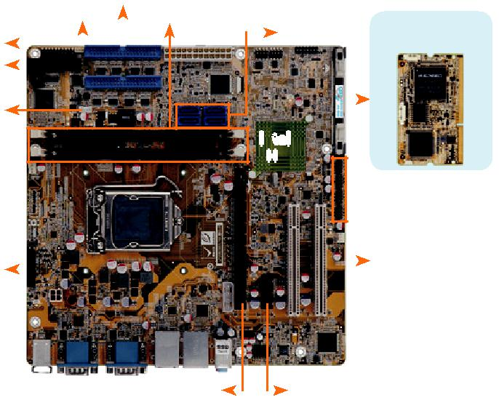
RS-422/485

Intel®
H81

8 x USB 2.0
iDP |  |  |  |  | PCI

PCIe x16 |  |  |  | PCIe x1

Specifications

CPU

支持 LGA1150 第四代 Intel® Core ™ i7/i5/i3, Pentium® or Celeron® 处理器

芯片组

Intel® H81

内存

两个 240-pin 1600/1333 MHz 双通道 DDR3 & DDR3L SDRAM 无缓冲 DIMMs 最高支持 16 GB
BIOS

UEFI BIOS

网络

LAN1: Intel® I217LM 支持 Intel® AMT9.0

LAN2: Intel® I210-AT PCIe 控制器支持 NCSI

图形引擎

Intel® 高清图形 Gen 7.5 支持 DX11.1 and OpenCL 1.2, OpenGL 3.2 Full MPEG2, VC1, AVC 解码

显示输出

独立双显

2 x VGA (最高至 1920x1200@60Hz)

1 x iDP interface for HDMI, LVDS, VGA, DVI, DP (最高至 3840x2160@60Hz)

音频

Realtek ALC662 HD 音频编解码器支持 5.1-通道

3 x 音频插孔 ( 音频输出 , 音频输入 , 麦克风输入 )on rear IO

1 x 前置音频 (2x5 pin)

iRIS 远程管理模块

1 x iRIS-2400 插槽

TPM

1 x TPM (2x10 pin)

SMBus

1 x SMBus (1x4 pin)

I²C

1 x I²C (1x4 pin)

网络灯: 2 x 网络灯 (1x2 pin)
外部 I/O 接口
1 x KB/MS 2 x USB 2.0

2 x RS-232 2 x USB 3.1 Gen 1 (5Gb/s)

部 I/O 接口
1 x LPT (2x13 pin, P=2.54) 2 x SATA 6Gb/s

1 x RS-422/485 (1x4 pin, P=2.0) 8 x RS-232 (2x20 pin, P=2.54)

2 x SATA 3Gb/s 8 x USB 2.0 (2x4 pin, P=2.54)

前面板

1 x 前面板 (2x7 pin, power LED, HDD LED, 扬声器 , 电源按钮 , 复位按钮 )

扩展接口

1 x PCIe x16 slot (Gen 3)

1 x PCIe x1 slot

2 x PCI slot

看门狗定时器:

软件可编程并支持 1~255 秒系

风扇接口

1 x CPU 智能风扇 (1x4 pin)

1 x System 智能风扇(1x3 pin)

电源

ATX 电源

功耗

3.3V@0.64A, 5V@4.20A, 12V@0.14A, Vcore_12V@3.88A, 5VSB@0.20A

(Intel® Core™ i7-4770K 3.90 GHz CPU 及 8 GB (two 4 GB) 1333 MHz DDR3 内存) 操作温度: -20°C ~ 60°C
存储温度: -30°C ~ 70°C

存储湿度: 5% ~ 95%, non-condensing

尺寸: 244mm x 244mm

重量: GW: 1200g / NW: 680g

CE/FCC 标准

Combo RJ-45: LAN2 / IPMI
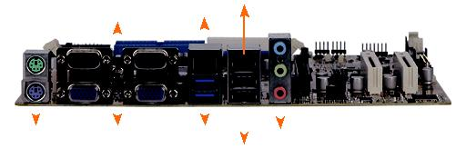

RS-232 LAN1

KB/MS |  |  |  | VGA 2 x USB 3.1 Gen 1 |  |  |  |  |  |  |  |  |  | Audio
 |  |  |  |  |  |  |  |  | 2 x USB 2.0

DDR3 | USB
 | USB 3.1 SATA 6Gb/s PCIe GbE
1600

特征

- 支持LGA1150第4代Intel®Core™i7 / i5 / i3，Pentium®或Celeron®处理器

- 双通道DDR3 1333/1600 MHz 支持高达 16 GB

- Intel® 高清图像技术集成了高性能图形和媒体处理功能

- 支持 PCI 32-bit 33/66 MHz
十个 COM ports, USB 3.1 Gen 1 (5Gb/s) 和支持SATA

- TPM V1.2 TPM模块支持的硬件安全功能

- IEI One Key Recovery解决方案允许您创建快速OS备份和恢复

- 支持 IPMI 2.0 via iRIS-2400 模块

- IEI 无跳线功能

包装清单

1 x IMB-H810-i2 single board computer | 2 x SATA cable
1 x I/O shielding | 1 x QIG

订购信息

Part No. | Description
 | microATX motherboard supports 22nm LGA1150 Intel® Core™
IMB-H810-i2-R11 | i7/i5/i3/Pentium® and Celeron® CPU per Intel® H81, DDR3,
 | VGA, Dual Intel® PCIe GbE, USB 2.0, PCI, COM, SATA 6Gb/s,
 | LPT, HD Audio, iRIS-2400 and RoHS
 | LGA1150 Intel® Core™ i7/i5/i3, Pentium® and Celeron® CPU
IMB-H810-ECO-R11 | per Intel® H81, DDR3, VGA, Dual PCIe GbE, USB 2.0, COM,
 | LPT, SATA 6Gb/s, HD Audio, ECO packing, RoHS (10 pce/pack)
iRIS-2400-R10 | IPMI 2.0 adapter card with AST2400 BMC chip for DDR3 SO-
 | DIMM socket interface
19800-000049-RS | LPT flat cable, 240mm, P=2.5
19800-000075-RS | PS/2 KB/MS cable with bracket, 220mm, P=2.0
19800-003100-100-RS | Dual port USB cable with bracket, 30mm, P=2.54
19800-010500-200-RS | USB 3.1 Gen 1 (5Gb/s) cable with bracket, 450mm
32102-000100-200-RS | SATA power cable, MOLEX 5264-4P to SATA15P
32205-001203-200-RS | RS-232 cable, 40-pin to four DB-9, 400mm, P=2.54
32205-003801-100-RS | RS-232/422/485, RS-422/485 cable, 500mm
CF-115XA-R10 | High performance LGA1155/LGA1156 cooler kit, 1U chassis
 | compatible, 73W
CF-115XE-R10 | High performance LGA1155/LGA1156 cooler kit, 95W
DP-DP-R10 | DisplayPort to DisplayPort converter board (for IEI iDP connector)
DP-DVI-R10 | DisplayPort to DVI-D converter board (for IEI iDP connector)
DP-HDMI-R10 | DisplayPort to HDMI converter board (for IEI iDP connector)
DP-LVDS-R10 | DisplayPort to 24-bit dual-channel LVDS converter board
 | (for IEI iDP connector)
DP-VGA-R10 | DisplayPort to VGA converter board (for IEI iDP connector)
TPM-IN01-R20 | 20-pin Infineon TPM module, software management tool,
 | firmware v3.1

IMB-H810-i2-2019-V10

