显示系统
w w w . i e i w o r l d . c o m
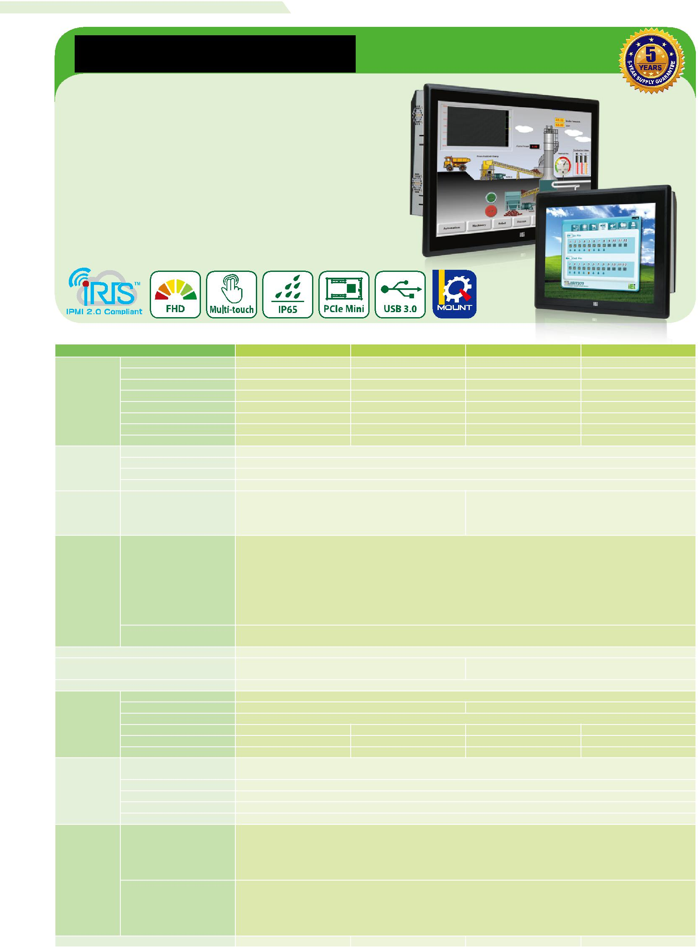

PPC-F H81系列

智能工业平板电脑

●支持iRIS- 2400威强电智能解决方案
●可扩展的英特尔®H81芯片组支持LGA1150英特尔®™第四代核心i7 / i5 / i3,Pentium®或赛扬®处理器高达65 wTDP
●JI坚固IP65铝质前面板
●美观超薄边框为无缝式安装
●投射电容式多点触摸
●双全尺寸PCIe迷你卡扩张
●AC / DC电源输入选项(DC型号根据订单生产)

规格参数

 | 型号 | PPC-F15A | PPC-F17A | PPC-F22A | PPC-F24A
 | LCD 尺寸 | 15’’ (4:3) | 17’’ (5:4) | 21.5’’ (16:9) | 23.8” (16:9)
 |  | 1024(W) x 768(H) | 1280(W) x 1024(H) | 1920(W) x 1080(H) | 1920(W) x 1080(H)
 | 亮度(cd/m²) | 450 | 350 | 250 | 250
LCD | 对比率 | 800 : 1 | 800 : 1 | 1000 : 1 | 3000 : 1
 | LCD颜色 | 16.2M | 16.7M | 16.7M | 16.7M
 | 像素间距 | 0.297 x 0.297 | 0.26 x 0.26 | 0.25 x 0.25 | 0.28 x 0.28
 | 可视角度 (H-V) | 160° / 150° | 170° / 160° | 170° / 160° | 178° / 178°
 | 背光灯 (hrs) | 70000 | 50000 | 30000 | 30000
 | SBC Model |  | FPPCMB-H81-R10
主板 | CPU | LGA1150 Intel® 4th generation Core™ i7/i5/i3, Pentium® or Celeron® processor with up to 65W TDP
 | 芯片组 |  | Intel® H81
 | RAM | Support 2 x 204-pin 1066/1333/1600 MHz dual-channel DDR3 SO-DIMM slots (max. 16GB)
 |  | 5-wire resistive single touch window, 3H/Penmount 9000
触摸 | 触摸屏& 控制器 | (Anti-glare Surface) |  | 10-point Projected capacitive touch window, 6H/EETI EXC3188
 |  | 10-point Projected capacitive touch window, 6H/EETI EXC3188 |  | (Anti-UV, Anti-glare Surface)
 |  | (Anti-UV, Anti-glare Surface)
 |  |  | 2 x RJ-45 LAN Port | 1 x VGA output
 |  |  | 2 x USB 3.1 Gen 1 (5Gb/s) | 1 x AC/DC power plug
 |  |  | 4 x USB 2.0 | (DC model is by build to order manufacturing)
 | I/O接口 & 开关 |  | 1 x HDMI output | 1 x AT/ATX switch
 |  |  | 4 x RS-232 | 1 x Clear CMOS
输入端口 |  |  | 1 x RS-422/485 | 1 x Reset button
 |  |  | 1 x MIC-in | 1 x Power switch
 |  |  | 1 x Line-out
 | 扩展 |  | 1 x Full-size/half-size PCIe Mini card (PCIe and USB signal)
 |  |  | 1 x Full-size/half-size PCIe Mini card (PCIe , USB and mSATA signal)
无线 |  |  | 802.11 b/g/n (optional)
驱动器材之架 |  | 1 x 2.5” HDD/SSD drive bay |  | 1 x 2.5” HDD/SSD drive bay or 1 x 3.5” HDD/SSD drive bay
 |  |  | 1 x mSATA | 1 x mSATA
iRIS 远程管理方案 |  |  | iRIS-2400 (optional)
 | 材质 |  | Aluminum front cover and sheet metal rear cover
 | 安装方式 | Panel mount, rack mount, 100x100 VESA mount |  | Panel mount, 100x100 VESA mount
物理属性 | 外壳颜色 |  | Black C
 | 尺寸(mm) | 303 x 378.5 x 68.7 | 341.4 x 408.4 x 73.8 | 350.4 x 550.4 x 71.7 | 382 x 600 x 71.7
 | 开孔尺寸 (mm) | 285.6 x 361.1 | 323 x 390 | 341 x 536 | 359.6 x 577.6
 | 净重/毛重(kg) | 5.6/ 8.3 | 7.5/10.7 | 10.1/14.4 | 10.5/14.8
 | 操作温度 |  | -10°C ~ 50°C
 | (空气流动)
环境 | 存储温度 |  | -20°C ~ 60°C
 | 相对温度 |  | 10% to 95% (non-condensing)
 | IP 等级 |  | Front IP 65
 | 安规和EMC |  | CE & FCC certified
 |  |  | AC input ATX power supply
 |  |  | - P/N: 63030-010220-100-RS
 | AC 输入 |  | - 220W power supply

- Input: 90VAC-264VAC, 50/60Hz

- Output (max.): 3.3V@10A, 5V@14A, 12V@14A, -12V@0.3A
电源需求 |  | DC input ATX power supply
 |  | - P/N: XACE-4520C-RS
DC 输入(根据订单需求) |  | - 200W power supply
 |  | - Input: 24VDC, 15A (max)
 |  | - Output (max.): 3.3V@12A, 5V@12A, 12V@15.4A, -12V@0.5A
功耗 | 80W | 100W | 110W | 120W

PPC-F H81-2019-V10 5-57

显示系统
w w w . i e i w o r l d . c o m

订购信息

型号 | 描述
PPC-F15AA-H81i-P/4G/PC-R22 | 15" 450 cd/m² XGA Panel PC with Intel® H81 chipset, Intel® Pentium® Processor G3420 (3M Cache, 3.20 GHz), TDP 53W, 2GB RAM*2, support
 | iRIS-2400, black color, PSU ACE-A622B, projective capacitive touch window with AG coating, R22
PPC-F15AA-H81i-i3/4G/PC-R22 | 15" 450 cd/m² XGA Panel PC with Intel® H81 chipset, Core i3 Dual Core i3-4330 Processor (4M Cache, 3.50 GHz), TDP 54W, 2GB RAM*2, support
 | iRIS-2400, black color, PSU ACE-A622B, PCAP touch window with AG coating, R22
PPC-F15AA-H81i-i5/4G/PC-R22 | 15" 450 cd/m² XGA Panel PC with Intel® H81 chipset, Core i5 Quad Core i5-4570S Processor (6M Cache, up to 3.60 GHz), TDP 65W, 2GB RAM*2,
 | support iRIS-2400, black color, PSU ACE-A622B, PCAP touch window with AG coating, R22
PPC-F15AA-H81i-P/4G/R-R22 | 15" 450 cd/m² XGA Panel PC with Intel® H81 chipset, Intel® Pentium® Processor G3420 (3M Cache, 3.20 GHz), TDP 53W, 2GB RAM*2, support
 | iRIS-2400, black color, PSU ACE-A622B, resistive touch window with AG coating, R22
PPC-F15AA-H81i-i3/4G/R-R22 | 15" 450 cd/m² XGA Panel PC with Intel® H81 chipset, Core i3 Dual Core i3-4330 Processor (4M Cache, 3.50 GHz), TDP 54W, 2GB RAM*2, support
 | iRIS-2400, black color, PSU ACE-A622B, resistive touch window with AG coating, R22
PPC-F15AA-H81i-i5/4G/R-R22 | 15" 450 cd/m² XGA Panel PC with Intel® H81 chipset, Core i5 Quad Core i5-4570S Processor (6M Cache, up to 3.60 GHz), TDP 65W, 2GB RAM*2,
 | support iRIS-2400, black color, PSU ACE-A622B, resistive touch window with AG coating, R22
PPC-F17AA-H81i-P/4G/PC-R13 | 17" 350 cd/m² SXGA Panel PC with Intel® H81 chipset, Intel® Pentium® Processor G3420 (3M Cache, 3.20 GHz), TDP 53W, 2GB RAM*2, support
 | iRIS-2400, black color, PSU ACE-A622B, projective capacitive touch window with AG coating, R13
PPC-F17AA-H81i-i3/4G/PC-R13 | 17" 350 cd/m² SXGA Panel PC with Intel® H81 chipset, Core i3 Dual Core i3-4330 Processor (4M Cache, 3.50 GHz), TDP 54W, 2GB RAM*2,
 | support iRIS-2400, black color, PSU ACE-A622B, projective capacitive touch window with AG coating, R13
PPC-F17AA-H81i-i5/4G/PC-R13 | 17" 350 cd/m² SXGA Panel PC with Intel® H81 chipset,Core i5 Quad Core i5-4570S Processor(6M Cache,up to 3.60 GHz),TDP 65W,2GB
 | RAM*2,support iRIS-2400,black color,PSU ACE-A622B,projective capacitive touch window with AG coating, R13
PPC-F17AA-H81i-P/4G/R-R13 | 17" 350 cd/m² SXGA Panel PC with Intel® H81 chipset, Intel® Pentium® Processor G3420 (3M Cache, 3.20 GHz), TDP 53W, 2GB RAM*2, support
 | iRIS-2400, black color, PSU ACE-A622B, resistive touch window with AG coating, R13
PPC-F17AA-H81i-i3/4G/R-R13 | 17" 350 cd/m² SXGA Panel PC with Intel® H81 chipset, Core i3 Dual Core i3-4330 Processor (4M Cache, 3.50 GHz), TDP 54W, 2GB RAM*2,
 | support iRIS-2400, black color, PSU ACE-A622B, resistive touch window with AG coating, R13
PPC-F17AA-H81i-i5/4G/R-R13 | 17" 350 cd/m² SXGA Panel PC with Intel® H811 chipset, Core i5 Quad Core i5-4570S Processor (6M Cache, up to 3.60 GHz), TDP 65W, 2GB
 | RAM*2, support iRIS-2400, black color, PSU ACE-A622B, resistive touch window with AG coating, R13
PPC-F22AA-H81i-i3/4G/PC-R13 | 21.5" 250 cd/m² FHD Panel PC with Intel® H81 chipset, Core i3 Dual Core i3-4330 Processor (4M Cache, 3.50 GHz), TDP 54W, 2GB RAM*2,
 | support iRIS-2400, black color, PSU ACE-A622B, AG projective capacitive touch window, R13
PPC-F22AA-H81i-i5/4G/PC-R13 | 21.5" 250 cd/m² FHD Panel PC with Intel® H81 chipset, Core i5 Quad Core i5-4570S Processor(6M Cache, up to 3.60 GHz), TDP 65W, 2GB
 | RAM*2, support iRIS-2400,black color,PSU ACE-A622B, AG projective capacitive touch window,R13
PPC-F22AA-H81i-P/4G/PC-R13 | 21.5" 250 cd/m² FHD Panel PC with Intel® H81 chipset, Intel® Pentium® Processor G3420 (3M Cache, 3.20 GHz), TDP 53W, 2GB RAM*2, support
 | iRIS-2400, black color, PSU ACE-A622B, AG projective capacitive touch window, R13
PPC-F24AA-H81i-P/4G/PC-R21 | 23.8" 250 cd/m² FHD Panel PC with Intel® H81 chipset, Intel® Pentium® Processor G3420 (3M Cache, 3.20 GHz), TDP 53W, 2GB RAM*2, support
 | iRIS-2400, black color, PSU ACE-A622B, projective capacitive touch window with AG coating, R21
PPC-F24AA-H81i-i3/4G/PC-R21 | 23.8" 250 cd/m² FHD Panel PC with Intel® H81 chipset, Core i3 Dual Core i3-4330 Processor (4M Cache, 3.50 GHz), TDP 54W, 2GB RAM*2,
 | support iRIS-2400, black color, PSU ACE-A622B, projective capacitive touch window with AG coating, R21
PPC-F24AA-H81i-i5/4G/PC-R21 | 23.8" 250 cd/m² FHD Panel PC with Intel® H81 chipset, Core i5 Quad Core i5-4570S Processor (6M Cache, up to 3.60 GHz), TDP 65W, 2GB
 | RAM*2, support iRIS-2400, black color, PSU ACE-A622B, projective capacitive touch window with AG coating, R21

可选配件

Item | PPC-F15A | PPC-F17A | PPC-F22A | PPC-F24A
Arm | ARM-31-RS | ARM-31-RS | ARM-31-RS | ARM-31-RS
Stand | STAND-A21 STAND-A19-RS | STAND-C19-R10 | STAND-C19-R10 | STAND-C19-R10
 | STAND-C19-R10 | STAND-A21-R10 | STAND-A21-R10 | STAND-A21-R10
Wall Mount Kit |  | WK-190MS-R10
Panel Mount Kit | FPK-04-R10 |  | FPK-05-R10 | FPK-06-R10
Rack Mount Kit | FRK15-R10 | FRK17-R10 |  | N/A
Wi-Fi Kit |  | EMB-WIFI-KIT11-R20
iRIS (IEI Remote Intelligent System) Kit |  | iRIS-2400-R10

包装清单

Item | Q’ty | Remark
Power Cord | 1 | Depends on shipping region
Screw Kit | 1
Touch Pen | 1 | Resistive touch only

5-58 PPC-F H81-2019-V10

显示系统

PPC-F15A

完全集成的I / O

PPC-F17A

完全集成的I / O

PPC-F22A

完全集成的I / O

PPC-F24A

完全集成的I / O

PPC-F15A结构尺寸
(单位:mm)

4.20

1

36.40

40.88

w w w . i e i w o r l d . c o m

GbE LAN USB 3.1 Gen 1 RS-422/485 Power Switch Line-out
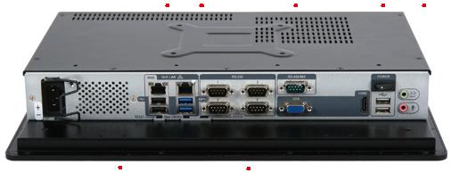

AC Input |  | USB 2.0 Reset |  |  |  |  |  |  | AT/ATX RS-232 |  |  |  |  | VGA |  | HDMI USB 2.0 |  |  |  |  |  |  |  |  |  | Mic
 |  |  |  | Clear CMOS
 |  |  | GbE LAN |  |  |  |  | USB 3.1 Gen 1 |  |  |  |  | RS-422/485 |  |  |  | Power Switch |  |  |  |  |  |  |  |  |  | Line-out
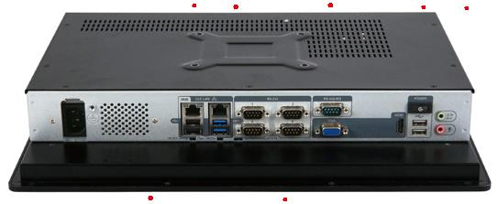
AC Input |  | USB 2.0 Reset |  |  |  |  |  |  |  | AT/ATX RS-232 VGA HDMI |  |  |  |  |  |  |  | USB 2.0 Mic
 |  |  |  | Clear CMOS
 |  |  |  |  |  |  | GbE LAN USB 3.1 Gen 1 RS-422/485 |  |  |  |  |  |  |  |  |  |  | Power Switch Line-out
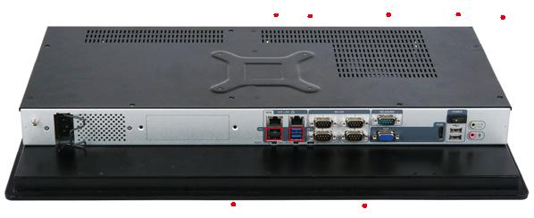
AC Input |  |  | USB 2.0 Reset |  |  |  |  |  |  |  | AT/ATX RS-232 |  |  |  |  |  |  |  |  |  |  | HDMI USB 2.0 Mic
 |  |  |  |  |  |  |  | Clear CMOS |  |  |  |  |  |  |  |  |  |  |  | VGA
 |  |  | GbE LAN USB 3.1 Gen 1 RS-422/485 |  |  |  |  |  |  |  |  |  |  |  |  |  |  |  |  |  |  |  | Power Switch
 |  |  |  |  |  |  |  |  |  |  |  |  |  |  |  |  |  |  |  |  |  |  |  |  |  |  |  |  |  |  |  | Line-out
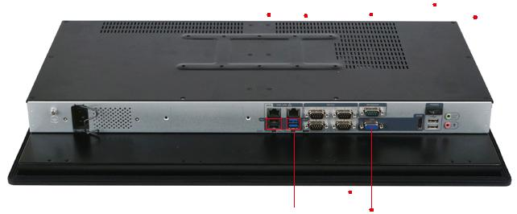
AC Input |  |  | USB 2.0 | Reset |  | AT/ATX |  | RS-232 | HDMI USB 2.0 Mic
 |  |  |  |  | Clear CMOS |  |  | VGA
358.10 ±0.50
194.20 | 81.95 |  |  |  |  |  |  |  |  | 6285.
 |  |  |  |  |  |  |  |  | 361.1
378.50 ±0.50
306 ±0.30 |  |  |  |  |  |  |  | 160 |  | 90
 |  |  |  |  |  |  |  | 5 |  | 5
 |  |  | 3083. | 236.±0.2080 | 282.60±0.50 | 5022. | 5014. |  |  |  | 14.50
 | 230±0.30 | 303±0.50 | 116 |  |  |  | 8 | 100 |  | 8 | 95
 |  |  |  |  |  |  |  |  |  | 2
 |  |  |  |  |  |  | 108.50 |  | 100 | 139.25
 |  |  | 49.20 ±0.20 |  |  |  |  | 20.90 | 173.30 | 20.90
 |  |  | 8
 |  |  | 68.66 ±0.50 |  |  |  |  | 81.70
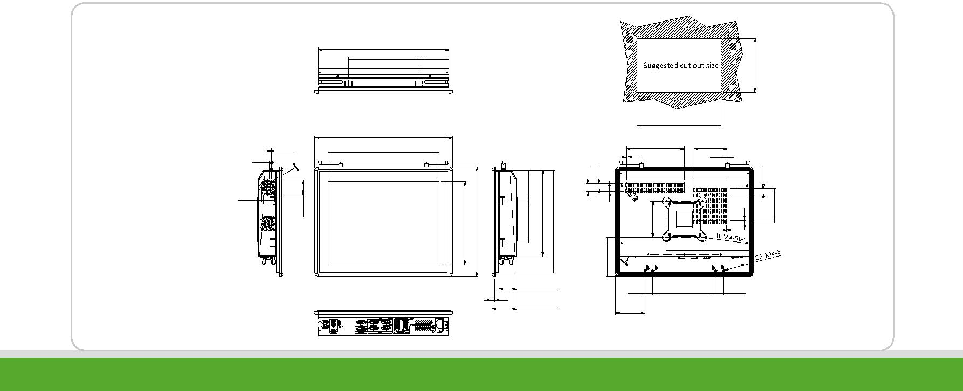

PPC-F H81-2019-V10 5-59

显示系统
w w w . i e i w o r l d . c o m
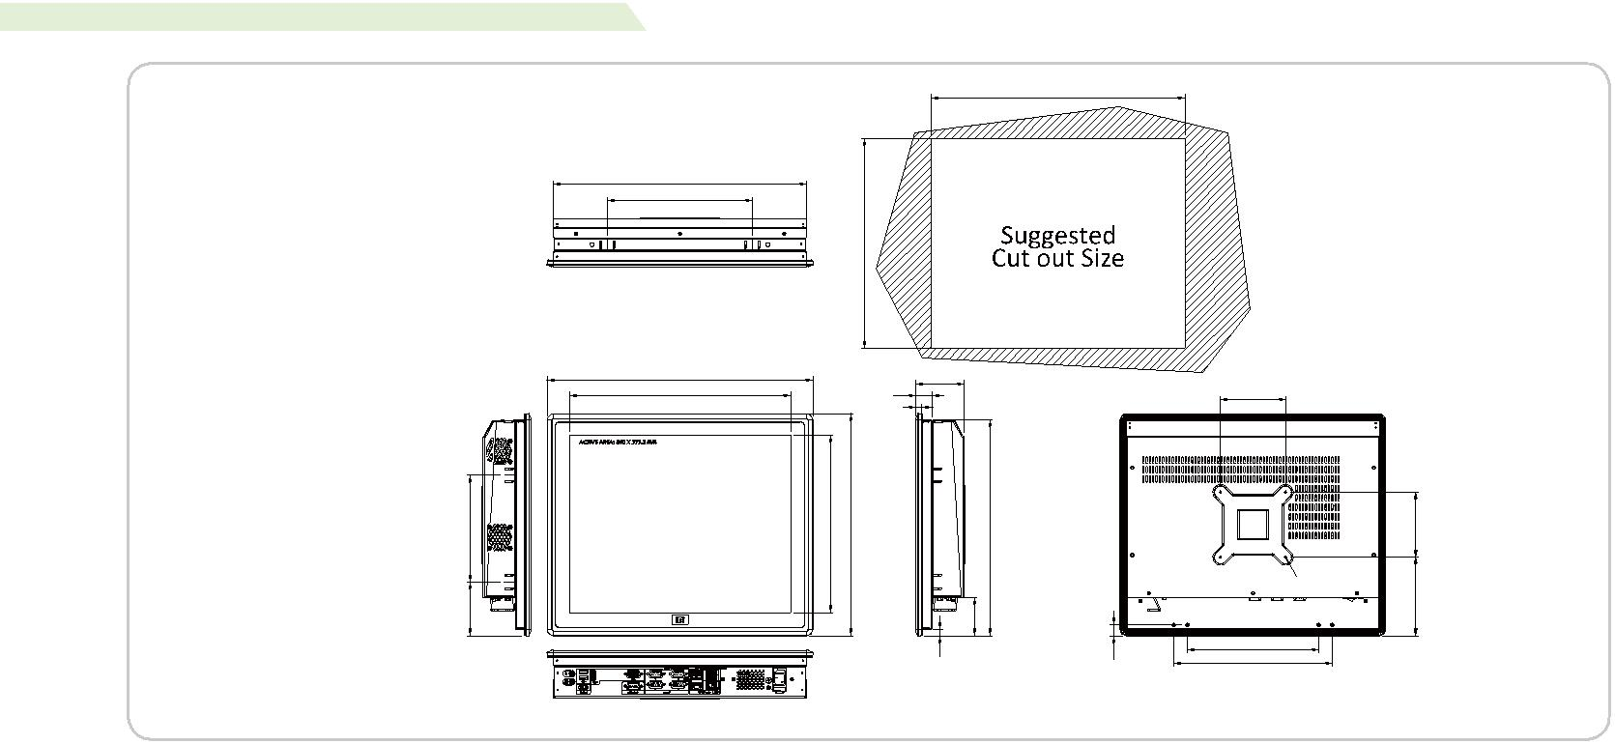

PPC-F17A结构尺寸
(单位:mm)

390

389

222.60

323

408.40 |  | 24.20 | 73.80
340
 |  | 8
40164. | 30272. | 341.40 |  | 331.50
82.40 |  |  |  | 9058.
 |  |  | 9.90 | 16.89
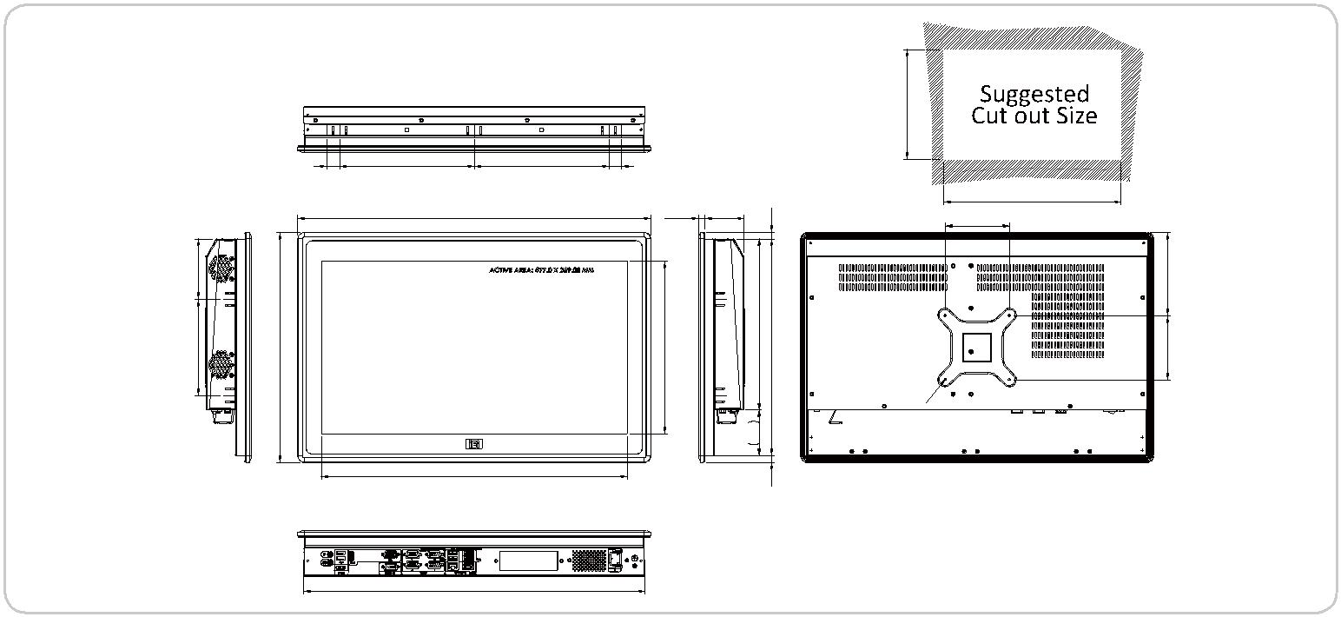

PPC-F22A 结构尺寸
(Unit: mm) |  |  |  |  |  |  |  | 341
 | 20 | 210 |  | 210 | 20
 |  |  | 550.40 |  | 10.26 | 60.90 | 10.20
94
150 | 358.40 |  |  |  | 269 |  | 50266.338
 |  |  |  |  |  |  |  | B-M4-5L
 |  |  |  |  |  |  | 5071.
 |  |  | 477 |  |  |  | 10.20
 |  |  | 533
PPC-F24A 结构尺寸 |  |  |  |  |  |  |  | 577.60
(Unit: mm)
 |  | 574.6
 | 161.2 | 80.6 | 80.6 |  | 161.2
 |  |  | 600 |  |  | 71.70 | 12.70
 |  | 528.6
 |  |  |  |  | 298392 |  | 133.6281.6060356. | 100
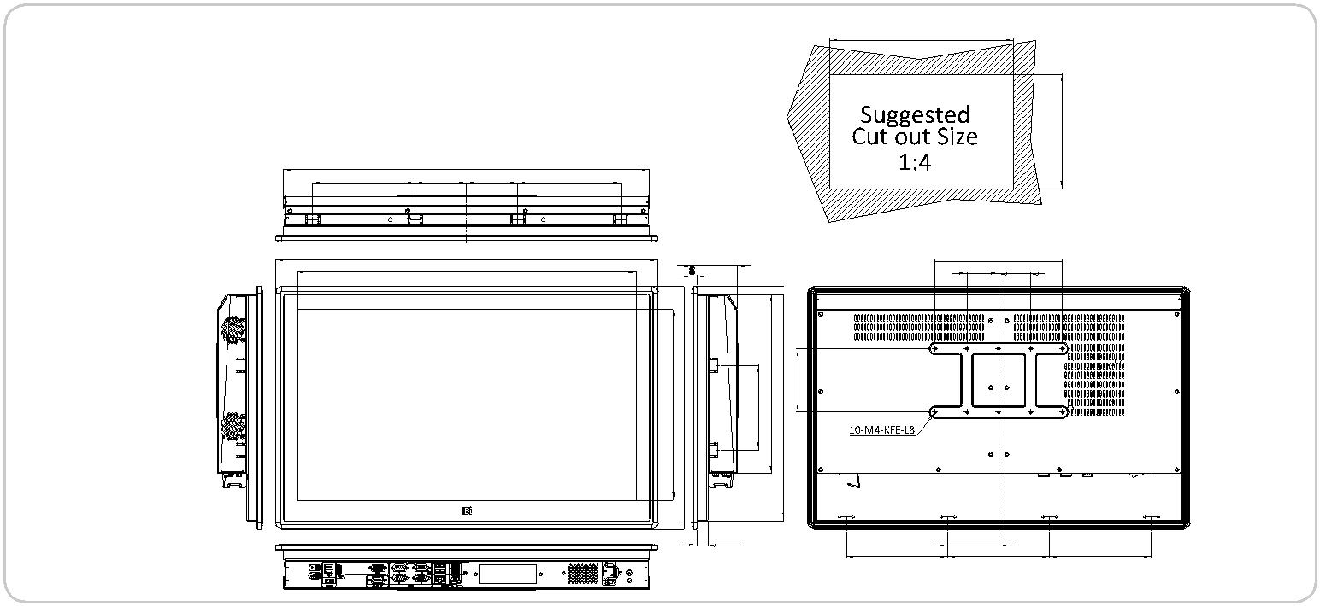

71.50

159.70

100

 | 100
4-M4-4.5L | 60120.

201.70
243.50

536

100

100 65129.

60359.

- 100
50 50

79.85

159.70 159.70

5-60 PPC-F H81-2019-V10

