***显示系统***

***w w w . i e i w o r l d . c o m***

**PPC-F系列**

IEI致力于开发完美的工业面板PC产品。PPC、PPC- f系列工业板材pc采用无缝安装方式，既保持了IP65防护的坚固设计，又丰富了美观体验。投射电容触摸选项添加到这些新系列的产品，提供多达2点多点触摸解决方案!此外，我们还提供高性能的H81系列和低功耗Bay Trail系列，以满足客户的要求。

* **工业面板PC系列**

PPC-F系列的设计目标是轻薄紧凑。因此，这个新系列在机械设计上做了很大的改进，达到了这个目标.

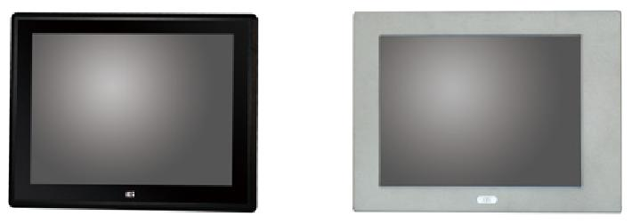

***VS***

**PPC-F15A-H81** **PPC-5150A-H61**

262.2 x 322.2 mm 309 x 410 mm

* **8mm超薄边框设计**

为了提高工业自动化应用的美观体验，PPC-F的前面板深度仅为8mm，最大限度地减小了墙体/面板安装时与系统的间隙，整体式简洁。

* **10 点触屏**

PPC系列支持10点投影电容式触控，操作更加流畅!IEI还提供12“至24”电阻式单屏和投射电容式触摸屏选项，丰富了简单直观的用户体验。

* **FHD工业平板电脑**

应工业平板电脑和显示器产品大屏化是市场趋势。为此，IEI推出了全新的PPC-F系列工业平板电脑，用户可以同时享受FHD面板的高品质图形和丰富的数据显示。

* **完美的前面板**

1. h防刮伤

PPC-F系列配备投射电容触摸屏，采用6H硬度防破坏强化玻璃，防止物理冲击造成的损坏。

前面板IP65防护等级

适用于恶劣环境，PPC-F系列提供前挡板IP65前边框，以抵御灰尘和入内。

**PPC-F15A-H81 vs.PPC-5150A-H61**

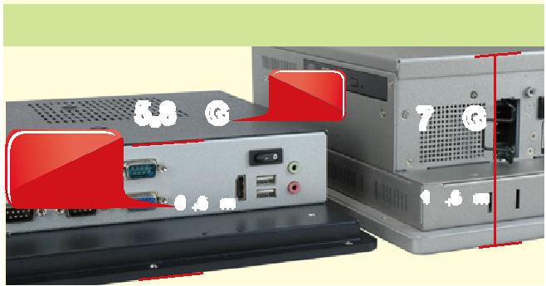

|  |  |  |  |  |  |
| --- | --- | --- | --- | --- | --- |
|  |  |  | **17%** |  |  |
|  | **5.8 KG** | | **lighter** | **7 KG** |  |
| **41%** |  |  |
|  |  |  |  |  |
|  |  |  |  |  |
| **thinner on** |  |  |  |  |  |
| **depth** |  | **65.5mm** |  | **110.5mm** |  |
|  |  |  |  |
|  |  |  |  |  |  |

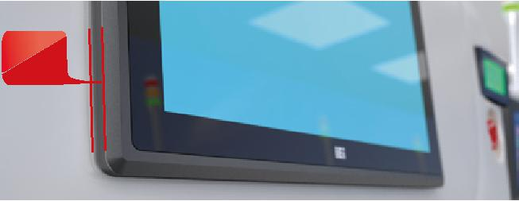

**8mm**

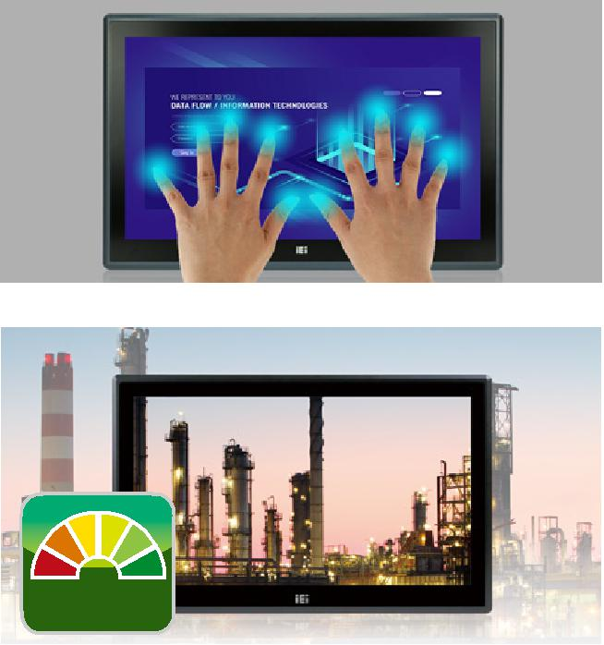

**FHD**

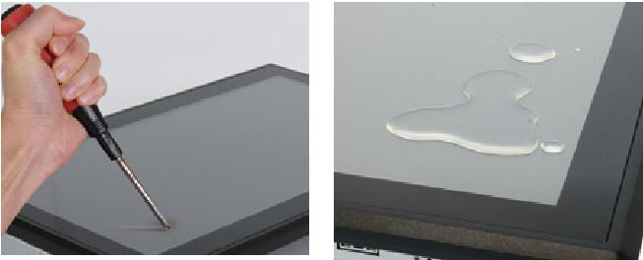

**PPC-F-Intro-2019-V10** **5-53**

***显示系统***

***w w w . i e i w o r l d . c o m***



**■ IEI远程智能管理系统**

PPP-f支持威强电iRIS远程管理，通过单一的管理界面帮助用户管理多个设备，提高工作效率。iRIS解决方案只需要一个模块和互联网连接!(仅针对于PPC-F H81及PPC-F 12B/15B/17B)



Internet

**iRIS Solution** **QNAP NAS**



**完整的物联网**

**解决方案!**

远程电源管理

用户可远程开启/关闭所有iRIS设备，设置电源周期，简化功率控制流程

**ON OFF**

**通过简单设置，统一工业自动化**

**过程!**

|  |  |  |  |  |  |  |  |
| --- | --- | --- | --- | --- | --- | --- | --- |
| 24小时活跃的复苏 |  |  |  |  |  |  |  |
| 远程故障排除无处不在，不再 | **自动错误报警** |  | **视频流和记录** |  | **远程故障排除** | |  |
| 需要派遣维修人员! |  |  |  |
|  |  |  |  |  |  |  |
|  |  |  |  |  |  |  |  |
|  | 当错误发生时，系统将通知通过电子邮件/ |  | 实时记录主屏幕视频故障诊断 |  | 维护人员可通过远程KVM排除错误 |  |  |
|  | 短信发送给指定的成员 |  |  |  |  |  |  |
|  |  |  |  |  |  |  |  |
|  |  |  |  |  |  |  |  |

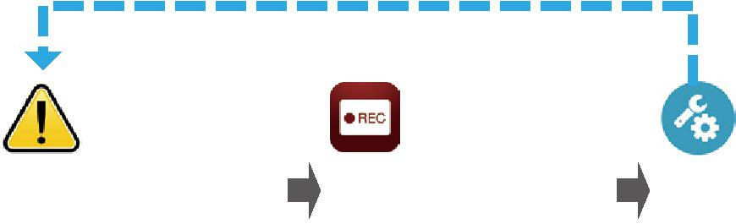

* **内置80 PLUS电源**

80plus电源应用于PPC-F H81系列，减少了电源损耗，提高了电源转换效率。有了该认证电源，交流电源与直流电源的功率转换效率可达85%，功耗仅为15%或更少。对于用户来说，高效的电源转换不仅可以降低成本，还可以减少热损耗。此外，它可以创造一个友好的环境。(仅适用于 PPC-F H81系列)

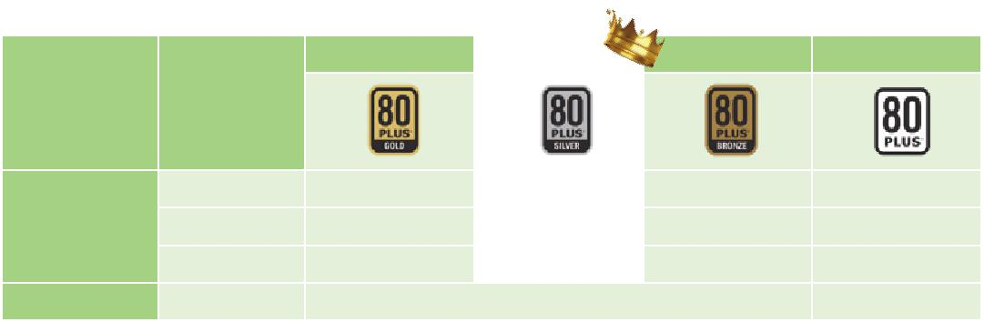

|  |  |  |  |  |  |  |  |
| --- | --- | --- | --- | --- | --- | --- | --- |
|  |  | **Gold** |  | **Silver** |  | **Bronze** | **80 Plus** |
| **参数** | **负载** |  |  |  |  |  |  |
|  | 20% | 87% |  | 85% |  | 82% | 80% |
| **效率** | 50% | 90% |  | 88% |  | 85% | 80% |
|  | 100% | 87% |  | 85% |  | 82% | 80% |
| **功率因素** | 50% |  | 90% (across the full range) | | |  | 90% (@100% Load) |

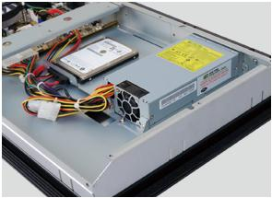

* **PCIe迷你卡扩展**

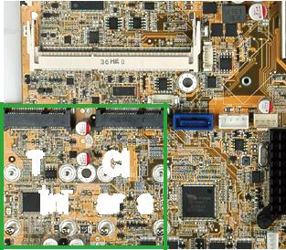

PPC-F系列预留两个全尺寸PCIe迷你卡扩展槽(视机型而定)。IEI PCIe迷你卡解决方案种类繁多，在系统中添加额外功能灵活方便。

**WiFi Module** **LAN Module** **3G Module** **USB3.0 Module** **Capture Card Module**

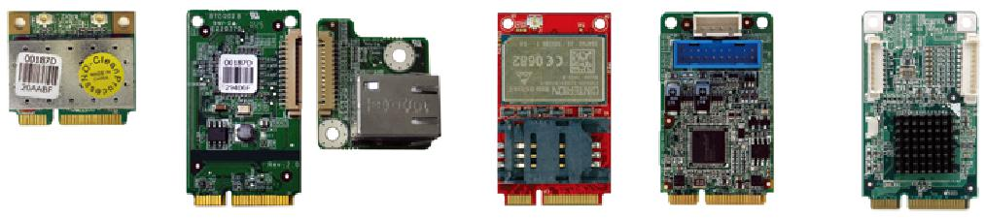

**WIFI-RT3593-DB-R10**

**Two PCIe**

**Mini** **Cards**

**MPCIE-LAN-R10** **MPCIE-3G-R10** **MPCIE-USB3-R10** **IVCME-C604**

**5-54** **PPC-F-Intro-2019-V10**

***显示系统***

***w w w . i e i w o r l d . c o m***



**PPC-F系列选型指南**

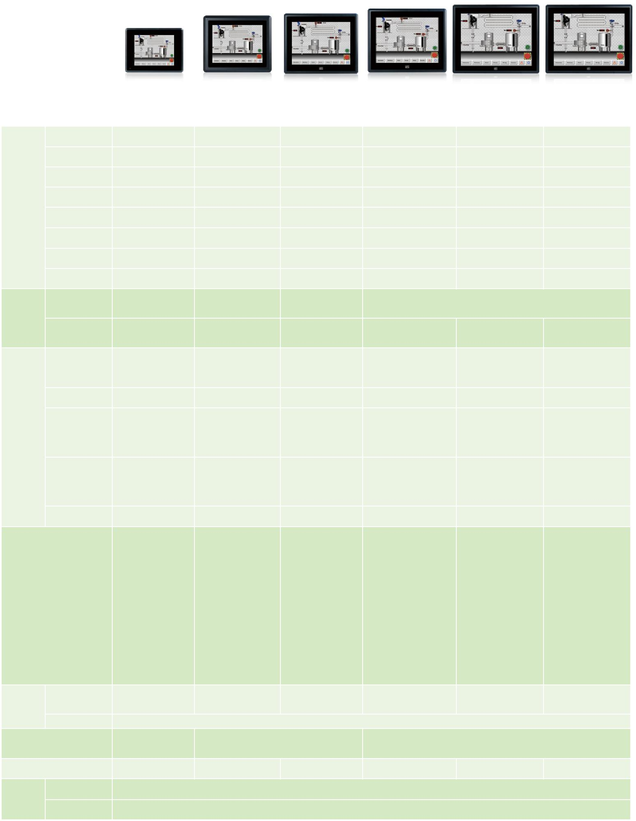

|  |  |  |  |  |  |  |  |  |
| --- | --- | --- | --- | --- | --- | --- | --- | --- |
|  | **LCD 尺寸** | **5.7”** | **8”** | **10.4”** | **12”** | **15”** | |  |
|  | **型号** | **PPC-F06B-BT** | **PPC-F08B-BT** | **PPC-F10B-BT** | **PPC-F12B-BT** | **PPC-F15A-H81** | **PPC-F15B-BT** |  |
|  | LCD 尺寸 | 5.7” (4:3) | 8” (4:3) | 10.4” | 12” (4:3) | 15’’ (4:3) | 15’’ (4:3) |  |
|  | 最大分辨率 | 640 (W) x 480 (H) | 800 (W) x 600 (H) | 800 (W) x 600 (H) | 1024 (W) x 768 (H) | 1024 (W) x 768 (H) | 1024 (W) x 768 (H) |  |
|  | 亮度 (cd/m²) | 550 | 500 | 400 | 600 | 450 | 450 |  |
|  | 对比率 | 800 : 1 | 500 : 1 | 700 : 1 | 700 : 1 | 800 : 1 | 800 : 1 |  |
| 显示 |  |  |  |  |  |  |  |  |
|  | LCD颜色 | 262K | 16.2M | 16.2M | 16.2M | 16.2M | 16.2M |  |
|  | 像素间距 (mm) | 0.18 x 0.18 | 0.2025 x 0.0675 | 0.264 x 0.264 | 0.24 x 0.24 | 0.297 x 0.297 | 0.297 x 0.297 |  |
|  | (HxV) |  |
|  |  |  |  |  |  |  |  |
|  | 可视角度(V/H) | 160**°** / 140**°** | 140**°** / 120**°** | 160**°** / 140**°** | 160**°** / 140**°** | 160**°** / 150**°** | 160**°** / 150**°** |  |
|  | 背光灯 MTBF (hrs) | 50000 | 50000 | 30000 | 50000 | 70000 | 70000 |  |
|  | 触摸屏 | 4-wire resistive type flat | 5-wire resistive type flat | 5-wire resistive type flat | 5-wire resistive single touch window, 3H (Anti-glare Surface) | | |  |
|  | touch window, 3H | touchscreen, 3H | touchscreen, 3H | 10-point Projected capacitive touch window, 6H (Anti-UV, Anti-glare Surface) | | |  |
|  |  |  |
| 触摸 |  |  |  |  |  |  |  |  |
|  | 触摸屏控制器 | PenMount DMC9000 | PenMount DMC9000 | PenMount DMC9000 | Penmount DMC 9000 | Penmount DMC 9000 | Penmount DMC 9000 |  |
|  | EETI EXC3188 | EETI EXC3188 | EETI EXC3188 |  |
|  |  |  |  |  |  |
|  |  | Intel® Celeron® processor | Intel® Celeron® J1900 on- | Intel® Celeron® J1900 |  | 4th generation Intel® |  |  |
|  |  | Intel® Celeron® quad-core | Core™ i7/ i5/i3, Pentium® | Intel® Celeron® quad-core |  |
|  | CPU | N2807, | board SoC, | on-board SoC, |  |
|  | J1900 SoC, 2GHz | and Celeron® processor, | J1900 SoC, 2GHz |  |
|  |  | dual-core, 1.58GHz | quad-core, 2GHz | quad-core, 2GHz |  |
|  |  |  | up to TDP 65W CPU |  |  |
|  |  |  |  |  |  |  |  |
|  | 芯片组 | N/A | N/A | N/A | N/A | N/A | Intel® H81 |  |
|  |  | 2GB DDR3L 1600MHz |  |  | 2 x 204-pin 1066/1333 MHz |  | 2 x 204-pin 1066/1333 |  |
|  |  | on-board RAM | 1 x 204-pin DDR3L SO- | 1 x 204-pin DDR3L SO- | 2 x 204-pin DDR3 SO- |  |
|  | RAM | DDR3L SO-DIMM supported | MHz DDR3L SO-DIMM |  |
| 主板 | (system max. 4GB by | DIMM slot (max. 8GB) | DIMM slot (max. 8GB) | DIMM slots (max. 16GB) |  |
|  | (max. 8GB) | supported (max. 8GB) |  |
|  |  | MOQ=300pcs) |  |  |  |  |
|  |  |  |  |  |  |  |  |
|  |  |  |  |  | 1 x PCIe GbE by Intel® I210 | 1 x PCIe GbE by Intel® I210 1 x PCIe GbE by Intel® I210 | |  |
|  | 以太网 | 2 x RTL 8111E | 2 x RTL 8111E | 2 x RTL 8111E | controller | controller | controller |  |
|  | 1 x PCIe GbE by Intel® I211 | 1 x PCIe GbE by Intel® I217 1 x PCIe GbE by Intel® I211 | |  |
|  |  |  |  |  |  |
|  |  |  |  |  | controller | controller | controller |  |
|  | 音频控制器 | Realtek ALC662 HD | Realtek ALC892 HD codec | Realtek ALC892 HD | Realtek ALC662 HD codec | Realtek ALC662 HD codec | Realtek ALC662 HD codec |  |
|  | codec | codec |  |
|  |  |  |  |  |  |  |
|  |  | 1 x RJ-45 LAN port | 1 x RS-232 COM port | 1 x RS-232 COM port | 2 x RJ-45 LAN port | 2 x RJ-45 LAN Port | 2 x RJ-45 LAN port |  |
|  |  | 1 x RS-232 COM port | (RJ-45 connector) | (RJ-45 connector) | 2 x USB 3.1 Gen 1 (5Gb/s) | 2 x USB 3.1 Gen 1 (5Gb/s) | 2 x USB 3.1 Gen 1 (5Gb/s) |  |
|  |  | (DB-9 connector) | 1 x RS-232/422/485 COM | 1 x RS-232/422/485 | 2 x USB 2.0 | 4 x USB 2.0 | 2 x USB 2.0 |  |
|  |  | (RI/5V/12V) | port (DB-9 connector) | COM port | 1 x HDMI | 1 x HDMI output | 1 x HDMI |  |
|  |  | 1 x RS-422/485 | (RI/5V/12V) | (DB-9 connector) | 2 x RS-232 | 4 x RS-232 | 2 x RS-232 |  |
|  |  | 2 x USB 3.1 Gen 1 | 2 x USB 3.1 Gen 1 (5Gb/s) | (RI/5V/12V) | 1 x RS-232/422/485 | 1 x RS-422/485 | 1 x RS-232/422/485 |  |
|  |  | (5Gb/s) | 2 x GbE LAN | 2 x USB 2.0 | 1 x VGA | 1 x MIC-in | 1 x VGA |  |
| I/O接口和开关 | | 2 x USB 2.0 | 1 x Power switch | 2 x USB 3.1 Gen 1 | 1 x 9 V~36 V DC jack (4-pin) | 1 x Line-out | 1 x 9 V~36 V DC jack |  |
| 1 x 9 V~36 V DC lockable | 1 x Reset button | (5Gb/s) | 1 x 9 V~36 V DC terminal | 1 x VGA output | (4-pin) |  |
|  |  |  |
|  |  | jack (2-pin) | 1 x AT/ATX switch | 2 x GbE LAN | block | 1 x AC/DC power plug | 1 x 9 V~36 V DC terminal |  |
|  |  | 1 x Audio port (line-out) | 1 x Audio port (line-out) | 1 x Power switch | 1 x Power switch | (DC model is by build to | block |  |
|  |  | 1 x Power switch | 1 x 9 V~30 V lockable | 1 x Reset button |  | order manufacturing) | 1 x Line-out |  |
|  |  | 1 x Reset button | power jack | 1 x AT/ATX switch |  | 1 x AT/ATX switch | 1 x Power switch |  |
|  |  | 1 x AT/ATX switch |  | 1 x Audio port (line-out) |  | 1 x Clear CMOS |  |  |
|  |  |  |  | 1 x 9 V~30 V lockable |  | 1 x Reset button |  |  |
|  |  |  |  | power jack |  | 1 x Power switch |  |  |
| 硬盘支架 | HDD 硬盘驱动支架 | N/A | N/A | 1 x 2.5” HDD bay | 1 x 2.5” HDD bay | 1 x 2.5” HDD bay | 1 x 2.5” HDD bay |  |
|  |  |  |  |  |  |  |  |
|  | SSD |  |  |  | mSATA |  |  |  |
|  |  | 1 Full Size PCIe Mini Slot | 1 x Full-size PCIe Mini slot | | 1 x Full-size PCIe Mini card slot | |  |  |
| 扩展插槽 |  | (with mSATA, PCIe/USB | (with mSATA/PCIe/USB signal) | |  |  |
|  | 1 x Full-size PCIe Mini card slot colay mSATA | | |  |
|  |  | Signal) | 1 x Half-size PCIe Mini slot for Wi-Fi modules | |  |
|  |  |  |  |  |  |
| 系统散热 |  | Fanless | Fanless | Fanless | Fanless | Active fan | Fanless |  |
|  | 操作温度 |  |  | -10°C~50°C (14°F~122°F) | |  |  |  |
|  |  |  |  |  |  |  |
| 环境 |  |  |  |  |  |  |  |  |
|  | 存储温度 |  |  | -20°C~60°C (-4°F~140°F) | |  |  |  |

**PPC-F-Intro-2019-V10** **5-55**

***显示系统***

***w w w . i e i w o r l d . c o m***



**PPC-F系列选型指南**

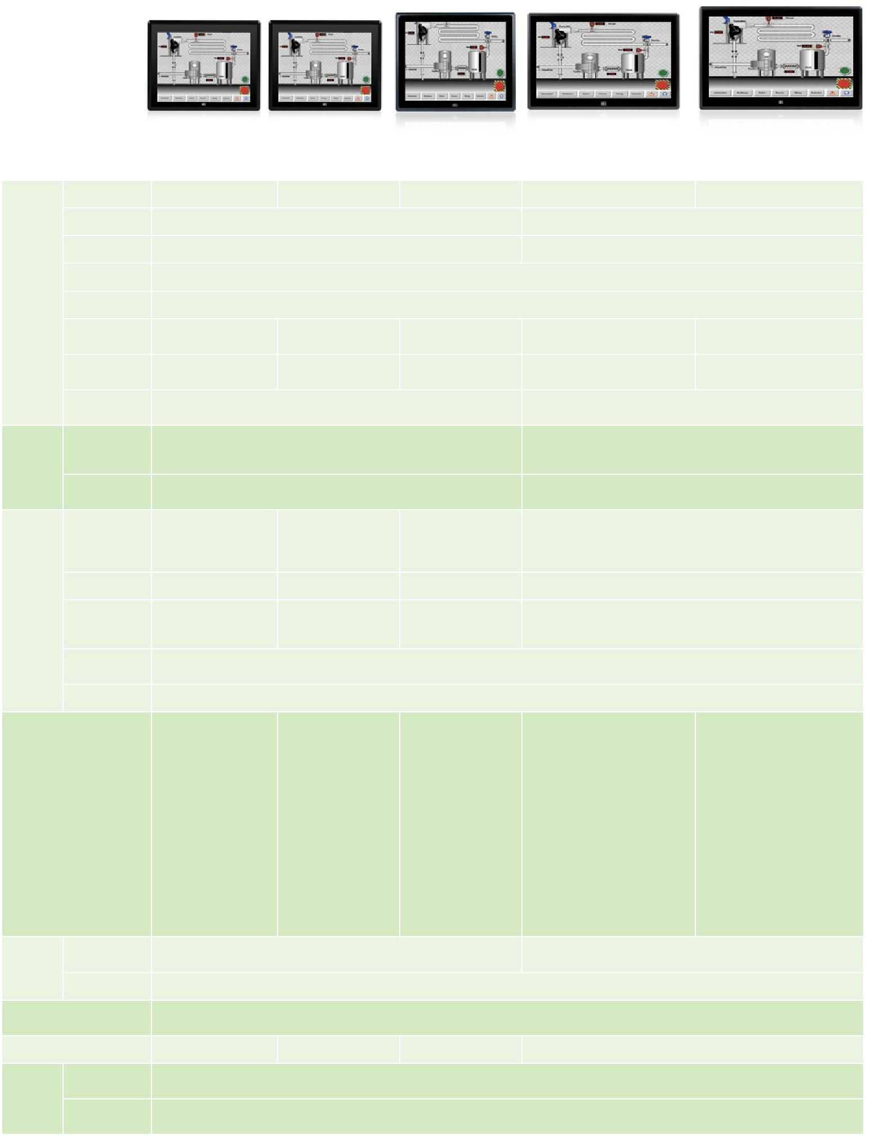

|  |  |  |  |  |  |  |  |
| --- | --- | --- | --- | --- | --- | --- | --- |
|  | **LCD 尺寸** | **17”** | | **19”** | **22”** | **23.8”** |  |
|  | **型号** | **PPC-F17A-H81** | **PPC-F17B-BT** | **PPC-F19B-BT** | **PPC-F22A-H81** | **PPC-F24A-H81** |  |
|  | LCD尺寸 | 17” | 17” | 19” | 22” | 23.8” |  |
|  | 最大分辨率 |  | 1280 (W) x 1024 (H) |  | 1920 (W) x 1080 (H) | |  |
|  | 亮度 (cd/m²) |  | 350 |  |  | 250 |  |
|  | 对比率 |  |  | 1000 : 1 |  |  |  |
| 显示 | LCD 颜色 |  |  | 16.7M |  |  |  |
|  | 像素间距(mm) | 0.26 x 0.26 | 0.26 x 0.26 | 0.294 x 0.294 | 0.25 x 0.25 | 0.28 x 0.28 |  |
|  | (HxV) |  |
|  |  |  |  |  |  |  |
|  | 可视角度 | 170**°** / 160**°** | 170**°** / 160**°** | 170**°** / 160**°** | 165**°** / 165**°** | 178**°** / 178**°** |  |
|  | (V/H) |  |
|  |  |  |  |  |  |  |
|  | 背光灯MTBF |  | 50000 |  |  | 30000 |  |
|  | (hrs) |  |  |  |  |
|  |  |  |  |  |  |  |
|  | 触摸屏 | 5-wire resistive single touch window, 3H (Anti-glare Surface) | | | 10-point Projected capacitive touch window, 6H | |  |
|  | 10-point Projected capacitive touch window, 6H (Anti-UV, Anti-glare Surface) | | | (Anti-UV, Anti-glare Surface) | |  |
| 触摸 |  |  |
|  |  |  |  |  |  |  |
|  | 触摸屏控制器 |  | Penmount DMC 9000 |  |  | EETI EXC3188 |  |
|  |  | EETI EXC3188 |  |  |  |
|  |  |  |  |  |  |  |
|  |  | 4th generation Intel® Core™ |  | Intel® Celeron® processor |  |  |  |
|  | CPU | i7/ i5/ i3, Pentium® and | Intel® Celeron® quad-core | 4th generation Intel® Core™ i7/ i5/ i3, Pentium® and Celeron® processor, up to | |  |
|  | Celeron® processor, up to | J1900 SoC, 2GHz | J1900 (2M cache, up to |  | TDP 65W CPU |  |
|  |  | 2.42 GHz) |  |  |
|  |  | TDP 65W CPU |  |  |  |  |
|  |  |  |  |  |  |  |
|  | 芯片组 | Intel® H81 | N/A |  |  | Intel® H81 |  |
| 主板 |  | 2 x 204-pin DDR3 SO-DIMM | 2 x 204-pin 1066/1333 | 2 x 204-pin DDR3L SO- |  |  |  |
|  | RAM | DDR3L SO-DIMM | DIMM slot (max. 8GB), pre- | 2 x 204-pin DDR3 SO-DIMM slots (max. 16GB) | |  |
|  | slots (max. 16GB) |  |
|  |  | supported (max. 8GB) | installed with 2GB |  |  |  |
|  |  |  |  |  |  |
|  | 以太网 |  |  | 1 x PCIe GbE by Intel® I210 controller | |  |  |
|  |  |  | 1 x PCIe GbE by Intel® I211 controller | |  |  |
|  |  |  |  |  |  |
|  | 音频控制器 |  |  | Realtek ALC662 HD codec | |  |  |
|  |  | 2 x RJ-45 LAN Port | 2 x RJ-45 LAN port | 2 x RJ-45 LAN port | 2 x RJ-45 LAN Port | 2 x RJ-45 LAN Port |  |
|  |  | 2 x USB 3.1 Gen 1 (5Gb/s) | 2 x USB 3.1 Gen 1 (5Gb/s) | 2 x USB 3.1 Gen 1 (5Gb/s) | 2 x USB 3.1 Gen 1 (5Gb/s) | 2 x USB 3.1 Gen 1 (5Gb/s) |  |
|  |  | 4 x USB 2.0 | 2 x USB 2.0 | 2 x USB 2.0 | 4 x USB 2.0 | 4 x USB 2.0 |  |
|  |  | 1 x HDMI output | 1 x HDMI | 1 x HDMI | 1 x HDMI output | 1 x HDMI output |  |
|  |  | 4 x RS-232 | 2 x RS-232 | 2 x RS-232 | 4 x RS-232 | 4 x RS-232 |  |
|  |  | 1 x RS-422/485 | 1 x RS-232/422/485 | 1 x RS-232/422/485 | 1 x RS-422/485 | 1 x RS-422/485 |  |
|  |  | 1 x MIC-in | 1 x VGA | 1 x VGA | 1 x MIC-in | 1 x MIC-in |  |
| I/O 接口和开关 | | 1 x Line-out | 1 x DC jack (4-pin) | 1 x 9 V~36 V DC jack | 1 x Line-out | 1 x Line-out |  |
| 1 x VGA output | 1 x Terminal block | (4-pin) | 1 x VGA output | 1 x VGA output |  |
|  |  |  |
|  |  | 1 x AC/DC power plug | 1 x Microphone & speaker | 1 x 9 V~36 V DC terminal | 1 x AC/DC power plug | 1 x AC/DC power plug |  |
|  |  | (DC model is by build to | 1 x power switch | block | (DC model is by build to order | (DC model is by build to order |  |
|  |  | order manufacturing) |  | 1 x Line-out | manufacturing) | manufacturing) |  |
|  |  | 1 x AT/ATX switch |  | (PPC-F15B & PPC-F17B & | 1 x AT/ATX switch | 1 x AT/ATX switch |  |
|  |  | 1 x Clear CMOS |  | PPC-F19B only) | 1 x Clear CMOS | 1 x Clear CMOS |  |
|  |  | 1 x Reset button |  | 1 x Power switch | 1 x Reset button | 1 x Reset button |  |
|  |  | 1 x Power switch |  |  | 1 x Power switch | 1 x Power switch |  |
|  | HDD 硬盘驱动支架 | 1 x 2.5” SATA HDD bay with anti-shook | | | 1 x 2.5” SATA HDD bay with anti-shook | |  |
|  | or 1 x 3.5” SATA HDD bay with anti-shook | |  |
| 硬盘支架 |  |  |  |  |  |
|  |  |  |  |  |  |  |
|  | SSD |  |  | mSATA |  |  |  |
| 扩展插槽 |  |  |  | 1 x Full-size PCIe Mini card | |  |  |
|  |  |  | 1 x Full-size PCIe Mini card co-lay mSATA | |  |  |
|  |  |  |  |  |  |
| 系统散热 |  | Active fan | Fanless | Fanless |  | Active fan |  |
|  | 操作温度 |  |  | -10°C~50°C (14°F~122°F) | |  |  |
|  |  |  |  |  |  |
| 环境 | 存储温度 |  |  |  |  |  |  |
|  |  |  | -20°C~60°C (-4°F~140°F) | |  |  |
|  |  |  |  |  |  |

**5-56** **PPC-F-Intro-2019-V10**