工业电脑机箱

w w w . i e i w o r l d . c o m . c n

RACK-3000G 4U 14个插槽全长卡 机架式机箱
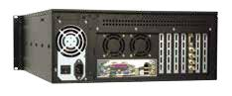

重启键 电源 LED HDD LED 前置式 3.5”或 3.5” 硬盘支架
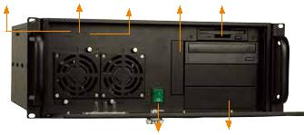

RACK-3000GBATX
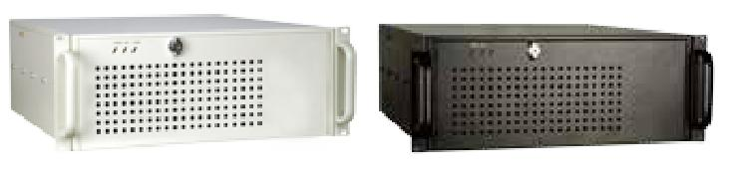

电源开关 | 3 x 5.25”

产品包装中不包含CD-ROM 和 HDD

特性

- 符合 RoHS 标准设计

- 兼容 ATX 和 microATX 主板

- 3 个 5.25”和 3 个 3.5”驱动器

- 2 个 8 cm 冷却风扇

- 前面板带锁设置防止未授权访问

规格
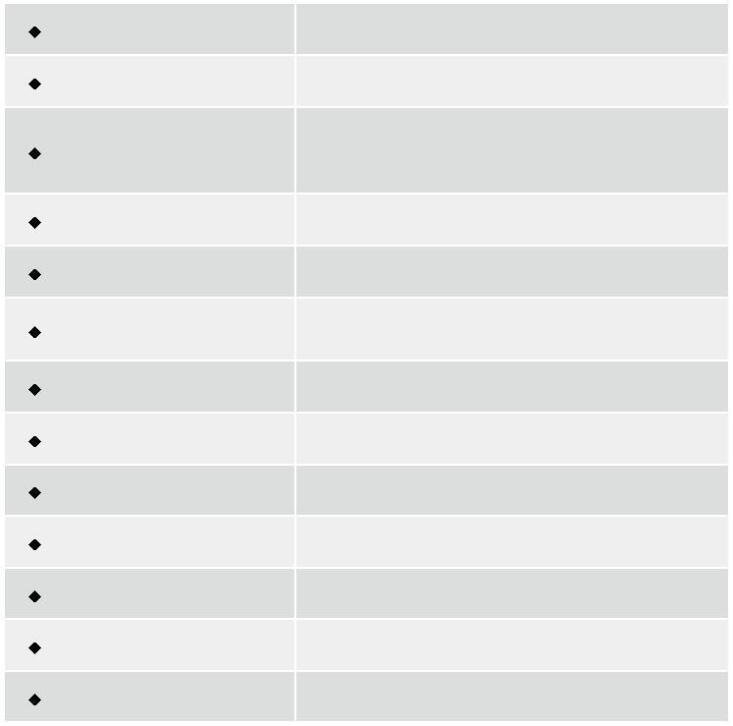

材质 | 重型金属
主板规格 | 全长CPU卡
 | 3 x 5.25" + 1 x front-accessible 3.5" + 2 x 3.5" HDD
驱动器 | or 3 x 5.25” + 2 x front-accessible 3.5” + 1 x 3.5”
 | HDD or 3 x 5.25” + 3 x 3.5” HDD
散热风扇 | 2 x 8 cm
I/O 开口 | 2 x COM, 2 x LPT, 1 x PS2
扩展槽 | 14 slots for RACK-3000G
 | 7 slots for RACK-3000GATX
指示灯 | Power, HDD
按钮 | 电源开关, 重启键
操作温度 | 0°C ~ 50°C
操作湿度 | 10% ~ 90%
颜色 | W: 白色/B: 黑色
净重/毛重 | 13 kg/18 kg
尺寸(DxWxH) | 520 mm x 431 mm x 176 mm

订购信息
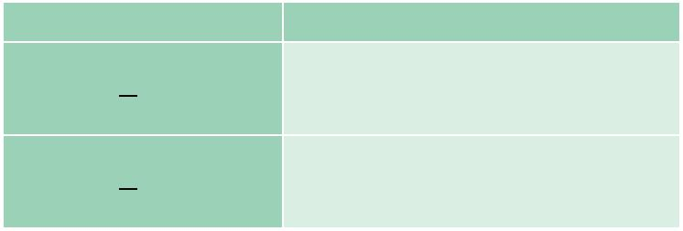

料号 | 描述

4U 14-slot rackmount chassis, (black/white),

RACK-3000G -R21/A130B 2 x 8 cm fan, with ACE-A130B-R10 (300W ATX model), RoHS

4U ATX motherboard rackmount chassis, (black/

RACK-3000G ATX-R21/A130B white), 2 x 8 cm fan, with ACE-A130B-R10 (300W ATX model), RoHS

颜色 Code: B-黑色 W-白色

RACK-3000GW RACK-3000GB

尺寸 ( 单位 : mm)
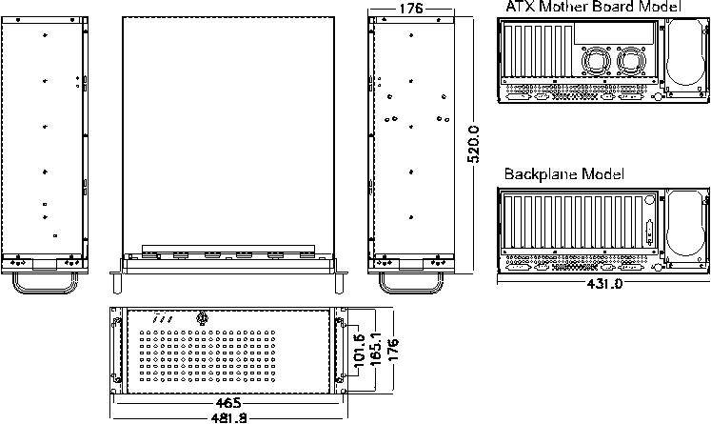

底板 ( 选配 )

型号 | SBC Type | PCI | ISA | PCIX |  | PCle |  | PSU 接口
 |  |  |  |  | x1 | x4 | x16
BP-14S-RS | ISA | 0 | 14 | 0 | 0 | 0 | 0 | AT
PCI-13SD-RS | PICMG 1.0 | 3+4 | 3+3 | 0 | 0 | 0 | 0 | AT/ATX
PCI-14S2-RS | PICMG 1.0 | 4 | 8 | 0 | 0 | 0 | 0 | AT/ATX
PCI-14S3-RS | PICMG 1.0 | 4 | 9 | 0 | 0 | 0 | 0 | AT/ATX
PX-14S3-RS | PICMG 1.0 | 12 | 2 | 0 | 0 | 0 | 0 | AT/ATX
PX-14S5-RS | PICMG 1.0 | 7 | 6 | 0 | 0 | 0 | 0 | AT/ATX
PE-6S | PICMG 1.3 | 2 | 0 | 0 | 2 | 0 | 1 | ATX
PE-10S | PICMG 1.3 | 4 | 0 | 0 | 4 | 0 | 1 | ATX
PE-10S2 | PICMG 1.3 | 4 | 0 | 0 | 4 | 0 | 1 | ATX
PXE-12S | PICMG 1.3 | 4 | 0 | 6 | 0 | 0 | 1 | ATX
PE-13SD | PICMG 1.3 | 4 | 0 | 0 | 4 | 1 | 2 | ATX
PXE-13S | PICMG 1.3 | 8 | 0 | 0 | 3 | 0 | 1 | ATX
SPXE-14S | PICMG 1.3 | 0 | 0 | 0 | 12 | 0 | 0 | ATX

电源 ( 选配 )

类型 | 型号 | 功率
AT | ACE-935AL-RS | 300W
 | ACE-T140A-RS | 400W
 | ACE-A130B-R10 | 300W
ATX | ACE-A140A-S-R11 | 400W
 | ACE-A160A-R11 | 600W
ATX Redundant | ACE-R4130AP-RS | 300W
 | ACE-R4140AP-RS | 400W

RACK-3000G supports single PS/2 PSU. For more IEI PSU models, please refer to section 5 or visit www.ieiworld.com.

RACK-3000G-2019-V10

