

*工业电脑机箱*



*w w w . i e i w o r l d . c o m . c n*



PAC-125G 10 个插槽全长卡紧凑式机箱

HDD LED



产品包装中不包含CD-ROM 和 HDD

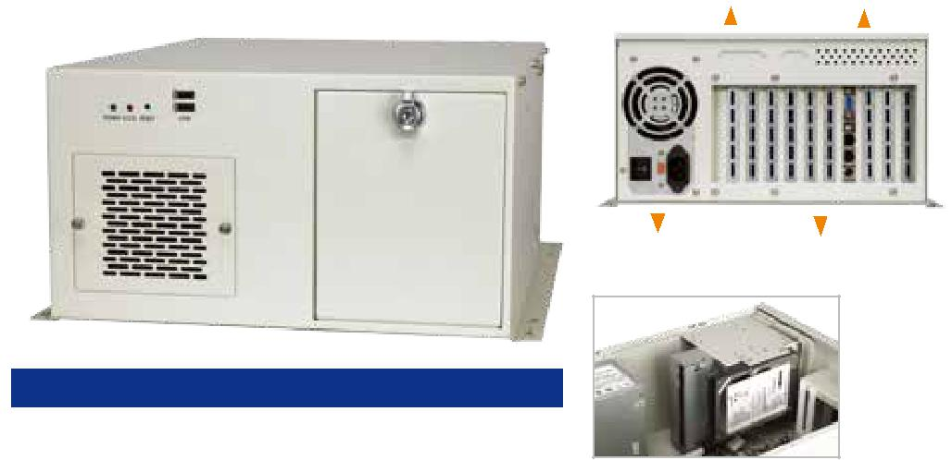

*特性*

* 符合 RoHS 标准设计
* 前面板设有 2 个 USB 接口
* 1 个 8 cm 热插拔冷却风扇设有过滤器
* 2 x 5.25”, 1 x 3.5”HDD, 1 x 前置 3.5”
* 前面板带锁设置防止未授权打开

*规格*

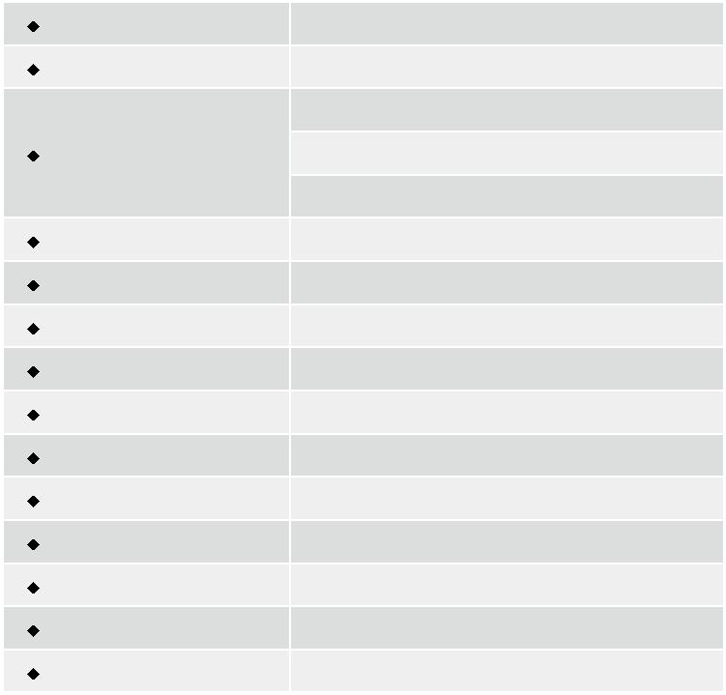

|  |  |
| --- | --- |
| 材质 | 重型金属 |
| 主板规格 | 全长CPU卡 |
|  | 2 x 5.25” |
| 驱动器 | 1 x Front accessible 3.5” |
|  | 1 x 3.5” HDD |
| 散热风扇 | 80mm x 80mm x 25mm |
| I/O 接口 | 2 x USB |
| I/O 开口 | 1 x LPT, 1 x COM |
| 扩展槽 | 10 slots |
| 指示灯 | Power, HDD |
| 按钮 | 电源开关, 重启 |
| 操作温度 | 0°C ~ 50°C |
| 操作湿度 | 10% ~ 90% |
| 颜色 | W: 白色 |
| 净重/毛重 | 7.2 kg/10.4 kg |
| 尺寸(DxWxH) | 420 mm x 321 mm x 176 mm |

|  |  |  |  |  |  |  |  |  |  |  |  |  |  |  |  |  |  |  |  |
| --- | --- | --- | --- | --- | --- | --- | --- | --- | --- | --- | --- | --- | --- | --- | --- | --- | --- | --- | --- |
| LPT/COM 开口 | | | | 通风口 | | | | | 电源 LED | | 重启键 | | | | | | 2 x USB 接口 | | |
|  |  |  |  |  |  |  |  |  |  |  |  |  |  |  |  |  |  |  |  |
|  |  |  |  |  |  |  |  |  |  |  |  |  |  |  |  |  |  |  |  |
|  |  |  |  |  |  |  |  |  |  |  |  |  |  |  |  |  |  |  |  |
|  |  |  |  |  |  |  |  |  |  |  |  |  |  |  |  |  |  |  |  |
|  |  |  |  |  |  |  |  |  |  |  |  |  |  |  |  |  |  |  |  |
|  |  |  |  |  |  |  |  |  |  |  |  |  |  |  |  |  |  |  |  |

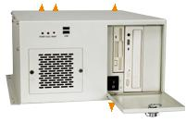

PS/2 PSU 10 扩展槽 电源开关

1 x 3.5” HDD

*尺寸 ( 单位 : mm)*

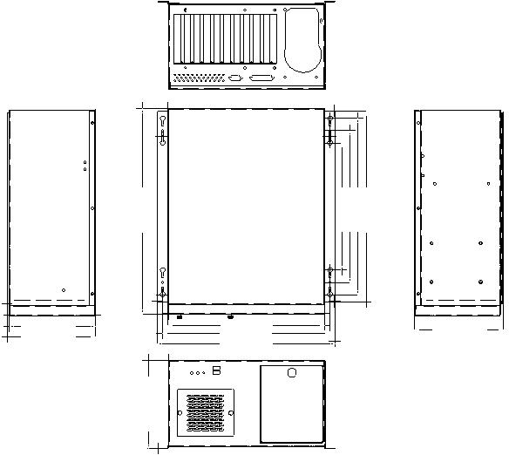

|  |  |  |  |  |  |  |  |  |  |  |
| --- | --- | --- | --- | --- | --- | --- | --- | --- | --- | --- |
|  | 420mm |  |  |  | 260mm310mm360mm390mm |  |  |  |  |  |
| 176.0mm |  |  | 321mm |  |  |  |  | 180.8mm |  |  |
| 180.8mm |  |  | 342mm |  |  |  |  |  |  |  |
|  |  |  | 362mm |  |  |  |  |  |  |  |
|  | 8mm180. |  |  |  |  |  |  |  |  |  |
| *底板 ( 选配 )* | |  |  |  |  |  |  |  |  |  |
| 型号 | SBC 类型 | PCI | ISA | PCIX |  | PCle | |  | PSU 接口 |  |
| x1 | x4 | x8 | x16 |  |
|  |  |  |  |  |  |  |
| BP-10S-RS | ISA | 0 | 10 | 0 | 0 | 0 | 0 | 0 | AT |  |
| PCI-10S-RS | PICMG 1.0 | 4 | 5 | 0 | 0 | 0 | 0 | 0 | AT/ATX |  |
| PX-10S-RS | PICMG 1.0 | 7 | 3 | 0 | 0 | 0 | 0 | 0 | AT/ATX |  |
| IP-8S-RS | PCISA | 4 | 3 | 0 | 0 | 0 | 0 | 0 | AT/ATX |  |
| IP-10S-RS | PCISA | 4 | 5 | 0 | 0 | 0 | 0 | 0 | AT/ATX |  |
| IPX-9S-RS | PCISA | 8 | 0 | 0 | 0 | 0 | 0 | 0 | AT/ATX |  |
| HPE-8S | PCI/PICOe | 4 | 0 | 0 | 2 | 0 | 0 | 0 | ATX |  |
| PE-6S | PICMG 1.3 | 2 | 0 | 0 | 2 | 0 | 0 | 1 | ATX |  |
| PE-8S¹ | PICMG 1.3 | 3 | 0 | 0 | 3 | 0 | 0 | 1 | ATX |  |
| SPXE-9S | PICMG 1.3 | 2 | 0 | 2 | 0 | 2 | 1 | 0 | ATX |  |
| SPE-9S | PICMG 1.3 | 3 | 0 | 0 | 0 | 3 | 1 | 0 | ATX |  |



*仅限 R20 或以上最版本支持 PICMG 1.3 底板

*订购信息*



|  |  |  |
| --- | --- | --- |
| 料号 | 描述 |  |
| PAC-125GW-R22/A130B | 10-slot full-size compact chassis, white, 1 x 8cm fan, |  |
| with ACE-A130B-R10 (300W ATX model), RoHS |  |
|  |  |
| PAC-125GW-R22/ACE-925AP | 10-slot full-size chassis, white, with ACE-925AP PSU |  |
| (200W), RoHS |  |
|  |  |

*电源 ( 选配 )*



|  |  |  |  |
| --- | --- | --- | --- |
| 类型 | 型号 | 功率 |  |
|  |  |  |  |
| AT | ACE-925AP-U-RS | 250W |  |
| ACE-935AL-RS | 300W |  |
|  |  |
|  | ACE-A130B-R10 | 300W |  |
| ATX | ACE-A140A-S-R11 | 400W |  |
|  | ACE-A160A-R11 | 600W |  |

PAC-125G 支持单个 PS/2 PSU。想了解威强电更多的电源产品 ，请参考章节 5 或直接访问 www.ieiworld.com.cn



PAC-125G-2019-V10