

*工业电脑机箱*

 *w w w . i e i w o r l d . c o m . c n* EBC-3000 Mini-ITX 机箱, 适用于高功耗应用

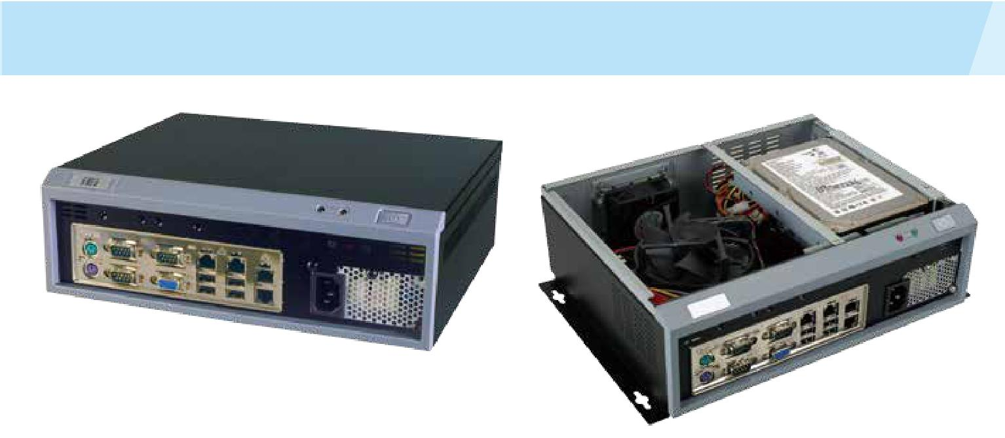

*特性*

* 高性能应用设计提供 270 W 高功率 ATX 电源
* 前面板 I/O 设计
* 1 个 3.5”硬盘驱动

|  |  |  |  |  |
| --- | --- | --- | --- | --- |
| *规格* |  | *尺寸 ( 单位 : mm)* |  |  |
| 型号 |  | EBC-3000 |  |  |
| 平台 |  | 仅机箱 |  |  |
|  | 颜色 | 黑色 |  |  |
|  | 尺寸 ( (WxDxH) (mm) | 280 x 230 x 88 |  |  |
| 机箱 |  |  | 00160. |  |
|  | 系统风扇 (WxDxH) (mm) | 60 x 60 x 25 |  |
|  |  |  |
|  | 机箱材质 | 重型金属，塑料前面板 | 20.00 |  |
|  | 主板型号 | Refer to KINO Series |  |
|  |  |  |
| 主板 |  |  |  |  |
|  | 主板尺寸 (mm) | Mini-ITX (170 x 170) |  |  |
| 存储 | 硬盘驱动器 | 1 x 3.5" SATA HDD space | 296.00 |  |
|  |  |
|  | 电源输入 | 90 V~264 V AC | 280.00 |  |
|  |  |  |
| 电源 |  |  |  |  |
|  | Power Model | ACE-A618A 180W, ACE-A627A 270W | 88.00 |  |
|  | 安装方式 | Desktop, wall mount |  |
| 可靠性 | 操作温度 | 0°C ~ 50°C |  |  |
|  |  | 230.00 | 312.00 |  |
|  | 净重 / 毛重 | 2.5 kg/3.9 kg |  |  |

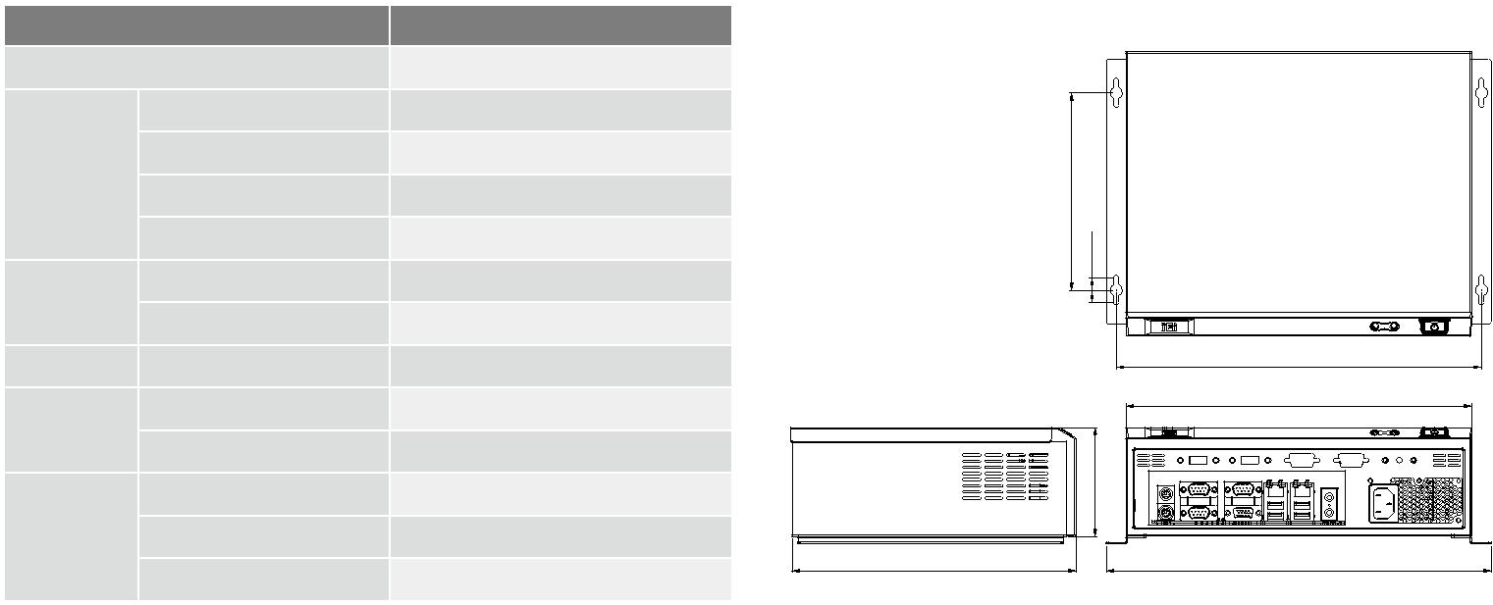

*兼容 SBC*

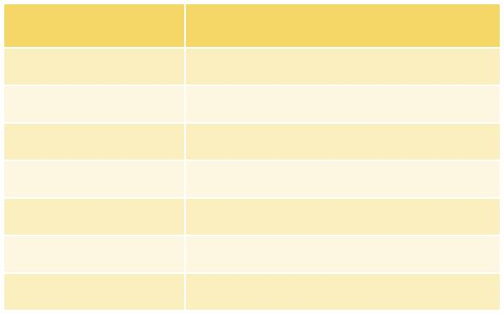

|  |  |
| --- | --- |
| 料号 | 推荐 CPU 风扇 |
| KINO-AQ170 | CF1156A-RS, CF-1156C-RS, CF-1156D-RS |
| KINO-ABT | 无风扇 |
| KINO-AA750-i2 | CF-989B-RS |
| KINO-AQ870 | CF-1150SC-RS |
| KINO-AQ670 | CF1156A-RS, CF-1156C-RS, CF-1156D-RS |
| KINO-AH611 | CF1156A-RS, CF-1156C-RS, CF-1156D-RS |
| KINO-AH612 | CF1156A-RS, CF-1156C-RS, CF-1156D-RS |

1U AC 输入

|  |  |  |  |  |  |  |  |  |  |  |  |
| --- | --- | --- | --- | --- | --- | --- | --- | --- | --- | --- | --- |
|  |  |  | 功率 |  |  | 输出电流范围 | |  |  |  |  |
|  | 产品 | 型号 | AT/ATX | 输入电压 |  |  |  |  |  | 效率 |  |
|  | +3.3 V | +5 V | +12 V | -12 V | +5 |  |
|  |  |  | PFC |  |  |  |
|  |  |  |  | Vsb |  |  |
|  |  | ACE-A630B | 300W | 90~265 | 16A | 15A | 0.5A | 0.8A | 3A | 82% |  |
|  |  | ATX | VAC | (0.5A min.) | (0.5A min) |  |
|  |  |  |  |  |  |  |  |
|  |  |  |  |  |  |  |  |  |  |  |  |
|  |  | ACE-A618B | 180W | 90~264 | 10A | 14A | 10A | 0.3A | 2.5A | 85% |  |
|  |  | ATX | VAC | (0.1A min) | (0.2A min.) | (0.6A min.) |  |
|  |  |  |  |  |  |  |  |  |  |  |  |

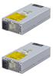

*订购信息*



|  |  |
| --- | --- |
| 料号 | 描述 |
| EBC-3000-R12/ACE-A618B | Mini-ITX embedded chassis, one 3.5” hard driver bay, with ACE-A618B-RS 180W ATX power supply, black |
| EBC-3000-R12/ACE-A630B | Mini-ITX embedded chassis, one 3.5” hard driver bay, with ACE-A630B-RS 300W ATX power supply, black |

*包装清单*



|  |  |  |
| --- | --- | --- |
| 1 x system fan | 1 x Screw set | 1 x QIG |
| 1 x Power cord | 1 x Wall mount kit |  |



EBC-3000-2019-V10