工业电脑机箱

w w w . i e i w o r l d . c o m . c n EBC-3220 IEI 单电压输入 Mini-ITX SBC 紧凑型嵌入式机箱

Mini-ITX
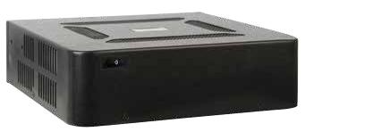

特性

● 搭配单电压输入 Mini-ITX SBC

● 严苛的空间应用

● 1个 2.5”硬盘空间

● 成本效益好，符合 RoHS 标准的设计

规格
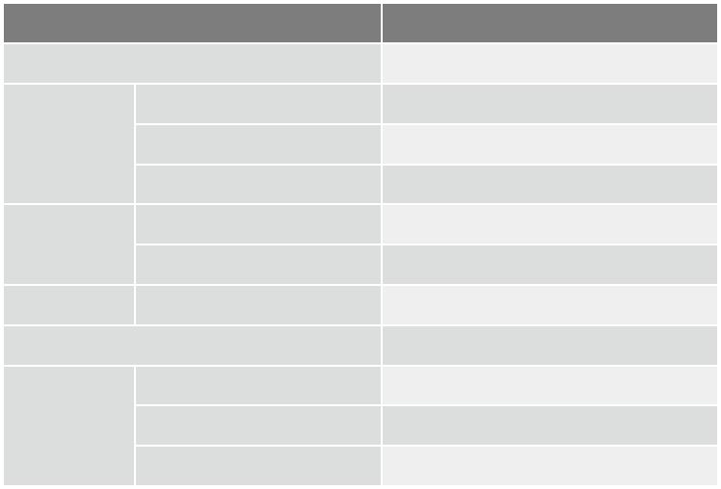

型号 |  |  | EBC-3220
平台 |  |  | 仅机箱
 | 颜色 |  | 黑色
机箱 | 尺寸 ( (WxDxH) (mm) |  | 190 x 180 x 55
 | 系统风扇 (WxDxH) (mm) |  | 40 x 40 x 10 (optional)
主板 | 主板型号 |  | Refer to KINO Series
 | 主板尺寸 (mm) |  | Mini-ITX (170 x 170)
存储 | 硬盘驱动器 |  | 1 x 2.5" HDD bracket
按钮 |  |  | 电源开关
 | 安装方式 |  | Desktop, wall mount, VESA mount
可靠性 | 操作温度 |  | -10°C ~ 50°C with air flow*
 | 净重 / 毛重 |  | 1 kg/2 kg
*Ambient air speed follows IEC-68-2-2 standard
兼容 Mini-ITX SBC
料号 |  | 推荐 CPU 风扇
tKINO-BW |  | 无风扇
KINO-DQM170 |  | 19100-000203-00-RS (suitable for 25W CPU)
KINO-DH810 |  | CF-1156A-RS, CF-1156C-RS, CF-1156D-RS
KINO-DBT |  | 无风扇
eKINO-BT |  | 无风扇
KINO-DA750-i2 |  | CF-989B-RS
KINO-KBN/SE-i2 |  | GX-424CC & GX415GA with fan
KINO-DQM871-i1 |  | 19100-000203-00-RS
KINO-DH610 |  | CF-1156A-RS, CF-1156C-RS, CF-1156D-RS
KINO-QM770 |  | CF-989A-RS
KINO-QM670 |  | CF-989A-RS
KINO-QM57A |  | CF-989A-RS, CF-989B-RS
KINO-HM551 |  | CF-989A-RS
KINO-CV/D2550/N26001 |  | 无风扇
KINO-PV-D4252/D5252 |  | 19FFD124010HB2A7-000001-RS
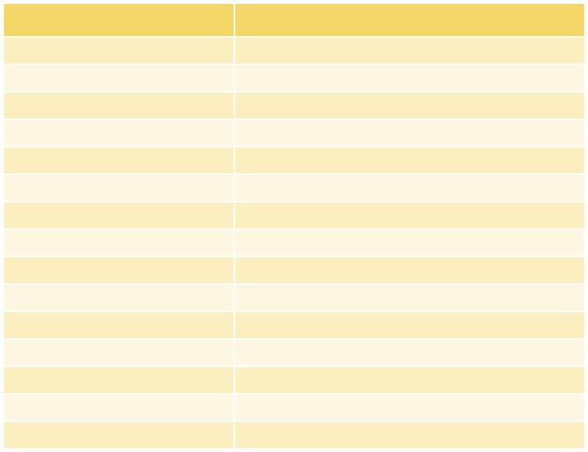

尺寸 ( 单位 : mm)
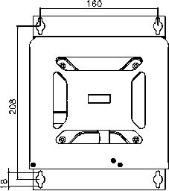
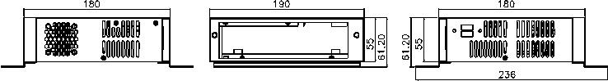
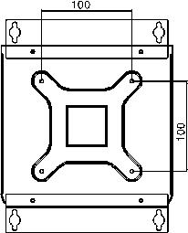

订购信息

料号 | 描述
EBC-3220-R11 | Mini-ITX embedded chassis, for DC input model only, with
 | one 2.5" HDD bracket, w/o power adapter, black, RoHS

包装清单

1 x QIG | 1 x Wall mount bracket kit | 1 x Screw set

可选配件
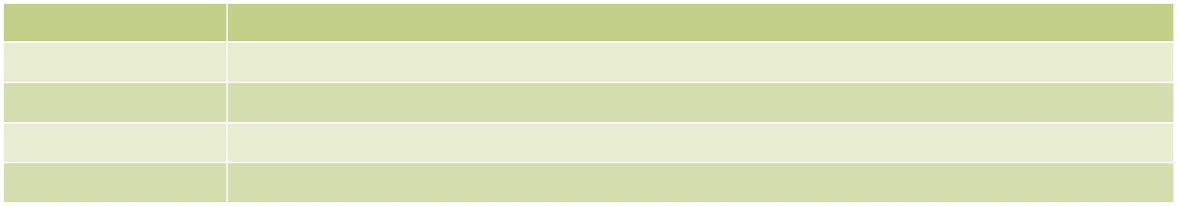

料号 | 描述
32001-010800-100-RS | Dual port USB cable, 200mm, w/o bracket
63040-010060-110-RS | Power adapter, FSP060-DIBAN2, 90 V~264 | V AC, 60W, 1500mm, 12 | V DC, Din 4-pin/lock, CCL, ErP, PSE,RoHS
63040-010084-010-RS | Power adapter, FSP084-DIBAN2, 90 V~264 | V AC, 84W, 1800mm, 12 | V DC, Din 4-pin/lock, CCL, ErP, RoHS
19FR124010BL-000003-RS | Fan module, L=200mm, 4cm, 3-pin, CCL, RoHS

EBC-3220-2019-V10

