

***工业系统***



ITG-100-AL

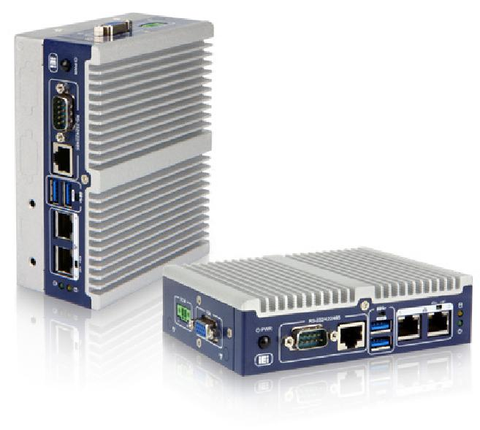

***w w w . i e i w o r l d . c o m***



* ***尺寸超紧凑***
* ***无风扇DIN导轨安装嵌入式系统***
* ***Intel®Atom x5-E3930 1.3GHz (up to 1.8GHz)***

***特征***

* Intel®Atom™ x5-E3930 1.3GHz (up to 1.8 GHz)
* 2个千兆网口
* **2**个 RS-232/422/485口
* 全尺寸 Mini PCIe 插槽和 M.2 扩展接口



|  |  |  |  |  |  |  |
| --- | --- | --- | --- | --- | --- | --- |
|  | ***USB*** |  |  |  |  |  |
| **Fanless** | **USB 3.1** | **Dual LAN** | **RS-232** | **M.2** | **PCIe Mini** |  |
| **Gen 1** | **/422/485** | **Expansion** |  |

***智能网关***

ITG-100-AL配备了基本的I/O端口，支持宽温，在智能工厂应用中是一台数据采集的网关。

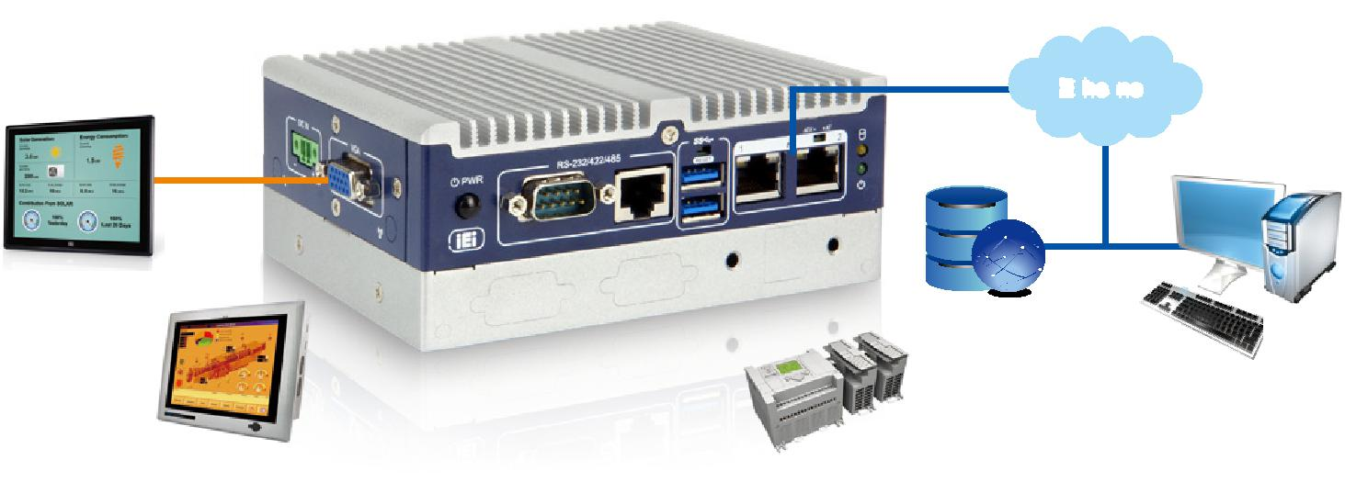

**Ethernet**

|  |  |  |  |  |  |
| --- | --- | --- | --- | --- | --- |
| VGA |  |  |  |  |  |
|  |  |  | Database | PC/ERP |  |
|  |  |  |  |  |
|  | RS-232/422/485 |  | |  |  |
| HMI |  |  | PLC |  |  |
|  |  |  |  |

|  |  |  |  |  |  |  |  |  |  |  |  |
| --- | --- | --- | --- | --- | --- | --- | --- | --- | --- | --- | --- |
| ***广泛的适用场合*** |  |  |  |  | ***多层结构*** |  | | | |  |  |
| 鉴于ITG-100-AL的实际特点，它可以应用于军事、工业自动化和交通 | | | |  | 通过选装I/O接口模块或2.5” SATA HDD/SSD托架以实现I/O接口或数据 | | | | | |  |
| 控制等多种应用领域。 |  |  |  |  | 存储扩展。ITG-100-AL可以模块化，以最适合用户的需求，并且仍然保 | | | | | |  |
|  |  |  |  |  | 持紧凑的尺寸。 | | | | | |  |
| Military | Industrial Automation | | Traffic control |  |  |  |  |  |  |  |  |
|  |  |  |  |  |  |  |  |  | 36.2 mm | |  |
|  |  |  |  |  |  |  |  |  |  |
|  |  |  |  |  |  |  |  |  |  |
|  |  |  |  |  |  |  |  |  |  |  |  |
|  |  |  |  |  |  |  |  |  |  |  |  |

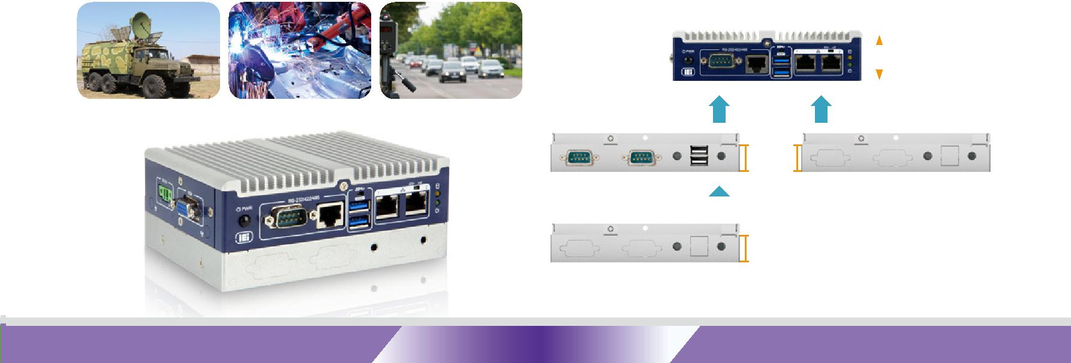

20 mm

|  |  |  |  |
| --- | --- | --- | --- |
| expansion I/O |  | 2.5’’ SATA HDD/SSD |  |
|  |  |
|  |  |  |  |

20 mm

**ITG-100-AL-2019-V10** **10-63**



***Industrial System***

|  |  |  |  |  |  |  |  |
| --- | --- | --- | --- | --- | --- | --- | --- |
|  |  |  |  |  | ***w w w . i e i w o r l d . c o m*** | | |
| ***功能扩展*** |  |  |  | ***超紧凑尺寸*** |  |  |  |
| 为**了**满**足系统增加更多功能的需求，ITG-100-AL设**计**了一个**为**3G/4G**预 | | | | 空间限制是当今工业环境中常见的制约因素之一。在严格的限制 | | | |
| **留的全尺寸mini PCIe插槽和一个**为**WiFi**预**留的M.2 插槽，以方便功能** | | | | 下，ITG-100-AL不仅提供手掌大小的设计以满足空间需求，而且还为各 | | | |
| 扩**展。** | | | | 种应用提供了足够的I/O接口。 | | | |

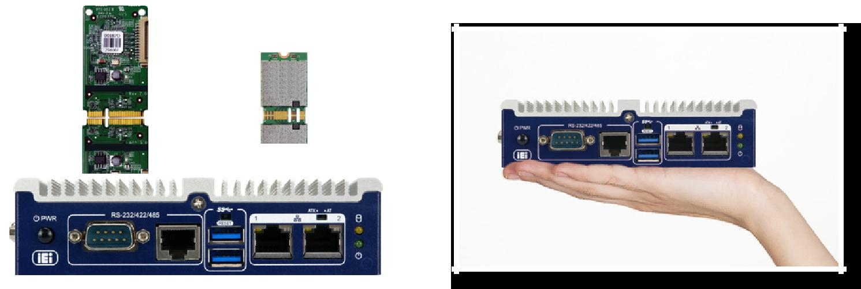

Full-size PCIe Mini M.2 A key

***规格***

**型号**

机身

主板

I/O 接口

扩展

电源

可靠性

**OS**

|  |  |  |  |
| --- | --- | --- | --- |
|  | **ITG-100-AL-E1/S** | **ITG-100-AL-E1** |  |
| 颜色 | Blue & Silver | |  |
| 尺寸 (WxDxH) (mm) | 137 x 102.8 x 36.2 | 137 x 102.8 x 56.2 |  |
| 系统风扇 |  | Fanless |  |
| 材质 | Extruded aluminum alloy | |  |
| **CPU** | Intel® Atom™ x5-E3930 1.3 GHz (up to 1.8GHz, dual-core, TDP=6.5W) | |  |
| 芯片组 |  | SoC |  |
|  | 1x 204-pin DDR3L SO-DIMM slot (system max. 8 GB) | 1x 204-pin DDR3L SO-DIMM slot (system max. 8 GB) |  |
| 系统内存 | (ITG-100-AL-E1/2GB/S-R10 sku is pre-installed with | (ITG-100-AL-E1/2GB-R10 sku is pre-installed with |  |
|  | 2 GB memory) | 2 GB memory) |  |
| **Hard Drive** | N/A | 1 x 2.5'' SATA 6Gb/s HDD/SSD bay |  |
| **eMMC** | 1 x eMMC 5.0 support (up to 32GB optional) | |  |
| **Micro SD** | 1 x Micro SD Slot(optional) | |  |
| **USB 3.1 Gen 1 (5Gb/s)** |  | 2 |  |
| **USB 2.0** | 2 by pin-header (optional) | |  |
| **Ethernet** |  | 2 x RJ-45 |  |
| PCIe GbE by I211-AT controller | |  |
|  |  |
| **COM Port** | 2 x RS-232/422/485 (DB-9/RJ45) | |  |
| 2 x RS-232 by pin-header (optional) | |  |
|  |  |
| **数字 I/O** | 8-bit digital I/O, 4-bit input/4-bit output by pin-header (optional) | |  |
| 显示 |  | 1 x VGA |  |
| 分辨率 | Up to 1920x1080@60Hz | |  |
| **Wireless** | 1 x 802.11a/b/g/n/ac (optional) | |  |
| **其他** | 1 x Power Button, 1 x Reset Button, 1 x AT/ATX Switch, | |  |
| 1 x LED for HDD (Yellow),1 x LED for Power (Green) | |  |
|  |  |
| **M.2** | 1 x M.2 2230 (A key, PCIe by 1, USB2.0) | |  |
| **PCIe Mini** | 1 x Full-size PCIe Mini slot (supports mSATA, colay with SATA) | |  |
| 电源输入 | 2-pin terminal block: 12 V DC | |  |
| 功耗 | 12V @ 1A (Intel® Atom™ E3930 with 2GB memory) | |  |
| 安装方式 | DIN-rail / Wall mounting | |  |
| 操作温度 | -20°C ~ 60°C with air flow (SSD), 10% ~ 95%, non-condensin | |  |
| 存储温度 | -30°C ~ 70°C with air flow (SSD), 10% ~ 90%, non-condensin | |  |
| 冲击测试 | Half-sine wave shock 5G, 11ms, 100 shocks per axis, IEC68-2-27 | |  |
| 振动测试 | MIL-STD-810G 514.6C-1 (SSD) | |  |
| 重量(净重/毛重) | 0.67 kg/1.03 kg | 0.86 kg/1.22 kg |  |
| **Safety / EMC** |  | CE/FCC |  |
| **看门狗** | Programmable 1~255 sec/min | |  |
| 支持的 OS | Microsoft® Windows 10 / Linux | |  |



**10-64** **ITG-100-AL-2019-V10**



***Industrial System***

***w w w . i e i w o r l d . c o m***



***丰富的****I/O*

|  |  |  |  |  |  |  |  |  |  |  |  |  |  |  |  |  |  |  |  |  |  |  |
| --- | --- | --- | --- | --- | --- | --- | --- | --- | --- | --- | --- | --- | --- | --- | --- | --- | --- | --- | --- | --- | --- | --- |
|  |  |  | RS-232/422/485 | | | |  |  | AT/ATX mode | | | | | | | |  |  |  |  |  |  |
| Power Switch | | | | |  |  | Reset | |  |  |  |  |  |  | 12V DC IN | |  |  | VGA | |  |  |
|  |  |  |  |  |  |  |  |  |  |  |
|  |  |  |  |  |  |  |  |  |  |  |  |  |  |  |  |  |  |  |
|  |  |  |  |  |  |  |  |  |  |  |  |  |  |  |  |  |  |  |  |  |  |  |
|  |  |  |  |  |  |  |  |  |  |  |  |  |  |  |  |  |  |  |  |  |  |  |
|  |  |  |  |  |  |  |  |  |  |  |  |  |  |  |  |  |  |  |  |  |  |  |
|  |  |  |  |  |  |  |  |  |  |  |  |  |  |  |  |  |  |  |  |  |  |  |
|  |  |  |  |  |  |  |  |  |  |  |  |  |  |  |  |  |  |  |  |  |  |  |
|  |  |  |  |  |  |  |  |  |  |  |  |  |  |  |  |  |  |  |  |  |  |  |

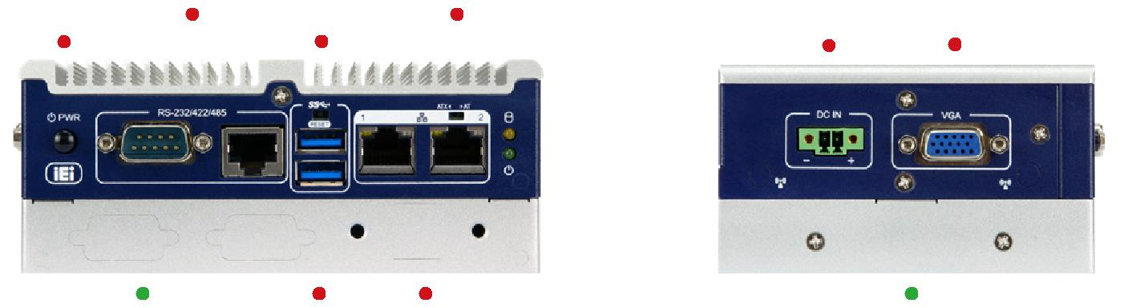

ITG-100-AL-E1 onl 2 x USB 3.1 Gen 1 2 x LAN ITG-100-AL-E1 only

***尺寸*** *(****单位****: mm)*

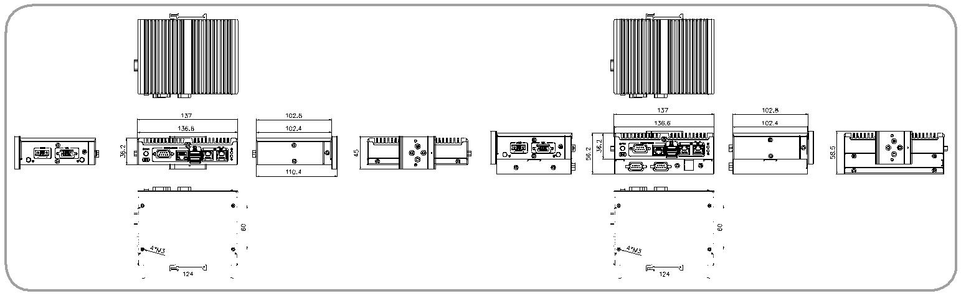

|  |  |  |  |  |  |  |  |  |  |  |  |  |  |  |  |  |  |  |
| --- | --- | --- | --- | --- | --- | --- | --- | --- | --- | --- | --- | --- | --- | --- | --- | --- | --- | --- |
|  |  |  |  |  |  |  |  |  |  |  |  |  |  |  |  |  |  |  |
|  |  |  |  |  |  |  |  |  |  |  |  |  |  |  |  |  |  |  |
| ***订购信息*** | |  |  |  |  |  |  |  |  | *ITG-100-AL-E1/S* | |  |  |  |  | *ITG-100-AL-E1* | |  |
|  |  |  |  |  |  |  |  |  |  |  |  |  |
|  |  |  |  |  |  |  |  |  |  |  |
|  |  |  |  |  |  |  |  |  |  |  |  |  |  |  |  |  |
|  | **Part No.** |  |  |  |  | **Description** | |  |  |  |  |  |  |  |  |  |  |  |
|  | **ITG-100-AL-E1/S-R10** | | | | |  |  |  |  |  |  |  |  |  |  |  |  |  |
|  | Fanless embedded system, Intel®Apollo Lake x5-E3930 1.3GHz (up to 1.8GHz, dual core), VGA, M.2, COM, 12V DC and RoHS | | | | | | | | | | | |  |
|  | **ITG-100-AL-E1/2GB/S-R10** | | | | | Fanless embedded system, Intel®Apollo Lake x5-E3930 1.3GHz (up to 1.8GHz, dual core), 2GB DDR3L pre-installed memory, VGA, M.2, COM, 12V DC | | | | | | | | | | | |  |
|  | and RoHS | |  |  |  |  |  |  |  |  |  |  |  |
|  |  |  |  |  |  |  |  |  |  |  |  |  |  |  |  |  |
|  | **ITG-100-AL-E1-R10** | | | | | Fanless embedded system, Intel®Apollo Lake x5-E3930 1.3GHz (up to 1.8GHz, dual core), VGA, M.2, COM, 12V DC, Flexible I/O Expansion and RoHS | | | | | | | | | | | |  |
|  | **ITG-100-AL-E1/2GB-R10** | | | | | Fanless embedded system, Intel®Apollo Lake x5-E3930 1.3GHz (up to 1.8GHz, dual core), 2GB DDR3L pre-installed memory, VGA, M.2, COM, 12V DC, | | | | | | | | | | | |  |
|  | Flexible I/O Expansion and RoHS | | | | | | | |  |  |  |  |  |
|  |  |  |  |  |  |  |  |  |  |  |
| ***可选模块*** | |  |  |  |  |  |  |  |  |  |  |  |  |  |  |  |  |  |
|  |  |  | |  | |  |  |  |  |  | | | |  |  |  |  |  |
|  | **Item** | **Part No.** | | | |  |  |  |  | **Description** | | | |  |  |  |  |  |
|  | **4GB Memory** | **79B00-G004-XXX-RS\*** | | | | | |  |  | DDR3L (204 PIN);4GB;1.35V;0**⁰**~85**⁰**;RoHS | | | |  |  |  |  |  |
|  | **8GB Memory** | **79B00-G008-XXX-RS\*** | | | | | |  |  | DDR3L (204 PIN);8GB;1.35V;0**⁰**~85**⁰**;RoHS | | | |  |  |  |  |  |
|  | **Wi-Fi Module** | **27319-000007-RS\*\*** | | | | | |  |  | Wireless Lan Module;WiFi+Bluetooth;Sparklan;R970181001;IEEE802.11a/b/g/n/ac;2.400GHz~2.484GHz,5.15GHz~5.85GHz;M.2 | | | | | | |  |  |
|  |  |  | 2230;3.3V;22*30*2.0mm;Qualcomm Atheros QCA6174A-5;2x2 MIMO;Dual Band;WNFQ-258ACN(BT) [W];CCL;RoHS | | | | | | |  |  |
|  |  |  |  |  |  |  |  |  |  |  |  |
|  | **Antenna** | **32505-000900-100-RS\*\*** | | | | | |  |  | External Antenna;WLAN;RG 178;108MM;TANK-700-QM67-R10;PEAK GAIN 2.0DBI;Exceltek;2.4-2.5GHz/5.15-5.85GHz;REVERSE | | | | | | |  |  |
|  |  |  | SMA PLUG;RoHS | | | |  |  |  |  |  |
|  |  |  |  |  |  |  |  |  |  |  |  |  |  |  |
|  | **RF Cable** | **32501-004000-100-RS\*\*** | | | | | |  |  | RF;RF CABLE;LINE DIAMETER:0.81mm;250MM;;;50Ω;Sparklan;0-6GHz;VSWR≤1.3;I-PEX MHF-4 Plug;REVERSE SMA | | | | | | |  |  |
|  |  |  | JACK;NUT*1;WASHER*1;;RoHS | | | |  |  |  |  |  |
|  |  |  |  |  |  |  |  |  |  |  |  |  |  |  |
|  | **DIO Cable** | **32231-000300-100-RS** | | | | | |  |  | FLAT CABLE;DIO CABLE;;2;50MM;28AWG;(A)D-SUB 9P FEMALE;(B)DU PONT 2*5P P=2.0 FEMALE,RoHS | | | | | | |  |  |
|  | **COM Cable** | **32205-007500-200-RS** | | | | | |  |  | FLAT CABLE;RS-232/422/485;COM CABLE;2;50mm;28AWG;(A)D-SUB 9P MALE;(B)DU PONT 2*5P P=2.0 FEMALE,RoHS | | | | | | |  |  |
|  | **USB Cable** | **32001-000800-200-RS\*\*\*** | | | | | |  |  | ROUND CABLE;USB CABLE;;2;150MM;28AWG;(A)DOUBLE LAYER USB A TYPE FEMALE(WITH EAR);(B)DU PONT 2*4P P=2.0 | | | | | | |  |  |
|  |  |  | FEMALE,RoHS | | | |  |  |  |  |  |
|  |  |  |  |  |  |  |  |  |  |  |  |  |  |  |
|  | **Adapter** | **63040-010036-210-RS** | | | | | |  |  | Adapter Power;FSP;FSP036-RHBN3;9NA0362707;;Vin:90~264VAC;36W;Dim:37.8*89.8*27.0mm;Plug=7.5mm;Cable=1500mm;Erp( | | | | | | |  |  |
|  |  |  | NO LOAD 0.075W);Vout:12VDC;Φ2.5/Φ5.5/lock;CCL;RoHS | | | |  |  |  |  |  |
|  |  |  |  |  |  |  |  |  |  |  |  |  |  |  |
|  | **Power Cable** | **32102-045700-100-RS** | | | | | |  |  | WIRE CABLE;POWER CABLE;;2;200mm;18AWG;(A)DC JACK 5.5*2.5;(B)TERMINAL BLOCK 2P P=3.5 180°,RoHS | | | | | | |  |  |
|  | **Power Cord** | **32702-000400-200-RS** | | | | | |  |  | European power cord | | | |  |  |  |  |  |
|  | **OS:Windows** | **ITG-100-W10E64-E-R10** | | | | | |  |  | OS Image with Windows® 10 IoT Enterprise Entry 64-bit for ITG-100-AL Series, with DVD-ROM, RoHS | | | | | | |  |  |
|  | **Embedded 10** |  |  |  |  |
|  |  |  |  |  |  |  |  |  |  |  |  |  |  |  |  |  |  |
|  |  |  |  |  |  |  |  |  |  |  |  |  |  |  |  |  |  |  |



* It is just a general P/N. Please contact your sales representatives to assist you in ordering. ** Each Wi-Fi module needs two antennas and two RF cables to fully support Wi-Fi function.

*** This USB cable cannot be used at the layer where the HDD drive bay is located.

***包装清单***

|  |  |  |
| --- | --- | --- |
| 1 x SATA cable & SATA power cable(for ITG-100-AL-E1 only) | 1 x Screw kit | 1 x Mounting bracket |



**ITG-100-AL-2019-V10** **10-65**