工业系统

TANK-620-ULT3

特征

w w w . i e i w o r l d . c o m

■ Intel Skylake ULT CPU

■ 无风扇嵌入式
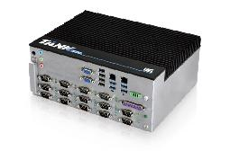

- Intel® Celeron® 3855U (1.6GHz, TDP=15W)

- 超多COM口（最多14个），带有TX/RX信号LED指示灯

- 多USB & LAN口

- 24点DI/O 控制

- M.2 插槽和全尺寸 Mini PCIe 扩展插槽

Fanless | Dual | Dual LAN | RS-232
 | Display |  | /422/485

规格

型号

机身

主板

存储

I/O 接口

扩展

电源

可靠性

OS

 | TANK-620-ULT3
颜色 | Black C + Silver
尺寸 (WxDxH) (mm) | 260 x 200 x100
系统风扇 | Fanless
材质 | 铝合金
CPU | Intel® Celeron® 3855U (1.6GHz, TDP=15W)
芯片组 | SoC
系统内存 | 1 x 260-pin DDR4 SO-DIMM
 | 1 x on-board DDR4 4GB pre-installed (system max: 32GB)
硬盘驱动器 | 2 x 2.5'' SATA 6Gb/s HDD/SSD Bay
CF | 1 x CF card (optional*)
NVRAM | 1 Mb FRAM
USB 3.1 Gen 1 (5Gb/s) | 4
USB 2.0 | 4
Ethernet | 2 x RJ-45 PCIe GbE by Intel® I211-AT controller
RS-232/422/485 | 6 x RS-232 (DB-9)
 | 8 x RS-232/422/485 ports with automatic flow control (DB-9
Digital I/O | 1 x 24-bit digital I/O (12-bit input/12-bit output)
显示 | 2 x VGA, (1 x LVDS or 1 x VGA optional)
分辨率 | VGA: Up to 1920 x 1200 @60Hz
 | LVDS: Up to 1920 x 1200 @60Hz (optional)
音频 | 1 x Mic in, 1 x Speaker out, 1 x Line out
Wireless | 1 x 802.11a/b/g/n/ac (optional)
LED | Power LED, HDD LED, COM ports
Others | 1 x Power Button, 1 x System Reset, 1 x AT/ATX Switch
PCIe Mini | 2 x Full-size PCIe mini slot (PCIe by1, USB2.0)
M.2 | 1 x M.2 2280 (M key,PCIe by 4, SATA co-lay SATA2)
电源输入 | 9 ~ 36 V DC +/- 5%
功耗 | 12V@2.73A (Intel® Celeron® 3855U with 8GB memory)
安装方式 | Wall Mount
操作温度 | -30 ~ 70 °C with air flow (SSD), 10% ~ 95%, non-condensin
存储温度 | -40 ~ 80 °C
冲击测试 | Half-sine wave shock 5G, 11ms, 100 shocks per axis
振动测试 | MIL-STD-810G 514.6C-1 (with SSD)
重量(净重/毛重) | 4.4 kg/6.5 kg
Safety / EMC | CE/FCC
看门狗计时器 | Programmable 1~255 sec/min
Supported OS | Microsoft® Windows 8 Embedded, Microsoft® Windows® Embedded Standard 7 E, Microsoft®
 | Windows® 10
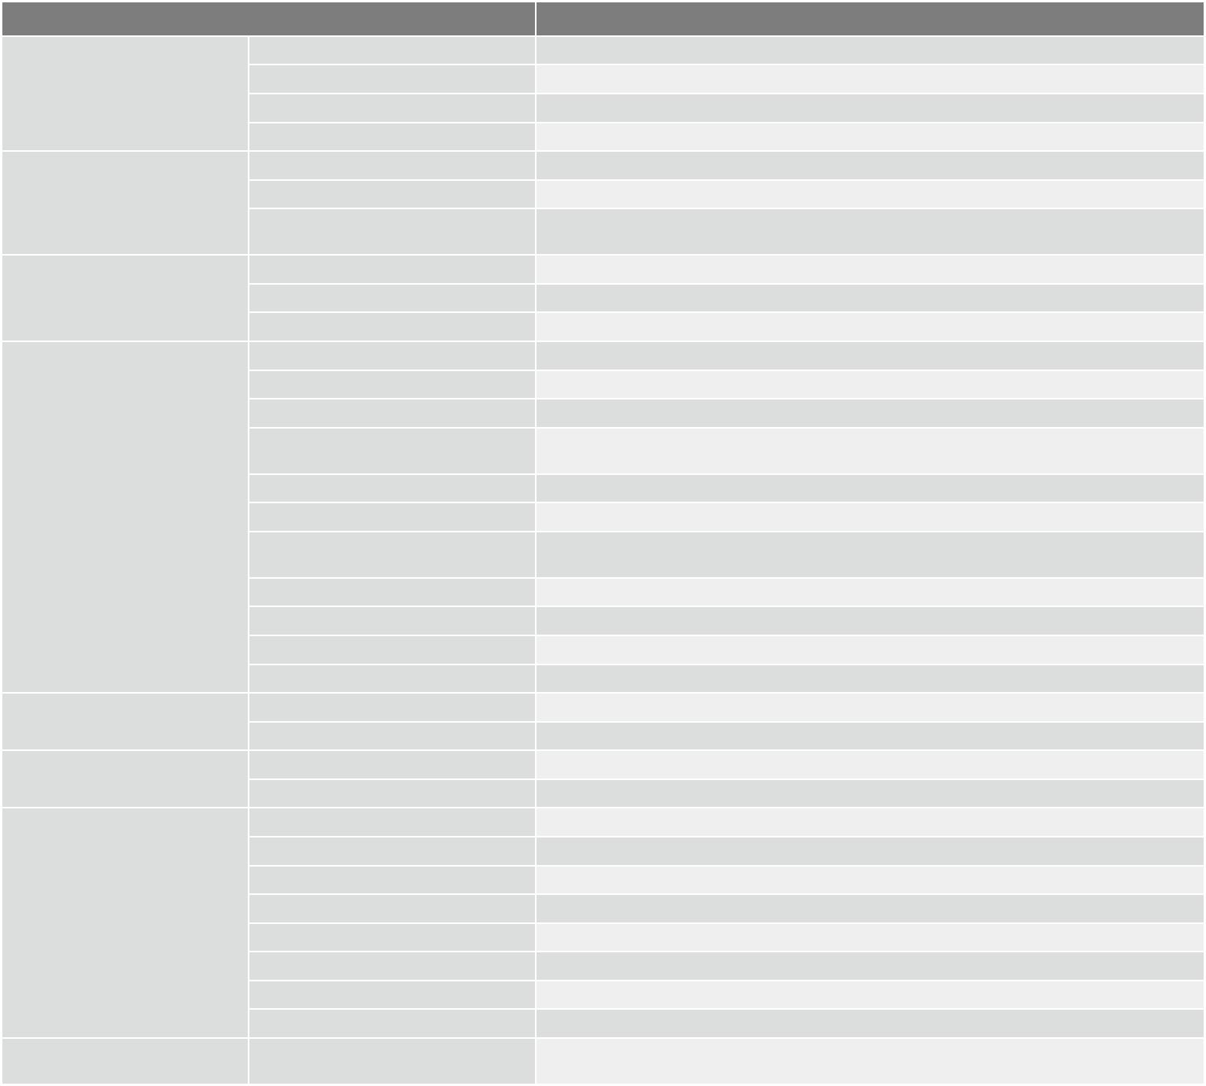

* 仅支持SATA转接卡

¹⁰⁻⁵² TANK-620-ULT3-2019-V10

工业系统

I/O接口

w w w . i e i w o r l d . c o m

LVDS VGA AT/ATX Mode 4 x USB 3.1 Gen 1
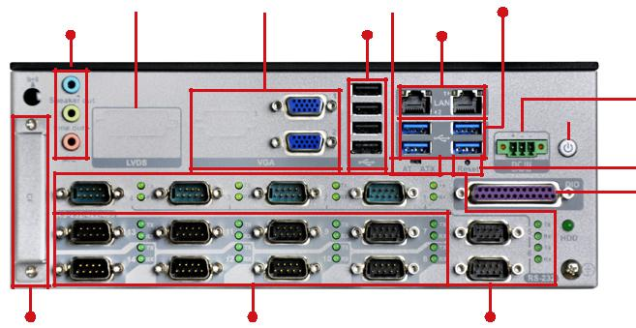
音频 4 x USB 2.0 2 x GbE LAN

Power 9~36V
(Terminal Block)
Power Switch

Reset
DIO

CF Card RS-232/422/485 RS-232

尺寸 (单位: mm)
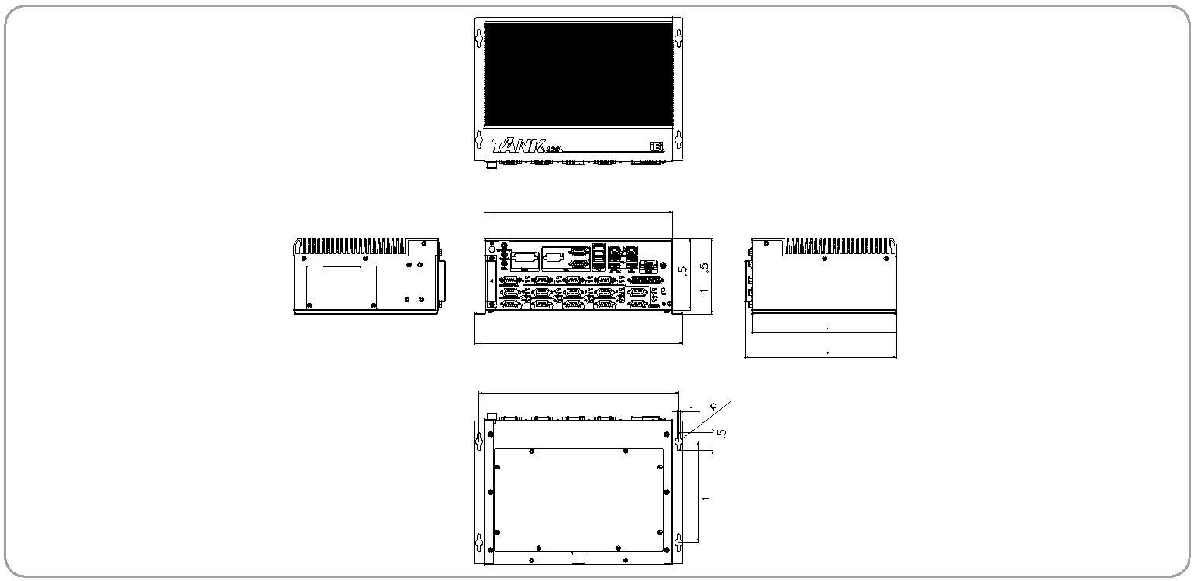

 | 260
 | 99.5 | 104.5
 | 288 | 199.6
 |  | 209.2
 | 276
 | 4.5n10
 |  | 24.5
 |  | 140
 |  | TANK-620-ULT3
订购信息
Part No. | Description
TANK-620-ULT3-CE/4G-R10 | Fanless wide temperature embedded system with Intel® Celeron® 3855U 1.6GHz (dual-core, TDP 15W), on-board 4GB DDR4 memory, 9 V~36V DC,
 | with USB, dual VGA, dual Intel® PCIe GbE, COM, DIO, RoHS
可选配件
Part No. | Description
034SBM2-00-100-RS | VGA Module for TANK-620 only
034SBM2-01-100-RS | LVDS Module for TANK-620 only
32102-047200-200-RS | WIRE CABLE;POWER CABLE;2;200mm;18AWG;(A)DC JACK 5.5*2.5mm;(B)TERMINAL BLOCK-3P P=3.5;RoHS
63040-010060-210-RS | Adapter Power;FSP;FSP060-DHAN3;9NA0608010;Vin:90~264VAC;60W;Dim:62.0*110*31.5mm;Plug=7.5mm;Cable=1200mm;Erp(NO LOAD
 | 0.21W);Vout:12VDC;Φ2.5/Φ5.5/lock;CCL;RoHS
32702-000200-100-RS | European power cord
EMB-WIFI-KIT01-R20 | 1T1R wifi module kit for embedded system, IEEE802. 1a/b/g/n/ac WiFi with Bluetooth 4.0/3.0+HS, 1 x wifi module, 2 x 250mm RF cable, 2 x Antenna,
 | RoHS
TANK-620-ULT3-WES7E64-R10 | OS image with Windows® Embedded Standard 7E 64-bit for TANK-620-ULT3 series, with DVD-ROM, RoHS
包装清单
1 x Wall mount bracket | 1 x Screw set
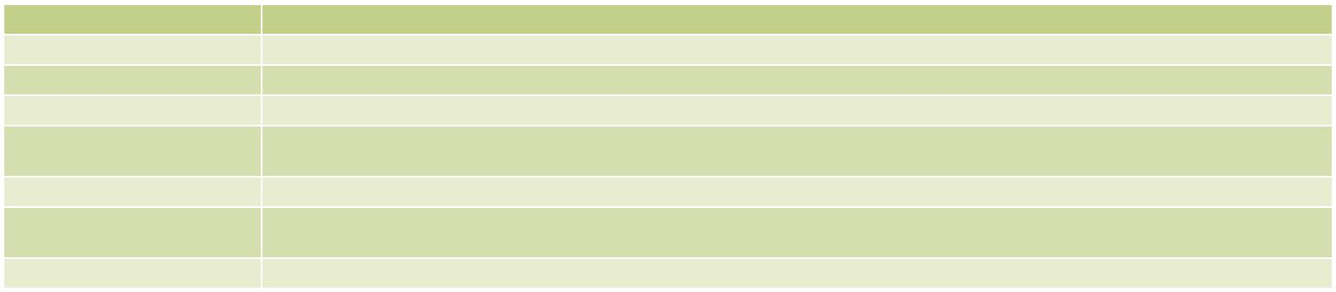

TANK-620-ULT3-2019-V10 ¹⁰⁻⁵³

