

***工业系统***

***w w w . i e i w o r l d . c o m***



TANK-820-H61 ***■*** ***Intel®*** ***Sandy Bridge 3扩展槽嵌入式系统***

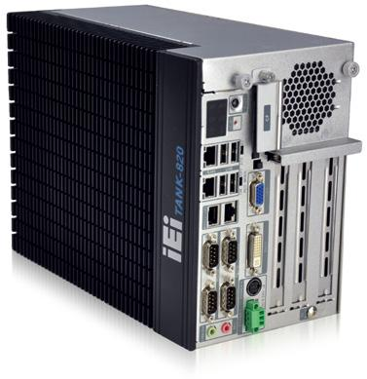

***特征***

* 第2/3代Intel®Core™低功耗处理器（最大功耗：6W）
* 板贴 2GB DDR3 内存 ，一个DDR3 SO-DIMM 内存扩展槽(系统最大内存：10GB)
* 双宽压电源输入



|  |  |  |  |  |  |
| --- | --- | --- | --- | --- | --- |
|  | **DDR3** |  | **PCI/PCIe** | **RS-232** |  |
| **Fanless** | **1333** | **Dual GbE** |  |
| **Expansion** |  |

*多功能扩展接口*

TANK-800/820 系列设有多种扩展接口，允许用户利用威强电扩充卡将附加电路和扩展板连接到系统。这些扩展选项可提供灵活多样的功能，简化系统。

|  |  |  |  |  |  |  |  |  |  |  |  |  |  |  |  |  |  |  |  |  |  |
| --- | --- | --- | --- | --- | --- | --- | --- | --- | --- | --- | --- | --- | --- | --- | --- | --- | --- | --- | --- | --- | --- |
| PCI | |  | | |  |  |  |  |  |  |  |  |  |  |  |  |  |  |  | PCIe x4 |  |
|  |  |  |  |  |  |  |  |  |  |  |  |  |  |  |  |  |  |  |
| PCI |  | | | |  |  |  |  |  |  |  |  |  |  |  |  |  |  |  | PCI |  |
| PCIe x16 |  | |  |  |  |  |  |  |  |  |  |  |  |  |  |  |  |  |  | PCIe x16 |  |

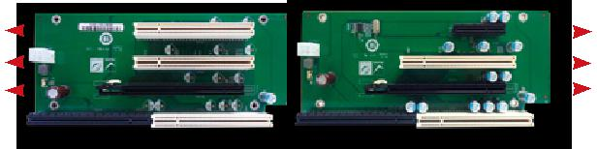

**● HPE-3S6 (2P1E)** **● HPE-3S7 (1P2E)**

* 背板的额定电压和电流



|  |  |  |  |
| --- | --- | --- | --- |
| Voltage | Current | Voltage | Current |
| +5 V | 7 A | -12 V | 0.1 A |
| +12 V | 3.75 A | +3.3 V | 8 A |

Max. power supported by the backplane: <45W

系统默认的功率是 90 W。支持扩展卡的底板最大功率为 45 W。 因此选择扩展卡的功率不能超过最大功率 (45 W)，否则，系统将不能稳定运行。

* 2种底板，支持标准 PCI/PCIe 扩展卡 , 允许扩展卡的最大尺寸： 111 mm （宽）x 190 mm （长）



|  |  |  |  |  |
| --- | --- | --- | --- | --- |
| **Backplane** | **Slot** | **TANK-800** | **TANK-820** |  |
| **Signal** | **Signal** |  |
|  |  |  |
| **HPE-3S6 (2P1E)** | PCI | PCI | PCI |  |
| PCIe x16 | PCIe x4 | PCIe x8 |  |
|  |  |
|  | PCI | PCI | PCI |  |
| **HPE-3S7 (1P2E)** | PCIe x4 | PCIe x1 | PCIe x1 |  |
|  | PCIe x16 | PCIe x2 | PCIe x8 |  |

*丰富的 I/O*

***前视I/O***

**Reset**

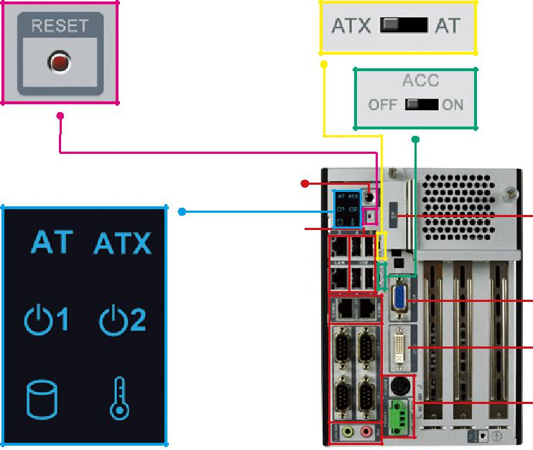

The reset button forces the system to be reset when the system hangs up.

Power Switch

Indicators

4 x USB

2 x LAN

2 X RS-422/485

4 x RS-232

Audio

***后视 I/O***

**AT/ATX Mode**

Users can select a suitable mode according to applications.

**ACC Mode**

ACC mode is designed for vehicle systems and PWR1 will be used as the priority power input.

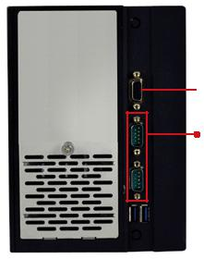

CF Card

VGA

DVI

Dual DC Input

To Ground



DIO

2 x RS-232 with isolation

1. Isolated protection voltage 2500V/minDC protection
2. Common-mode transient immunity > 25 kV/ μs ESD protection

2 x USB 3.1 Gen 1

**TANK-820-H61-2019-V10** **10-45**



***工业系统***



*Specifications*

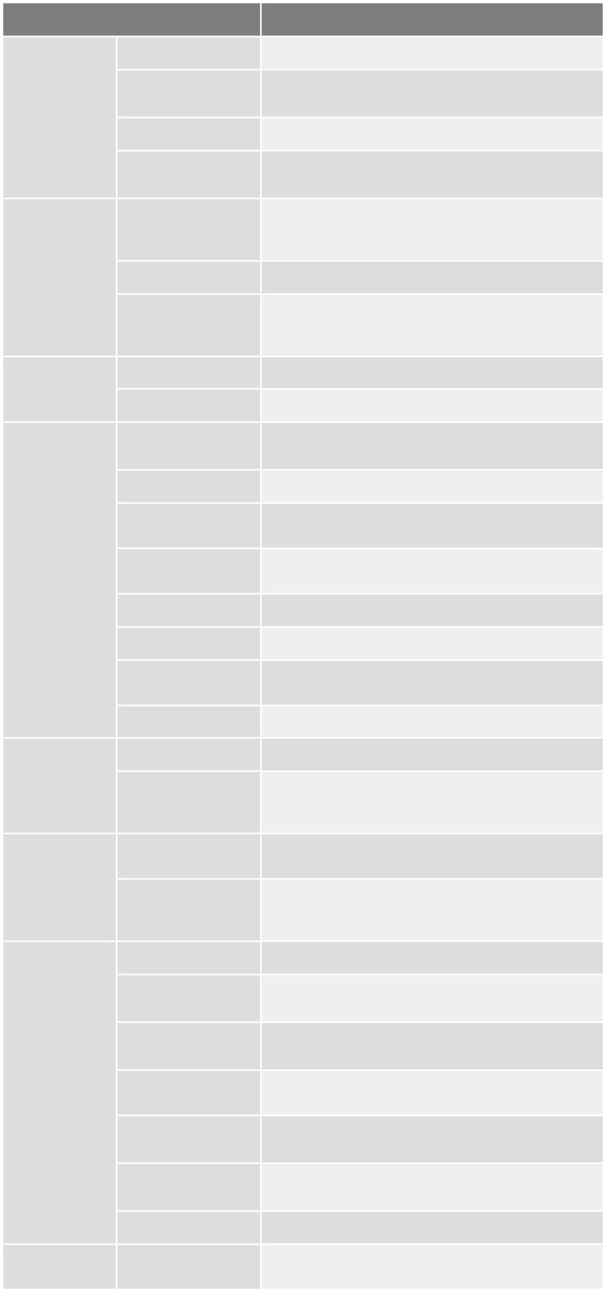

|  |  |  |  |
| --- | --- | --- | --- |
| 型号 |  | **TANK-820-H61** |  |
|  | 颜色 | Black C + Silver |  |
| 机身 | 尺寸 (WxDxH) (mm) | 133 x 269 x 208 |  |
|  |  |  |
|  | 系统风扇 | Fanless |  |
|  | 材质 | Extruded aluminum alloys |  |
|  | **CPU** | Intel® Core™ i5-2xxT (above 2.7 GHz) |  |
|  | Intel® Core™ i3-2xxT (above 2.5 GHz) |  |
|  |  | Intel® Pentium® G6xxT (above 2.2 GHz) |  |
| 主板 | 芯片组 | Intel® H61 |  |
|  |  | On-board DDR3 2 GB memory |  |
|  | 系统内存 | 1 x 204-pin DDR3 SO-DIMM (system max: 10 |  |
|  |  | GB) |  |
|  | **Hard Drive** | 1 x 2.5'' SATA 3Gb/s HDD/SSD bay |  |
| 存储 | **CF Card/CFast** | 1 x CF Type II |  |
|  |  |
|  | **USB 3.1 Gen 1** | 2 |  |
|  | **(5Gb/s)** |  |
|  |  |  |
|  | **USB 2.0** | 4 |  |
|  | **Ethernet** | 2 x RJ-45 |  |
|  | PCIe GbE by Realtek 8111E controller |  |
|  |  |  |
|  | **COM Port** | 6 x RS-232 (DB-9, two with isolation) |  |
|  | 2 x RS-422/485 (RJ-45) |  |
|  |  |  |
| I/O 接口 | 数字 I/O | 8-bit digital I/O, 4-bit input/4-bit output |  |
|  |  |
|  | **显示接口** | 1 x VGA, 1 x DVI-I |  |
|  | 分辨率 | VGA: Up to 2048 x 1536@75Hz |  |
|  | DVI-I: Up to 1920 x 1080@60Hz |  |
|  | 音频 | 1 x Line-out, 1 x Mic-in |  |
|  | **PCI** | 2P1E: 2 x PCI, 1P2E: 1 x PCI |  |
| 扩展 | **PCle** | 2P1E: One PCIe x8 (physical PCIe x16 slot) |  |
| 1P2E: One PCIe x1 (physical x4 slot), |  |
|  |  |
|  |  | One PCIe x8 (physical x16 slot) |  |
|  | 电源输入 | DC Jack: 9 V~24 V DC |  |
|  | Terminal Block: 9 V~24 V DC |  |
|  |  |  |
| 电源 |  | 19 V@3.5 A |  |
|  | 功耗 | (Intel® Core™ i3-2100 with 6 GB DDR3 memory) |  |
|  |  | w/o add-on card |  |
|  | 安装方式 | Wall mount |  |
|  | 操作温度 | -20°C ~ 60°C with air flow (SSD), 5% ~ 95%, non |  |
|  | condensing |  |
|  | 存储温度 | -20°C ~ 70°C |  |
| 可靠性 | 冲击测试 | Half-sine wave shock 5G, 11ms, 3 shocks per |  |
| axis |  |
|  |  |  |
|  | 振动测试 | MIL-STD-810F 514.5C-2 (with SSD) |  |
|  | 重量 ( 净重 / 毛重 ) | 4.2 kg/6.3 kg |  |
|  | **Safety/EMC** | CE/FCC |  |
| **OS** | 支持的 OS | Microsoft® Windows® Embedded Standard 7 E, |  |
| Microsoft® Windows® XP Embedded |  |
|  |  |  |

***w w w . i e i w o r l d . c o m***

*Dimensions (Unit: mm)*

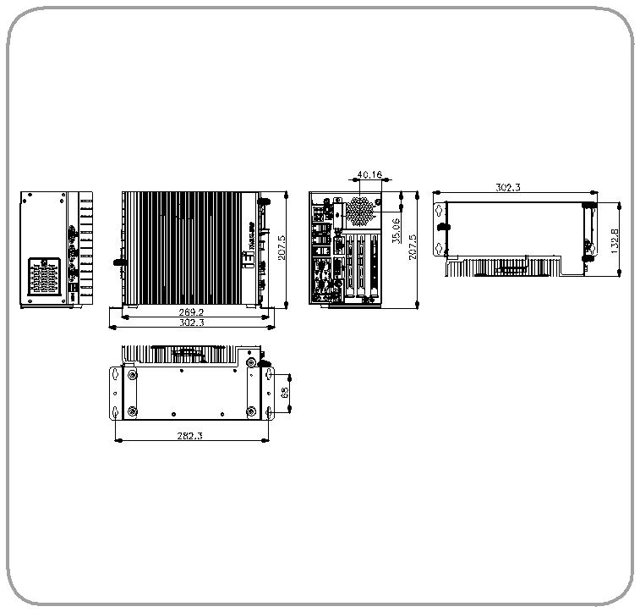

|  |  |
| --- | --- |
|  | *TANK-820-H61* |
| ***订购信息*** |  |
| **Part No.** | **Description** |
|  |  |
|  | Fanless wide temperature embedded system with |
|  | one PCIe x8 and two PCI expansions, Intel® Core™ |
| **TANK-820-H61-i5/2G/2P1E-R22** | i5 dual-core 2xxT CPU (above 2.7 GHz, |
|  | TDP 35 W), dual 9 V-24 V DC-IN, 2 GB DDR3 on- |
|  | board memory, -20°C ~ 60°C |
|  | Fanless wide temperature embedded system with |
|  | one PCIe x1, one PCIe x8 and one PCI expansion, |
| **TANK-820-H61-i5/2G/1P2E-R22** | Intel® Core™ i5 dual-core 2xxT CPU |
|  | (above 2.7 GHz, TDP 35 W), dual 9 V-24 V DC-IN, 2 |
|  | GB DDR3 on-board memory, -20°C ~ 60°C |
|  | Fanless wide temperature embedded system with |
|  | one PCIe x8 and two PCI expansions, Intel® Core™ |
| **TANK-820-H61-i3/2G/2P1E-R22** | i3 dual-core 2xxT CPU (above 2.5 GHz, |
|  | TDP 35 W), dual 9 V-24 V DC-IN, 2 GB DDR3 on- |
|  | board memory, -20°C ~ 60°C |
|  | Fanless wide temperature embedded system with |
|  | one PCIe x1, one PCIe x8 and one PCI expansion, |
| **TANK-820-H61-i3/2G/1P2E-R22** | Intel® Core™ i3 dual-core 2xxT CPU |
|  | (above 2.5 GHz, TDP 35 W), dual 9 V-24 V DC-IN, 2 |
|  | GB DDR3 on-board memory, -20°C ~ 60°C |
|  | Fanless wide temperature embedded system |
|  | with one PCIe x8 and two PCI expansions, Intel® |
| **TANK-820-H61-P/2G/2P1E-R22** | Pentium® dual-core G6xxT CPU (above 2.2 GHz, |
|  | TDP 35 W), dual 9 V-24 V DC-IN, 2 GB DDR3 on- |
|  | board memory, -20°C ~ 60°C |
|  | Fanless wide temperature embedded system with |
|  | one PCIe x1, one PCIe x8 and one PCI expansion, |
| **TANK-820-H61-P/2G/1P2E-R22** | Intel® Pentium® dual-core G6xxT CPU |
|  | (above 2.2 GHz, TDP 35 W), dual 9 V-24 V DC-IN, 2 |
|  | GB DDR3 on-board memory, -20°C ~ 60°C |



***可选配件***

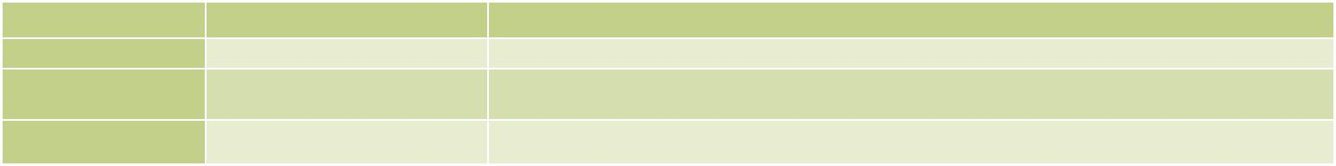

|  |  |  |  |
| --- | --- | --- | --- |
| **Item** | **Part No.** | **Description** |  |
| **OS: XP** | **TANKCF-800-D525-XPE-4G-R10** | OS Image with XPE,For TANK-800 D525 Series,W/Compact Flash Memory Card 4GB,R10 |  |
| **OS: Windows Embedded** | **TANKCF-800-D525-WES7E-4G-R10** | OS Image with Windows® Embedded Standard 7 E for TANK-800 D525 Series, 4 GB CompactFlash® card, RoHS |  |
| **7 (4GB CF Card)** |  |
|  |  |  |
| **System Fan** | **EMB-FAN-KIT02-R10** | Fan Module;MODIFY 31100-000272-RS;+12V DC;4PIN;40*40*15mm ;STANDARD;;FD124015LB2W3;; L= 400mm |  |
| MOLEX 5051-04P P=2.54;CCL;RoHS |  |
|  |  |  |

***包装清单***



|  |  |  |
| --- | --- | --- |
| 1 x Power Cord | 4 x HDD Screw | 1 x Pluggable DC-in Terminal Block |
| 1 x Power Adapter | 4 x Rubber Foot Pad Screw | 2 x Mounting Bracket |
| 2 x Foot Pad | 4 x Mounting Bracket Screw | 2 x RJ-45 to DB-9 COM Port Cable |
| 4 x Fan screw |  |  |



**10-46** **TANK-820-H61-2019-V10**