工业系统

TANK-871-Q170

Features

w w w . i e i w o r l d . c o m

- 高性能6th/7th Generation Intel® Core™ Processor

- 无风扇嵌入式电脑
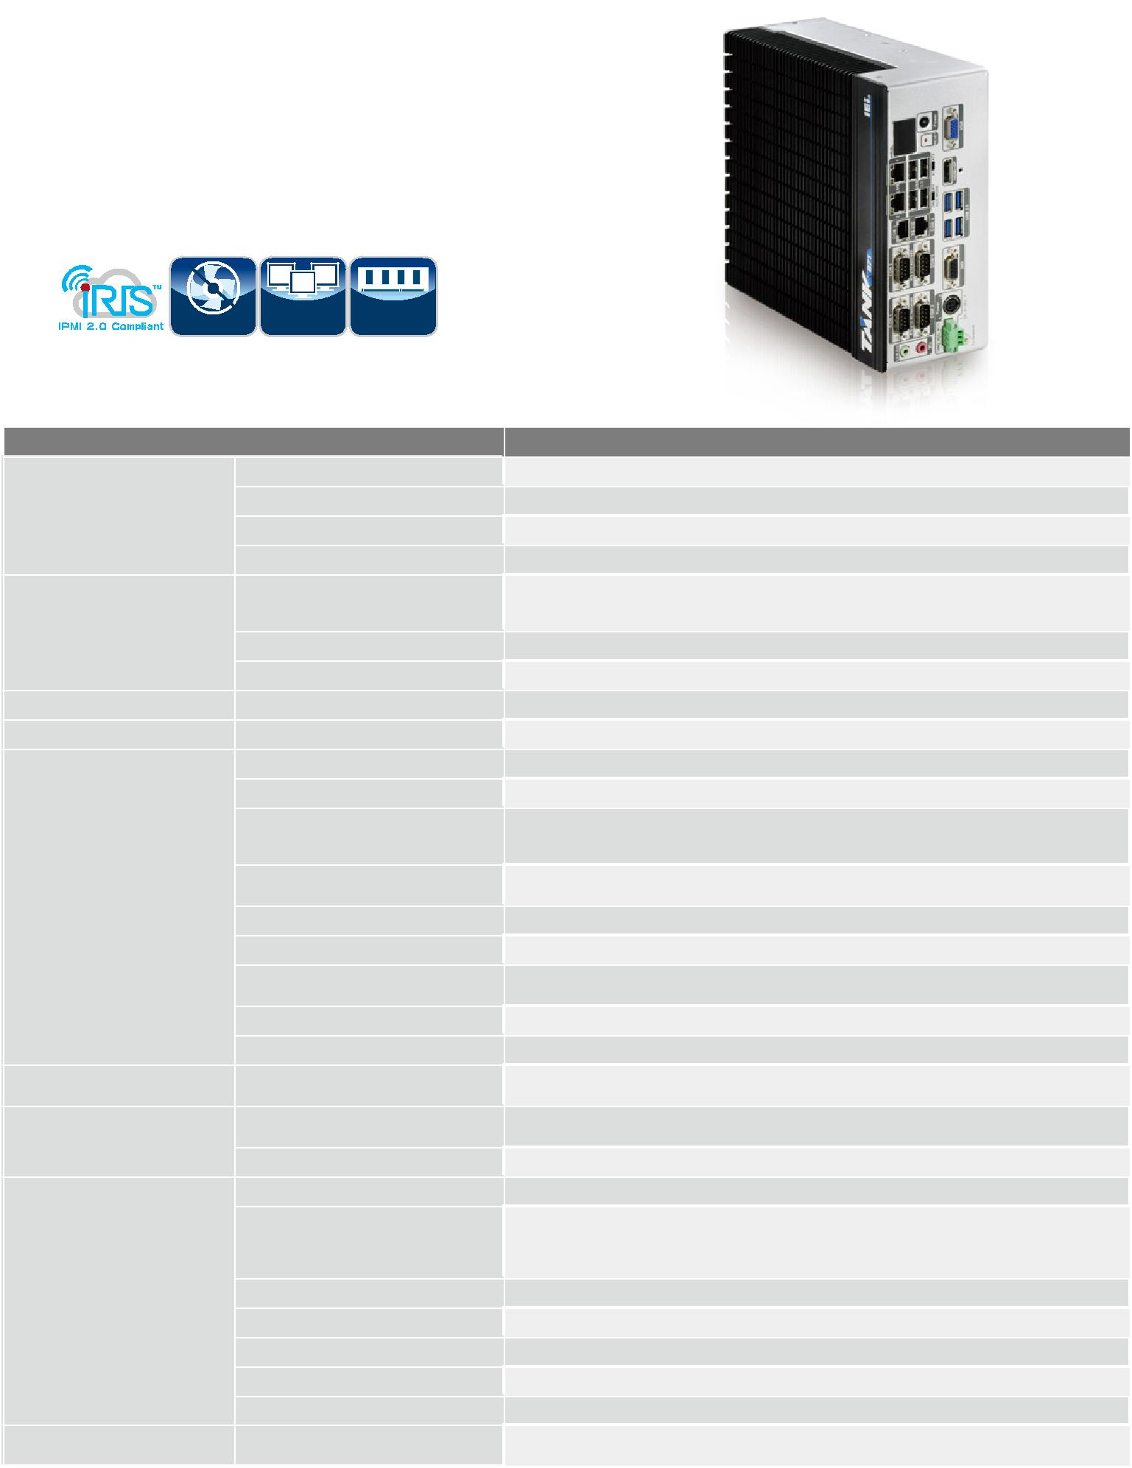

- 6th/7th Gen Intel® Core™ 处理器平台采用 Intel® Q170 芯片组和DDR4 内存

- 独立三显，支持高清

- 丰富的高速 I/O 接口位于一侧，便于安装

- IEI iRIS-2400 解决方案

Triple | DDR4
Fanless Display | 2133

Specifications

0RGHO1DPH

 | 颜色
机身 | 尺寸 (WxDxH)(mm)
 | 系统风扇
 | 材质
主板 | &38
 | 芯片组
 | 系统内存
,30, | L5,6VROXWLRQ
存储 | +DUG'ULYH
 | 86%*HQ*EV
 | 86%
 | (WKHUQHW
I/O 接口 | &203RUW
 | 'LJLWDO,2
 | 显示
 | 分辨率
 | 音频
 | :LUHOHVV
扩展槽 | 3&,H0LQL
电源 | 电源输入
 | 功耗
 | 安装方式
 | 使用温度
 | 保存环境
可靠性 | 冲击测试
 | 震动测试
 | 重量（净重/毛重)
 | 6DIHW\(0&
26 | 支持的 OS

7$1.4

Black C + Silver

82.2 x 255.2 x 204

Fanless

Extruded aluminum alloy

Intel 7th Gen Core CPU &

Intel® Core™ i7-6700TE (2.4 GHz, quad-core, TDP=35W)

Intel® Core™ i5-6500TE (2.3 GHz, quad-core, TDP=35W)

Intel® Q170

2 x 260-pin DDR4 SO-DIMM, pre-installed one 4GB (system max: 32GB)

1 x iRIS-2400 (optional)

2 x 2.5’’ SATA 6Gb/s HDD/SSD bay (RAID 0/1 support)

4

4

2 x RJ-45

LAN1 (iRIS): Intel® I210 PCIe controller

LAN2: Intel® I219LM PCIe controller

4 x RS-232 (2 x RJ-45, 2 x DB-9 w/2.5KV isolation protection)

2 x RS-232/422/485 (DB-9)

8 bit Digital I/O, 4 bit input / 4 bit output

1 x VGA, 1 x HDMI+DP, 1 x iDP (optional)

1 x VGA (Up to 1920 x 1200@60Hz)

1 x HDMI/DP (Up to 3840x2160@30Hz / 4096×2304@60Hz)

1 x Line-out ; 1 x Mic-in

1 x 802.11a/b/g/n/ac (optional)

1 x Half-size PCIe Mini slot

1 x Full-size PCIe Mini slot (supports mSATA, colay with SATA)

DC Jack: 9 V~36 V DC

Terminal Block: 9 V~36 V DC

19 V@3.68 A (Intel® Core™ i7-6700TE with 8 GB memory)

Wall mount

i7-6700TE: -20°C ~ 45°C with air flow (SSD)

10% ~ 95%, non-condensing

i5-6500TE: -20°C ~ 60°C with air flow (SSD)

10% ~ 95%, non-condensing

-40°C ~85°C with air flow (SSD), 10% ~ 90%, non-condensin

Half-sine wave shock 5G; 11ms; 100 shocks per axis

MIL-STD-810G 514.6 C-1 (with SSD)

3.5 kg/4.5 kg

CE/FCC

Microsoft® Windows® 8 Embedded, Microsoft® Windows® Embedded Standard 7 E, Microsoft® Windows® 10 IoT Enterprise

TANK-871-Q170-2019-V10

工业系统
w w w . i e i w o r l d . c o m

丰富的 I/O接口 尺寸 (单位: mm)
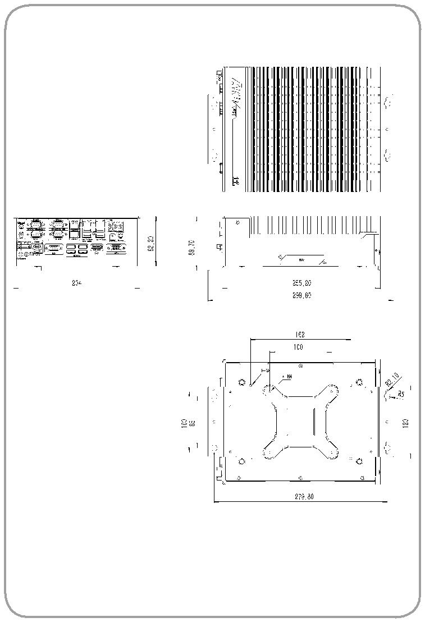

电源开关
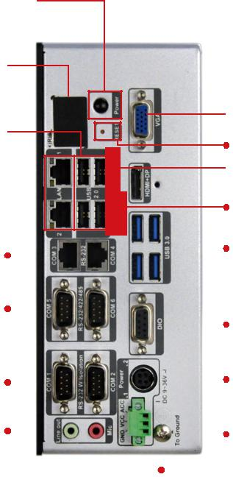

1. Long-press 2 sec. to power on

2. Long-press 5 sec. to power off

LED

VGA

4 x USB 2.0
Reset

AT/ATX Mode

2 x GbE LAN ^{HDMI+DP}
ACC Mode
2 x RS-232 |  |  |  |  |  |  |  |  |  |  |  |  |  |  |  |  |  |  | 4 x USB 3.1
 |  |  |  |  |  |  |  |  |  |  |  |  |  |  |  |  |  |  | Gen 1
2 x RS-232/
422/485 |  |  |  |  |  |  |  |  |  |  |  |  |  |  |  |  |  |  | DIO
 |  |  |  |  |  |  |  |  |  |  |  |  |  |  |  |  |  |  | Power2
2 x RS-232 |  |  |  |  |  |  |  |  |  |  |  |  |  |  |  |  |  |  | (DC Jack)
Audio |  |  |  |  |  |  |  |  |  |  |  |  |  |  |  |  |  |  | To Ground
 |  |  |  |  |  |  |  |  |  |  |  |  |  |  |  | Power1 |  |  |  | TANK-871-Q170
 |  |  |  |  |  |  |  |  |  |  |  |  |  |  |  | (接线端子)
订购信息
3DUW1R |  |  |  |  |  |  |  | 'HVFULSWLRQ
7$1.4LL*5 |  |  |  |  |  |  |  | Ruggedized fanless embedded system with Intel® Core™ i7-6700TE 2.4 GHz (up to 3.4 GHz, quad core, TDP 35W), 4GB DDR4 pre-installed memory,
 |  |  |  |  |  |  |  | VGA/HDMI+DP/iDP, iRIS-2400 optional, 9~36V DC, RoHS
7$1.4LL*5 |  |  |  |  |  |  |  | Ruggedized fanless embedded system with Intel® Core™ i5-6500TE 2.3 GHz (up to 3.3 GHz, quad core, TDP 35W), 4GB DDR4 pre-installed memory,
 |  |  |  |  |  |  |  | VGA/HDMI+DP/iDP, iRIS-2400 optional, 9~36V DC, RoHS
可选配件
3DUW1R |  |  |  |  |  |  |  | 'HVFULSWLRQ
56 |  |  |  |  |  |  |  | European power cord
56 |  |  |  |  |  |  |  | Adapter power, FSP090-DIEBN2, 9NA0904739, Active PFC, Vin:90~264VAC, 90W, plug=6.5mm, cable=1500mm, Erp (no load 0.5W), Vout:19VDC,
 |  |  |  |  |  |  |  | 4-pin DIN with lock, CCL, RoHS
L5,65 |  |  |  |  |  |  |  | IPMI 2.0 adapter card with AST2400 BMC chip for DDR3 SO-DIMM socket interface
(0%:,),.,75 |  |  |  |  |  |  |  | 1T1R wifi module kit for embedded system, IEEE802. 1a/b/g/n/ac WiFi with Bluetooth 4.0/3.0+HS, 1 x wifi module, 2 x 250mm RF cable, 2 xAntenna,
 |  |  |  |  |  |  |  | RoHS
'3'35 |  |  |  |  |  |  |  | DisplayPort to DisplayPort converter board (for IEI IDP connector)
'3+'0,5 |  |  |  |  |  |  |  | DisplayPort to HDMI converter board (for IEI IDP connector)
'3/9'65 |  |  |  |  |  |  |  | DisplayPort to 24-bit dual channel LVDS converter board (for IEI IDP connector)
'39*$5 |  |  |  |  |  |  |  | DisplayPort to VGA converter board (for IEI IDP connector)
'3'9,5 |  |  |  |  |  |  |  | DisplayPort to DVI-D converter board (for IEI IDP connector)
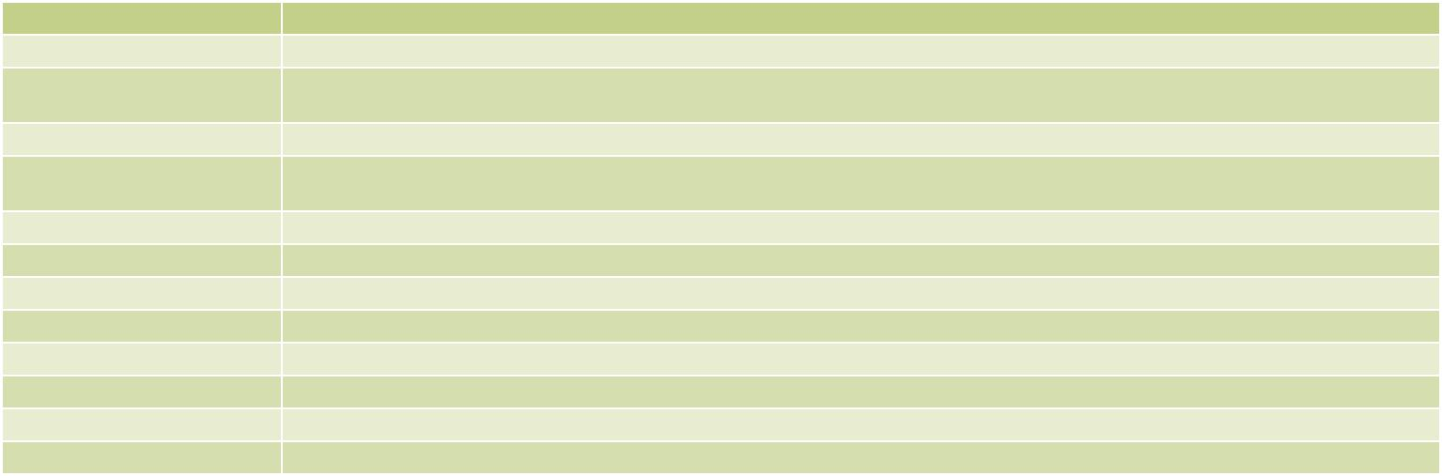

7$1.4:(6(5 OS Image with Windows® Embedded Standard 7 E 64-bit for TANK-870-Q170 Series, with DVD-ROM, RoHS

7$1.4:(+5 OS Image with Windows Embedded Standard 10 E High End 64-bit for TANK-870-Q170-i7 Series, with DVD-ROM, RoHS

7$1.4:(95 OS Image with Windows Embedded Standard 10 E Value 64-bit for TANK-870-Q170-i5 Series, with DVD-ROM, RoHS

包装清单

1 x Chassis Screw | 1 x Mounting Bracket

TANK-871-Q170-2019-V10

