工业系统
w w w . i e i w o r l d . c o m

uIBX-250-BW
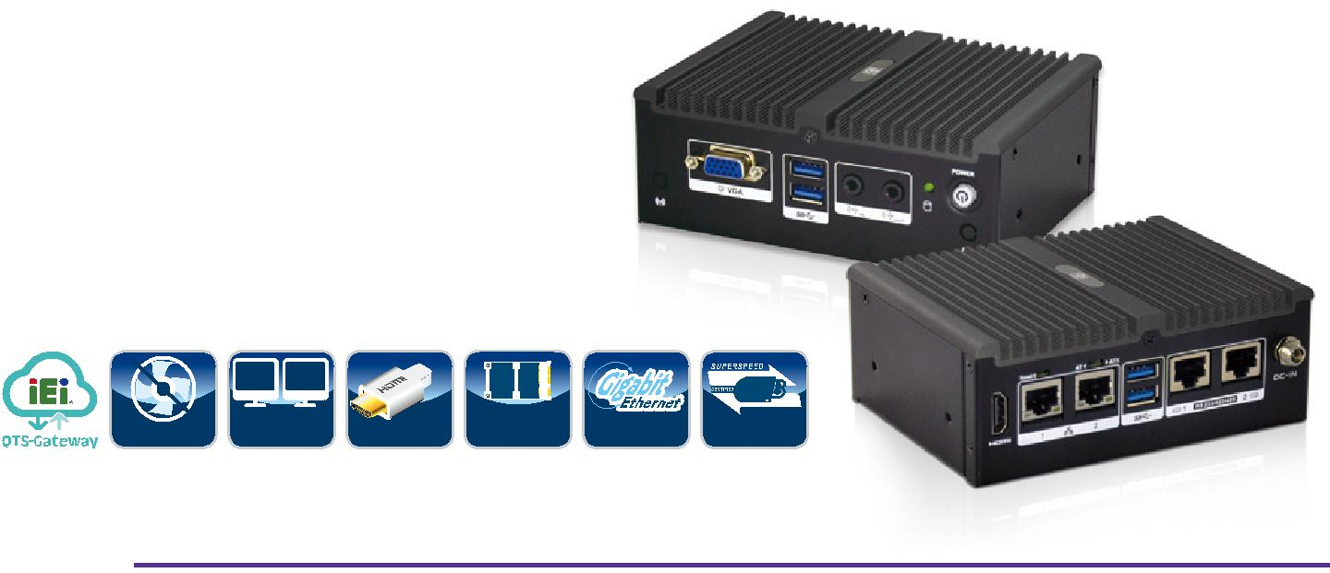

特征

● 无风扇系统采用 Intel® Celeron® N3160 处理器

● 支持双显

- 2个 RS-232/422/485

- 全长 PCIe Mini 扩展插槽

- 4个 USB 3.0 接口

- 2个 GbE LAN 接口

 |  |  |  |  | USB
Fanless | Dual | HDMI | PCIe Mini | GbE | USB 3.1
 | Display |  | Expansion |  | Gen 1

智能安装设计
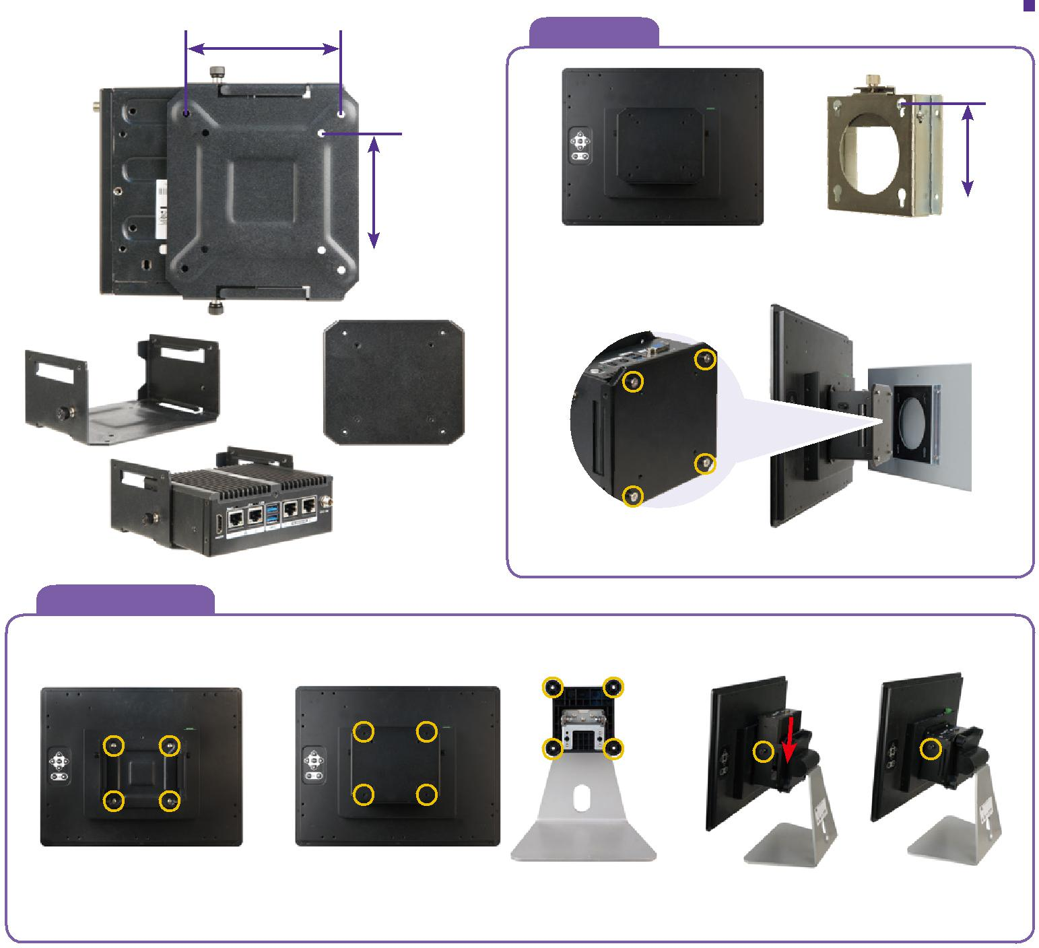

A. Wall mount

100 mm

75mm
将 uIBX-250 使用 uIBX-KIT-R10 安装
AFLWK-12/AFLWK-19
在显示器的背面。

+

 |  | uIBX-KIT-R10
 |  |  | 显示器和 uIBX-250 可以轻松安装在墙壁上，并支持 VESA 75/100。
B. VESA mount 75/100
Step.1 | Step.2 |  | Step.3 screw to fix uIBX-250

将支持 VESA 75/100 的 uIBX-KIT-R10 安装在显示器的背面。

安装 uIBX-250，支架和显示器。 | 将显示器背面安装到支架上节省更多空间，uIBX-
 | 250 的位置可根据用户的不同应用进行调节。

¹⁰⁻⁶⁶ uIBX-250-BW-2019-V10

工业系统 |  | w w w . i e i w o r l d . c o m
规格
型号 |  | uIBX-250-BW
 | 颜色 | Black
机身 | 尺寸 (WxDxH) (mm) | 136.6 x 102.4 x 52
 | 系统风扇 | Fanless
 | 材质 | Extruded aluminum alloy
 | CPU | Intel® Celeron® N3160 (up to 2.24 GHz, quad-core, 2 MB cache, TDP=6W)
主板 | 芯片组 | SoC
 | 系统内存 | 1 x 204-pin DDR3L SO-DIMM slot (2 GB pre-installed, system max: 8GB)
存储 | Hard Drive | 1 x 2.5'' SATA 6Gb/s HDD/SSD bay
 | USB 3.1 Gen 1 (5Gb/s) | 4
 | Ethernet | 2 x RJ-45 PCIe GbE by Intel® I211 controller
 | COM Port | 2 x RS-232/422/485 (RJ-45)
I/O 接口 | 按钮 | 1 x Power button, 1 x AT/ATX switch, 1 x Reset button
 | 显示 | 1 x HDMI, 1 x VGA
 | 分辨率 | HDMI: 3840 x 2160@30MHz, VGA: 1920 x1200@60Hz
 | 音频 | 1 x Line-out, 1 x Line-in
 | Wireless | 1x 802.11a/b/g/n/ac (optional)
扩展 | PCIe Mini | 1 x Full-size PCIe Mini (support mSATA, colay with SATA)*
电源 | 电源输入 | DC Jack: 12 V DC
 | 功耗 | 12V @ 2A (Intel® Celeron® N3160 with 2 GB memory)
 | 安装方式 | Wall mount, VESA 75
 | 操作温度 | -20°C ~60°C with air flow (SSD), 10% ~ 95%, non-condensin
可靠性 | 冲击测试 | Half-sine wave shock 5G, 11ms, 3 shocks per axis
 | 振动测试 | MIL-STD-810F 514.5 C-1 (HDD), MIL-STD-810F 514.5 C-2 (SSD)
 | 重量(净重/毛重) | 470 g/1.4 kg
 | Safety/EMC | CE/FCC
OS | 支持的 OS | Microsoft® Windows 8, Microsoft® Embedded Standard 7 E

*uIBX-250-BW-QGW-R20 没有PCIe mini 扩展槽

尺寸 (单位: mm)
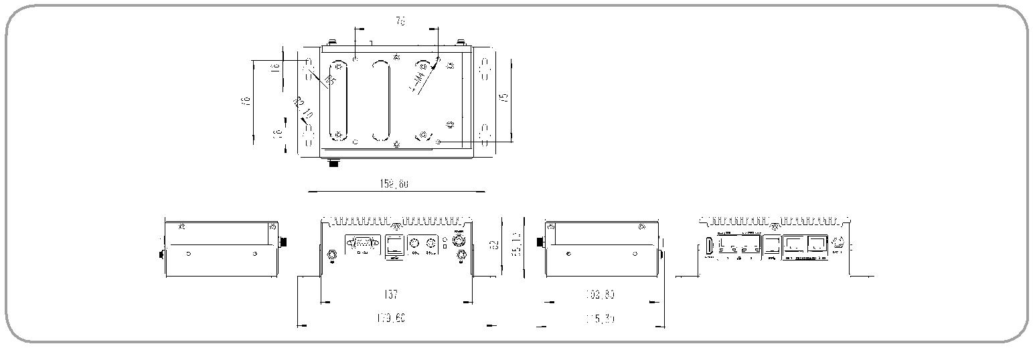

uIBX-250-BW

订购信息

Part No. | Description
uIBX-250-BW-N3/2G-R20 | Fanless embedded system with Intel® Celeron® N3160 1.6 GHz (up to 2.24 GHz, quad core, TDP 6 W), 2 GB DDR3L pre-installed memory,
 | 12V DC, with RS-232/422/485, USB 3.1 Gen 1 | (5Gb/s), VGA/HDMI, dual Intel® PCIe GbE, RoHS
uIBX-250-BW-QGW-R20 | Fanless embedded system with Intel® Celeron® N3160 1.6 GHz (up to 2.24 GHz, quad core, TDP 6 W), 4 GB DDR3L pre-installed memory,
 | 12V DC, with RS-232/422/485, USB 3.1 Gen 1 | (5Gb/s), VGA/HDMI, dual Intel® PCIe GbE, with QTS-Gateway, RoHS

可选配件

Part No. | Description
EMB-WIFI-KIT01-R20 | 1T1R wifi module kit for embedded system, IEEE802. 1a/b/g/n/ac WiFi with Bluetooth 4.0/3.0+HS, 1 x wifi module, 2 x 250mm RF cable, 2 x
 | Antenna, RoHS
DK-75-R10 | VESA 75 to DIN-Rail mounting kit
uIBX-KIT-R10 | uIBX smart mounting kit for monitor and stand
uIBX-250-BW-WES7E64-R10 | OS image with Windows® Embedded Standard 7 E 64-bit for uIBX-250, DVD-ROM, RoHS

包装清单

1 x Power Adapter | 1 x Mounting Bracket | 2x RS-232/422/485 round cable

uIBX-250-BW-2019-V10 ¹⁰⁻⁶⁷

