w w w . i ei w or l d .c om
GRAND-C610
Hyper converged High-performance Computing, Virtualization, Storage, and Application server in one chassis for streamlined efficiency and manageability.

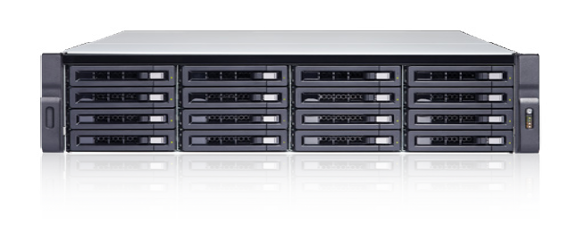
Features
- Double Server, support Intel® Xeon® E5-2600 v3
- 16 x DIMM Slots, up to 1TB memory with 16 x 64GB DIMMs
- 4 x PCIe slot can support 40GbE network card
- Storage expandable, up to 1PB
- IPMI Remote Management
- 10GbE network card support ready

SAS
12Gb/s
SAS
Storage
Expansion

Ready

DDR4
up to 128GB RAM
ECC RAM
support

Server-grade Hardware Design Robust, Reliable & Innovative
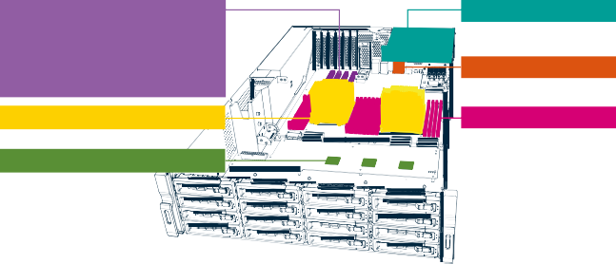Suited for enterprise environments which demand the highest performance, simplified IT management, uninterrupted service, and optimized virtualization environments, the GRAND-C610 is designed with high-standard hardware specifications to meet those needs.
GPU Pass-Through
10GbE / 40GbE Card Support PCIe SSD NVMe
12Gb/s SAS HBA Suppout
4 x 2.5” SSD
IPMI

Dual Intel® Xeon® E5 CPUs
16 RDIMM/ LRDIMM
3 x SAS 12Gb/s Controller

Hyperconverged Storage Server
High Computing and Storage Server
- High-performance application server based on dual Intel® E5 CPU
- VMware®, Citrix®, or Windows Hyper-V: for virtualization deployment
- Storage server: This component is used to mount storage using iSCSI/NFS for the application server
- High-speed connection: 10GbE or 40GbE

Specifications
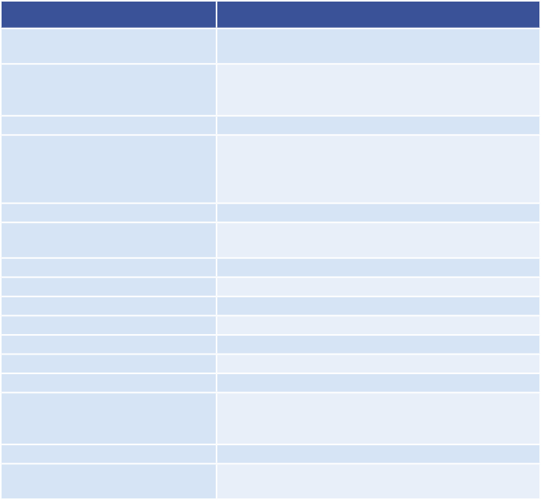
Model GRAND-C610-20C
CPU FCLGA2011-3 sockets-support Xeon® E5-2600 v3 family
System memory: RDIMM / LRDIMM

Options

Item Order P/N Description
Network card LAN-40G2SF-MLX Dual-port 40GbE QSFP+ network expansion
card
Network card LAN-10G2SF-MLX Dual-port 10GbE SFP+ network expansion

Memory (RAM) USB 2.0 / 3.0
Internal Hard Drive and Type

Max. Raw Capacity Interface
Ethernet PCIe slot Cache
Form Factor Dimensions (H x W x D) Power
Fan
Weight (Net/Gross) kg Noise

Power Consumption
Total memory slots: 16
Memory expandable up to: 1 TB (64 GB x 16) 4 x USB 3.1 Gen 1 (5Gb/s)
16 x 3.5" SAS (12Gbps/6Gbps) / SATA (6Gbps/3Gbps) HDDs or 2.5" SAS/SATA SSD 4 x 2.5" SAS (12Gbps) SSD or SAS/SATA
(6Gbps/3Gbps) SSD 128 TB
SAS 12Gb/s backward-compatible to SAS/SATA 6Gb/s
2 x GbE
4 (3 x PCIe Gen3 x8, 1 x PCIe Gen3 x16)
M.2 Gen.2 x4 3U, Rackmount
88 x 442.5 x 530.5 mm
650W (Redundant) Smart Fan 4 (6cm 12V DC)
Net (NAS): 22.42 kg / 49.43 lb
Gross (with accessories and package): 30.19 kg /
66.56 lb
Sound Pressure Level (LpAm): 64.8 dB Sleep mode: 254.21 W
In Operation: 362.86 W

Network card

USB card SAS Card Rail kit

Cable

CPU

LAN-10G2T-X550

USB-U31A2P01 SAS-12G2E RAIL-A03-57
CAB-SAS10M-8644 CAB-SAS05M-8644
Intel® Xeon® Processor E5-2620 v3

Intel® Xeon® Processor E5-2630 v3

Intel® Xeon® Processor E5-2640 v3
card
Dual-port 10GBASE-T network expansion card
USB 3.1 Gen 2 10Gbps Type-A dual-port PCIe card
Dual port storage expansion, SAS 12Gbps
A03 series (Chassis) slide, Maxmium load 57 kg
MiniSAS Cable (SFF-8644 to SFF- 8644),1.0m
MiniSAS Cable (SFF-8644 to SFF-8644), 0.5m
Intel® Xeon®, 2.4 GHZ, 0.65V~1.30V, 85W, 15MB(L3), FCLGA, 2011pin, 22nm, CM8064401831400 SR207, LGA 2011-
3 Socket, R2, Haswell, Intel® Xeon® Processor E5-2620 v3, RoHS
Intel® Xeon®, 2.4 GHZ, 0.65V~1.30V, 85W, 20MB(L3), FCLGA, 2011pin, 22nm, CM8064401831000 SR206, LGA2011-
3 Socket, R2, Haswell, Intel® Xeon® Processor E5-2630 v3, RoHS
Intel® Xeon®, 2.6 GHz, 90W, 20MB(L3), FCLGA, 2011pin, 22nm, CM8064401830901 SR205,
LGA2011-3 Socket, R2, Haswell, Intel® Xeon® Processor E5-2640 v3, RoHS

Ordering Information
Part No.
GRAND-C610-20C-R10
Description
3U 16Bay front 3.5", 4bay rear 2.5" HDD or SSD support, rackmount storage server (Barebone), with 650W redundant PSU, RoHS
GRAND-C610-2019-V10
Data Storage
*Pre-install CPU & Memory by Request

Packing List
Ethernet cable x 2
Power cord x 2
Flat head screws (for 2.5” HDD)
Flat head screws (for 3.5” HDD)

