PCI-1723
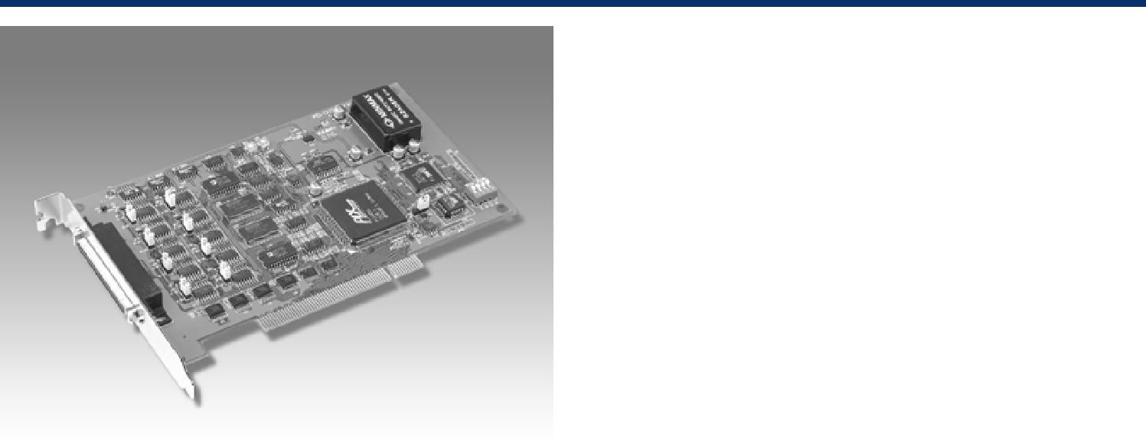

16 8 !
!"#

!"#

!"#$%&'( 16 DAC

!"#

!"#$%&'(

2 16 !"#$%& / BoardIDTM

PCI-1723 !"#$%&' PCI !"#$ !"#$%&'()* 16 !" DAC !"#$%&'()* BoardIDTM PCI-1723 !"#$%&'()*+,-./

!"

! !

! !
!"/

!

! !

!

I/O !

! ! !

8

!" !

-10 ~ +10 V, 0 ~ 20 mA, 4 ~ 20 mA ( !"#$)

6 LSB

!" 6 LSB ( )

< 6 LSB

0.1Ω !

PC !(Direct AO)

50 ∝ s ( FSR 6 LSB)

- ()

2

0.8 V ! 2.0 V !

0.5 V @ 24 mA 2.4 V @ 15 mA

68 SCSI-II !

175 x 100 mm (6.9" x 3.9")

+5 V @ 850 mA, +12 V @ 600 mA +5 V @ 1 A, +12 V @ 700 mA
0 ~ 60º C (32 ~ 158 ^{º}F) (IEC 68-2-1,2)

-20 ~ 85º C (-4 ~185 ^{º}F)

5 ~ 95%RH ( IEC 68-2-3)

CE

!

PCI-1723 16 8 !"#$%&'

PCL-10168!"#$% 68 SCSI-II!

!"#$%&' 1 2

ADAM-3968 DIN !" 68 SCSI-II !

!

!" !"#$ !"#$ !" PID V !"#

!
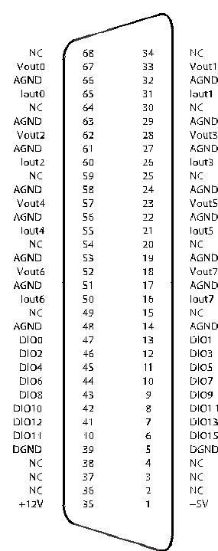

6-28 | !"#$%&'

