PPC-6150 | 15" Panel PC with Intel® Core™ i3 / i5 /
 | Celeron® Processor
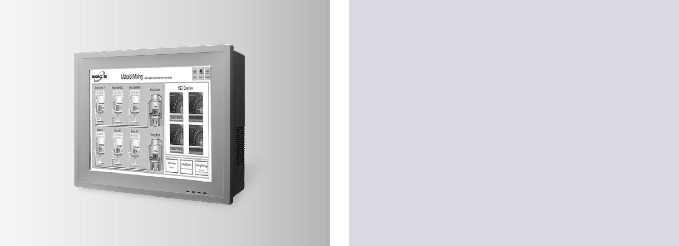

Features

 Intel® Core™ i3, i5, Celeron 1020E + Intel QM77 PCH  1X DDR3/DDR3L SODIMM supports to 8 GB

 Multiple expansion slots including one PCIe x4, one PCI + one PCIe x1, two PCI (optional) and two PCIe x1 (optional)

 Optional second HDD, supports Intel RAID

 One isolated RS-232/422/485 port; (selectable in by BIOS)

 One GPIO/RS-232 (8 channels, TTL level); (by swapping pin header)

 Dual GbE, supports Intel AMT8.0

 Supports iManager, SUSIAccess and Embedded Software APIs

Introduction

The PPC-6150 is a Panel PC with an Intel® Core™ i3/i5 or Celeron® processor, and a 15" color TFT LCD panel. It features extremely high computing power, modular design, excellent connectivity, and can support virtually any application. In addition, its user-friendly interface makes it a great host for information appliances. Two expansion slots, dual hard drives supporting Intel® RAID, and one isolated RS-232/422/485 port make the PPC-6150 highly reliable, and provide a great solution for a wide range of applications.

Specifications

 | CPU | Intel® Core i5-3610ME | Intel® Core i3-3120ME | Intel® Celeron 1020E
 | Cores | Dual Core | Dual Core | Dual Core
 | Frequency | 2.7 GHz | 2.4 GHz | 2.2 GHz
 | L3 Cache | 3 MB | 3 MB | 2 MB
 | Chipset | QM77
 | Memory | 1 x SO-DIMM, DDR3 1600/DDR3L 1333, Max 8 GB
 |  | 1 x 2.5" SATA Bay
 | Storage | Either one:
 |  | Second 2.5" SATA bay (Intel RAID supported, optional)
 |  | Slim type 8X or above DVD +/- RW (optional)
 | Network (LAN) | 2 x 10/100/1000 Mbps Ethernet (GbE1- Intel 82579LM, GbE2 – Intel 82583V),Intel AMT supported
Processor System |  | 4 x Serial ports: 1 x isolated RS-232/422/485, 3 x RS-232
 |  | 1 x GPIO/RS-232 (8 channels, TTL level); by pin header
 | I/O ports | 3 x USB 3.0, 2 x USB 2.0
 |  | 1 x VGA
 |  | 1 x HDMI
 |  | 1 x Line-out,1 x Mic-in
 |  | 1 x PCI + 1x PCIe x1 (default)
 |  | 1 x PCIe x4 (in the accessory box)
 | Expansion | 2 x PCIe x1 (optional)
 |  | 2 x PCI (optional)
 |  | 1 x Full-size Mini PCIe (Supports mSATA)
 |  | 1 x half-size Mini PCIe
 | Speaker | 2 x 1W
 | Fan | 2 x 12V 60x60x13mm with smart fan control, (70,000 hours continuous test @ 40° C)
Physical Characteristics | Dimensions | 395.5 x 316.8 x 105.5mm (15.6" x 12.5" x 4.15")
 | Weight | 6.5 Kg (14.32lb)
OS Support | OS Support | Microsoft® Windows XPE/Windows XP Pro/WES7 32bit&64bit/Windows 7 32bit&64bit/ Windows 8.1 32bit&64bit/
 |  | Linux
 | Output Rating | 150 W (max.)
Power Consumption | Input Voltage | 100 - 240 Vac, 50/60Hz, 4-2A
 |  | 61W with i5-3610ME
 | Power Consumption | 50W with i3-3120ME
 |  | (Burn-in test 7.0 in Windows 7 32 bit)
 | Display Type | 15" TFT LED Panel
 | Max. Resolution | 1024 x 768
LCD Display | Viewing Angle | 80 (left), 80 (right), 70 (up), 70 (down)
 | Luminance (cd/m2) | 400
 | Contrast Ratio | 700
 | Backlight Lifetime | 50,000 hrs min.

Panel PCs

All product specifications are subject to change without notice. Last updated :16-Jun-2017

PPC-6150

Dimensions

379.0
012. 523.

_{105.5} 395.5
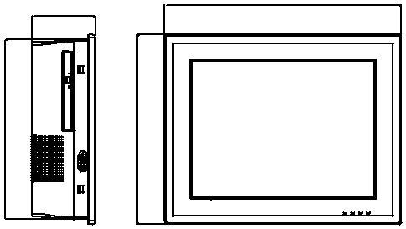

300.0 | 8316.

Max. depth for VESA mounting screws is 7.5 (mm)
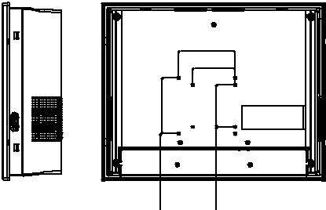

 | 100.0
 | 75.0
100.0 | 75.0 | 302
883. | 96.3

Cut-Out dimension: 381 x 302 mm

Unit: mm

381

CUT
OUT

 | Touch Type | Analog Resistive 5-wire
Touchscreen | Light Transmission | 80+/-3%
 | Controller | RS-232 interface (COM5), USB interface is available as an option
 | Durability (Touches) | 36 million
 | Operating Temperature | 0 ~ 50°C (32 ~ 122°F)
 | Storage Temperature | -40 ~ 60°C (-40 ~ 140°F)
 | Relative Humidity | 10 ~ 95% @ 40°C (non-condensing)
Environment | Shock | Operating 10 G peak acceleration (11 ms duration), follow IEC 60068-2-27
 | Vibration | Operating Random Vibration Test 5 ~ 500Hz, 1Grms @with HDD, follow IEC 60068-2-64
 | EMC | CE, FCC Class A, BSMI
 | Safety | CB, UL,CCC, BSMI
 | Front Panel Protection | IP65 compliant

Ordering Information

Part No. | Description
PPC-6150-Ri5AE | Intel Core i5-3610ME (2.7G) Panel PC with 15" XGA LED
 | backlight and 5-wire resistive T/S, w/o memory
PPC-6150-Ri3AE | Intel Core i3-3120ME (2.4G) Panel PC with 15" XGA LED
 | backlight and 5-wire resistive T/S, w/o memory
PPC-6150-RC10AE | Intel Celeron 1020E (2.2G) Panel PC with 15" XGA LED
 | backlight and 5-wire resistive T/S, w/o memory
PPC-WLAN-B1E | WiFi Module with Antenna Cable 40cm for PPC
989K091800E | Two PCI slots for PPC-6150/6170
989K091700E | Two PCIe x1 slots for PPC-6150/6170
98R3615000E | Second 2.5" SATA HDD/SSD Module for PPC-6150/6170
PPC-6150-DVDE | Module with 8X SATA DVD-RW for PPC-6150/PPC-6170
PPC-174T-WL-MTE | Wall mount kit for PPC series
PPC-ARM-A03 | PPC ARM VESA Standard
PPC-Stand-A1E | Stand for PPC series
1702002605 | Power cord 90D 220V EUROPEAN 250V/6A, 1.8M
1702002600 | Power cord UL/CSA (USA) 180D 125V/10A 1.83M
96CB-POWER-B-1.8M1 | POWER CORD for China 1.8M
1700019336 | Cable for an external 25-pin LPT port
2070013299 | WES7P PPC-6150/70 32-bits V5.1.6 10multi-languages
 | with SUSI Access
2070013328 | WES7P PPC-6150/70 64-bits V5.6.6 10multi-languages
 | with SUSI Access
2070012935 | WES2009 PPC-6150/6170 x32 V4.0 Eng/Cht
98R3415010E | 98 Level For 9663415010E Front USB Cable 100cm
98R3612000E | mSATA/CFast to USB card reader

I/O Placement

A B C D E F G
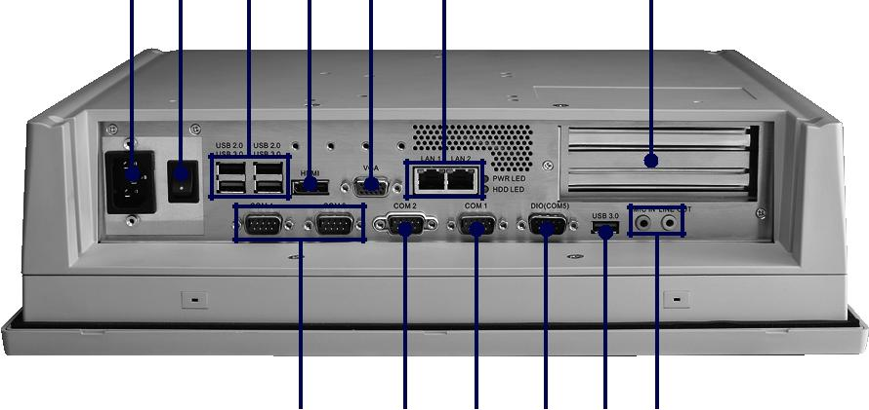

K L K J I H

A: AC Inlet | G: 2 Expansion slots
B: Power Switch | H: Line-out/Mic-in
C: USB 3.0 x 2, USB 2.0 x 2 | I: USB 3.0 x 1
D: HDMI | J: GPIO / RS-232 (by swapping pin header)
E: VGA | K: RS-232 x 3
F: Gigabit Ethernet x 2 | L: Isolated RS-232/422/485 (selecting by BIOS)

Online Download www.advantech.com/products

