PCA-6011 | CPU卡,带 VGA/DVI/双GbE端口
 | LGA775 Intel® Core 2 Quad™ 全长
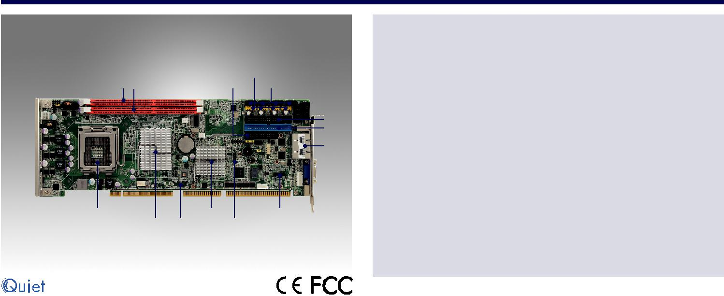

DDR3 1333 | LPT | USB * 8
Max 8GB |  | SATA * 4

COM1
COM2
FDD
IDE

LAN2
LAN1

VGA1

KBMS1

Core™ 2 Quad |  | ICH7/ICH7R | LPC1
FSB 1333 MHz | G41 DVI | HDAUD1
Processors

特性

 符合 PICMG 1.0标准

 支持 LGA 775 Intel® Core™2 Quad FSB 1333 MHz 处理器

 支持双通道 DDR3 1333 SDRAM ，最高可达 8 GB  双 GbE LAN via 双 PCIe x1 通道

- 2 COM端口, 4 SATA端口， 8 USB 接口

- G2版本支持VGA双显和DVI-D

规格

 | CPU (45nm/65nm) | Intel Core 2 Quad | Intel Core 2 Duo |  | Intel Pentium |  | Intel Celeron
 | 最大主频 | Q9650 3.0 GHz | E8500 3.16 GHz |  | E6500 2.93 GHz |  | E1500 2.2 GHz
处理器系统 | 二级缓存 | 12 MB | 6 M |  | 8 M |  | 512 KB
 | 芯片组 | Intel G41 + ICH7/ICH7R (only for G2 SKU)
 | BIOS | AMI 16 Mb SPI Flash
 | FSB | 800/1066/1333 MHz
系统总线 | PCI | 32 bit/33 MHz PCI
 | ISA | HISA (ISA High Driver)
 | 规范 | 双通道DDR3 800/1066/1333 DIMMs
内存 | 最大可支持容量 | 8 GB
 | 插槽 | 240-pin DIMM x 2
 | 控制器 | Intel Graphics Media Accelerator X4500
显示芯片 | VRAM | 共享352MB系统内存
 | 视频输出 | 15-Pin VGA D-sub 接口r x1/DVI 接口x1 (only for G2 SKU)
 | 接口 | 10/100/1000 Mbps
以太网 | 控制芯片 | Intel 82583 V
 | 接口 | RJ-45 带指示灯接口r x 2 (G2 SKU), x1 (VG SKU)
 | 带宽 | 300 MB/s
SATA | 通道 | 4 ports
 | RAID | 0, 1, 5, 10 (only for G2 SKU)
 | 模式 | ATA 100/66/33
EIDE | 通道 | 1 (最多可支持2个IDE设备; 主设备可替换1个 CF 插槽)
 | CF | (Optional)
 | USB 2.0 | 8个排针转接口VG SKU); 6 个排针转接口/1 个位于背板I/O (G2 SKU)
 | 串口 | 2 RS-232在主板排针转接口, 加模块自动流量控制的RS-485端口 (optional,
I/O 接口 |  | Advantech P/N: PCA-COM485-00A1E)
 | 并口
 |  | 1 (EPP/ECP/SPP)
 | FDD | 1
 | PS/2 | 1 (用于连接鼠标键盘，包装中含有Y型电缆)
看门狗定时器 | 输出 | 系统复位
 | 间隔 | 可编程的1~255 sec
其他功能 | 音频输出 | IIntel高清晰度音频接口（要求1个音频扩展模块P/
 |  | N: PCA-AUDIO-HDA1E)
 | CPU | 配置1: Core 2 Quad Q9400 (3.0 G, 95 W) + DDR3 1066 2 G x2
 | 电压 | +12 V | +5 V | +3.3 V | +5 VSB | -12 V | -5 V
电源 | 电流 | 5.14 A | 4.04 A | 0 A | 0.17 A | 0 A | 0 A
 | CPU | 配置2 2: Core2 Duo E8400 (3.0G, 65W) + DDR3 1066 2 GB x2
 | 电压 | +12 V | +5 V | +3.3 V | +5 VSB | -12 V | -5 V
 | 电流 | 3.63 A | 3.4 A | 0 A | 0.15 A | 0 A | 0 A
环境 |  | 工作状态 |  |  | 非工作状态
 | 温度 | 0 ~ 60 °C (32 ~ 140 °F) |  |  | -40 °C ~ 85 °C
 |  | 工作湿度: 40 °C @ 85% RH 非凝结) |  |  | 60 °C @ 95% RH 非凝结
外观 | 尺寸(L x H) | 338 x 122 mm (13.3" x 4.8")

Slot SBC & Passive Backplanes

All product specifications are subject to change without notice. Last updated: 13-Sep-2017

PCA-6011

系统图
 |  |  |  |  |  | Intel LGA775
 |  |  |  |  |  | C2Q/C2D
 |  |  |  |  | 1066 / 1333 |  |  | MHz FSB
 |  | CRT |  | VGA |  |  |  |  |  |  | Channel A |  |  | DDR3 800/1066/1333
 |  |  |  |  |  |  | G41
 |  | DVI |  |  |  | GMCH
 |  |  |  | Display port |  |  |  |  |  |  | Channel B |  |  | DDR3 800/1066/1333
 |  | (only for G2 SKU)
 |  |  |  |  |  |  |  | DMI
 |  |  |  |  |  |  |  |  |  |  | PCIe x1 |  |  |  | G-LAN1
 |  | IDE |  | DMA 33/66/100 |  |  |  |  |  |  |  |  |  | Intel 82583V
 |  |  |  |  |  |  |  |  |  |  | PCIe x1 |  |  |  | G-LAN2
 |  | 4 SATA II Ports |  | 300 MHz |  |  |  |  |  |  |  |  |  | Intel 82583V
 |  |  |  |  |  | ICH7/
 |  |  |  |  |  |  |  |  |  |  | PCI Bus |  |  | PCI to ISA Bridge
 |  |  |  |  |  | ICH7R |  |  |  |  |  |  |  |  | ITE8888
 |  | 8 USB Ports |  | USB 2.0/1.1
 |  | HD Audio
 |  |  |  | HD Audio |  |  |  |  |  |  |  |  |  | Backplane
 |  | (Optional) |  |  |  |  |  |  |  |  | PCI Bus
 |  |  |  |  |  | SPI |  |  |  |  |  |  |  | (PICMG 1.0)
 |  |  |  |  |  |  |  |  |  |  |  | LPC Bus
 |  |  |  |  | BIOS
 |  |  |  |  |  |  |  |  |  |  |  | Super I/O
 |  |  |  |  |  |  |  | 2 COM |  |  |  |  |  |  |  | GPIO
 |  |  |  |  |  |  |  |  |  |  |  | Winbond
 |  |  |  |  |  |  |  | Ports
 |  |  |  |  |  |  |  |  |  |  |  | 83627DHG-P
订购信息
型号 |  | LAN |  | VGA | COM |  |  | SATA |  |  | S/W RAID |  |  | USB |  | DVI |  |  | CF
PCA-6011VG-00A1E |  | Single GbE |  | Yes | 2 |  | 4 |  |  | - |  |  |  | 8 |  | No (Optional) |  |  | No (Optional)
PCA-6011G2-00A1E |  | Dual GbE |  | Yes | 2 |  | 4 |  |  |  | Yes |  |  | 7 |  | Yes |  |  | No (Optional)
可选配件 |  |  |  |  |  |  |  |  |  | 配件包
 |  |  |  |  |  |  |  |  |  | 型号 |  |  |  |  | 说明
型号 | 说明 |  |  |  | 数量
1701400452 | IDE HDD电缆 |  |  |  | x 1 |  |  |  |  | 1750000332 |  |  |  |  | 用于115 W TDP CPU的LGA 775 CPU冷却器
1700008461-11 | 带4个端口的USB电缆 |  |  |  | x 1 |  |  |  |  | PCA-AUDIO-HDA1E |  |  |  |  | 音频扩展模块
1700022749 | 串行ATA HDD电源线串行ATA |  |  |  | x 1 |  |  |  |  | 1701090401 |  |  |  |  | 单COM电缆套件
1700003194 | HDD数据线 |  |  |  | x 2 |  |  |  |  | PCA-COM485-00A1E |  |  |  |  | 4 x 422/485 COM模块
1700060202 | 用于PS/2鼠标和键盘Y形电缆 |  |  |  | x 1 |  |  |  |  | 1700008822-11 |  |  |  |  | DVI-D电缆
1701260305 | 打印机的COM电缆 |  |  |  | x 1
9689000068 | 跳线组件 |  |  |  | x 1
2190000902 | 保修卡 |  |  |  | x 1
2002601110 | 启动手册 |  |  |  | x 1
2062601100 | 实用CD |  |  |  | x 1
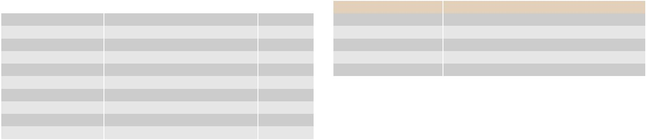
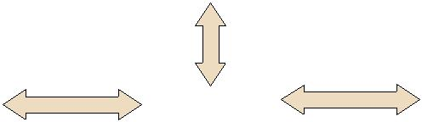
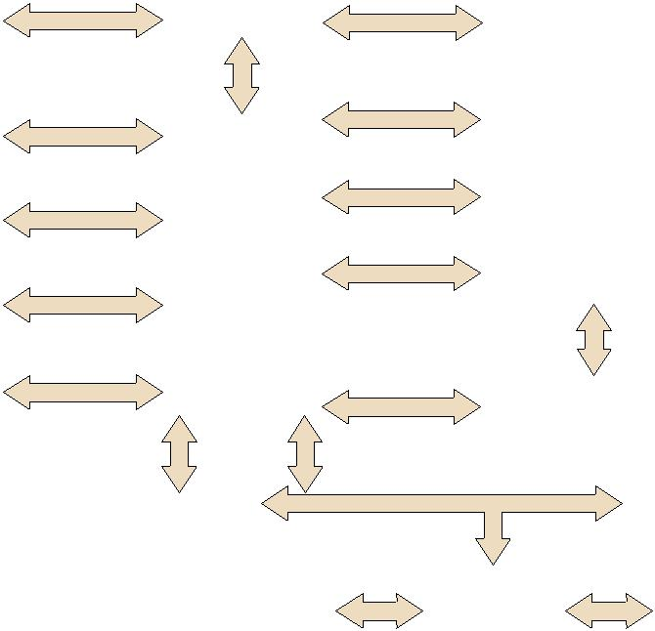

接口图

PCA-6011G2-00A1E PCA-6011VG-00A1E

Online Download www.advantech.com/products

