

|  |  |  |  |  |  |  |  |  |  |  |  |  |  |  |  |  |
| --- | --- | --- | --- | --- | --- | --- | --- | --- | --- | --- | --- | --- | --- | --- | --- | --- |
|  | **AIMB-501** | | | |  | **Intel® Core™ i7/i5/i3 LGA1155 MicroATX 带** | | | | | | | | | |  |
|  |  | **CRT/DVI/LVDS, 10 COM, 10 USB 2.0, 双通道** | | | | | | | | | |  |
|  |  |  |  |  |  |  |  |  |  |  |  |  |  |  |  |  |
|  |  |  |  |  |  |  |  |  |  |  |  |  |  |  |  |  |
|  |  |  |  |  |  |  | **特性** |  |  |  |  |  |  |  |  |  |
|  |  |  |  |  |  |  | ****支持Intel®Core™ i7/i5/i3处理器带H61芯片组 | | | | | |  |  |  |  |
|  |  |  |  |  |  |  | ****两个DIMM插槽最高支持16 GB DDR3 1600/1333 MHz SDRAM | | | | | | |  |  |  |
|  |  |  |  |  |  |  | ****支持双显VGA, DVI, LVDS和双GbE LAN | | | | | |  |  |  |  |
|  |  |  |  |  |  |  | ****支持10 COM, LPT, TPM 1.2 (Optional) | | | | | |  |  |  |  |
|  |  |  |  |  |  |  | ****支持10 USB 2.0或2 USB 3.0和8 USB 2.0 | | | | | |  |  |  |  |
|  |  |  |  |  |  |  | ****支持SUSIAccess, McAfee, Acronis和嵌入式软件APIs | | | | | | |  |  |  |
|  |  |  |  |  |  |  | **软件APIs:** |  |  |  |  |  |  |  |  |  |
|  |  |  |  |  |  |  |  |  |  |  |  |  |  |  |  |
|  |  |  |  |  |  |  |  | SMBus | | | H/W Monitor | WatchdogGPIO |  |  |  |  |
|  |  |  |  |  |  |  | **公用设施:** |  |  |  |  |  |  |  |  |  |
|  |  |  |  |  |  |  |  | BIOS flash | | | Monitoring |  |  |  |  |  |
| **规格列表** | |  |  |  |  |  |  |  |  |  |  |  |  |  |  |  |
|  |  |  |  |  |  |  |  |  |  |  |  |  |  |  |
|  |  |  |  |  |  |  |  |  |  |  |  |  |  |  |
|  |  |  |  |  |  |  |  |  |  |  |  |  |  |  |  |  |
|  |  | CPU | | Intel Core | Intel Core | | Intel Core | Intel Core | | | Intel Core | Intel Core | Pentium | Celeron | |  |
|  |  | i7-3770 | i5-3550S | | i3-3220 | i7-2600 | | | i5-2400 | i3-2120 | G850 | G540 | |  |
|  |  |  |  |  |
|  |  | 芯片数 | | 4 | 4 | | 2 | 4 |  |  | 4 | 2 | 2 | 2 |  |  |
|  | 处理器 | 最大主频 | | 3.4 GHz | 3.0 GHz | | 3.3 GHz | 3.4 GHz | | | 3.1 GHz | 3.3 GHz | 2.9 GHz | 2.50 GHz | |  |
|  | 集成显卡 | | Yes | Yes | | Yes | Yes | | | Yes | Yes | Yes | Yes | |  |
|  |  |  |
|  |  | 三级缓存 | | 8 MB | 6 MB | | 3 MB | 8 MB | | | 6 MB | 3 MB | 3 MB | 2 MB | |  |
|  |  | 芯片组 | | H61 |  |  |  |  |  |  |  |  |  |  |  |  |
|  |  | BIOS | | AMI EFI 64 Mbit SPI | | |  |  |  |  |  |  |  |  |  |  |
|  |  | PCI | | 32-bit/33 MHz, 2 slots | | |  |  |  |  |  |  |  |  |  |  |
|  | 扩展槽 | PCIe x 1 (Gen2) | | 500MB/s 每个方向, 1 slot | | |  |  |  |  |  |  |  |  |  |  |
|  |  | PCIe x16 (Gen3) | | 16 GB/s 每个方向, 1 slot | | |  |  |  |  |  |  |  |  |  |  |
|  |  | 规范 | | 双通道DDR3 1600/1333 MHz SDRAM 16 | | | |  |  |  |  |  |  |  |  |  |
|  | 内存 | 最大可支持容量 | | GB/8 GB per DIMM | | |  |  |  |  |  |  |  |  |  |  |
|  |  | 插槽 | | 2 x 240-pin DIMM (Non-ECC) | | |  |  |  |  |  |  |  |  |  |  |
|  |  | 控制器 | | Intel HD Graphics | | |  |  |  |  |  |  |  |  |  |  |
|  |  | VRAM | | 安装了2GB及以上系统内存的1GB最大共享内存 支持双通道48 | | | | | | | | |  |  |  |  |
|  | 显示芯片 | LVDS | | bit 高达1920 x 1200 | | |  |  |  |  |  |  |  |  |  |  |
|  | CRT | | Yes, 支持最大分辨率 2048 x 1536 | | | |  |  |  |  |  |  |  |  |  |
|  |  |  |  |  |  |  |  |  |  |  |
|  |  | DVI | | 1 (A2E sku) |  |  |  |  |  |  |  |  |  |  |  |  |
|  |  | 双显 | | CRT1+LVDS, CRT1+DVI; CRT1+CRT2 | | | |  |  |  |  |  |  |  |  |  |
|  |  | 接口 | | 10/100/1000 Mbps | | |  |  |  |  |  |  |  |  |  |  |
|  | 以太网 | 控制器 | | GbE LAN: Realtek 8111E | | |  |  |  |  |  |  |  |  |  |  |
|  |  | 连接器 | | RJ-45 X 2 |  |  |  |  |  |  |  |  |  |  |  |  |
|  | SATA | 带宽 | | 300 MB/s (SATA 2.0) | | |  |  |  |  |  |  |  |  |  |  |
|  | 通道 | | 4 |  |  |  |  |  |  |  |  |  |  |  |  |
|  |  |  |  |  |  |  |  |  |  |  |  |  |  |
|  |  | CRT | | 2 |  |  |  |  |  |  |  |  |  |  |  |  |
|  |  | DVI | | 1 (A2E sku) |  |  |  |  |  |  |  |  |  |  |  |  |
|  |  | 以太网 | | 2 |  |  |  |  |  |  |  |  |  |  |  |  |
|  | 后置 I/O | USB | | 4 (A1E: USB 2.0 x 4. A2E: USB 2.0 x 2 /USB 3.0 x 2) | | | | | | |  |  |  |  |  |  |
|  | Parallel | | 1 |  |  |  |  |  |  |  |  |  |  |  |  |
|  |  |  |  |  |  |  |  |  |  |  |  |  |  |
|  |  | Audio | | 2 (Mic-in, Line-out) | | |  |  |  |  |  |  |  |  |  |  |
|  |  | 系列 | | - |  |  |  |  |  |  |  |  |  |  |  |  |
|  |  | PS/2 | | 2 (1 x 键盘和 1 x 鼠标) | | |  |  |  |  |  |  |  |  |  |  |
|  |  | USB | | 6 (USB 2.0) |  |  |  |  |  |  |  |  |  |  |  |  |
|  |  | 系列 | | 10(8 x RS-232, 2 x RS-232/422/485; COM 3 和COM 7 支持RS-232/422/485 自动流量控制; COM 1和 COM 2 支 | | | | | | | | | | | |  |
|  |  | 持5V/12V **j**umper 选择) | | |  |  |  |  |  |  |  |  |  |  |
|  |  | IDE | |  |  |  |  |  |  |  |  |  |  |
|  | 内置连接器 | - |  |  |  |  |  |  |  |  |  |  |  |  |
|  | SATA | | 4 (SATA 2.0) |  |  |  |  |  |  |  |  |  |  |  |  |
|  |  |  |  |  |  |  |  |  |  |  |  |  |  |
|  |  | LVDS & Inverter | | 1 |  |  |  |  |  |  |  |  |  |  |  |  |
|  |  | IrDA | | - |  |  |  |  |  |  |  |  |  |  |  |  |
|  |  | GPIO | | 8-bit GPIO |  |  |  |  |  |  |  |  |  |  |  |  |
|  | 看门狗计时器 | 输出 | | 系统复位 |  |  |  |  |  |  |  |  |  |  |  |  |
|  | 间隔 | | 可编程的1 ~ 255 sec | | |  |  |  |  |  |  |  |  |  |  |
|  |  |  |  |  |  |  |  |  |  |  |  |
|  |  |  |  | Intel Core i7-2600 3.4GHz, 4GB DDR3 1333MHz x 2pcs | | | | | | |  |  |  |  |  |  |
|  | 电源需求 | 通电 | | +3.3 V | +12 V | | -12 V | 5 VSB | | | 5 V |  |  |  |  |  |
|  |  |  |  | 1.05 A | 6.66 A | | 0.13 A | 0.49 A | | | 2.25 A |  |  |  |  |  |
|  | 环境 |  |  | 工作 |  |  |  |  |  |  |  | 非工作 | |  |  |  |
|  | 温度 | | 0 ~ 60° C (32 ~ 140° F),取决于CPU速度和冷却器解决方案 | | | | | | | | -40 ~ 85° C (-40 ~ 185° F) | | | |  |
|  |  |  |
|  | 物理特性 | 尺寸 | | 244 mm x 244 mm (9.6" x 9.6") | | | |  |  |  |  |  |  |  |  |  |

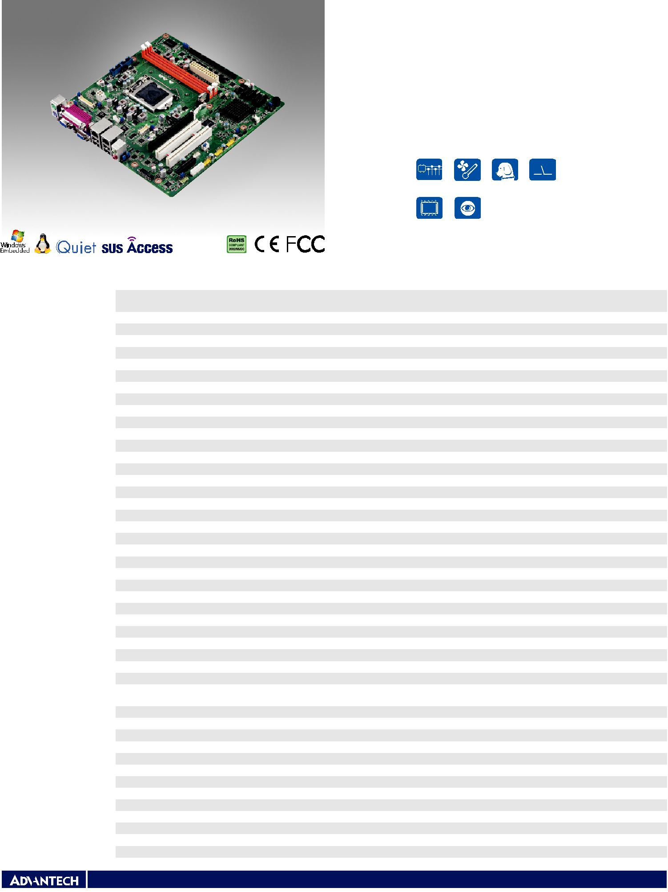

**Industrial Motherboards & Systems**

All product specifications are subject to change without notice Last updated : 15-Jan-2014

**AIMB-501**

**框架图**

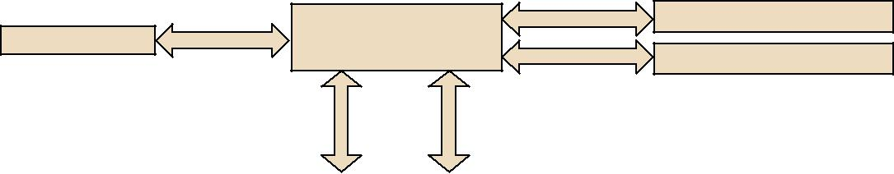

Channel A

Intel Core i7/i5/i3

PCIex16 PCIEx16 processor

Channel B

|  |  |  |  |
| --- | --- | --- | --- |
| Direct Media | Interface | Flex Display | Interface |

DDR3 1333/1600 MHz DIMM

DDR3 1333/1600 MHz DIMM

|  |  |  |  |  |  |  |  |  |  |  |  |  |  |  |  |  |  |  |  |  |  |  |  |  |  |  |  |  |
| --- | --- | --- | --- | --- | --- | --- | --- | --- | --- | --- | --- | --- | --- | --- | --- | --- | --- | --- | --- | --- | --- | --- | --- | --- | --- | --- | --- | --- |
|  | Dual Channel | |  |  |  |  |  |  |  |  |  |  |  |  |  |  |  |  |  |  |  |  |  |  |  |  |  |  |
| LVDS |  | LVDS |  | Chrontel 7308B | | SDVO |  |  |  |  |  |  | PCIex1 | |  |  | GbE LAN1: RTL 8111E-VL | | | | | | | |  |  |  |  |
|  | 24 bit/Channel | |  |  |  |  |  |  |  |  |  |  |  |  |  |  |  |  |
|  |  |  |  |  |  |  |  |  |  |  |  |  |  |  |  |  |  |  |  |  |  |  |  |  |  |  |  |  |
|  |  |  | CRT 1 | |  | CRT |  |  |  |  |  |  |  |  |  |  |  |  |  |  |  |  |  |  |  |  |  |  |
|  |  |  |  |  | H61 | | |  | PCIex1 | |  |  | GbE LAN2: RTL 8111E-VL | | | | | | | |  |  |  |  |
|  |  |  |  |  |  |  |  |  |  |  |  |  |  |  |  |
|  |  |  |  |  |  |  |  |  |  |  |  |  |  |  |  |  |  |  |  |  |  |  |  |  |  |
| CRT2 |  |  |  | Chrontel 7317 | | SDVO |  |  |  |  |  |  |  |  |  |  |  |  |  |  |  |  |  |  |  |
|  |  |  |  |  |  |  |  |  | 1 PCIex1 | | | |  | PCIex1 connector | | | | | | |  |  |  |  |
| (A1E sku) |  |  |  |  |  |  |  |  |  |  |  |  |  |  |  |  |  |
|  |  |  |  |  |  |  |  |  |  |  |  |  |  |  |  |  |  |  |  |  |  |  |  |  |  |  |  |  |
|  |  |  | DVI | |  | DVI |  |  |  |  |  |  |  |  |  |  |  |  |  |  |  |  |  |  |  | PCI1 connector | |  |
|  |  |  | (A2E sku) | |  |  |  |  |  |  |  |  | PCIex1 | |  | IT8892F | | | |  | 32 bit/33 MHz PCI Bus | | | | | PCI2 connector | |  |
|  |  |  |  |  |  |  |  |  |  |  |  |  |  |  |  |  |  |  |  |  |  |  |  |  |  |  |
|  |  | 10 USB 2.0 | | |  | USB 2.0 |  |  |  |  |  |  |  |  |  |  |  |  |  |  |  |  |  |  |  |  |
|  |  | (A2E sku: 8 USB 2.0 Ports) | | |  |  |  |  |  |  |  |  |  |  |  |  |  |  |  |  |  |  |  |  |  |  |  |  |
|  |  |  |  |  |  |  |  | 300MB/s | | | | 4 SATA2 Ports | | | | |  |  |  |  |  |  |  |
|  |  |  |  |  |  |  |  |  |  |  |  |  |  | | |  |  |  |  |
| 2 USB 3.0 |  |  |  | NEC7202 | | PCIe |  |  |  |  |  |  |  |  |  |  |  |  |  |  |  |  |  |  |  |  |  |  |
| (A2E sku only) |  |  |  |  |  | Intel HD | Audio | | SPI | | |  |  |  |  | LPC BUS | | | |  |  |  |  |  |  |  |  |  |
|  |  |  |  |  |  |  |  |  |  |  |  |  |  |  |  |  |  |
|  |  |  |  |  |  |  |  |  |  |  |  |  |  |  |  |  |  |  |  |  |  |  |  |  |
|  |  |  |  |  |  |  |  |  |  |  |  |  |  |  |  |  |  |  |  |  |  |  |  |  |  |  |  |  |
|  |  |  |  |  |  | Audio Codec | |  | BIOS |  |  |  |  |  |  |  |  |  |  |  |  |  |  |  |  |  |  |  |
|  |  |  |  |  |  | Realtek ALC892 | |  |  |  |  |  |  |  |  |  |  |  |  |  |  |  |  |  |  |  |  |
|  |  |  |  |  |  |  |  |  | TPM | |  |  | Fintek | |  |  |  |  | Fintek | |  |  | Super I/O | |  |  |
|  |  |  |  |  |  |  |  |  |  |  |  |  |  |  |  |  |  | |  |  |
|  |  |  |  |  |  |  |  |  |  |  |  |  |  |  |  |
|  |  |  |  |  |  |  |  |  |  |  | (Optional) | |  |  | 81216AD | |  |  |  |  | 81216AD | |  | | Nuvuton 6776F | |  |  |
|  |  |  |  |  |  |  |  |  |  |  |  |  |  |  |  |  |  |  |  |  |  |  |  |  |  |  |  |  |
|  |  |  |  |  |  |  | | |  |  |  |  |  |  |  |  |  |  |  |  |  |  |  |  |  |  |  |  |
|  |  |  |  |  |  | TDA 1517 | |  |  |  |  |  |  |  |  |  |  |  |  |  |  |  |  |  |  |  |  |  |
|  |  |  |  |  |  |  |  |  |  |  |  |  |  |  |  |  |  |  |  |  |  |  |  |  |  |  |  |  |
|  |  |  |  |  |  |  |  |  |  |  |  |  |  |  | 4 RS-232 | |  |  |  |  | 4 RS-232 | | |  | 2 x RS-232, | |  |  |
|  |  |  |  |  |  | Amplifier (6W) | |  |  |  |  |  |  | (1 w/RS-422/485) | | | |  |  | (1 w/RS-422/485) | | | |  | PS/2, Parallel, | |  |  |
|  |  |  |  |  |  |  |  |  |  |  |  |  |  |  |  |  |  |  |  |  |  |  |  |  | GPIO, WDT | |  |  |
|  |  |  |  |  |  |  |  |  |  |  |  |  |  |  |  |  |  |  |  |  |  |  |  |  |  |  |  |  |

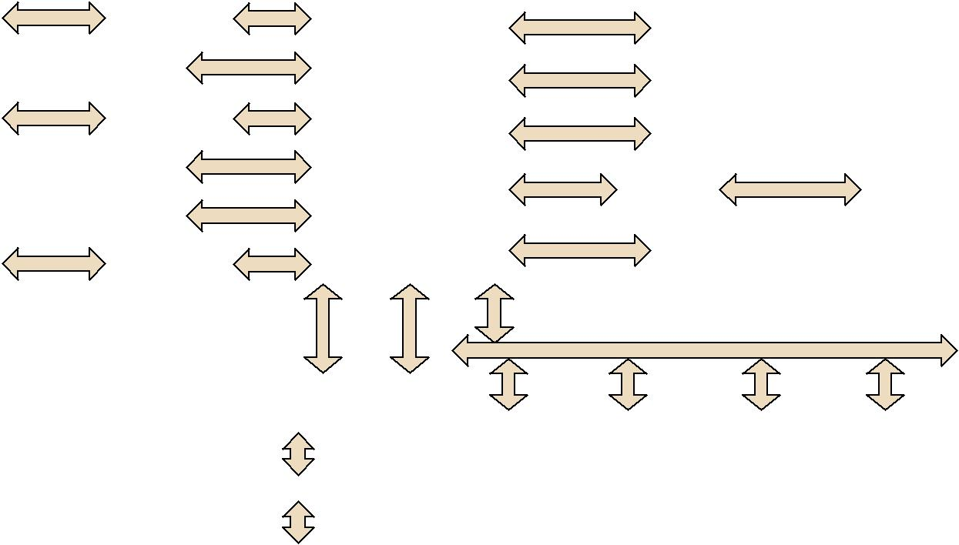

**订购信息**

|  |  |  |  |  |  |  |  |  |  |  |  |  |  |  |  |  |
| --- | --- | --- | --- | --- | --- | --- | --- | --- | --- | --- | --- | --- | --- | --- | --- | --- |
| **料号** | **PCH** | **内存** | **VGA** | **DVI** | **LVDS** | **USB** | | **SATA** | **COM** | **TPM** | **LAN** | **PCIe x 16** | **PCIe** | **PCI** | **AMP** |  |
| **3.0/2.0** | | **2.0** | **x 1** | **slot** |  |
|  |  |  |  |  |  |  |  |  |  |  |  |
| AIMB-501G2-KSA1E | H61 | Non ECC | 2 | (1) | 1 | 0 /10 | | 4 | 10 | (1) | 2 | 1 | 1 | 2 | Yes (6W) |  |
| AIMB-501VG-KSA1E | H61 | Non ECC | 1 | (1) | 0 | 0 /10 | | 4 | 10 | (1) | 1 | 1 | 1 | 0 | Yes (6W) |  |
| AIMB-501L-KSA1E | H61 | Non ECC | 1 | 0 | 0 | 0 | /10 | 4 | 2 | (1) | 1 | 1 | 1 | 0 | No |  |
| AIMB-501G2-KSA2E | H61 | Non ECC | 1 | 1 | 1 | 2 | / 8 | 4 | 10 | (1) | 2 | 1 | 1 | 2 | Yes (6W) |  |

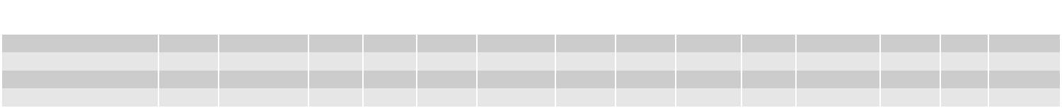

*() BOM options available on MP version.

**转接卡**

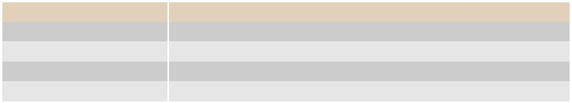

|  |  |
| --- | --- |
| **料号** | **说明** |
| AIMB-RP10P-01A1E | 1U转接卡，带1个PCI扩展 |
| AIMB-RP30P-03A1E | 具有3个PCI扩展的2U转接卡 |
| AIMB-RP3PF-21A1E | 具有1个PCIe x16和2个PCI扩展的2U转接卡 |
| AIMB-RF10F-01A1E | 1U转接卡，带1个PCI E x 16扩展 |

**包装列表**

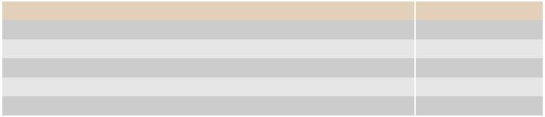

|  |  |
| --- | --- |
| **说明** | **数量** |
| 串行ATA HDD数据电 | 2 |
| 缆COM端口电缆套件 | 3 |
| I/O端口支架 | 1 |
| 启动手册 | 1 |
| 驱动程序CD | 1 |

**I/O视图**

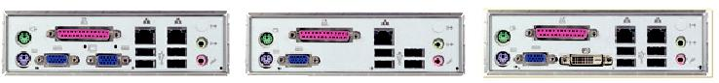

**可选附件**

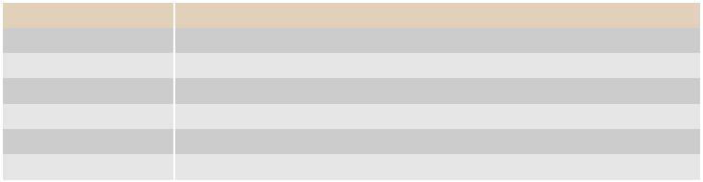

|  |  |
| --- | --- |
| **料号** | **说明** |
| 1700002204 | 带双端口的USB电缆，27厘米 |
| 1700008822 | DVI电缆 |
| 1960047669N001 | 用于4U和壁挂式机箱的LG1156 CPU冷却器 |
| 1700018699 | KBMS电缆1*6P-2.5/DIN-6P（F）*2，25 cm |
| 1700000447 | 1到4个串行端口电缆套件，45cm |
| 1701400181 | 1到4个串行端口电缆套件，18cm |

注：必须从Advantech购买AIMB-501专用CPU冷却器；其他品牌的CPU冷却器与AIMB-501不兼容。

**内置OS/API**

|  |  |  |
| --- | --- | --- |
| **OS/API** | **料号** | **说明** |
| WIN XPE | 2070011383 | Image XPE WES2009 AIMB-501KS V4.3 ENG |
| WES7 | 2070011384 | Image WES7E AIMB-501KS V5.1.2 ENG |



AIMB-501G2-KSA1E AIMB-501VG/L-KSA1E AIMB-501G2-KSA2E



**Online Download** www.advantech.com/products