AIMB-290
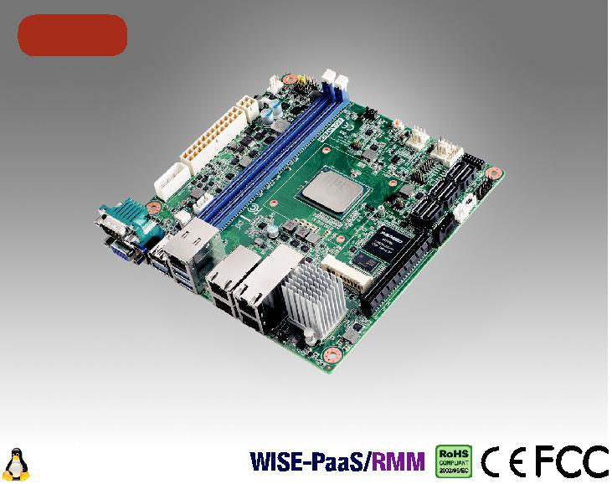

NEW

Windows Server 2016

Intel ATOM C3000 处理器与 DDR4 ECC/ non-ECC内存, VGA, 双GbE, Dual 10GbE, PCIe x8, eMMC ATX 或直流输入

特性

支持IPMI 2.0

 搭载多达16核Intel ATOM C3000 处理器
- eMMC on board

- 双288-pin DDR4 ECC/non-ECC DIMM高达64GB/32GB DDR4 2400/2133 MHz DRAM

- 双10GbE 和双GbE LANs
- EMMC 5.1, 6xSATAIII, 1xmSATA

- TPM 2.0 (optional)

- 支持直流12V 4-pin 或r ATX 24-pin 连接器

软件APIs:

SMBus H/W Monitor Watchdog GPIO

公用设施:

BIOS flash Monitoring

规格列表

 | CPU | C3958 |  | C3758 | C3558
 | 芯片数 | 16c |  | 8c | 4c
处理器 | 最大主频 | 2.0GHz |  | 2.2 GHz | 2.2GHz
 | 二级缓存 | 16MB |  | 16 MB | 8MB
 | TDP | 31W |  | 25 W | 16W
 | BIOS | AMI EFI 128Mbit SPI
扩展槽 | Mini-PCIe | 1 | F/S miniPCIe slot support mSATA
 | PCIe x8 (Gen3) | 8 GB/s per direction, 1 slot (by sku)
 | 规范 | 单通道, DDR4 1600/1866/2133/2400MHz ECC/Non-ECC 带288-pin U-DIMM/R-DIMM
内存 | 最大可支持容量 | 16GB/per DIMM for DDR4 non-ECC/ECC 2400MHz with U-DIMM,
 |  | 32GB/per DIMM for DDR4 ECC 2400MHz with R-DIMM
 | 插槽 | 2 x 288pin DDR4 DIMM socket
显示芯片 | 控制器 | ASPEED AST2500/2510 BMC 控制器 (by sku)
 | VGA | Yes,支持最大分辨率1920 x 1200 @ 60 Hz
 | 接口 | 2x 100/1000Mbps & 2x 10GbE
 |  | LAN 1/2: Marvell 88E1512 with RJ45 for 1GbE
以太网 | 控制器 | LAN 3/4: Intel X557-AT2 with RJ45 for 10GbE (optional)
 |  | LAN 5: Realtek RTL8201 with RJ45 for IPMI (optional)
 | 连接器 | 5 x RJ-45 (optional)
eMMC | 容量 | 16GB
SATA | 带宽 | 600 MB/s (SATA 3.0)
 | 通道 | 6 | (SATA III)
 | VGA | 1
后置 I/O | 以太网 | 5 | (optional)
 | USB | 4 | (3 x USB3.0,1 x USB2.0)
 | 系列 | 1 | (RS-232)
 | USB | 0 or 2 (USB2.0) (by sku)
 | 系列 | 1 | (RS-232/422/485 autoflow control)
内置I/O | SATA | 6 | (SATA III)
 | Mini-PCIe | 1 | (F/S Mini-PCIe colay mSATA)
 | GPIO | 8bit
 | KB/MS | 1
看门狗计时器 | 输出 | 系统复位
 | 间隔 | 可编程的1 ~ 255 sec/min
电源需求 | 输入功率 | ATX 24-pin or 12V 4-pin *
 | 功耗 | Intel C3958 + 32GB RAM + 64GB SSD: 35W
 |  | 工作 |  |  | 非工作
环境 | 温度 | 0 | ~ 60° C (32 ~ 140° F) |  | -40 ~ 85° C (-40 ~ 185° F)
 |  | (10GbE IC使用AIMB-290标准冷却器和系统风扇)
物理特性 | 尺寸 | 170 mm x 170 mm (6.69" x 6.69")

- 请使用EATXPWR1或ATX12V1。不要同时使用两个接头。

Industrial Motherboards & Systems

All product specifications are subject to change without notice. Last updated: 22-Nov-2018

AIMB-290

框架图

VGA

DDR3

SPI 16MB

REAR I/O

^{RJ-45} MDI RTL8201 10/100m

PCIe x8 slot
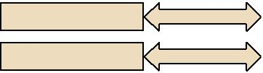

6 SATA ports

3 USB 3.0 port

1 or 3 USB 2.0 ports

eMMC 16GB

AST 2500

Co-lay

AST 2510

RMII LPC

BIOS SPI

8-bit GPIO

PS/2 KB/MS

PCIe Gen3
600 MB/s
 | Intel ATOM
USB 3.0 | C3000 Processor
USB 2.0
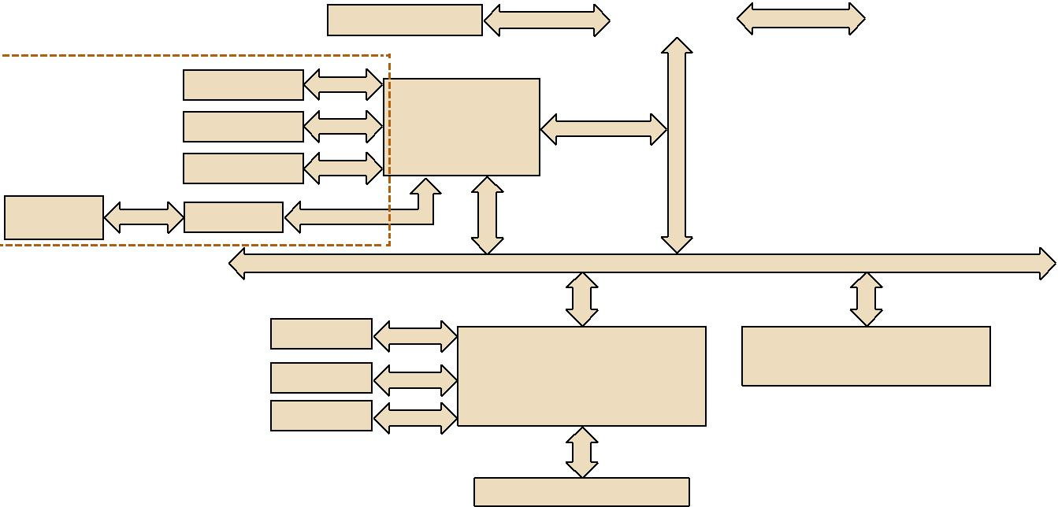

PCIe x1

LPC

Super I/O Winbond

NCT6776D

Channel A | DDR4 2133/2400MHz DIMM
Channel B | DDR4 2133/2400MHz DIMM
SGMII | 1GbE LAN1&2:
 | Marvell 88E1512
KR | 10GbE LAN3&4:
 | Intel X557-AT2 (optional)
(PCIex1/USB signal)
PCIe x1 | Full-size Mini-PCIe
 | (colay mSATA)

In neon TPM 2.0
(optional)

1 RS-232, 1 RS-232/422/485

订购信息

P/N | CPU | eMMC | VGA | GbE LAN | 10GbE | COM | SATA | USB3.0/2.0 | MiniPCIe | TPM | PCIEx8 | IPMI
AIMB-290G4-S1A1E | C3958 | 16GB | 1 | 2 | 2 | 2 | 6 | 3/1 | 1 F/S | (1) | 1 | Yes
AIMB-290G4-S2A1E | C3758 | 16GB | 1 | 2 | 2 | 2 | 6 | 3/1 | 1 F/S | (1) | 1 | Yes
AIMB-290G2-S3A1E | C3558 | 16GB | 1 | 2 | 0 | 2 | 6 | 3/3 | 1 F/S | (1) | 0 | NA

*() BOM options available on MP version.

包装列表

料号 | 说明 | 数量
1700003194 | SATA HDD cable | 4
1700027538-01 | SATA power cable | 1
1700100250 | Serial port cable (1 port, 25cm) | 1
1960084693T000 | I/O port bracket | 1
2006029000 | Startup manual | 1
2026029000 | China RoHS letter | 1
1960054541N031 | CPU cooler | 1
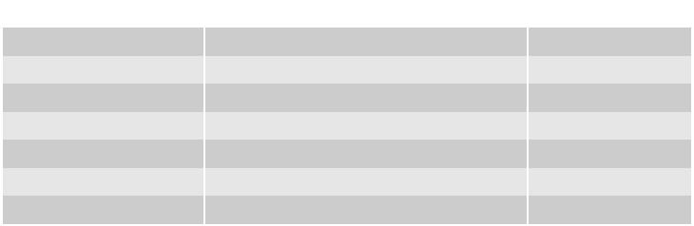

嵌入式OS/API

OS/API | 说明
Windows Server | Windows Server 2016
Linux Server | Red Hat Enterprise Linux Server (x64)

后置 I/O
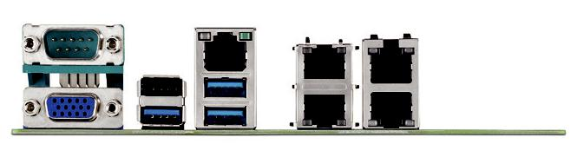

可选附件
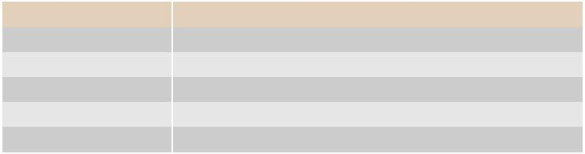

料号 | 说明
1703100121 | USB 2.0 cable with two ports, 12 cm
1703100261 | USB 2.0 cable with two ports, 26 cm
1703060191 | KB/MS cable 1*6P-2.0/M-DIN 6P(F)*2, 19cm
AIMB-RF10F-01A1E | Riser, PCIex16 to PCIex16
AIMB-RF20F-02A1E | Riser, PCIex16 to 2 PCIex16

可选底盘

料号 说明

AIMB-B2000-15ZE Mini-ITX chassis with 150W power

Note :

- 为防止干扰，当您将aimb-mb集成到aimb-b2000系列时，请再次用机箱数据表确认CPU冷却器的零件号。

- 10GbE局域网集成电路由于其优异的性能，温度很高。在用AIMB-290组装外壳时，请确保所实施的系统风扇能够将机箱中的10GbE LAN IC散热。

Online Download www.advantech.com/products

