

**AIMB-205**

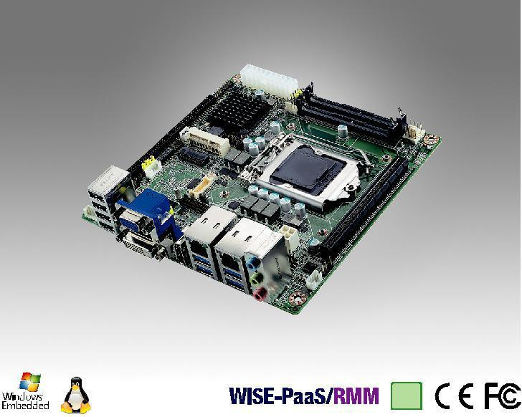

**RoHS**

**顺应性**

**2002/95/EC**

标准 7

**规格**

**Intel®Core™i7/i5/i3 LGA 1151 Mini-**

**ITX， VGA/DP/DVI-D/LVDS(EDP)，**

**8 COM，双通道 LAN，PCIE X16，M.2， DDR4**

**特性**

●支持 1 F/S MiniPCIe 和 1 M.2 2242 (B key for SSD)

●支持 DirectX 12, OpenGL 4.4, OpenCL 2.0 以提供

卓越3D显示性能

●支持独立双显: DP/DVI-D/VGA/LVDS(eDP)

●2 x 260-pin SO-DIMM 最高可达 32GB DDR4 2133 MHz SDRAM

●支持 Intel® 7th Gen Core™ & 6th Gen Core™ i 处理器 / Pentium / Celeron (LGA1151) 并搭载Intel H110芯片组

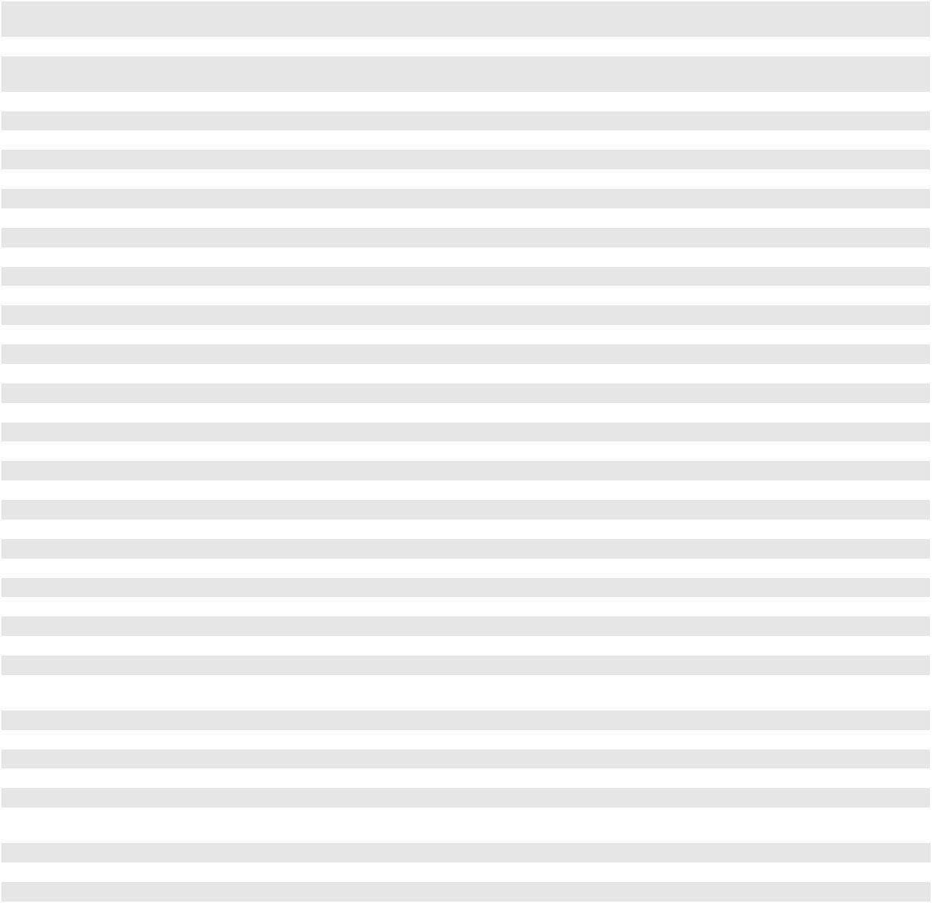

|  |  |  |  |  |  |  |  |  |  |  |  |  |  |
| --- | --- | --- | --- | --- | --- | --- | --- | --- | --- | --- | --- | --- | --- |
|  | CPU | i7-7700/ | | i7-6700/ | i5-7500/ | i5-6500/ | i3-7101/ | i3-6100/ | Pentium | Pentium | Celeron | Celeron |  |
|  | 7700T | | i7-6700TE | i5-7500T | i5-6500TE | i3-7101TE | i3-6100TE | G4400 | G4400TE | G3900 | G3900TE |  |
|  |  |  |
|  | 芯片数 | 4/4 | | 4/4 | 4/4 | 4/4 | 2/2 | 2/2 | 2 | 2 | 2 | 2 |  |
|  | 最大主频 | 3.6GHz/ | | 3.4GHz/ | 3.4GHz/ | 3.2GHz/ | 3.9GHz/ | 3.7GHz/ | 3.3G | 2.4G | 2.8G | 2.6G |  |
| 处理器 | 2.9GHz | | 2.4GHz | 2.7GHz | 2.3GHz | 3.4GHz | 2.7GHz |  |
|  |  |  |  |  |  |
|  | 三级缓存 | 8M/8M | | 8M/8M | 6M/6M | 6M/6M | 3M/3M | 3M/4M | 3M | 3M | 2M | 2M |  |
|  | TDP | 65W/35W | | 65W/35W | 65W/35W | 65W/35W | 54W/35W | 51W/35W | 54W | 35W | 51W | 35W |  |
|  | 芯片组 | H110 | |  |  |  |  |  |  |  |  |  |  |
|  | BIOS | AMI EFI 128 Mbit SPI | | |  |  |  |  |  |  |  |  |  |
|  | 规范 | 双通道DDR4 2400/2133 MHz non ECC SDRAM (只支持DDR4 2133 MHz SDRAM for SKL-S CPU) | | | | | | | | |  |  |  |
| 内存 | 最大可支持容量 | 高达32GB (16GB per SO-DIMM) | | | |  |  |  |  |  |  |  |  |
|  | 插槽 | 2 x 260-pin SO-DIMM | | |  |  |  |  |  |  |  |  |  |
|  | 控制器 | Integrated Intel® HD Graphics 530 | | | |  |  |  |  |  |  |  |  |
|  | VRAM | 共享系统内存， 2 GB及以上, 总系统内存共享 1GB 最大视频内存 | | | | | | |  |  |  |  |  |
|  | VGA | 最大分辨率1920 x 1200 @ 60 Hz | | | |  |  |  |  |  |  |  |  |
| 显示芯片 | DVI-D | 支持最大分辨率1920 x 1200 @ 60Hz | | | |  |  |  |  |  |  |  |  |
|  | 显示端口 | 最大分辨率4096 x 2160 @ 60Hz | | | |  |  |  |  |  |  |  |  |
|  | LVDS/eDP | LVDS:支持双通道24-bit up to 1920 x 1200 / eDP:带internal pin header, 支持最大分辨率4096 x 2160 @ 60 Hz | | | | | | | | | |  |  |
|  | 双显 | Yes (DP+VGA, DP+LVDS (or eDP), DP+DVI-D, DVI-D+VGA, DVI-D+LVDS (or eDP), VGA+LVDS (or eDP) | | | | | | | | |  |  |  |
|  | 接口 | 10/100/1000 Mbps | | |  |  |  |  |  |  |  |  |  |
| 以太网 | LAN 1 控制芯片 | Realtek RTL8111G GbE LAN | | |  |  |  |  |  |  |  |  |  |
| LAN 2 控制芯片 | Realtek RTL8111G GbE LAN | | |  |  |  |  |  |  |  |  |  |
|  |  |  |  |  |  |  |  |  |  |
|  | 接口 | 2 x RJ-45 | |  |  |  |  |  |  |  |  |  |  |
|  | M.2 | 1 | M.2 2242 (B key for SSD) | |  |  |  |  |  |  |  |  |  |
| 扩展槽 | Mini PCIe | 1 | F/S miniPCIe slot support mSATA | | |  |  |  |  |  |  |  |  |
|  | PCIe x16 (Gen2/3) | 1 | (16GB/s per direction) | |  |  |  |  |  |  |  |  |  |
| 硬盘 | SATA 3.0 | 2 | (600MB/s per port) | |  |  |  |  |  |  |  |  |  |
|  | DVI-D | 1 |  |  |  |  |  |  |  |  |  |  |  |
|  | VGA | 1 |  |  |  |  |  |  |  |  |  |  |  |
|  | DisplayPort | 1 |  |  |  |  |  |  |  |  |  |  |  |
| 后置I/O | RJ-45 | 2 |  |  |  |  |  |  |  |  |  |  |  |
|  | USB 3.0 | 4 |  |  |  |  |  |  |  |  |  |  |  |
|  | USB 2.0 | 4 |  |  |  |  |  |  |  |  |  |  |  |
|  | Audio | 3 | (line-in, line-out, mic-in) | |  |  |  |  |  |  |  |  |  |
|  | USB 2.0 | 6 | (USB11-14 is BOM optional) | | |  |  |  |  |  |  |  |  |
|  | 串口 | 7 x RS232, 1 x RS232/422/485 | | | |  |  |  |  |  |  |  |  |
|  | COM1: 支持5V/12V 跳线选择, COM2: 支持 RS-232/422/485 BIOS 选择 | | | | | | |  |  |  |  |  |
| 内置连接器 | SATA 3.0 |  |  |  |  |  |
| 2 | |  |  |  |  |  |  |  |  |  |  |
|  |  |  |  |  |  |  |  |  |  |  |
|  | TPM | (optional SLB9660 TPM 1.2/ SLB9665 TPM 2.0) | | | | |  |  |  |  |  |  |  |
|  | GPIO | 1 | (8-bit) |  |  |  |  |  |  |  |  |  |  |
| 看门狗计时器 | 输出 | 系统复位 | |  |  |  |  |  |  |  |  |  |  |
| 间隔 | 可编程的1-255 sec/min | | |  |  |  |  |  |  |  |  |  |
|  |  |  |  |  |  |  |  |  |  |
| 电源要求 | 输入功率 | ATX | |  |  |  |  |  |  |  |  |  |  |
| Win Idle 10.43W (Intel core i7-7700 3.6GHz / DDR4 2133MHz 16GB x 2) | | | | | | |  |  |  |  |  |
|  |  |  |  |  |  |  |
| 环境 | 工作温度 | 0 | ~ 60° C (32 ~ 140° F) | |  |  |  |  |  |  |  |  |  |
| 非工作温度 | -40 ~ 85° C (-40 ~ 185° F) | | |  |  |  |  |  |  |  |  |  |
|  |  |  |  |  |  |  |  |  |  |
| 物理特性 | 尺寸 | 170 x 170 mm (6.7" x 6.7") | | |  |  |  |  |  |  |  |  |  |



**Industrial Motherboards & Systems**

All product specifications are subject to change without notice. Last updated: 17-Aug-2017

**AIMB-205**

**框架图**

DVI -D (rear IO)

DP (rear IO)

Display port

PCIex 16

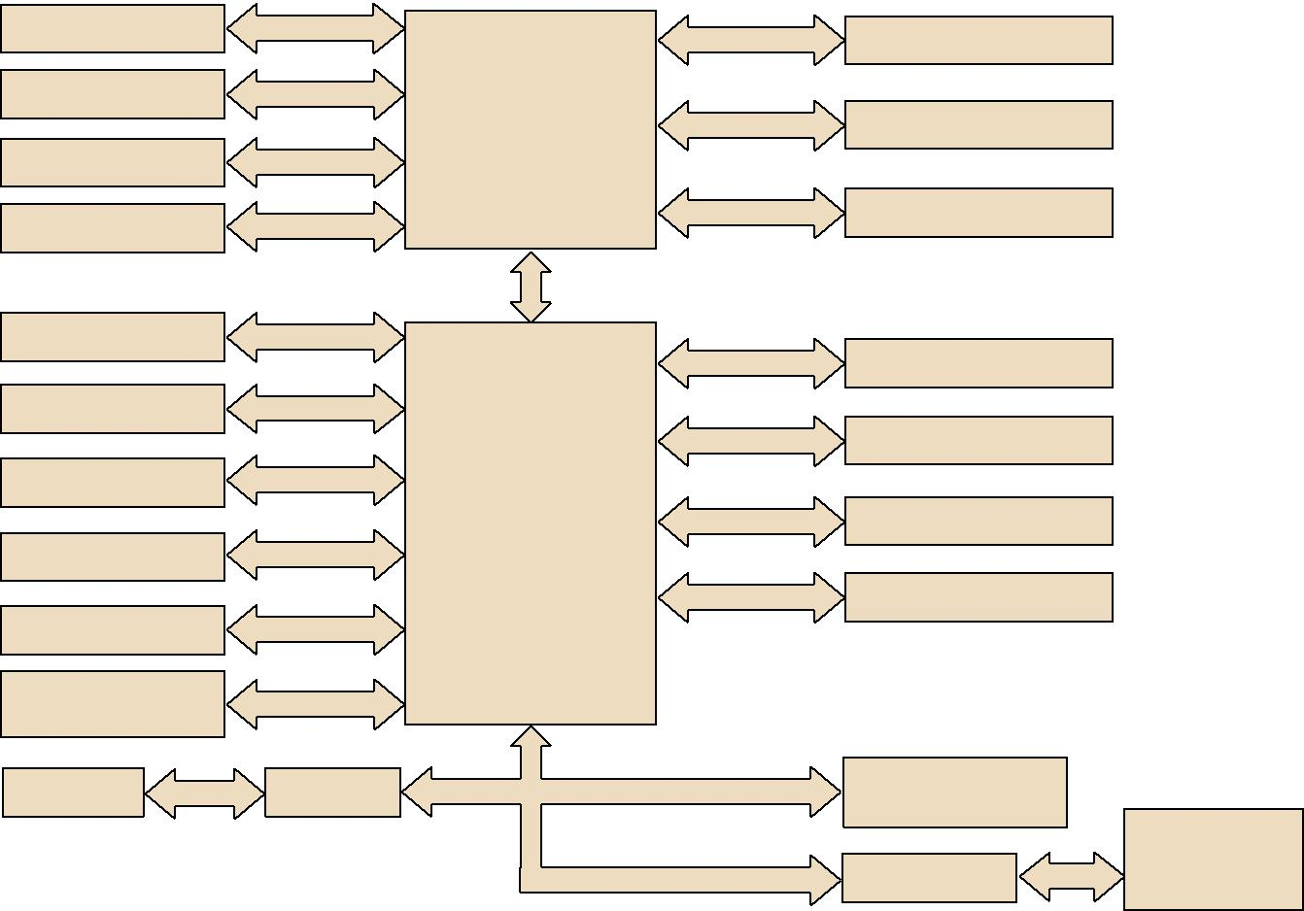

PCIe x 16 Slot

LVDS, colay eDP

VGA (rear IO)

eDP

Intel 7th & 6th Gen Core i / Pentium / Celeron

processor

DMI x 4

Channel A

Channel B

DDR4 SO-DIMM1

DDR4 SO-DIMM2

2 SATA3 ports

4 USB3.0 ports (rear IO)

4 USB2.0 ports (rear IO)

2 USB2.0 (internal)

4 USB 2.0 (optional)

Realtek Audio Codec

ALC892

4 x RS232

SATA3

USB 3.0/2.0

USB 2.0

Intel H110

USB 2.0

PCIe x 1

HD Audio

F81216HD

|  |
| --- |
| LPC |

PCIe x 1

PCIe x 1

PCIE/USB/SATA

SATA/PCIEx2/USB

GbE LAN1: Realtek 8111G

GbE LAN2: Realtek 8111G

1 F/S mini PCIe (colay mSATA)

1 M.2-B for SSD (2242)

TPM 1.2/2.0

SLB9660&9665

(optional)

NCT6106D

3 x RS-232 &

1 x RS-232/422/485 PS/2 , WDT, 8-bit GPIO

**订购信息**

|  |  |  |  |  |  |  |  |  |  |  |  |  |  |  |
| --- | --- | --- | --- | --- | --- | --- | --- | --- | --- | --- | --- | --- | --- | --- |
| **料号** | **芯片组** | **DP** | **DVI-D** | **VGA** | **LVDS** | **GbE LAN** | **COM** | **SATA** | **USB 3.0/2.0** | **M.2** | **Mini PCIe** | **TPM** | **AMP** | **PCIe x 16** |
| AIMB-205G2-00A1E | H110 | 1 | 1 | 1 | 1 | 2 | 8 | 2 | 4/6 | 1 (1 M.2-B 2242) | 1 F/S | (1) | 1 | 1 |

*() BOM options available on MP version.

**包装列表**

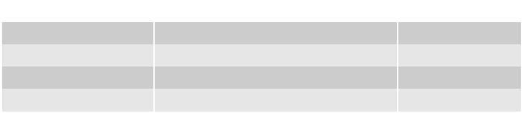

|  |  |  |
| --- | --- | --- |
| **零件号** | **说明** | **数量** |
| 1700003194 | SATA HDD cable | 1 |
| 1700008876 | 1-to-4 serial ports, 35 cm | 2 |
| 1960082356T000 | I/O port bracket | 1 |
| 2006B20500 | Startup manual | 1 |
| **可选底盘** |  |  |



**可选配件**

**零件号**

1700026162-01

1960053207N001

1960060732N001

1703060191

**说明**

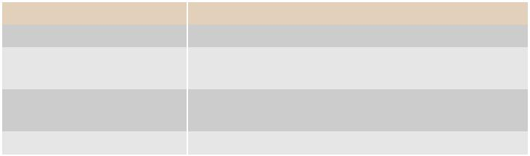

USB 2.0 cable with two ports, 30 cm with bracket LGA1150 CPU cooler for CPU TDP 65W,

92.9 (W) x 92.9 (L) x 46 (H) mm LGA1150 CPU cooler for CPU TDP 45W, 80 (W) x 80 (L) x 32.2 (H) mm

KB/MS cable 1*6P-2.0/M-DIN 6P(F)*2, 19cm

**零件号** **说明**

AIMB-B2000-15ZE Mini-ITX chassis (w/ 150W PSU)

**I/O视图**

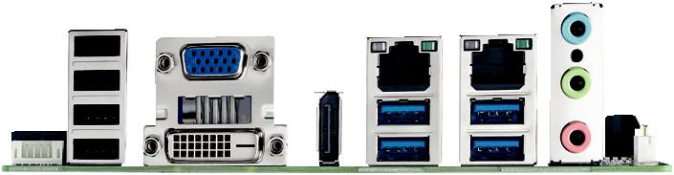

**嵌入式 OS/API**

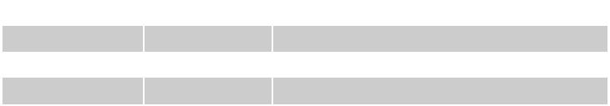

|  |  |  |  |
| --- | --- | --- | --- |
| **OS/API** | **料号** | **说明** |  |
| Win10 IoT Ent | 2070015197 | img W10 | 16HL AIMB-205 64b 1701 ENU |
| Win10 IoT Ent | 2070015198 | img W10 | 16VL AIMB-205 64b 1701 ENU |
| WE8.1 | 2070015281 | img W81 IP AIMB-205 64b 1609 ENU | |

**KBL-S CPU only support windows 10

**Online Download** www.advantech.com/products