

**AMD Merlin Falcon Quad Core Mini-ITX**

**AIMB-227** **with DP/DVI-D/HDMI, 6COM, and Dual LAN**

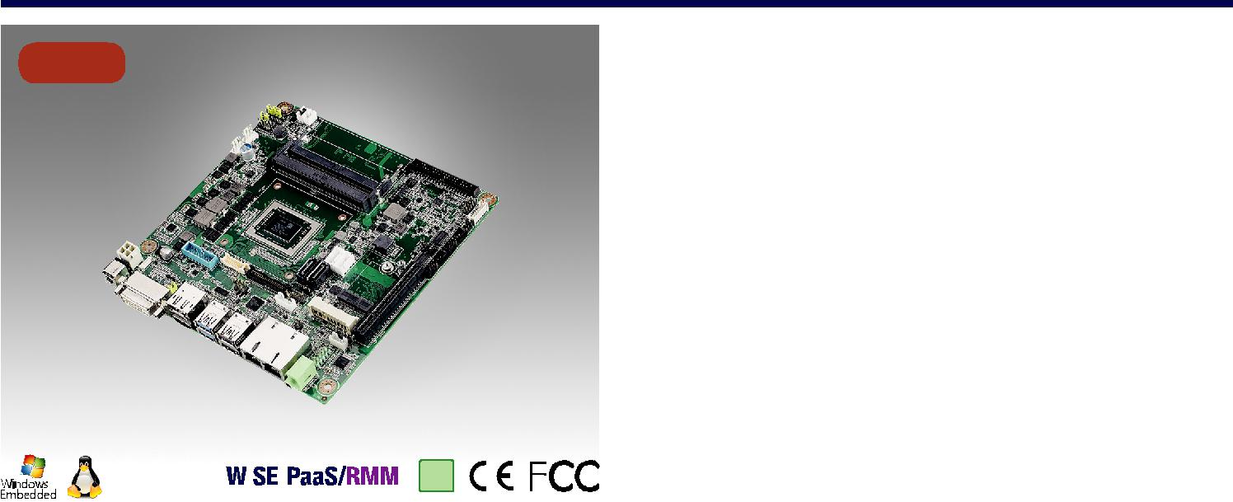

|  |  |  |  |  |  |  |  |  |  |
| --- | --- | --- | --- | --- | --- | --- | --- | --- | --- |
| **NEW** |  |  |  |  | **特性** | | |  |  |
|  |  |  |  |  | ****支持AMD Merlin Falcon / Brown Falcon / Prairie Falcon处理器 | | | |  |
|  |  |  |  |  | ****两个260-pin SO-DIMM，最高16GB DDR4 2133 SDRAM | | | |  |
|  |  |  |  |  | ****支持DP/eDP/LVDS + DVI-D + HDMI三重显示 | | | |  |
|  |  |  |  |  | ****支持1个PCIe x8和1个Mini-PCIe扩展插槽 | | | |  |
|  |  |  |  |  | ****6个COM，4个USB 2.0，4个USB 3.0 | | | |  |
|  |  |  |  |  | ****支持SUSIAccess和嵌入式软件API | | | |  |
|  |  |  |  |  | **软件 APIs:** |  |  |  |  |
|  |  |  |  |  |  |  |  |  |
|  |  |  |  |  | SMBus | | | H/W Monitor Brightness WatchdogGPIO |  |
|  |  |  |  |  | **公用设施：** | | |  |  |
|  |  |  |  |  | BIOS flash | | | Monitoring |  |
|  |  |  |  |  |  |  |  |  |  |
|  |  | **RoHS** |  |  |  |  |  |  |  |
|  |  | **COMPLIANT** |  |  |  |  |  |  |  |
|  |  | **2002/95/EC** |  |  |  |  |  |  |  |



**规格表**



|  |  |  |  |  |  |  |
| --- | --- | --- | --- | --- | --- | --- |
|  | SOC (28nm) | AMD Quad RX-421BD | | RX-216GD | GX-224IJ |  |
| 处理器 | 最大主频 | 2.1GHZ (Quad Core 35W) | | 1.6GHz (Dual Core 15W) | 2.4GHz (Dual Core 15W) |  |
| 二级缓存 | 2 Mb | | 1 Mb | 1Mb |  |
|  |  |
|  | BIOS | AMI 16 Mbit SPI | | AMI 16 Mbit SPI | AMI 16Mbit SPI |  |
|  | M.2 | 1, E key (2230) | |  |  |  |
| 扩展槽 | Mini-PCIe | 1, F/S x 1支持 mSATA 和 SIM 扩展 | |  |  |  |
|  | PCIe | 1, PCIe x8 (BF and PF 支持1 PCIe x4) | |  |  |  |
|  | 技术 | 双通道DDR4 2400MHz SDRAM | |  |  |  |
| 内存 | 最大容量 | 16 GB/8 GB per SO-DIMM | |  |  |  |
|  | 插槽 | 2 x 260-pin DDR4 SO-SIMM with ECC 支持 (PF支持1 DDR4 SO DIMM插槽和无ECC功能) | | | |  |
|  | 控制器 | AMD Radeon 3rd Generation GCN (Up to 8 CUs) | | |  |  |
|  | DVI-D | 1, 支持高达 SXGA 1920 x 1200 | |  |  |  |
|  | eDP Version 1.4 | 1, 2560 x 1600 @ 60Hz Max (Optional) | |  |  |  |
| 显示 | LVDS | 1, 支持双通道 48-bit up to 1920 x colay DP 1.2 port (Optional) | | |  |  |
| 显示端口 1.2 | 1, 支持DP++, 分辨率4096 x 2160 @ 24Hz | | |  |  |
|  |  |  |
|  | HDMI V2.0 | 1, 4096 x 2160 @ 60Hz Max (60Hz requires re-timer) | | |  |  |
|  | 双显 | Merlin Falcon: DP/eDP/LVDS + DVI-D +HDMI | | |  |  |
|  | Brown Falcon & Prairie Falcon: DP/eDP/LVDS + DVI-D | | |  |  |
|  |  |  |  |
|  | 接口 | 10/100/1000 Mbps | |  |  |  |
| 以太网 | 控制器 | GbE LAN1: Realtek 8111G | |  |  |  |
| GbE LAN2: Realtek 8111G | |  |  |  |
|  |  |  |  |  |
|  | 连接器 | RJ-45 x 2 | |  |  |  |
| SATA | 带宽 | 600 MB/s | |  |  |  |
| 通道 | 2, SATA 2 colay mSATA (optional); SATA 1 support SATA-DOM device | | |  |  |
|  |  |  |
|  | DVI-D (Default) | 1 |  |  |  |  |
|  | DP1.2 (Default) | 1 |  |  |  |  |
|  | HDMI (Default) | 1 | (Brown Falcon / Prairie Falcon no support) | |  |  |
| 后置 I/O | 以太网 | 2 |  |  |  |  |
|  | USB | 2 x USB 2.0/2 x USB 3.0 | |  |  |  |
|  | Audio | 1 | (Line out) |  |  |  |
|  | DC jack | 1 | (2.5 mm) |  |  |  |
|  | LVDS & Inverter (Optional) | 1/1 | |  |  |  |
|  | eDP (Optional) | 1 |  |  |  |  |
|  | USB | 2 x USB3.0, 2 x USB2.0 | |  |  |  |
|  | Serial | 6 | (5 x RS232,1 x RS232/422/485; COM 3 support RS232/422/485 auto flow control; COM6 support 5v/12V by jumper | | |  |
|  | selection; 1 COM support CCtalk ; 1 COM support TTL) | | |  |  |
| 内置连接器 |  |  |  |
| SATA | 2 |  |  |  |  |
|  |  |  |  |  |
|  | SATA PWR 连接器 | 2 |  |  |  |  |
|  | PS/2 KB & MS | 1 |  |  |  |  |
|  | 入侵保护 | 1 |  |  |  |  |
|  | GPIO | 8-bit | |  |  |  |
| 看门狗计时器 | 输出 | 系统复位 | |  |  |  |
| 间隔 | 可编程的 1 ~ 255 sec/min | |  |  |  |
|  |  |  |  |
| 电源 | 电源类型 | 单压12V 直流输入; 1 x External DC jack; 1 x Internal 4-pin (2x2) 电源连接器; 支持AT/ATX 模式 | | | |  |
| 典型功耗 | TBD | |  |  |  |
|  |  |  |  |
| 环境 |  | 工作 | | 非工作 |  |  |
| 温度 | 0 | ~ 60° C (32 ~ 140° F) | -40 ~ 85° C (-40 ~ 185° F) | |  |
|  |  |
| 物理特性 | 尺寸 | 170 mm x 170 mm (6.69" x 6.69") | |  |  |  |



**Industrial Motherboards**

All product specifications are subject to change without notice. Last updated: 26-Apr-2018

**AIMB-227**

**框架图**

DP++

DVI-D

HDMI (BF/PF no support)

2 SATAIII ports

4 USB 2.0

4 USB 3.0

Realtek Audio codec ALC892

BIOS

|  |  |  |  |
| --- | --- | --- | --- |
| DDI 1 |  |  |  |
| Colay eDP/LVDS |  |  |  |
| DDI 2 |  | Channel |  |
|  | PF only support |  |
|  |  |  |
|  |  | 1 SODIMM |  |
| DDI 3 |  | PCIe x 8 |  |
|  |  |  |
|  |  | BF & PF only |  |
| SATA III | AMD Merlin Falcon / | support PCIe x 4 |  |
|  |  |
|  | Brown Falcon / | 1 PCIe x 1 |  |
|  | Prairie Falcon |  |  |
| USB 2.0 | Platform |  |  |
|  |  | 1 PCIe x 1 |  |
| USB 3.0 |  |  |  |
|  |  | 1 PCIe x 1 |  |
| HD Audio |  |  |  |
| SPI |  | 1 PCIe x 1 / 1 USB 2.0 |  |
|  |  |  |
|  |  |  |  |
|  | LPC |  |  |

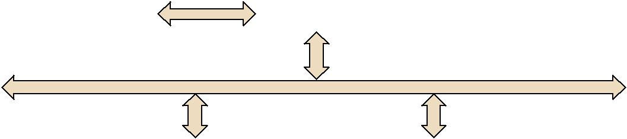

DDR4 2133 MHz SODIMM

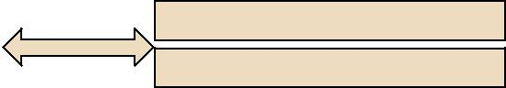

DDR4 2133 MHz SODIMM



1 PCIex8 Slot



GbE LAN1:

Realtek RTL8111G



GbE LAN2:

Realtek RTL8111G



1 F/S mPCIe colay mSATA /SIM card holder



M.2 E key (2230)

|  |  |  |  |  |  |  |
| --- | --- | --- | --- | --- | --- | --- |
| Infineon TPM | 2.0 |  | NCT6106D |  | PS2 KB/MS, WDT, 8bit GPIO, |  |
| (optional) |  |  |  | Smart Fan, HW.M, 6COM ports |  |
|  |  |  |  |  |
|  |  |  |  |  |  |  |



**订购信息**



|  |  |  |  |  |  |  |  |  |  |  |
| --- | --- | --- | --- | --- | --- | --- | --- | --- | --- | --- |
| **料号** | **CPU** | **显示器** | **TPM** | **eDP/LVDS** | **PCIe Slot** | **USB 3.0/2.0** | **GbE** | **SATA** | **COM** | **Thermal Solution** |
| AIMB-227MG2-00A1E | RX-421BD | DP/eDP/LVDS, DVI-D, HDMI | (1) | (1) | x8 | 4/4 | 2 | 2 | 6 | Active |
| AIMB-227MG2-01A1E | RX-216GD | DP/eDP/LVDS, DVI-D, HDMI | (1) | (1) | x8 | 4/4 | 2 | 2 | 6 | Passive |
| AIMB-227PG2-02A1E | GX-224IJ | DP/eDP/LVDS, DVI-D | (1) | (1) | x4 | 4/4 | 2 | 2 | 6 | Passive |

Note: Passive = fanless; Active = with fan

*() BOM options available on MP version.

**包装列表**

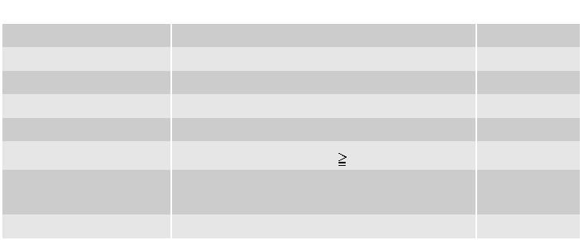

|  |  |  |  |
| --- | --- | --- | --- |
| **料号** | **说明** | **数量** |  |
| 1700003194 | SATA HDD cable | 1 |  |
| 1700018785 | SATA power cable | 1 |  |
| 1700008876 | 1-to-4 serial ports cable kit, 35 cm | 1 |  |
| 1700100250 | 1-to-1 serial ports cable kit, 25 cm | 2 |  |
| 1960078398T000 | I/O port bracket | 1 |  |
| 1960054541N031 | CPU Cooler (CPU TDP 35W); RX-421BD | 1 |  |
| 1960083981N001 | CPU Heatsink (CPU TDP<= 15W); | 1 |  |
| RX-216GD, GX-224IJ |  |
|  |  |  |
| 2006022700 | Startup manual | 1 |  |

**可选底盘**

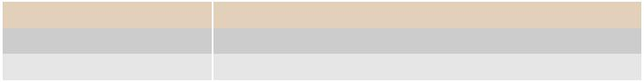

**料号** AIMB- **说明**

**可选附件**

**料号**

1700020277-01

1700026162-01

1700023474-01

1700025573-01

1700023082-11 96PSA-A84W12V1 96PSA-A60W12V1-1 1702002600 1702002605 1702031801 1700000237 1700000596-11

**说明**

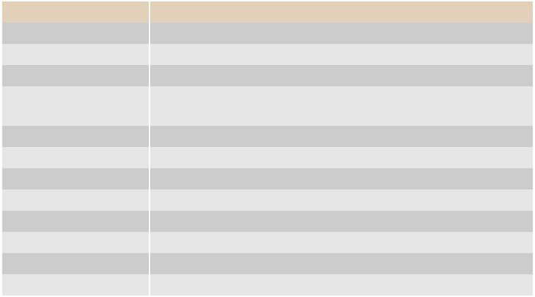

Dual port USB 3.0 cable 30cm with IO bracket USB 2.0 cable with two ports, 30 cm with bracket

2 port USB cable, F10p/2.0, lock 10-pin(right-up), 345 mm USB 3.0 Cable A CABLE USB 3.0 A/M*2/2*10P 2.0 90D 20CM

A cable 2*10P-4.2/1*3P-2.0 15cm

ADAPTER AC100~240V 84W +12V/7A (FSP)

ADAPTER AC100~240V 60W +12V/5A (FSP)

Power cable 3-pin 180 cm,USA type

Power cable 3-pin 180 cm, Europe type

Power cable 3-pin 180 cm, UK type

Power cable 3-pin PSE Mark 183 cm

Power cable 3-pin 180 cm, China type

B22270G-00YE AIMB- EPC-B2227 W/ RX-421BD Barebone system

T1227A-00YE EPC-T1227 W/ RX-216GD Barebone system

**I/O 视图**

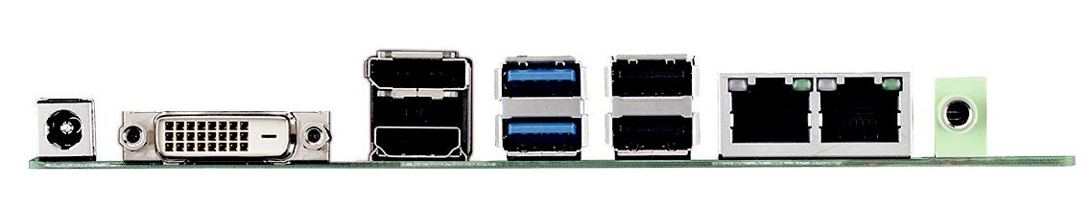

**嵌入式 OS**

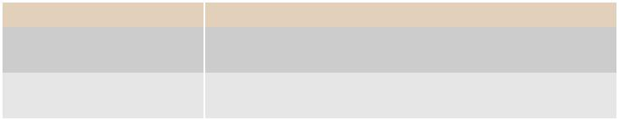

|  |  |  |  |
| --- | --- | --- | --- |
| **料号** | **说明** |  |  |
| 20706WX6VS0002 | img W10 | 16VL AIMB-227 64b 1709 ENU |  |
| (Merlin Falcon) | |  |
|  |  |
| 20706WX6ES0003 | img W10 | 16EL AIMB-227 64b 1709 ENU |  |
| (Brown Falcon, Prairie Falcon) | |  |
|  |  |

**Online Download** www.advantech.com/products