AIMB-276
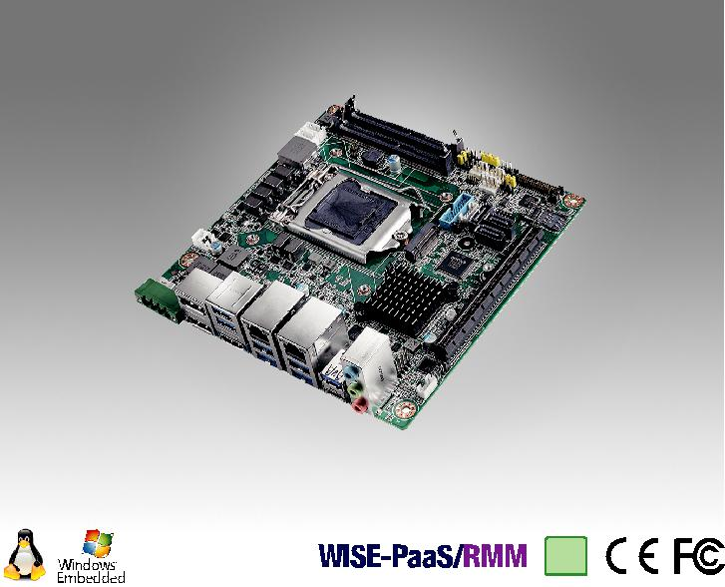

RoHS
COMPLIANT

2002/95/EC

Intel® Core™ i7/i5/i3 LGA 1151 Mini-ITX 双DP⁺⁺/HDMI/LVDS(eDP), 2 COM, Dual LAN, PCIe x16, M.2, DDR4, 直流输入

特性

支持第8代英特尔®Core™i处理器(LGA1151)与英特尔Q370芯片组两个260引脚SO-DIMM高达32GB DDR4 2666兆赫兹存储支持双DP++/HDMI 2.0a/LVDS(或eDP)独立三显

支持PCIe x16(第3代)，1 x M.2 B键+ 1 x M.2 E键，6 USB 3.1和4 USB 3.0，和3 SATA III 支持宽范围12V~24V直流输入

支持英特尔vPro, AMT 12.0，软件RAID 0.1 . 5.10, TPM 1.2 / 2.0(可选)
支持WISE-PaaS/RMM 以及嵌入式软件APIs

软件 APIs:

SMBus H/W Monitor Watchdog GPIO

公用设施:

BIOS flash Monitoring

规格列表

 | CPU | i7-8700/i7-8700T |  | i5-8500/i5-8500T | i3-8100/i3-8100T | Pentium G5400/G5400T | Celeron G4900/G4900T
 | 芯片数 | 6/6 |  | 6/6 | 4/4 | 2/2 | 2/2
 | 最大主频 | 3.2/2.4 GHz |  | 3.0/2.1 GHz | 3.6/3.1 GHz | 3.7/3.1 GHz | 3.1/2.9 GHz
处理器 | 智能缓存 | 12/12 MB |  | 9/9 MB | 6/6 MB | 4/4 MB | 2/2 MB
 | TDP | 65/35 W |  | 65/35 W | 65/35 W | 54/35 W | 54/35 W
 | 芯片组 | Q370
 | BIOS | AMI EFI 256 Mbit SPI
 | M.2 | 2, 1 x B key for SSD and 3G/4G (Type: 2242, 3042mm) & 1 x E key for wireless (Type: 2230mm);
扩展槽 |  | B key 默认支持SATA/PCIe 通道, USB2.0 支持BOM更改
 | PCIe x16 (Gen3) | 16 GB/s per direction, 1 slot
 | 技术 | 单通道 DDR4 2666 MHz SDRAM 32GB
内存 | 最大可支持容量 | (高达16GB per SO-DIMM)
 | 插槽 | 2 x 260 PIN DDR4 SO-DIMM (Non-ECC)
 | 控制器 | Intel® UHD Graphics 630 / Intel® HD Graphics 615
 | LVDS | 支持单通道 24-bit高达1920 x 1200
显示 | HDMI | Yes, 支持最大分辨率 4096 x 2160 @60 Hz (HDMI 2.0a)
 | eDP | Yes, 带internal pin header, 支持最大分辨率4096 x 2304 @ 60 Hz (BOM optional) Yes,
 | 显示端口 1.2 | 支持 2 x DP++ 最大分辨率 4096 x 2304 @ 60 Hz
 | 三显 | DP+DP+HDMI, DP+HDMI+LVDS (or eDP), LVDS(or eDP)+DP+DP
 | 接口 | 10/100/1000 Mbps
以太网 | 控制器 | GbE LAN1: Intel i219LM; LAN2: Intel I211AT
 | 连接器 | RJ-45 x 2
SATA | 最大数据传输速率 | 600 MB/s (SATA 3.0)
 | 通道 | 3 | (SATA III)
 | HDMI | 1 | (HDMI 2.0a)
 | 显示端口 1.2 | 2
后置I/O | 以太网 | 2
 | USB | 6 | USB 3.1 + 2 USB USB 3.0 (USB06 is USB 3.1 type C, supports 5V/3A, BOM optional)
 | Audio | 3 | (Mic-in, Line-out, Line-in)
 | Phoenix 连接器 | 1
 | USB | 2 | (USB 3.0)
 | LVDS/inverter | 1
 | Serial | 2 | (1 x RS-232/422/485, 1 x RS-232, supports 5V/12V)
内置连接器 | SATA | 3 | (SATA 3.0)
 |  | 2, 1 x B key for SSD and 3G/4G (Type: 2242, 3042mm);
 | M.2
 |  | 1 x E key for wireless (Type: 2230mm)
 | IrDA | -
 | GPIO | 8-bit
看门狗计时器 | 输出 | 系统复位
 | 间隔 | 可编程的1 ~ 255 sec/min
电源需求 | 输入功率 | 12 ~ 24V DC Input
 |  | TBD
环境 |  | 工作 |  |  | 非工作
 | 温度 | 0 | ~ 60° C (32 ~ 140° F), 取决于CPU运行速 |  | -40 ~ 85° C (-40 ~ 185° F)
 |  | 度及冷却器解决方案
物理特性 | 尺寸 | 170 mm x 170 mm (6.69" x 6.69")

Industrial Motherboards & Systems

All product specifications are subject to change without notice. Last updated: 25-Feb-2019

AIMB-276

框架图

Display Port 1.2

Display Port 1.2

LVDS 24/48 bits

eDP (optional)

HDMI 2.0a

3 SATA III Ports

6 USB 3.1 ports,
USB06 is optional
(type C)

4 USB 3.0 ports

Display port
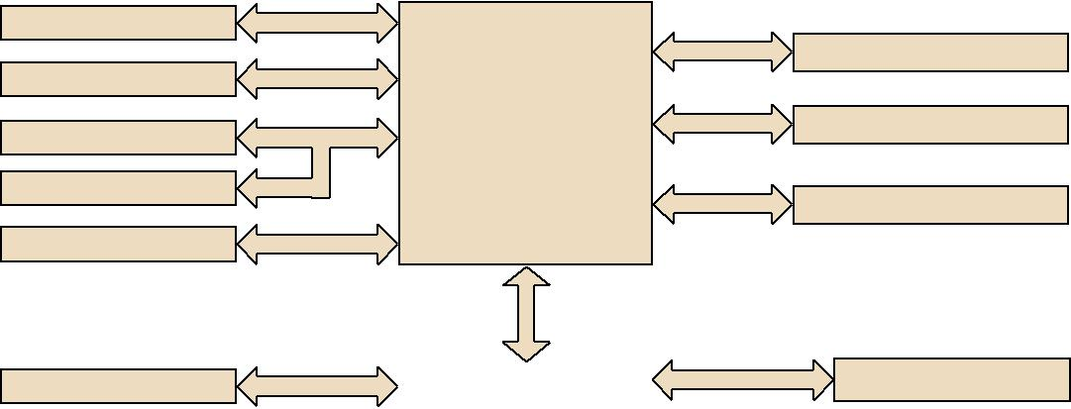

PCIe x 16

Display port

Intel 8th Gen

_{Display port} Core i7/i5/i3/Pentium/ ^{Channel A} Celeron processor

Channel B

Display port

 |  |  |  | DMI x 4
SATA 3 |  |  |  |  |  |  | PCIe x1
 |  |  |  |  |  |  | PCIe x1
USB 3.1 |  |  |  | Q370 |  |  | PCIex1
 |  |  |  |  |  |  | USB 2.0
USB 3.0 |  |  |  |  |  |  | SATA/ PCIex2
 |  |  |  |  |  |  | USB 2.0
 | HD Audio |  |  | SPI |  | LPC
 | Audio Codec |  |  | BIOS |  | Inÿneon TPM 1.2/2.0
 | Realtek ALC888S |  |  |  |  | (Optional)

PCIe x 16 (Gen 3)

DDR4 2666 MHz SO-DIMM

DDR4 2666 MHz SO-DIMM

GbE LAN1: Intel I219LM

GbE LAN2: Intel I211AT

M.2_E key
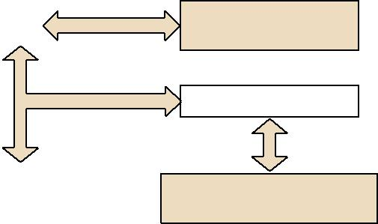

M.2_B key
(USB2.0 support by
BOM change)

Super IO Nuvuton 6776D

1 x RS-232 & 1 x RS-232/422/485,

PS/2, WDT, 8-bit GPIO

订购信息

P/N | 芯片组 | DP | LVDS/eDP | HDMI | GbE LAN | COM | M.2 B key | M.2 E key | SATA III | USB 3.1/3.0 | TPM | AMP | PCIex16 | Power
AIMB-276G2-00A1E | Q370 | 2 | 1/(1) | 1 | 2 | 2 | 1, Type: 2242 & 3042 | 1, Type: 2230 | 3 | 5+(1)/4 | (1) | (1) | 1 | 12~24V (via phoenix
 |  |  |  |  |  |  |  |  |  |  |  |  |  | connector)
AIMB-276G2-01A1E | Q370 | 2 | 1/(1) | 1 | 2 | 2 | 1, Type: 2242 & 3042 | 1, Type: 2230 | 3 | 5+(1)/4 | (1) | (1) | 1 | 12V (via ATX12V1)

*() BOM options available on MP version.

包装列表
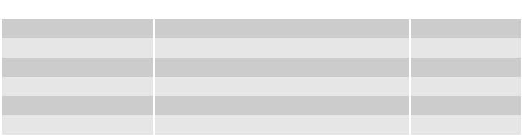

可选附件
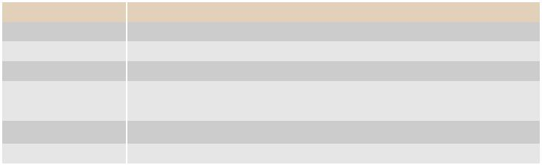

料号 | 说明 | 数量
1700003194 | SATA HDD cable | 1
1700018785 | SATA power cable (1 port, 25cm) | 1
1700022363-01 | 1-to-1 serial port cable 17CM | 2
TBD | I/O port bracket | 1
TBD | Startup manual | 1
1700023082-11 | ATX 2*10P to 1*3P-2.0 25cm cable | 1

料号

1700020277-01

1703060191

1700023768-01

1960053207N001

1960060732N001 96PSA-A120W12P4

说明

Dual port USB 3.0 cable 30cm with IO bracket KB/MS cable 1*6P-2.0/M-DIN 6P(F)*2, 19cm 1x4P Phoenix to DC Jack 15cm cable

LGA1150 CPU cooler for CPU TDP 65W, 92.9 (W) x 92.9 (L) x 46 (H) mm

LGA1150 CPU cooler for CPU TDP 45W, 80 (W) x 80 (L) x 32.2 (H) mm ADP A/D 100-240V 120W 12V C14 TERMINAL BLOCK 4P

可选底盘

料号 说明

AIMB-B2000-15ZE Mini-ITX chassis with 150W ATX power supply

AIMB-B2000-00YE Mini-ITX chassis (Optional external AC-DC 60W/84W Adaptor)

I/O 视图
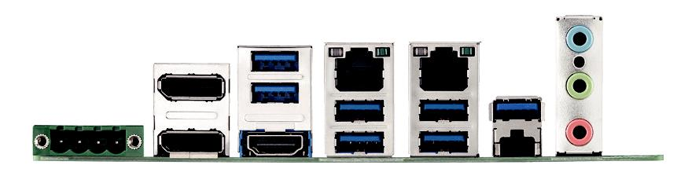

嵌入式OS/API

OS/API | Part No. | 968 P/N | 说明

Windows 10

转接卡

料号 说明

AIMB-RF10F-01A1E 1U riser card with 1 PCIex16 expansion

AIMB-RF20F-02A1E 2U riser card for 1xPCIex16 to 2 PCIex16 (both Lane are PCIEX8 only) ** compliant with AIMB-276G2 (Q370) sku only

Online Download www.advantech.com/products

