AIMB-286
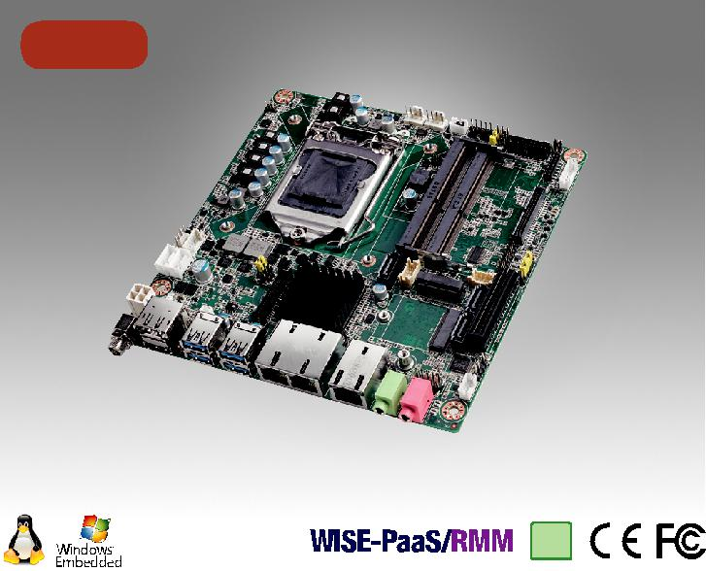

NEW

RoHS
COMPLIANT

2002/95/EC

第八代Intel® Core™ i7/i5/i3 LGA 1151 Mini-ITX 与 DP⁺⁺/HDMI/LVDS(eDP), 6 COM, Dual LAN, PCIe x4, M.2, DDR4, DC 输入

特性

支持英特尔®第8代核心™i处理器(LGA1151)与英特尔H310芯片组两个260引脚SO-DIMM高达32GB DDR4 2666 兆赫兹存储

支持PCIe x 4(第3代)，1 M.2 B键，1 M.2 E键，4 USB 3.0和
3 SATA III

支持DP/HDMI/LVDS(或eDP)双显示器

支持12V直流输入

支持TPM 1.2 / 2.0(可选)

6.12V电压输入超薄Mini-ITX

软件 APIs:

SMBus H/W Monitor Watchdog GPIO

公用设施:

BIOS flash Monitoring

规格列表

 | CPU | i7-8700/i7-8700T |  | i5-8500/i5-8500T | i3-8100/i3-8100T | Pentium G5400/G5400T | Celeron G4900/G4900T
 | 芯片数 | 6/6 |  | 6/6 | 4/4 | 2/2 | 2/2
 | 最大主频 | 3.2/2.4 GHz |  | 3.0/2.1 GHz | 3.6/3.1 GHz | 3.7/3.1 GHz | 3.1/2.9 GHz
处理器 | 智能缓存 | 12/12 MB |  | 9/9 MB | 6/6 MB | 4/4 MB | 2/2 MB
 | TDP | 65/35 W |  | 65/35 W | 65/35 W | 54/35 W | 54/35 W
 | 芯片组. | H310
 | BIOS | AMI EFI 128 Mbit SPI
 | M.2 | 2, 1 x B key for SSD and 3G/4G (Type: 2242, 3042mm); with SIM card holder
扩展槽 |  | 1 x E key for wireless (Type: 2230mm)
 | PCIe x4 (Gen3) | 4 | GB/s per direction, 1 slot
 | 规范 | 双通道DDR4 2666 MHz SDRAM 32GB
内存 | 最大可支持容量 | (up to 16GB per SO-DIMM)
 | 插槽 | 2 x 260 PIN DDR4 SO-DIMM (Non-ECC)
 | 控制器 | Intel HD Graphics
 | LVDS | 支持双通道24-bit 高达 1920 x 1200 (colay with eDP)
显示芯片 | HDMI 1.4 | Yes, 支持最大分辨率 4096 x 2160 @ 24 Hz
 | eDP | Yes, 带Internal pin header,支持最大分辨率4096 x 2304 @ 60 Hz (BOM optional) Yes,
 | 显示端口 1.2 | 支持1 x DP++ 最大分辨率4096 x 2304 @ 60 Hz
 | 双显 | DP+HDMI, DP+LVDS (or eDP), HDMI + LVDS (or eDP)
 | 接口 | 10/100/1000 Mbps
以太网 | 控制器 | GbE LAN1/2: Realtek 8111G
 |  | GbE LAN3: Intel i211AT
 | 连接器 | RJ-45 x 3
SATA | 最大数据传输速率 | 600 MB/s (SATA 3.0)
 | 通道 | 3 | (SATA III)
 | HDMI | 1 | (HDMI 1.4)
 | 显示端口 1.2 | 1
后置/O | 以太网 | 3
 | USB | 4 | USB 3.0 (USB04 colay with M.2 B key for USB 3.0)
 | Audio | 2 | (Mic-in, Line-out)
 | DC Jack | 1
 | USB | 4 | (USB 2.0)
 | LVDS/inverter | 1
 | Serial | 6 x RS-232 (COM1: RS-232, 支持 5V/12V跳线选择; COM2/3: RS-232/422/485 w/auto 自动流量控制, 默认支持
 |  | RS-232 , RS-422/485 按OM选项支持; COM4/5/6: RS-232)
内置连接器 | SATA | 3 | (SATA 3.0)
 | M.2 | 2, 1 x B key for SSD and 3G/4G (M.2 B key USB 3.0 colay with USB04), Type: 2242, 3042mm;
 |  | 1 x E key for wireless, Type: 2230mm
 | IrDA | -
 | GPIO | 16-bit
看门狗计时器 | 输出 | 系统复位
 | 间隔 | 可编程的1 ~ 255 sec/min
电源需求 | 输入功率 | 12V DC Input
 |  | Intel Core i7-8700 3.2GHz, 2pcs 16GB DDR4 2666MHz SDRAM, +12V @ 11.095A
环境 |  | 工作 |  |  |  | 非工作
 | 温度 | 0 | ~ 60° C (32 ~ 140° F), 取决于CUP运行速度和冷却器 |  |  | -40 ~ 85° C (-40 ~ 185° F)
物理特性 | 尺寸 | 170 mm x 170 mm (6.69" x 6.69")

Industrial Motherboards & Systems

All product specifications are subject to change without notice. Last updated: 9-Jan-2019

AIMB-286

框架图

Display Port 1.2
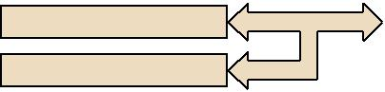

LVDS 24/48 bits

eDP (optional)

HDMI 1.4

3 SATA III Ports

4 USB 3.0 ports
(USB04 3.0 colay with
M.2 B key)

4 USB 2.0 ports
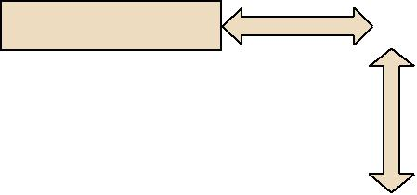

Audio Codec
Realtek ALC892

Display port |  |  | PCIe x 4 |  | PCIe x 4 (Gen 3)
Display port |  | Intel 8th Gen
 |  |  | Channel A | DDR4 2666 MHz SO-DIMM
 |  | Core i7/i5/i3/Pentium/
 |  | Celeron processor
Display port |  |  | Channel B | DDR4 2666 MHz SO-DIMM
 |  | DMI x 4
SATA 3 |  |  | PCIe x1 |  | GbE LAN1: Realtek 8111G
 |  |  | PCIe x1 |  | GbE LAN2: Realtek 8111G
USB 3.0
 |  | H310 | PCIe x1 |  | GbE LAN3: Intel I211AT
USB 2.0 |  |  | PCIex1
 |  |  |  |  | M.2 (E key)
 |  |  | USB 2.0
HD Audio |  |  | SATA/ PCIex2
 |  |  |  |  | M.2 (B key, USB 3.0 colay
 |  |  | USB 3.0/2.0 |  | with USB04)
 | SPI |  | LPC BUS
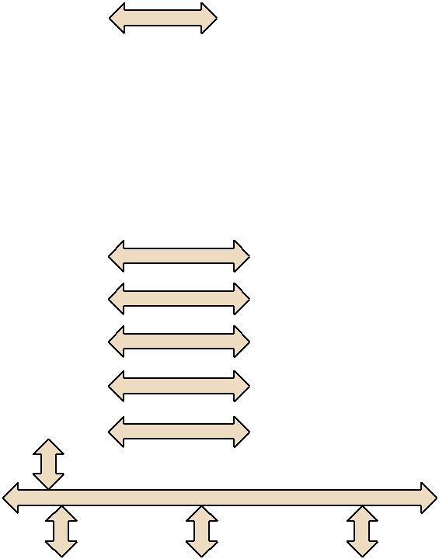

 |  |  |  |  |  | BIOS |  |  | Super I/O |  |  |  |  |  |  | Infineon
 |  |  |  |  |  |  |  |  | Nuvuton |  |  | NCT5114D
 |  |  |  |  |  |  |  |  |  |  |  |  |  |  |  | TPM 1.2/2.0 (Option)
 |  |  |  |  |  |  |  |  | NCT6776
 |  |  |  |  |  | 1 RS-232, 1 x RS-232/422/485, |  |  |  |  |  | 3 x RS-232, 1 x RS-232/422/485
 |  |  |  |  |  | PS/2, WDT, 16-bit GPIO |  |  |  |  | (RS-422/485 support by BOM optional)
订购信息
P/N | Chipset | DP | LVDS/eDP | HDMI 1.4 |  | GbE LAN | COM |  | SATAIII | USB3.0/2.0 |  |  | M.2 B key |  |  | M.2 E key | PCIex4 |  | TPM | AMP
AIMB-286F-00A1E | H310 | 1 | 1 / (1) | 1 |  | 3 | 6 |  | 3 | 4/4 |  |  | 1 |  |  | 1 | 1 |  | (1) | (1)
AIMB-286G2-00A1E | H310 | 1 | 1 / (1) | 1 |  | 2 | 2 |  | 3 | 4/4 |  |  | 1 |  |  | 1 | 1 |  | (1) | (1)
AIMB-286L-00A1E | H310 | 1 | 0 | 1 |  | 1 | 2 |  | 2 | 4/0 |  |  | 1 |  |  | 1 | 0 |  | 0 | 0

*() BOM options available on MP version.

包装列表

料号 | 说明 | 数量
1700003194 | SATA HDD cable | 1
1700018785 | SATA power cable (1 port, 25cm) | 1
1701200220 | 1-to-2 serial port cable, 22cm | 1
1960090424T001 | I/O port bracket | 1
1700029538-01 | 1-to-4 serial port cable, 35cm | 1
2046028600 | Startup manual | 1
1700023082-11 | ATX 2*10P to 1*3P-2.0 25cm cable | 1
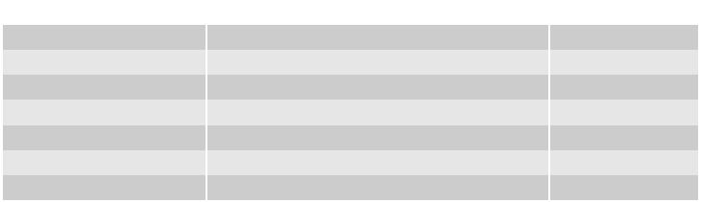

可选附件

料号

1700029428-01

1960053207N001

1960060732N001 96PSA-A120W12V1

说明
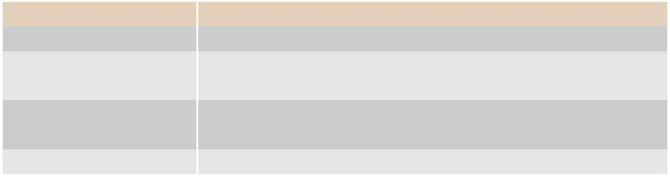
M cable USB-A 4P(F)*2/2*4P-2.0 25cm

LGA1150 CPU cooler for CPU TDP 65W, 92.9 (W) x 92.9 (L) x 46 (H) mm

LGA1150 CPU cooler for CPU TDP 45W, 80 (W) x 80 (L) x 32.2 (H) mm

ADP A/D 100-240V 120W 12V C14 DC Plug 180ŁX

可选底盘

料号 | 说明
AIMB-B2000-15ZE | Mini-ITX chassis with 150W ATX power supply
AIMB-B2000-00YE | Mini-ITX chassis (Optional external AC-DC 60W/84W Adaptor)

嵌入式OS/API

OS/API | Part No. | 968 P/N | 说明

Windows 10

I/O 视图
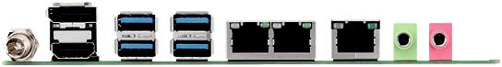

Online Download www.advantech.com/products

