EKI-2525/I EKI-2528/I
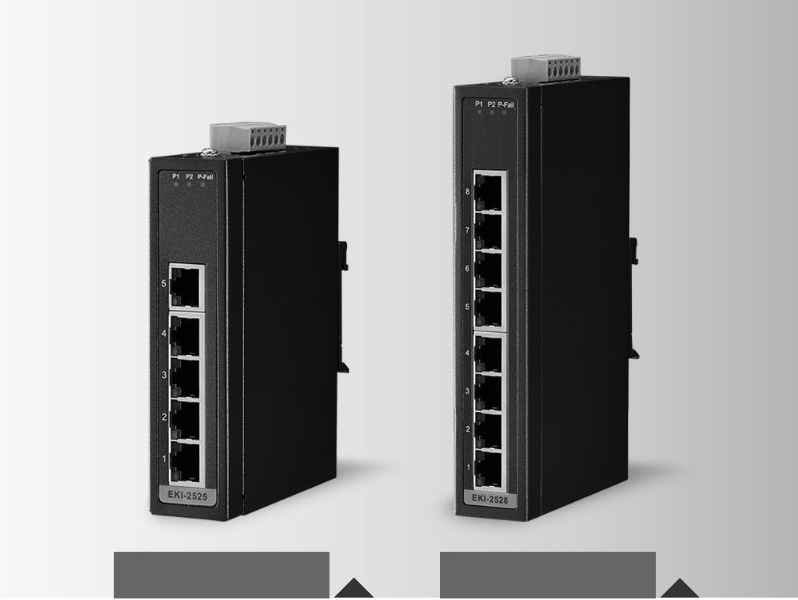

5端口非管理型以太网工业交换机

8端口非管理型以太网工业交换机

特性

 提供5/8以太网端口，使用自动MDI / MDI-X  支持10/100Mbps自适应

 提供广播暴风的保护

 提供了紧凑型尺寸与导轨/挂壁安装,IP40金属机制  支持冗余12 ~ 48个直流电源输入和P-Fail继电器  支持宽温 -40 ~ 85°C (EKI-2525I/EKI-2528I)

EKI-2525 EKI-2528

RoHS
COMPLIANT

2011/65/EU

介绍

EKI-2525/2528 支持快速以太网解决方案。功率为+ 12 ~ 48 VDC冗余输入设计，具有双重保护机制:功率极性反向保护和过载电流可复位引信。前者耐受反向电力布线，而后者而后者可保护系统不受过载电流影响。随着电源供应的正常，EKI- 2525 / 2528将自动恢复工作。EKI-2525 / 2528的每个端口都有2个LED指示灯，以显示链路状态传输速度和碰撞状态。它还提供一个事件警报的中继输出。如果出现电源故障，内置的LED将激活警报以通知管理员。工程师可以通过检查LED指示灯来简单地验证硬件的状态，并且可以简单快速地解决问

题。EKI-2525/2528提供了一种紧凑的金属外壳，IP40等级可以在帮助抵御布满灰尘的工业环境。

规格

通信

IEEE 标准

- LAN

传输距离

传输速度

MAC表

包转发率

包缓冲区

交换延迟

接口

连接器

LED 指示灯

电源

电力消耗

电源输入

故障输出

机构

尺寸 (W x H x D)

外壳

安装

 | 保护
802.3, 802.3u, 802.3x ,H323、SIP | 反极性
10/100Base-T (X) ,100BASE-FX(for si version) | 过载电流
Up to 100 m | 环境
Up to 100 Mbps
MAC = 2K | 操作温度
0.1488Mpps |  储存温度
Buffer size = 512Kbit | 操作湿度
<4.38µs | 储存湿度
 | 
 |  MTBF
8 x RJ45 (EKI-2528/I) or 5 x RJ45 (EKI-2525/I) | 认证
 | 安全
6-pin removable screw terminal (power & relay)
P1, P2, P-Fail
10/100T (X): Link/Activity, Duplex/Collision | EMI
 | EMS
EKI-2525/I: 2.93Watts
EKI-2528/I: 4.71 Watts

12 ~ 48 VDC, redundant dual inputs,220AC/DC ( adapter required)

1 Relay Output

 | Shock
EKI-2525: 30 x 120 x 95 mm (1.18'' x 4.72'' x 3.74) | Freefall
 | Vibration
EKI-2528: 30 x 140 x 95 mm (1.18'' x 5.51'' x 3.74)
IP40, Metal shell with solid mounting kits
DIN-rail, Wall

Present

Present

-10 ~ 60°C (14 ~ 140°F)

-40 ~ 85C (-40 ~ 185°F), (EKI-2525I and EKI-2528I)

-40 ~ 85°C (-40 ~ 185°F)

5% ~ 95% (non-condensing)

5%~ 95% (non-condensing)

689,000 hours (EKI-2528/I)

687,904 hours (EKI-2525/I)

EKI-2525/I: UL/cUL 60950 EKI-2528/I: UL/cUL 60950 Class I, Division 2, Groups A, B, C and D

FCC Part 15 Subpart B Class A, EN 55022 Class A EN 61000-4-2

EN61000-4-3

EN61000-4-4

EN61000-4-5

EN61000-4-6

EN 61000-4-8

IEC 60068-2-27

IEC 60068-2-32

IEC 60068-2-6

Industrial Ethernet Soultions

All product specifications are subject to change without notice Last updated : 10-May-2016

EKI-2525/I

EKI-2528/I

结构图

EKI-2525/I

30
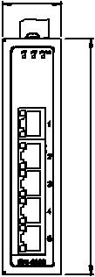

120

EKI-2528/I

30
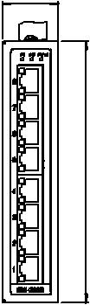

140

46.90
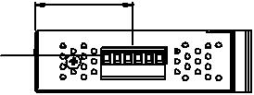

7517.

104 | 104
95
 | 35
 | 120
 | 38
104
 | 30
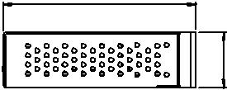
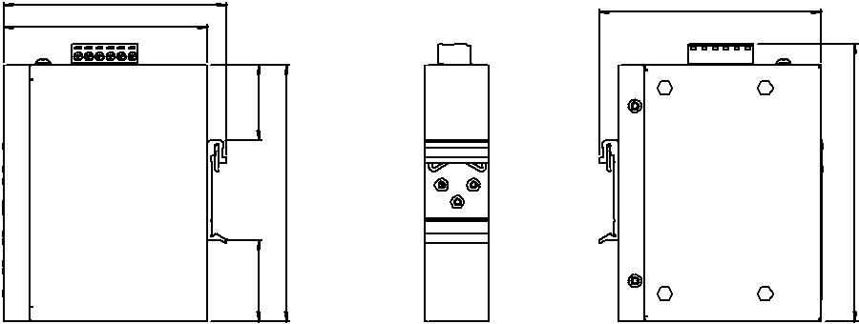

Panel Cut-out Dimensions: 30 x 120 x 95 mm (1.18" x 4.72" x 3.74")

47.30
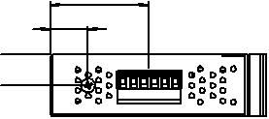

18

15

95 | 30 | 104
45
47 | 140
48
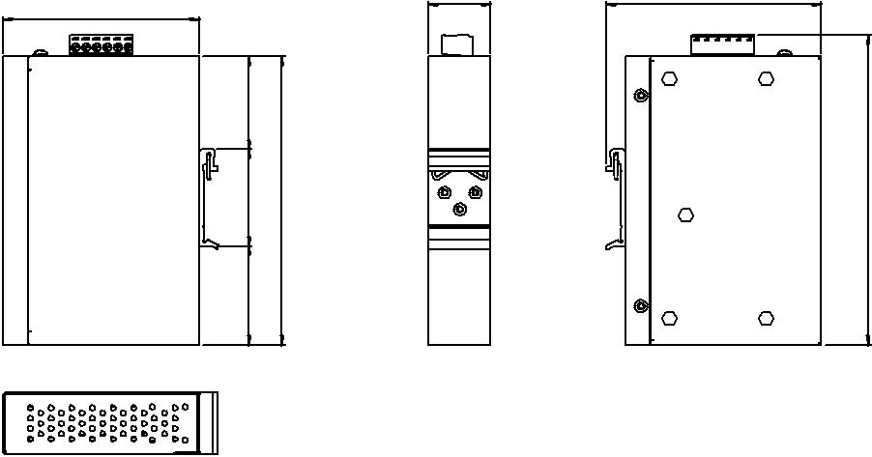

Unit: mm

130

150.20

 | Panel Cut-out Dimensions: 30 x 140 x 95 mm ( 1.18" x 5.51" x 3.74")
订购信息
 EKI-2525-BE | 5-port Ethernet Switch
 EKI-2525I-BE | 5-port Ethernet Switch w/ Wide Temp
 EKI-2528-BE | 8-port Ethernet Switch
 EKI-2528I-BE | 8-port Ethernet Switch w/ Wide Temp

Online Download www.advantech.com/products

