EKI-2525P EKI-2526PI
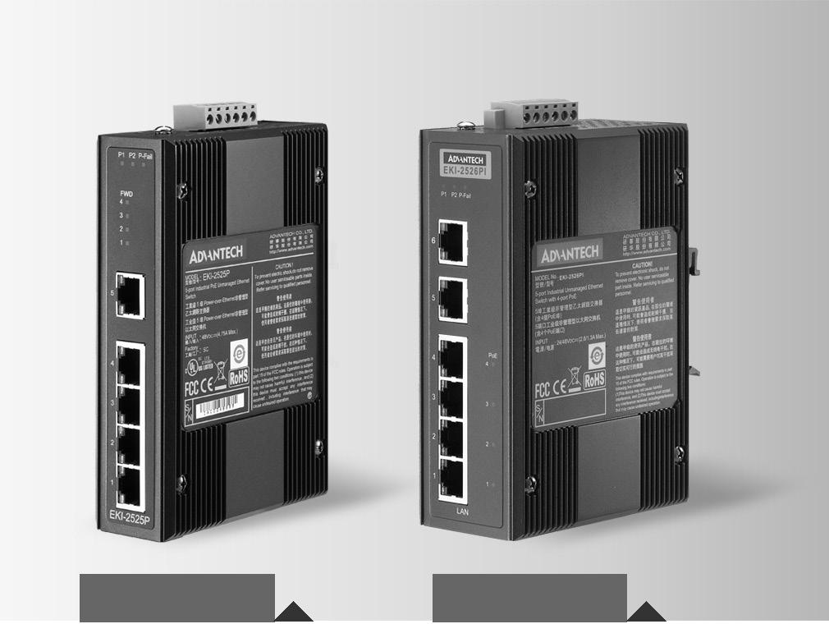

5端口非网管型工业PoE交换机

6端口宽温工业PoE交换机

特性

 提供5/6个快速以太网端口（其中4个PoE端口）

 支持10/100Mbps自适应

 提供广播风暴保护

 支持以太网ESD保护

 P30金属结构，结构紧凑，支持DIN 导轨安装/壁挂式安装

 支持48VDC 冗余电源输入和继电器报警

 宽工作温度：-10 ~60°C (EKI-2525P)

 宽工作温度：-40 ~ 75℃ (EKI-2526PI)

EKI-2525P EKI-2526PI

RoHS
COMPLIANT

2011/65/EU

介绍

EKI-2525P是5 端口非网管型PoE (网线供电)工业以太网交换机， EKI-2525PI是6端口的PoE交换机，均支持4 个PSE (供电端设备)接口，每个PoE 端口可支持15.4W 的电源输出。研华PoE 工业以太网交换机可以为IEEE802.3af 标准的受电端设备(PD) 提供电源，免去了额外电源布线的需求。EKI 系列PoE交换机继承了研华EKI 系列交换机大家庭的优越特质，支持48VDC 冗余电源输入，具有双重保护机制：电源极性反接保护及电流过载保险丝防护。研华EKI系列PoE设备配有小巧的金属外壳，防护等级为IP30，可防止灰尘弥漫的工业环境。

规格

通信

 | 标准 | IEEE 802.3, 802.3u, 802.3x, 802.3af
 | LAN | 10/100Base-T (X)
 传输距离 |  | Ethernet: Up to 100 m (EKI-2525P/EKI-2526PI)
 | 传输速度 | Up to 100 Mbps

光纤(EKI-252SPI)

 单模 1310 nm

Tx Power: -8/-15 dBm

Rx Sensitivity: -34 dBm

Parameters: 9/125 um

捷库

 控制器 PoE Ports: 4 (Ports 1 ~ 4)

Ethernet x1 (EKI-2525P)

Ethernet x2 (EKI-2526PI)

6-pin removable screw terminal (power & relay)

 LED 连接器 P1, P2, P-Fail
10/100TX: Link/Activity, Duplex/Collision

机构

 尺寸 (W x H x D) 37 x 140 x 95 mm (1.46" x 5.51" x 3.74")
(EKI-2525P)

48.6 x 140 x 95 mm (1.91" x 5.51" x 3.74")

(EKI-2526PI)
 外壳 IP30, Metal shell with solid mounting kits
安装 DIN-rail, Wall

保护

 反极性 Present
 过载电流 Present

环境

 操作温度 -10 ~ 60°C (14 ~ 140°F) (EKI-2525P)

-40 ~ 75°C (-40 ~ 167°F) (EKI-2526PI)

 储存温度 -40 ~ 85°C (-40 ~ 185°F)
 操作湿度 5 ~ 95% (non-condensing)
 储存湿度 0 ~ 95% (non-condensing)

 MTBF 440,132 hours

电源

 功耗

电源输入
功率输出
故障输出

EKI-2525P: 65 W (Full load PoE)

EKI-2526PI: 62.6 W (Full load PoE)

48 VDC (EKI-2525P/EKI-2526PI), redundant dual inputs

15.4 W at 48 V (per PoE port)

1 Relay Output

认证

 | 安全 | UL 60950-1, CAN/CSA-C22.2 No.60950
 | EMI | FCC Part 15 Subpart B Class A, EN 55022 Class A
 | EMS | EN 61000-4-2
 |  | EN 61000-4-3
 |  | EN 61000-4-4
 |  | EN 61000-4-5
 |  | EN 61000-4-6
 |  | EN 61000-4-8
 Shock |  | IEC 60068-2-27
 Freefall |  | IEC 60068-2-32
 Vibration |  | IEC 60068-2-6
 Patent |  | http://www.advantech.com/legal/patent

Industrial Ethernet Soultions

All product specifications are subject to change without notice Last updated : 23-Aug-2016

EKI-2525P

EKI-2526PI

结构图

EKI-2525P

3018. |  | [0.72] | 1515. |  | 60][0. | 11.40 | [0.45]
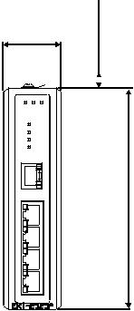

36.60 [1.44] [0.37]

9.50

00140. [5.52]

Unit: mm [inch]
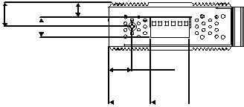

18.00
[0.71]
32.30 30.00
[1.27] [1.18]

104.00 [4.10]
95.00 [3.74]
32.30 30.00 |  | 36.60 [1.44] | 95.00 [3.74]
[1.27] [1.18]
.89] | 00140.[5.52] | 50149.[5.89] | 149.[5.89]50
47.05[1.85]
.95
47[1
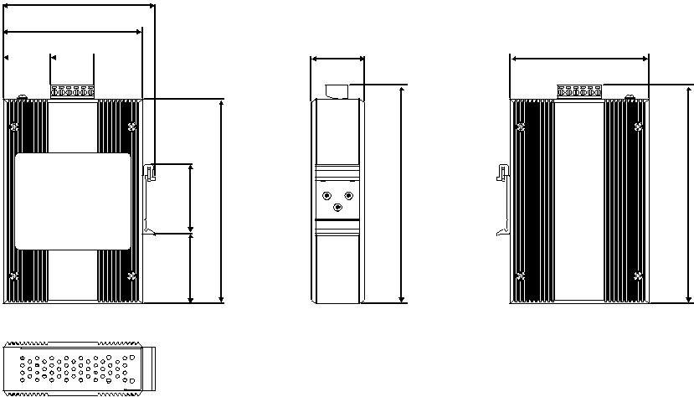

Panel Cut-out Dimensions: 104.00 x 140.00 x 36.60 mm (4.10" x 5.52 x 1.44")

EKI-2526PI |  | 24.80 [0.98] 35.00 [1.38]
13.00 [0.51]
15. [0.59]00 | 4011. [0.45] | 8012. [0.50]
 |  | 104.00 [4.10]
 |  | 95.00 [3.74]
 |  | 40.00 [1.58]
48.60 [1.91] |  | 22.30 [0.88] |  | 48.60 [1.91] | 95.00 [3.74]
[0.33]
8.50
[5.52] |  | 47.05[1.85] | [5.52] | [5.85] | [5.85]
00140. |  | .85] | 140.00 | 50148. | 148.50
 |  | .95
 |  | 46[1
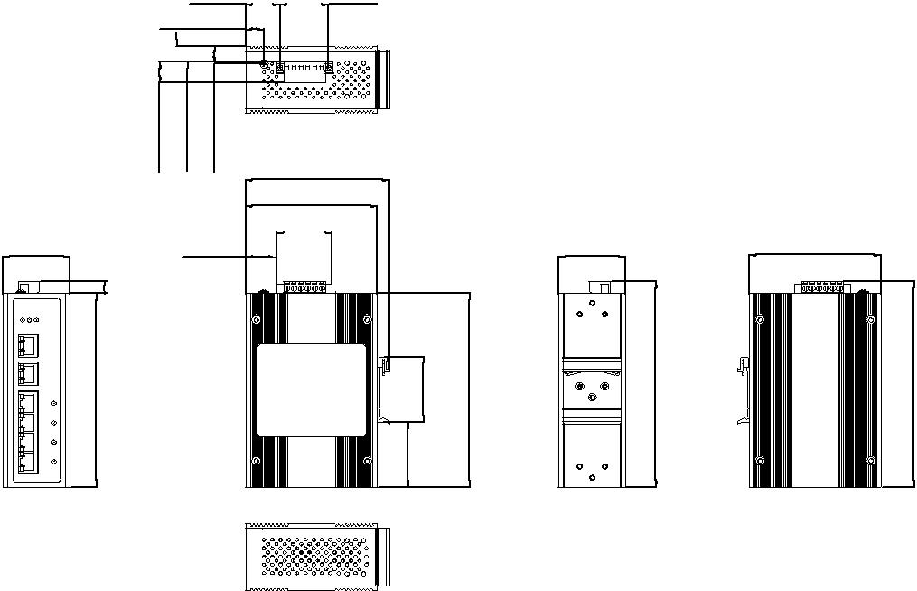

Panel Cut-out Dimensions: 104 x 140 x 48.6 mm (4.1" x 5.52" x 1.91")

订购信息

 EKI-2525P 5-port Switch with 4 port-PoE
 EKI-2526PI 6-port Switch with 4 port-PoE

Online Download www.advantech.com/products

