

**EKI-2725/I** **5端口千兆非网管工业以太网交换机**

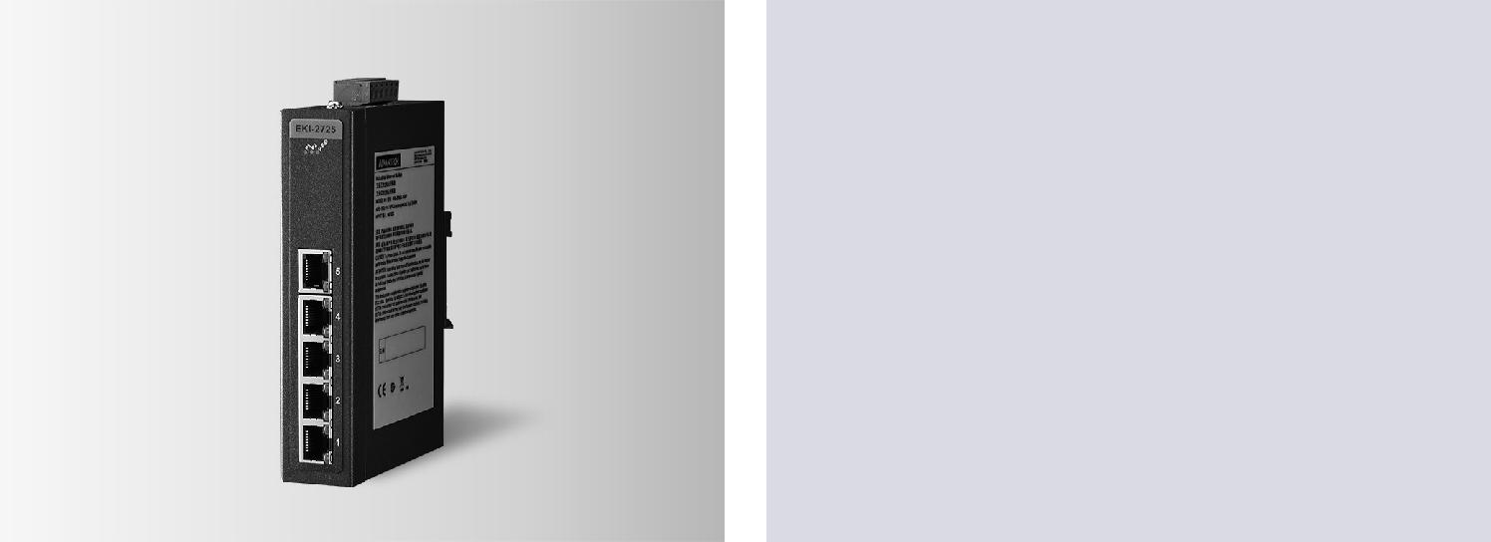

**特性**

****提供5个千兆自适应以太网口

****支持10/100/1000Mbps自适应

****支持最大9k字节的巨帧传输

****结构紧凑，支持DIN导轨安装

****支持12-48VDC冗余电源输入和继电器报警

****提供广播风暴保护



**RoHS**

**COMPLIANT**

2011/65/EU

**介绍**

EKI-2725/2728设备具有EKI系列标准性能。它提供 12~48VDC冗余电源输入设计及电源极性反接保护、过载可重设保险管双重安全保护机制。前者

可保证当电源连线正、负端被接反时，设备也不会因此损坏，仍会正常工作。后者可保证电源连接恢复正常时，系统免于过载电流的损害并回到正常工作状态。EKI-2725/2728的每个端口都有连接状态传输速度及冲突状态的指示灯。在电源发生故障时，设备将会使用继电器输出，LED指示灯亮并报警通知管理员。工程师可方便地通过指示灯对硬件进行快速的检查及故障诊断。EKI-2725配备了紧凑型金属外壳，防护等级为IP30，有助于防止尘土飞扬的工业环境。

**规格**

**通信**

|  |  |  |
| --- | --- | --- |
| ** 标准** | | IEEE 802.3, 802.3u, 802.3x, 802.3ab |
| **** | **LAN** | 10/100/1000Base-T(X) |
| ** 传输距离** | | Up to 100 m (4-wire Cat.5e, Cat.6 RJ45 cable) |
| **** | **传输速度** | Up to 1000 Mbps |

**接口**

** 连接器** 5 x RJ45

6-pin removable screw terminal (power & relay)

** LED 指示灯** P1, P2, P-Fail

10/100/1000T (X): Link/Activity, Duplex/Collision

**电源**

** 功耗** 2.5W

**电源输入** 12 ~ 48 VDC, redundant dual inputs

**电源输出** 1 Relay Output

**机构**

** 尺寸 (W x H x D)** 30 x 140 x 95 mm (1.18" x 5.51" x 3.74")

** 外壳** IP30, Metal shell with solid mounting kits

** 安装** DIN-rail, Wall

**环境**

|  |  |  |  |  |
| --- | --- | --- | --- | --- |
| **** | **操作温度** | -10 ~ 60°C (14 | | ~ 140°F) |
|  |  | -40 ~ 75°C (-40 | | ~ 167°F) / (I model) |
| **** | **储存温度** | -40 | ~ 85°C (-40 ~ 185°F) | |
| ** 操作湿度** | | 10 | ~ 95% (non-condensing) | |
| ** 储存湿度** | | 10 | ~ 95% (non-condensing) | |
| ** MTBF** | | 2,296,909 hours | | |

**认证**

|  |  |  |
| --- | --- | --- |
| **安全** | | UL 60950 |
| **** | **EMI** | CE, FCC Class A |
| **** | **EMS** | EN 61000-4-2 |
|  |  | EN 61000-4-3 |
|  |  | EN 61000-4-4 |
|  |  | EN 61000-4-5 |
|  |  | EN 61000-4-6 |
|  |  | EN 61000-4-8 |
| ** Shock** | | IEC 60068-2-27 |
| ** Freefall** | | IEC 60068-2-32 |
| ** Vibration** | | IEC 60068-2-6 |

**保护**

** 反极性** Present

**过载电流** Present



**Industrial Communication**

All product specifications are subject to change without notice. Last updated: 12-Feb-2018

**结构图**

|  |  |  |
| --- | --- | --- |
|  | 47.30 [1.86] |  |
| 18 [0.71] | |  |
| 15 [0.59] | 13.75 [0.54] |  |
| 140[5.5] | 104 [4.09] |  |
| 47[1.85]45[1.77]10.[0.40]20 |  |
| 30 [1.18] | 95 [3.74] |  |
|  | 48 [1.89] |  |

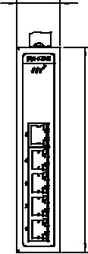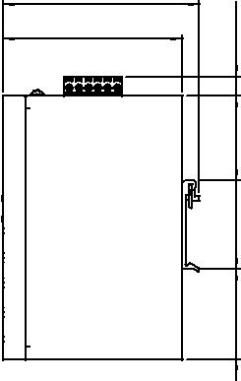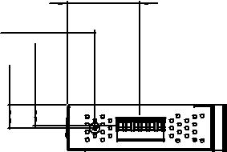

**订购信息**

** EKI-2725-CE** 5-port Gigabit Unmanaged Switch

** EKI-2725I-CE** 5-port Gigabit Unmanaged Switch w/wide temp

**EKI-2725/I**

Unit: [mm]

30 [1.18] 104 [4.09]

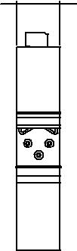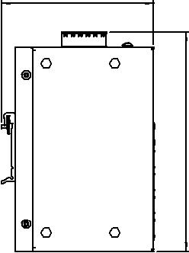

|  |
| --- |
| 20150. [5.9] |

**Online Download** www.advantech.com/products