EKI-5626C/CI-MB EKI-5629C/CI-MB

16 + 2G Combo ports Entry-Level Managed Switch Supporting Modbus/TCP 8 + 2G Combo ports Entry-Level
Managed Switch Supporting Modbus/TCP

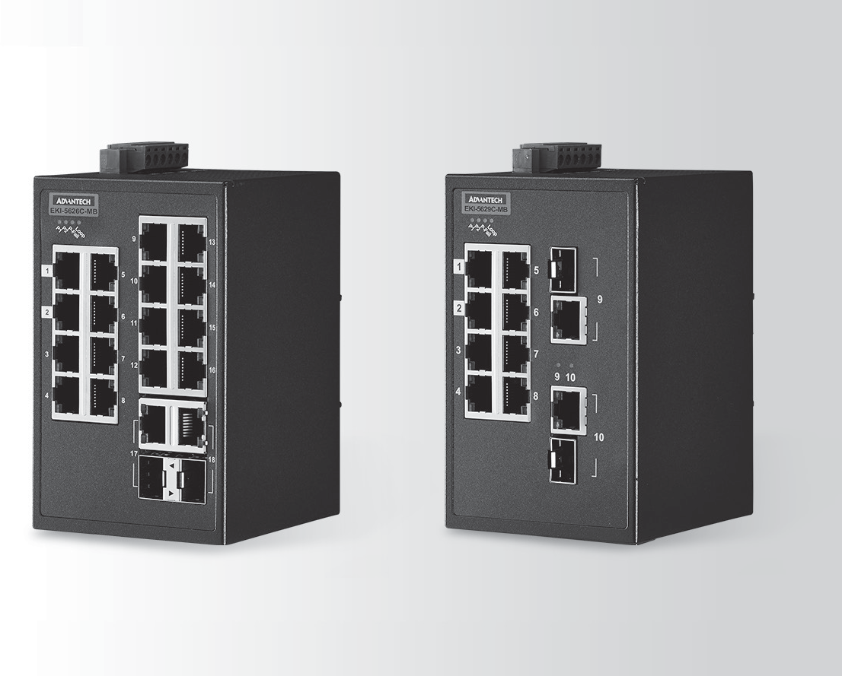 EKI-5626C/CI-MB EKI-5629C/CI-MB
Features
- 16 Fast Ethernet ports + 2 Gigabit Copper/SFP combo ports
(EKI-5626C/CI-MB) & 8 Fast Ethernet ports + 2 Gigabit Copper/SFP combo ports (EKI-5629C/CI-MB)
- Entry-Level Managed Switch
- IXM function enables fast deployment
- Management: SNMP v1/v2c/v3, WEB, Standard MIB, Private MIB
RoHS
COMPLIANT
2011/65/EU
Introduction

The EKI-5626C/CI-MB and EKI-5629C/CI-MB are a new generation of entry-level managed switch products. They support basic Layer 2 managed function such as Ring, SNMP, IGMP etc. Besides, they support Modbus/TCP and can easily integrate with SCADA. The devices come with a compact metal housing that is IP30 rated to protect against dusty industrial environments. The wide power input power (8.4 to 52.8 VDC) is dedicated to operating in areas of unstable power and rugged environments.

Specifications

Communications
 Standard IEEE 802.3, 802.3u, 802.3x, 802.1D, 802.1w,802.1p, 802.1Q, 802.1X,
802.3AD,802.3az
 LAN 10/100Base-T (X),
- Transmission Distance Ethernet: UP to 100m (4-wire Cat.5e, Cat.6
RJ-45 cable suggested for Gigabit port) SFP: UP to 110km (depends on SFP)
- Transmission Speed Ethernet Ethernet: 10/100Mbps Auto-Negotiation
Gigabit Copper: 10/100/1000Mbps, Auto-Negotiation
Gigabit Fiber: UP to 1000Mbps
Interface
 I/O Port EKI-5626C/CI-MB: 16 x RJ-45 + 2 x RJ-45/SFP
combo ports
EKI-5629C/CI-MB: 8 x RJ-45 + 2 x RJ-45/SFP
combo ports
- Power Connector 6-pin screw Terminal Block (including relay)

Physical
- Enclosure Metal Shell
- Protection Class IP 30
- Installation DIN-Rail
- Dimensions (W x H x D) 74 x 120 x 84 mm

LED Display
- System LED PWR1, PWR2, P-Fail, Loop detection
- Port LED Link / Speed / Activity

Environment
- Operating Temperature EKI-5626CI-MB & EKI-5629CI-MB:
-40 ~ 75°C (-40 ~ 167°F)
EKI-5626C-MB & EKI-5629C-MB:
-10 ~ 60°C (14 ~ 140°F)
- Storage Temperature -40 ~ 85°C
- Ambient Relative Humidity 10 ~ 95% (non-condensing)
- Humidity 10 ~ 95% (non-condensing)
- MTBF EKI-5626C/CI-MB: 2,825,281 hours EKI-5629C/CI-MB: 3,183,604 hours

Power
- Power Consumption EKI-5626C/CI-MB: Max 8.2W
EKI-5629C/CI-MB: Max 5.8W
- Power Input 12 ~ 48 VDC (8.4~52.8 VDC), redundant dual power input
- Fault Output 1 Relay Output

Certification
- EMI CE, FCC Class A
- Safety UL508, Class 1 Division 2, ATEX
 EMC EN 61000-4-2; EN 61000-4-3; EN 61000-4-4;
EN 61000-4-5; EN 61000-4-6; EN 61000-4-8
 Shock IEC 60068-2-27
- Freefall IEC 60068-2-32
- Vibration IEC 60068-2-6

L2 Features
- L2 MAC Address 8K
- Jumbo Frame 9216 Bytes
- VLAN Group 256 (VLAN ID 1~4094)
- VLAN Arrange Port based VLAN, GVRP
- Port Mirroring Per port, Multi-source port,
- IP Multicast IGMP Snooping v1/v2/v3, MLD Snooping, IGMP Immediate leave
- Storm Control Broadcast, Multicast, Unknown unicast
- Redundancy IEEE 802.1D-STP, IEEE 802.1s-MSTP, IEEE 802.1w-RSTP,
X-Ring, with ultra high-speed recovery time less than 20ms

QoS
- Priority Queue WRR (Weighted Round Robin), SP (Strict Scheduling
Scheduling Priority) Hybrid Priority
- Class of Service IEEE 802.1p Based CoS, IP TOS, DSCP based CoS
- Rate Limiting Ingress Rate limit, Egress Rate limit
- Link Aggregation IEEE 802.3ad Dynamic Port Trunking, Static Port Trunking

Security
- Port Security Static, Dynamic, MAC address filtering
- Authentication 802.1x (Port-Based, MD5/TLS/TTLS/PEAP Encryption)

Industrial Ethernet Soultions
All product specifications are subject to change without notice Last updated : 27-Jul-2016

EKI-5626C/CI-MB EKI-5629C/CI-MB

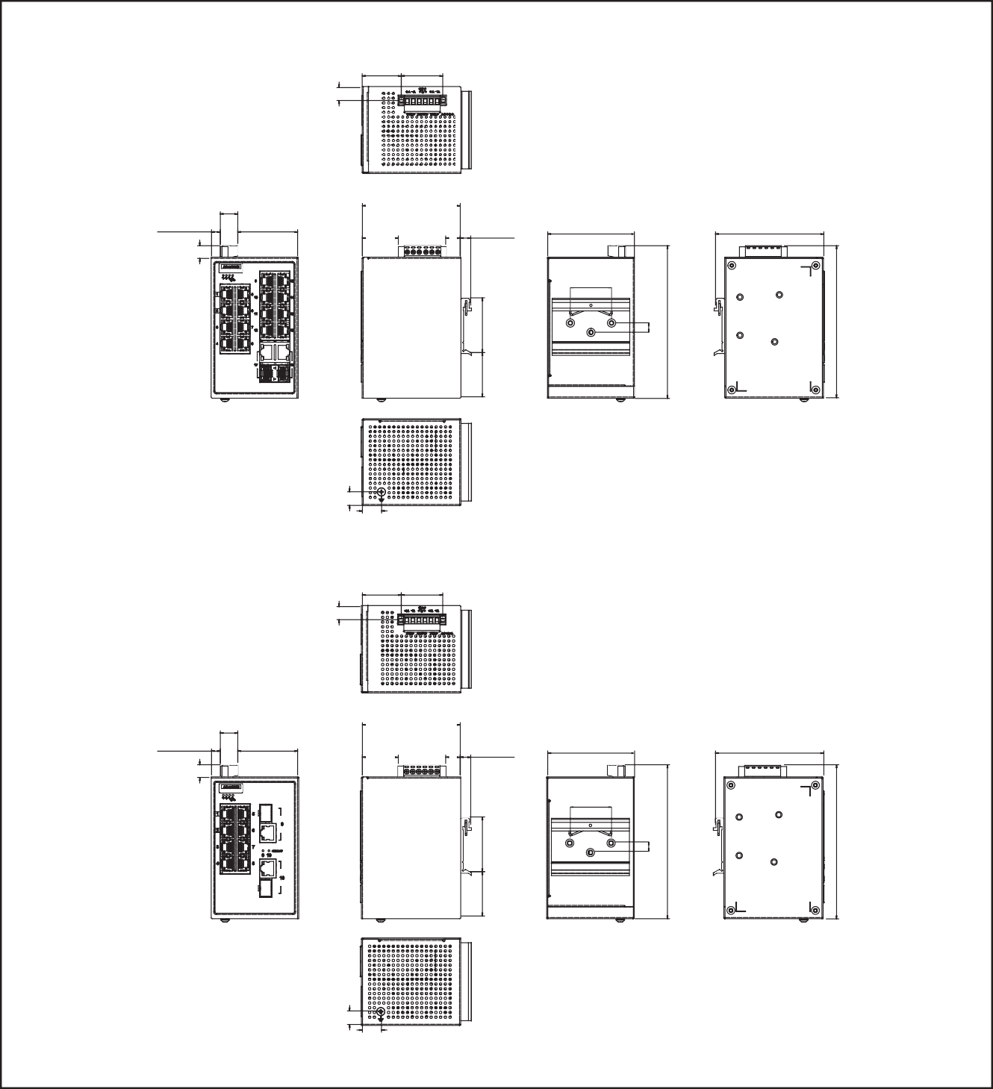
Dimensions

33.4 35.6
11.1 [0.439]

Unit: mm [inch]

EKI-5626C/CI-MB
[1.315] [1.400]

15
[0.591]
7.6 [0.299] 51.4 [2.024]

84 [3.307]

9 [0.354]

74 [2.913]

93 [3.661]

EKI-5626C-MB
35 [1.378]
30.9 12.5
[1.215] [0.492]
10.9
[0.429]
38 47
[1.496] [1.850]
8 [0.315]
120 [4.724]
129.8 [5.110]

EKI-5629C/CI-MB
16.4
[0.646]
11.7
[0.461]

33.4
11.1 [0.439]

35.6

[1.315] [1.400]

15
[0.591]
7.6 [0.299] 51.4 [2.024]

84 [3.307]

9 [0.354]

73 [2.874]

93 [3.661]

EKI-5629C-MB
35 [1.378]
30.9 12.5
[1.215] [0.492]
10.9
[0.429]
38 47
[1.496] [1.850]
8 [0.315]
130 [5.118]
130 [5.118]

16.4
11.7
[0.461]
[0.646]

Management
- DHCP Client, Option 82
- Access SNMP v1/v2c/v3, WEB, Standard MIB, Private MIB
- Software upgrade TFTP, HTTP, Dual Image
- NTP SNTP client
- Data Syslog
- Protocols IPV6, LLDP, Modbus/TCP

Ordering Information
- EKI-5626C-MB-AE 16 + 2G Combo ports entry-level managed switch Support
Modbus/TCP
- EKI-5626CI-MB-AE 16 + 2G Combo ports entry-level managed switch support Modbus/TCP w/wide temp.
- EKI-5629C-MB-AE 8 + 2G Combo ports entry-level managed switch support
Modbus/TCP
- EKI-5629CI-MB-AE 8 + 2G Combo ports entry-level managed switch support
Modbus/TCP w/wide temp.

Online Download www.advantech.com/products

