EKI-5629CI EKI-5626CI
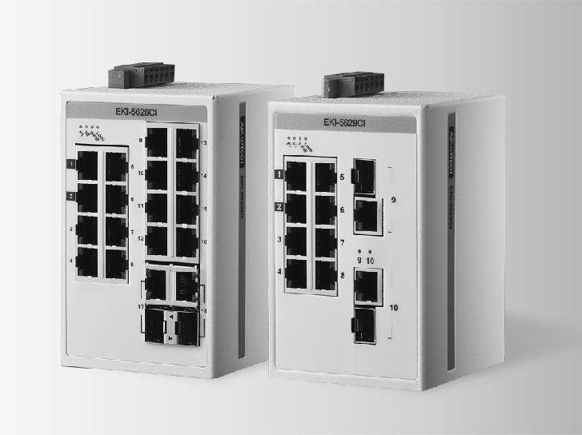

8FE+2GE组合以太网前置交换机

16FE+2GE组合以太网前置交换机

特性

支持“自动化语言”Modbus/TCP协议，可用组态软件管理

支持“IT语言” SNMP协议，可方便采用网管NMS软件进行管理

基于QoS的VIP端口可保障关键数据的可靠传输

支持-40~75°C操作温度范围(仅限EKI-5629CI/5626CI型号)

EMS level 3 工业标准更适合苛刻环境应用

8.4 ~52.8 VDC 宽电压输入

IEEE 802.3az 节能标准更加节能环保

支持9,216 Bytes巨帧传输，让数据传输更高效支持12~48V冗余直流电源输入及P-Fail继电器环路故障自动诊断

RoHS
COMPLIANT

2002/95/EC

介绍

EKI-5629C/CI及EKI-5626C/CI是全球首款兼备工控与IT 双重特质的非管理型工业以太网交换机。其支持Modbus/TCP 及SNMP 协议，可无缝连接SCADA系统及IT 网管软件，该款产品符合IEEE 802.1p QoS- VIP 端口- 确保关键数据的可靠传送。此外，其拥有专用VIP 端口、自动环路故障检测、智能节能、智能故障诊断及支持9,216 byte 巨型帧高效传输，支持8.4 ~ 52.8VDC 冗余电源输入及-40~75°C 宽工作温度范围，保障严苛环境中的稳健运行，以抵御工业电阻的电磁接口。

规格

通信

 | 标准 | IEEE 802.3, 802.3u, 802.3x, 802.1p, 802.3az , 802.3ab
 | LAN | 10/100/1000Base-T(X), Optional 100Base-FX,
 |  | 1000Base-SX/LX/LHX/XD/ZX/EZX
 传输距离 |  | Ethernet: UP to 100m (4-wire Cat.5e, Cat.6 RJ-45 cable
 |  | suggested for Gigabit port)
 |  | SFP: UP to 110km (depends on SFP)
 | 传输速度 | Ethernet: 10/100Mbps Auto-Negotiation
 |  | Gigabit Copper: 10/100/1000Mbps, Auto-Negotiation
 |  | Gigabit Fiber: UP to 1000Mbps

接口

 连接器 | EKI-5629CI: 8 x Fast Ethernet (RJ45) + 2 x Giga (RJ45/
 | SFP) combo ports
 | EKI-5626CI:16 x Fast Ethernet (RJ45) + 2 x Giga
 | (RJ45/SFP) combo ports
 LED 指示灯 | 6-pin removable screw terminal (power & relay)
 | P1, P2, P-Fail, Loop detection
 | 10/100T(X): Link/Activity, Speed
 | Gigabit Copper: Link/Activity, Speed (1000 Mbps)
 | SFP: Lin k/Activity

开关属性

 MAC 面板尺寸 | 8K
 数据包缓存 | 4.1M bit
 开关容量 | EKI-5629CI: 5.6 Gbps
 Jumbo Frame | EKI-5626CI: 7.2 Gbps
 | 9216 bytes

电源

 电力消耗 | EKI-5629CI: 5.8W
 | EKI-5626CI: 8.2W
 电源输入 | 12 ~ 48 VDC (8.4 ~ 52.8 VDC), redundant dual inputs
 故障输出 | 1 Relay Output

机构

 尺寸 (W x H x D) 74 x 120 x 84 mm
 外壳 IP30, metal shell with solid mounting kits
安装 DIN-Rail, Wall

保护

反极性 Present
过载电流 Present

环境

 操作温度 -40 ~ 75°C (-40 ~ 167°F)
 储存温度 -40 ~ 85°C (-40 ~ 185°F)
 操作湿度 10 ~ 95% (non-condensing)
 储存湿度 10 ~ 95% (non-condensing)
 MTBF EKI-5629CI: 3,183,604 hours
EKI-5626CI: 2,825,281 hours

认证

 | 安全 | UL508, Class 1 Division 2, ATEX
 | EMI | CE/FCC
 | EMS | EN 61000-4-2 (Level 3)
 |  | EN 61000-4-3 (Level 3)
 |  | EN 61000-4-4 (Level 3)
 |  | EN 61000-4-5 (Level 3)
 |  | EN 61000-4-6 (Level 3)
 Shock |  | EN 61000-4-8 (Level 3)
 |  | IEC 60068-2-27
 Freefall |  | IEC 60068-2-32
 Vibration |  | IEC 60068-2-6

订购信息

 EKI-5629CI-AE | 8FE + 2GE Combo Ethernet ProView Switch with Wide
 EKI-5626CI-AE | Temperature
 | 16FE + 2GE Combo Ethernet ProView Switch with Wide
 | Temperature

Industrial Communication

All product specifications are subject to change without notice. Last updated: 5-Mar-2018

EKI-5629CI & EKI-5626CI

结构图

EKI-5629CI

11.1 [0.439]

33.4 | 35.6 |  | Unit: mm [inch]
[1.315] | [1.400]
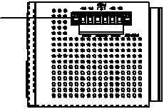

15
[0.591]
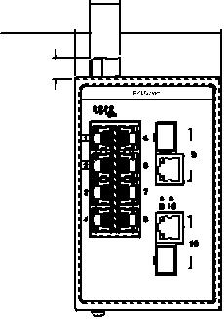

7.6 [0.299] | 51.4 [2.024]
10.9[0.429]

EKI-5626CI

 | 84 [3.307]
 | 30.9 | 12.5
 | [1.215] | [0.492] | 9 [0.354] | 73 [2.874] | 93 [3.661]
 |  |  | 47 [1.850] | 130 [5.118] | 130 [5.118]
 |  |  | 38 [1.496]
711.461][0.
16.4 [0.644]
 | 33.4 | 35.6
1 439]11.[0. | [1.315] | [1.400]
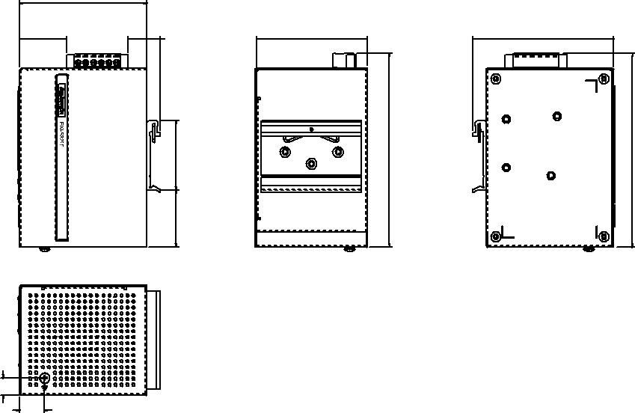
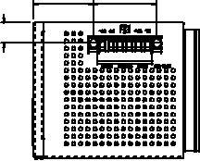

15
[0.591]
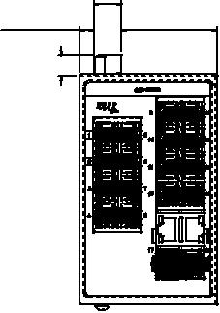

7.6 [0.299] | 51.4 [2.024]
10.9[0.429]

84 [3.307]
30.9 | 12.5
[1.215] | [0.492] | 9 [0.354] | 73 [2.874] | 93 [3.661]
 |  | 47 [1.850] | 130 [5.118] | 130 [5.118]
 |  | 38 [1.496]
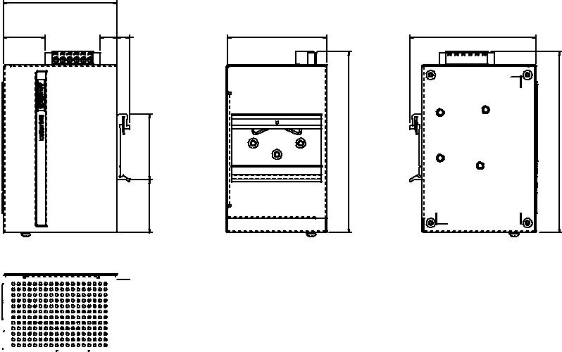

461][0. 711.

Online Download www.advantech.com/products

