EKI-7428G-4CI EKI-7428G-4CPI
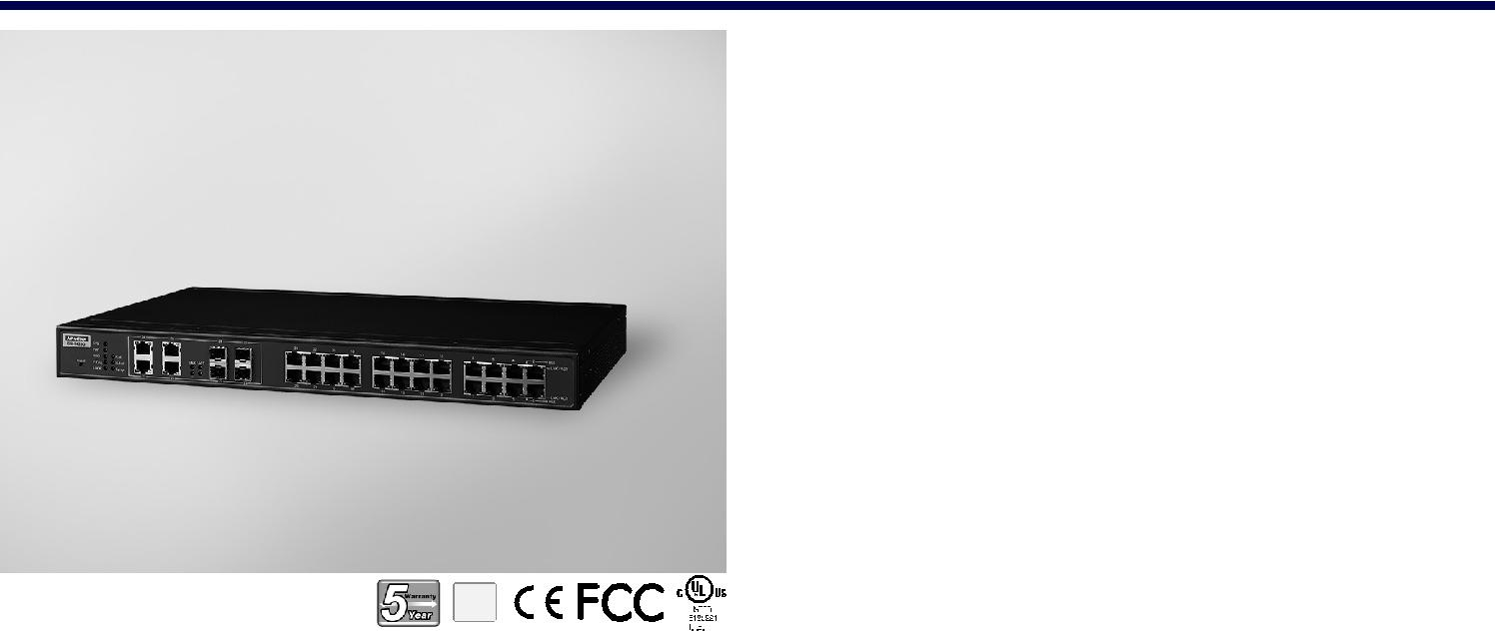

24G+4G组合端口L2网管交换机24G+4G组合端口L2网管PoE交换机

特性

24 x IEEE 802.3 AF/AT PoE千兆端口+4 x千兆铜缆/SFP组合端口，每个

端口最多提供30瓦
SFP插座，方便灵活的光纤扩展
管理：SNMP v1/v2c/v3、web、telnet、标准MIB
IXM功能支持快速部署

安全：802.1X（基于端口，MD5/TLS/TTLS/PEAP加密）、HTTPS、SSH

和SNMPv3
冗余：Gigabit X-Ring Pro（超高速恢复时间<20 ms）、RSTP/
STP（802.1w/1d）、MSTP

48Vdc电源输入（PoE AF为46-57 Vdc，AT为53-57 Vdc）和2个继电器

输出

-40~70°C宽范围工作温度
支持安全包以抵御内部和外部网络威胁

RoHS
COMPLIANT

2002/95/EC

介绍

EKI-7428G是一款工业级第2层全网管交换机，包括24个千兆端口和4个千兆组合端口。它是为机架安装而设计的，可以部署在苛刻的工业环境中。它适用于边缘到核心的工业网络。它集成了第2层交换软件，该软件针对规模和性能进行了优化，为第2层流量转发提供跨所有端口高达56 Gbps的网速。此外，PoE设计为每个端口提供高达30瓦的功率，以满足高功耗设备的需要，此外，它还支持-40~70°C工作温度下的高可靠性，以及双48 Vdc输入电源设计，以确保最短的停机时间确保重要的网络功能。它还嵌入了Advantech ixm，通过快速部署，用户受益匪浅，可以显著节省工程师的时间和成本。

规格

通信

 | 标准 | IEEE 802.3, 802.3u, 802.3x, 802.3z, 802.1D, 802.1w,
 |  | 802.1p, 802.1Q, 802.1X, 802.3ad, 802.3ab
 | LAN | 10/100/1000Base-T (X), Optional 100Base-FX,
 |  | 1000Base-SX/LX/LHX/XD/ZX/EZX
 传输距离 |  | Ethernet: Up to 100 m (4- wire Cat.5e, Cat.6 RJ45
 |  | cable suggested for Gigabit port)
 |  | SFP: Up to 110 km (depends on SFP)
 | 传输速度 | Gigabit Copper: 10/100/1000 Mbps, Auto-Negotiation
 |  | Gigabit Fiber: Up to 1000 Mbps

接口

 连接器 24 x RJ45 (Ethernet)

4 x RJ45/SFP (mini-GBIC) combo ports

4-pin removable screw terminal (Power)

3-pin removable screw terminal (Relay)

 LED 指示灯 10/100T (X): Link/Activity, Duplex/Collision
Gigabit Copper: Link/Activity, Speed (1000 Mbps)

SFP: Link/Activity

 控制台 RS-232 (RJ45)

网络管理

 | 配置 | Web browser, Telnet, Serial console, TFTP, SNMPv1/
 |  | v2c/v3, Port Speed/Duplex Configuration, IPv6
 | VLAN | IEEE 802.1Q, GVRP, Port-based VLAN
 冗余 |  | Advantech X-Ring, 802.1w/1D/1s RSTP/STP/MSTP
 | 安全 | IP Security, SSH, SSL, SNMPV3, HTTPS, IP Source
 |  | Guard, DHCP Snooping, ARP Spoofing Prevention,
 |  | 802.1X, TACACS+, Access Control List
 | Traffic 控制 | IGMP Snooping/Query for multicast group
 |  | management, Port Trunking, Static/802.3ad, LACP Rate
 |  | limit and storm control, IEEE 802.1p QoS CoS/TOS/
 |  | DSCP priority queuing, IEEE 802.3x flow control
 | 诊断 | Port Mirroring, Real-time traffic statistic, MAC Address
 |  | Table, SNTP, Syslog, E-Mail Alert, SNMP Trap, RMON

构

 | 外壳 | IP30, metal shell with solid mounting kits
 尺寸(W x H x D) |  | 438 x 43.6 x 259.20 mm (17.24" x 1.72" x 10.2")
 | 安装 | 1U 19" Rack mount

源

 | 功耗 | 20W | @ 24V | (EKI-7428G-4CI)
 |  | 20W | @ 48V | (EKI-7428G-4CPI)
 | 电力预算 | 685W (EKI-7428G-4CPI)
 | 电源输入 | EKI-7428G-4CI 12-48 VDC
 |  | EKI-7428G-4CPI 48 VDC (46 to 57 VDC),
 |  | 53 -57 VDC is recommended for 802.3at
 | 故障输出 | 2 Relay Outputs

护

反极性 Present

过载电流 Present

Industrial Ethernet Soultions

All product specifications are subject to change without notice. Last updated: 22-Jun-2018

EKI-7428-4CI
EKI-7428-4CPI

结构图

426 [16.77]
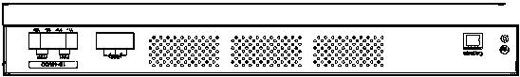

79.30 31.50
[3.12] [1.24]
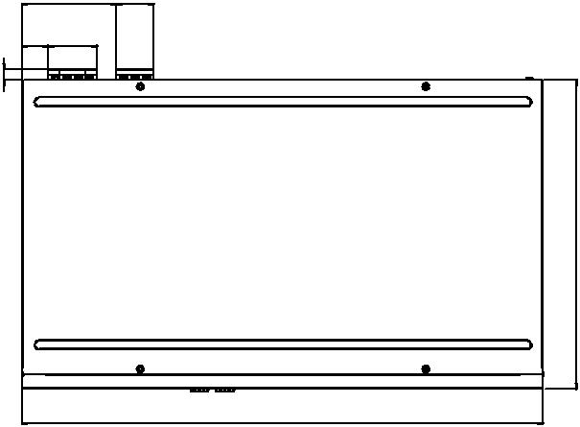
22 41
[0.87] [1.61]

[0.36] 209.

438 [17.24]
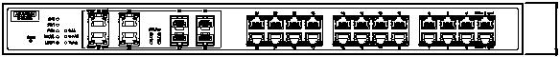

Unit: mm [inch]

12 [0.47]

259.20 [10.20]

72][1. 6043.

境

 工作温度

 储存温度

 工作湿度

储存湿度

- MTBF

-40 ~ 70°C (-40 ~ 158°F)

-40 ~ 85°C (-40 ~ 185°F)

10 ~ 95% (非凝结)

10 ~ 95% (非凝结)

EKI-7428-4CI: 787,940 hours

EKI-7428G-4CPI: 424,517 hours

订购信息

 EKI-7428G-4CI-AE 24GE+4G Combo Port Managed Ethernet Switch

w/ Wide Temp

 EKI-7428G-4CPI-AE 24G+4G Combo Port POE Managed Ethernet Switch w/ Wide Temp

证

 安全

- EMI

- EMS

UL 61010-2-201

CE FCC EN55022 Class A

EN 61000-4-2

EN 61000-4-3

EN 61000-4-4

EN 61000-4-5

EN 61000-4-6

EN 61000-4-8

 | Shock | IEC 60068-2-27
 | Freefall | IEC 60068-2-32
 | Vibration | IEC 60068-2-6
 Railway Track Side |  | EN 50121-4
 | Patent | http://www.advantech.com/legal/patent

Online Download www.advantech.com/products

