EKI-7708E-4FP EKI-7708E-4FPI
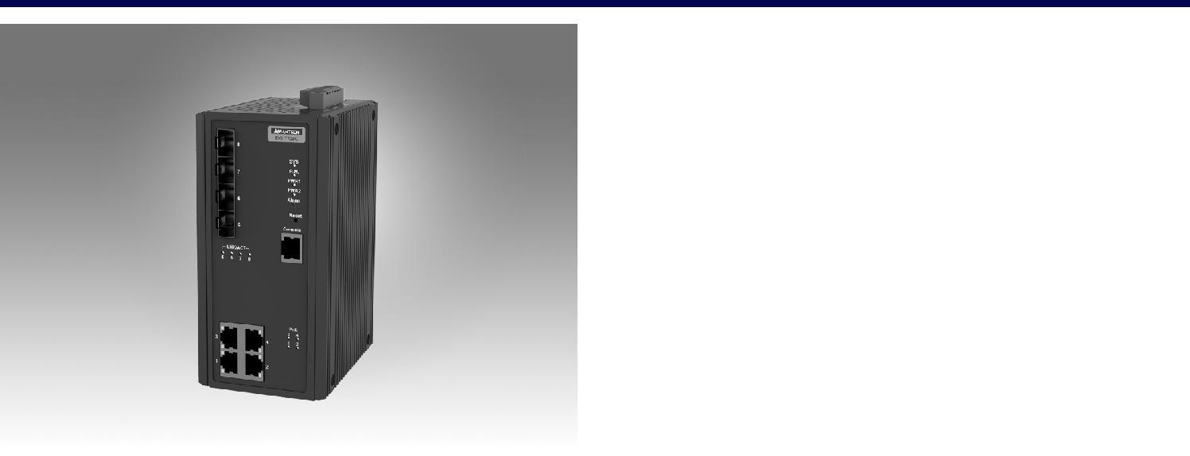

4FE+4G SFP端口千兆网管型工业POE以太网交换机

特性

4个IEEE 802.3 AF/AT PoE快速以太网端口+4个SFP端口

SFP插座，方便灵活的光纤扩展

冗余：X-Ring Pro（超高速恢复时间，<20 ms），RSTP STP（802.1w/1d）

IXM功能支持快速部署

安全：802.1X（基于端口，MD5/TLS/TTLS/PEAP加密），radius

管理：SNMP v1/v2c/v3、web、telnet、标准MIB、私有MIB

用于交通控制的NEMA TS2

EN50121-4铁路轨旁部署审批

宽工作温度范围-40~75°C（EKI-7708E-4FPI）

双48 Vdc电源输入和1 x继电器输出

RoHS
COMPLIANT

2002/95/EC

介绍

EKI-7708E-4FP/4FPI提供4个快速以太网IEEE 802.3 AF/AT PoE端口和4个SFP（mini-GBIC）端口。它们可以为每个端口提供高达30 W的功率，以满足高功耗功率设备的要求。它们嵌入了Advantech的IxM功能，可以通过快速部署为用户带来好处，并且可以大大节省工程时间和成本。eki-7708e系列还支持NMS，帮助IT经理进行网络维护和故障预防。最后，他们配备了X-Ring Pro，可以实现<20 ms的超高速恢复时间，从而确保网络的稳定

性。EKI-7708E-4FPI还特别具有-40~75°C的宽工作温度范围和NEMA TS2额定值，使其非常适合用于交通应用。最后，EKI-7708E-4FP/4FPI符合EN50121-4欧洲铁路标准对排放和铁路平台以及轨旁部署的要求。

规格

接口

 I/O 端口 4 x 10/100BASE-T/TX RJ-45
4 x SFP (mini-GBIC) port

 控制端口 RS-232 (RJ45)

 电源连接器 6-pin screw Terminal Block (including relay)

物理特性

 外壳 Metal Shell

 防护等级 IP 30

 安装 DIN-Rail

 尺寸 (W x H x D) 74 x 152 x 105 mm (2.91" x 5.98" x 4.13")

LED 显示屏

 LED系统 PWR1, PWR2, SYS, Alarm and R.M.

 LED接口 Link / Speed / Activity

环境

 工作温度 | -40 | ~ 75°C (-40 | ~ 167°F) (7708E-4FPI)
 | -10 | ~ 60°C (-40 | ~ 140°F) (7708E-4FP)
 储存温度 | -40 | ~ 85°C
 环境相对湿度 | 10 ~ 95% (非凝结)
 储存湿度 | 10 ~ 95% (非凝结)

电源

 | 功耗 | 12.1W @ 48VDC (System)
 | 电源输入 | 48 | VDC (46 to 57 VDC),
 |  | 53 | -57 VDC is recommended for 802.3at,

redundant dual power input

 电力预算 120W

 故障输出 1 Relay Output

认证

 EMI | CE, FCC Class A
 EMC | EN 61000-4-2
 | EN 61000-4-3
 | EN 61000-4-4
 | EN 61000-4-5
 | EN 61000-4-6
 | EN 61000-4-8
 | EN50121-4
 Shock | IEC 60068-2-27
 Freefall | IEC 60068-2-32
 Vibration | IEC 60068-2-6
 Traffic control | NEMA TS2
*= Compliant
 Patent | http://www.advantech.com/legal/patent

二级功能

 L2 MAC Address 8K

 Jumbo Frame 9216 Bytes

 VLAN Group 256 (VLAN ID 1 ~ 4094)

 VLAN Arrange Port based VLAN, Q-in-Q (VLAN Stacking), GVRP

 Port Mirroring Per port, Multi-source port,

 IP Multicast IGMP Snooping v1/v2/v3, MLD

Snooping, IGMP Immediate leave

 Storm Control Broadcast, Multicast, Unknown unicast

 Redundancy IEEE 802.1D-STP, IEEE 802.1s-MSTP, IEEE

802.1w-RSTP, X-Ring Pro, with ultra high-speed recovery time less than 20ms

Industrial Ethernet Solutions

All product specifications are subject to change without notice. Last updated: 27-Jun-2018

EKI-7708E-4FP/4FPI

结构图

74 [2.913]
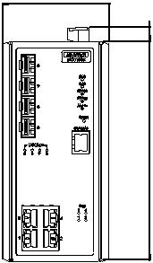

Unit: mm [inch]

4556.[2.22] | [0.591] |  | 1056.[2.209]
 | 781][1.
 | 2545.
 | 15
 |  | 37.72 | 35.56
 |  | [1.485] | [1.400]
 |  | 83.50 [3.287]
 |  | 114 [4.488] |  |  | 74 [2.913]
 |  |  |  |  | 37 [1.457]
 |  | 105 [4.134]
 |  |  |  |  | 35 | 19.50
 |  | 35.18 | 40.64 |  |  |  |  |  | 105 [4.134]
9.90[0.390] |  | [1.385] | [1.600] |  | [1.378] | [0.768]
152 [5.984] |  |  | [2.165] 47 [1.850] | 152 [5.984] |  | 130 [5.118] | 110 [4.331] | 90161. [6.374] | 152 [5.984]
 |  |  | 55 |  |  | 11[0.433] | 21[0.827]
 |  |  |  |  | 6-M3xP0.5
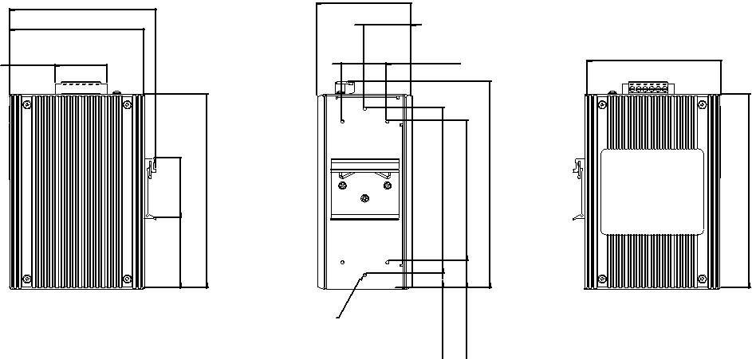
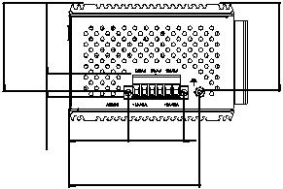

Panel Cut-out Dimensions: 105 x 152 x 74 (4.134" x 5.98" x 2.913")

QoS |  |  | 订购信息
 Priority Queue |  | WRR (Weighted Round Robin), SP (Strict Scheduling |  EKI-7708E-4FPI-AE | 4FE + 4G SFP Port Managed PoE Ethernet Switch w/
 | Scheduling | Priority) Hybrid Priority
 |  |  |  | Wide Temp
 Class of Service |  | IEEE 802.1p Based CoS, IP TOS, DSCP based CoS
 |  |  |  EKI-7708E-4FP-AE | 4FE + 4G SFP Port Managed PoE Ethernet Switch
 Rate Limiting |  | Ingress Rate limit, Egress Rate limit
 Link Aggregation |  | IEEE 802.3ad Dynamic Port Trunking, Static Port
 |  | Trunking
安全
 | 接口安全 | Static, Dynamic IP Source Guard, ARP Spoofing
 |  | Prevention, Access Control List, DHCP Snooping
 | 认证 | 802.1x (Port-Based, MD5/TLS/TTLS/PEAP
 |  | Encryption), TACACS+
管理
 DHCP |  | Client, Server, Option66/67/82
 Access |  | SNMP v1/v2c/v3, WEB, Telnet, RMON, Standard MIB,
 |  | Private MIB
 Security access |  | SSH2.0, SSL
 Software upgrade |  | TFTP, HTTP, Dual Image
 NTP |  | SNTP client

Online Download www.advantech.com/products

